Linking UAV and Spaceborne Imaging Spectroscopy for Multi-scale Calibration and Validation of a Mediterranean Saline Surface |  | EARSeL WS IS 2026  Abstract  Corresponding Author:  michal.gallay@upjs.sk
Michal Gallay¹, Ján Kaňuk², Ján Šašak¹, Katarína Onačillová¹, Petra Dávidová¹, Maria Teresa Melis³, Massimo Musacchio⁴, Marco Casu⁵, Ilaria Nobile³, Claudia Collu^{3,5}, Constantino Nieddu³
¹ Pavol Jozef Šafárik University in Košice, Faculty of Science, Institute of Geography, Slovakia
² PHOTOMAP, s.r.o., Slovakia
³ University of Cagliari, Department of Chemical and Geological Sciences, Italy
⁴ Istituto Nazionale di Geofisica e Vulcanologia (INGV), Italy
⁵ Sapienza University of Rome, Dept. of Civil, Constructional and Environmental Engineering, Italy
Keywords (5): UAV, spaceborne hyperspectral data, CAL/VAL, spectral similarity, saline surfaces

Challenge
New hyperspectral satellite missions such as ASI-PRISMA and DLR-EnMAP, together with the forthcoming ESA-CHIME mission and emerging commercial hyperspectral systems including Planet-Tanager, Airbus’ planned hyperspectral constellation, and Maxar’s commercial hyperspectral imaging program under development, are rapidly expanding access to detailed spectral observations. Ensuring cross-sensor consistency and interoperability across these platforms requires robust calibration and validation (CAL/VAL) approaches grounded in traceable multi-scale measurements. UAV-based hyperspectral imaging provides an effective intermediate link between ground spectrometry and orbital observations, offering high spatial detail and flexible acquisition conditions for controlled reflectance comparison. The goal of this study is to assess the suitability of Sal ’e Porcus as a CAL/VAL reference site by evaluating whether UAV-based hyperspectral data, calibrated with in-situ spectrometry, can provide reliable reflectance measurements for cross-sensor comparison with ASI-PRISMA and DLR-EnMAP.
Methodology
The methodological framework is designed to assess the suitability of a saline surface for imaging spectroscopy calibration and surface characterisation through a consistent analytical workflow spanning ground, UAV, and satellite observation scales. The study targets spaceborne imaging spectroscopy systems currently in operation, specifically ASI-PRISMA and DLR-EnMAP, which represent the present generation of hyperspectral missions requiring robust calibration and validation (CAL/VAL) support.
Surface reflectance at point scale was characterised using field spectroradiometric measurements acquired with an ASD FieldSpec instrument. These spectra were used as reference signatures for evaluating reflectance behaviour across spatial scales. UAV-based hyperspectral imagery was acquired in the visible to near-infrared range (400–1000 nm) using an AISA Kestrel 10 sensor (Specim) mounted on a customised DJI Agras T30 multicopter, providing high-resolution reflectance data suitable for assessing small-scale surface variability. UAV data were acquired under stable conditions at a flight speed of approximately 5 m s⁻¹ and 90 m above ground level, using a sensor field of view of 40°, with mild wind, clear-sky conditions, air temperatures exceeding 43 °C, and data collection conducted around local solar noon.
UAV reflectance mosaics were generated following radiometric processing based on empirical line calibration using in-situ reference targets, implemented in ENVI 5.3. To ensure spectral comparability across platforms, UAV hyperspectral data were spectrally resampled to the spectral response functions of the PRISMA and EnMAP sensors using R software. Cross-scale spectral consistency was evaluated using band-wise correlation analysis, linear regression, and residual statistics, enabling the assessment of agreement, potential bias, and scale-dependent effects in reflectance.
The methodological emphasis is placed on evaluating surface-driven spectral behaviour and scale transferability rather than on sensor intercomparison alone, supporting a surface-oriented perspective on CAL/VAL site assessment.

Study area and data
The study area is a temporary saline pond located on the Sinis Peninsula in western Sardinia (Italy), occupying a flat interdunal depression with no tributaries or outlets. Seasonal evaporation during summer leads to the exposure of an extensive saline crust developed over impermeable clay sediments. This process produces large, contiguous surfaces with limited vegetation cover and low surface roughness, making the site well suited for multi-scale spectral analysis.
All datasets used in this study were acquired during the dry season, when the saline surface was fully exposed. The presented analysis is entirely based on measurements collected in July 2023, corresponding to peak summer evaporation and maximum development of the saline crust. Ground spectrometry and UAV hyperspectral data were acquired during this period, and coincident PRISMA and EnMAP satellite acquisitions were selected to minimise temporal mismatch between observation scales.
The combination of ground-based, UAV-borne, and satellite hyperspectral data enables the assessment of surface spectral behaviour from centimetre to decametre spatial scales under consistent environmental conditions.

Discussion and Conclusions
Spectral comparisons across ground-based ASD measurements, UAV hyperspectral imagery, and spaceborne PRISMA and EnMAP data reveal consistently high agreement over the 400–1000 nm wavelength range. The closest correspondence is observed between UAV and ASD spectra (Pearson r = 0.995, slope = 1.001, R² = 0.990), indicating that the empirical line calibration applied to the UAV data effectively preserves in-situ reflectance characteristics. This result confirms the suitability of UAV hyperspectral imaging as a reliable intermediate scale between point-based ground measurements and satellite observations.
Both PRISMA and EnMAP exhibit strong spectral agreement with UAV and ASD data, with high correlation coefficients (r > 0.97) and coefficients of determination (R² > 0.94), although slight differences in reflectance magnitude are reflected in regression slopes below unity. Residual statistics remain low and unbiased across all sensor comparisons (RMSE < 0.016 reflectance), demonstrating internally consistent reflectance scaling and the absence of significant scale-dependent distortions.
These findings support the suitability of the Sal ’e Porcus saline surface as a candidate calibration and validation reference site for current and forthcoming imaging spectroscopy missions. The observed spectral stability and cross-scale consistency indicate that the site can support both radiometric CAL/VAL activities and spectrally meaningful surface characterisation. UAV-based hyperspectral imaging emerges as a practical and flexible component of CAL/VAL strategies, complementing ground spectrometry and satellite data by bridging spatial scales under well-controlled surface conditions.

Acknowledgement
This research originated thanks to the COOL project supported by the Italian Space Agency (ASI); additional support came from the VEGA project No. 1/0780/24 and the KEGA project No. 023UPJŠ-4/2025, both funded by the Ministry of Education, Science, Research, and Youth of the Slovak Republic, and from the CLIMANEMU project (No. 09I04-03-V02-00002) supported by the Recovery and Resilience Plan for Slovakia co-funded by the European Union and the Slovak Republic.

Figure 1 Location of the area and the distribution of the sampled points within the area corresponding to the analyzed pixels belonging to the ASI-PRISMA and DLR-EnMAP.

Table 1. Cross-scale spectral regression statistics between ASD FieldSpec, UAV, PRISMA, and EnMAP hyperspectral data in the 400–1000 nm range.
Data pair |  |  | N of interpolated spec. bands | PEARS. COR | REGRES. SLOPE | R² | BIAS = MEAN RESID. | RMSE | MAE | SD_RES
PRISMA | vs | UAV | 589 | 0.970 | 0.863 | 0.942 | 0.000 | 0.016 | 0.011 | 0.016
PRISMA | vs | ASD | 589 | 0.981 | 0.877 | 0.962 | 0.000 | 0.013 | 0.008 | 0.013
PRISMA | vs | ENM | 589 | 0.961 | 0.714 | 0.924 | 0.000 | 0.015 | 0.010 | 0.015
UAV | vs | ASD | 589 | 0.995 | 1.001 | 0.990 | 0.000 | 0.007 | 0.005 | 0.007
UAV | vs | ENM | 589 | 0.986 | 0.824 | 0.972 | 0.000 | 0.009 | 0.006 | 0.009
ASD | vs | ENM | 589 | 0.984 | 0.817 | 0.969 | 0.000 | 0.010 | 0.006 | 0.010

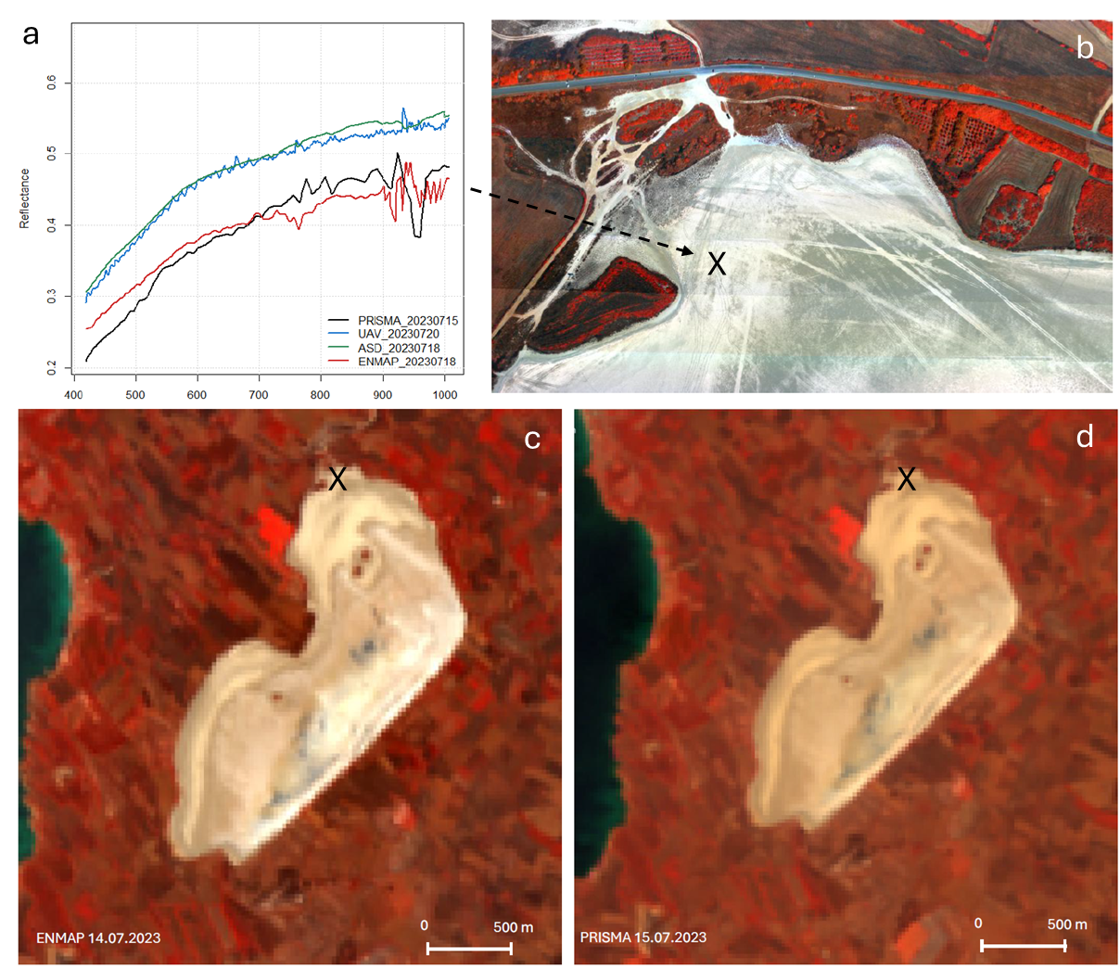
Figure 2 Reflectance spectra (a) extracted at point 2 marked X, shown together with the corresponding pixel locations in (b) UAV, (c) EnMAP, and (d) PRISMA hyperspectral datasets.

