**Príklady Python skriptov v GRASS-e**

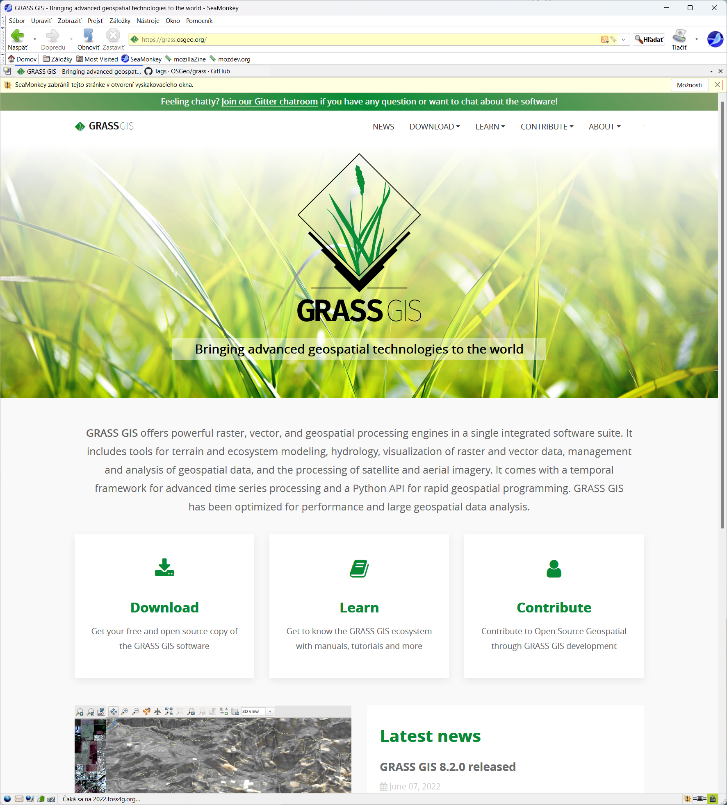

Zdrojový kód GRASS-u

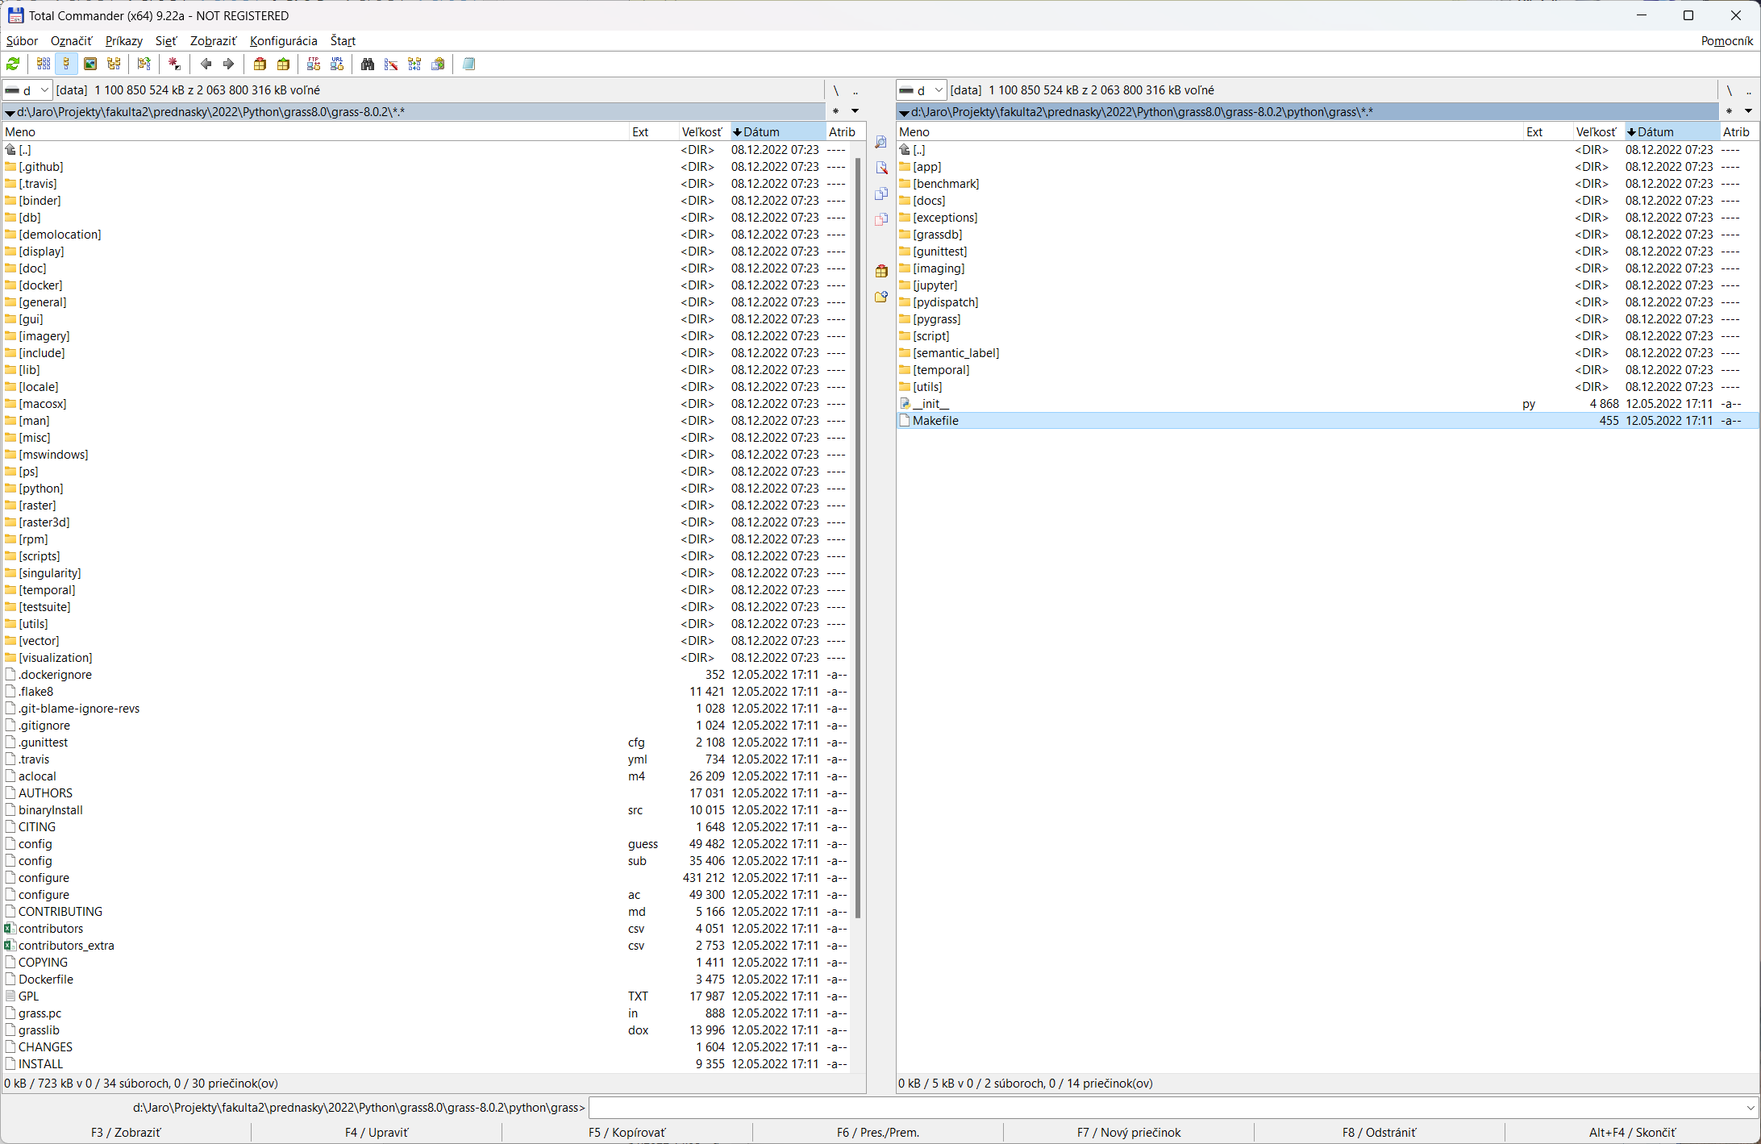

Moduly GRASS-u napísané v Pythone (81). Väčšina z nich bola pôvodne napísaná v shellscripte.

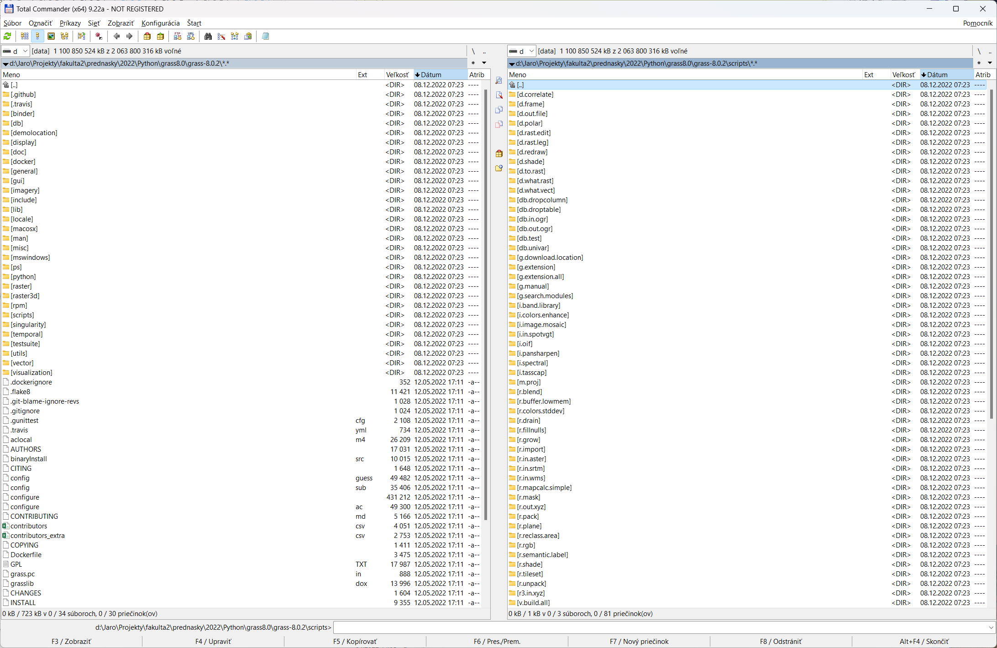

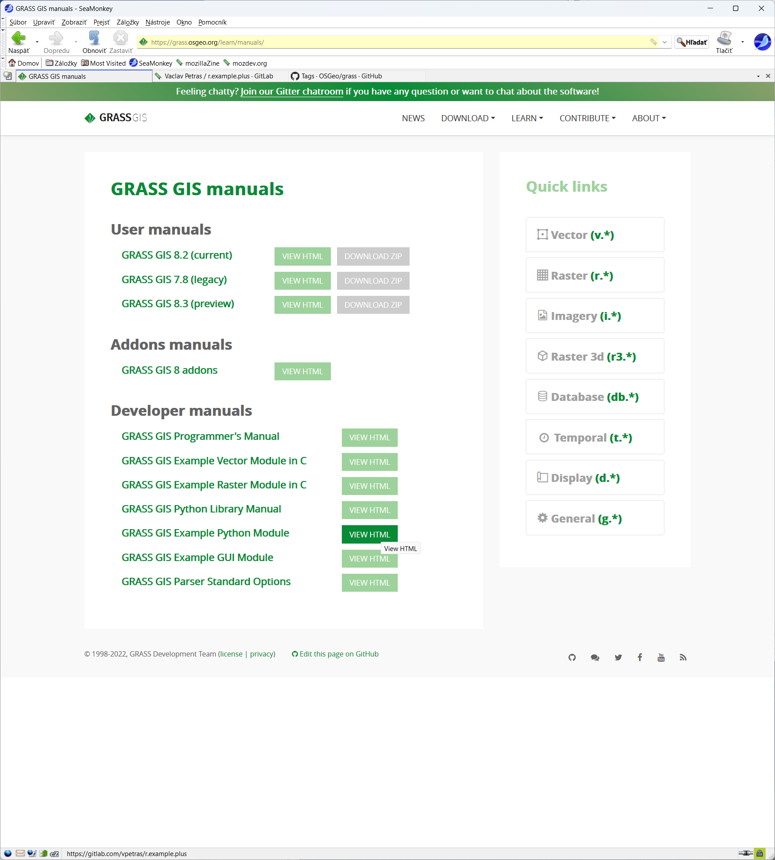

#!/usr/bin/env python

"""

MODULE: r.example.plus

AUTHOR(S): Vaclav Petras <wenzeslaus gmail com>

PURPOSE: Add two raster maps (an example of a module in Python)

COPYRIGHT: (C) 2018 by Vaclav Petras and the GRASS Development Team

This program is free software under the GNU General Public

License (>=v2). Read the file COPYING that comes with GRASS

for details.

"""

#%module

#% description: Adds the values of two rasters (A + B)

#% keyword: raster

#% keyword: algebra

#% keyword: sum

#%end

#%option G_OPT_R_INPUT

#% key: araster

#% description: Name of input raster A in an expression A + B

#%end

#%option G_OPT_R_INPUT

#% key: braster

#% description: Name of input raster B in an expression A + B

#%end

#%option G_OPT_R_OUTPUT

#%end

import sys

import grass.script as gs

def main():

options, flags = gs.parser()

araster = options['araster']

braster = options['braster']

output = options['output']

gs.mapcalc('{r} = {a} + {b}'.format(r=output, a=araster, b=braster))

return 0

if __name__ == "__main__":

sys.exit(main())

