**Landslides identification with machine learning methods**

Landslides are mass movements of primarily rock, soil or sediment typically induced by heavy rainfall, earthquake or volcanic eruptions. Despite landslides pose a significant risk to the housing estates, technical and transportation infrastructure, residents of local communities generally tend to neglect or underestimate their risk. Therefore, it is of the highest public interest to locate the occurrence landslides. The resulting landform of landsliding has a well recognizable manifestation in the terrain morphology which can be used to detect the landslide by the means of a digital terrain analysis. In Slovakia, landslides are a common natural hazard and the new laser scanning data has brought new opportunities to discover the landslides which have remained hidden under forest canopy. The aim of the challenge is to solve a practical issue of landslides identification using machine learning methods and algorithms applied on highly detailed digital terrain models.

**Challenge:** construction of a classifier (in the form of a decision tree, k-nearest neighbor classifier support vector machine, decision list, neural network, deep learning methods, and others) based on a training set.

**Training set:** digitalterrain model as a regular grid (raster) of terrain heights from laser scanning of Slovakia, reference vector data (polygons) of existing landslides to train the classifier (example images below)

(<https://zbgis.skgeodesy.sk/mkzbgis/sk/teren?pos=48.800000,19.530000,8>

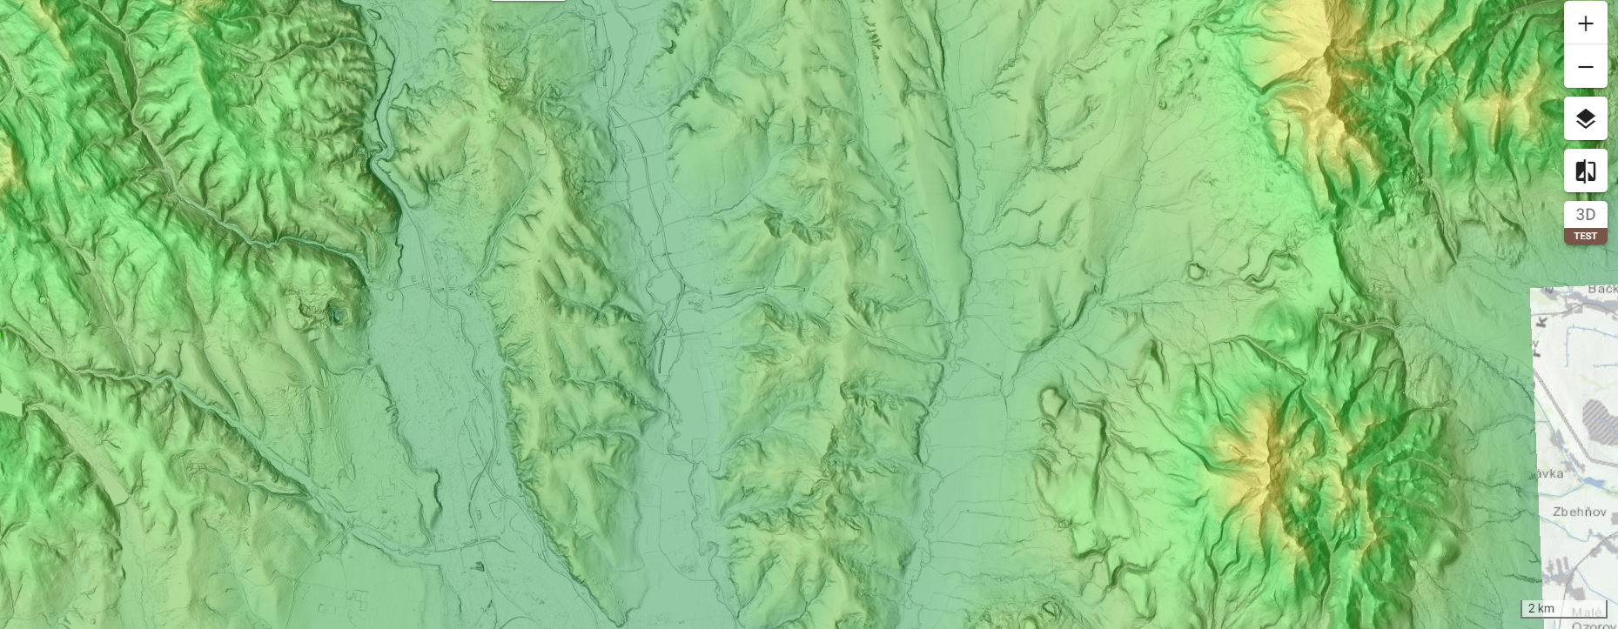

Highly detailed digital terrain model derived from airborne laser scanning data (Košice area). (<https://zbgis.skgeodesy.sk/mkzbgis/sk/teren?pos=48.800000,19.530000,8>

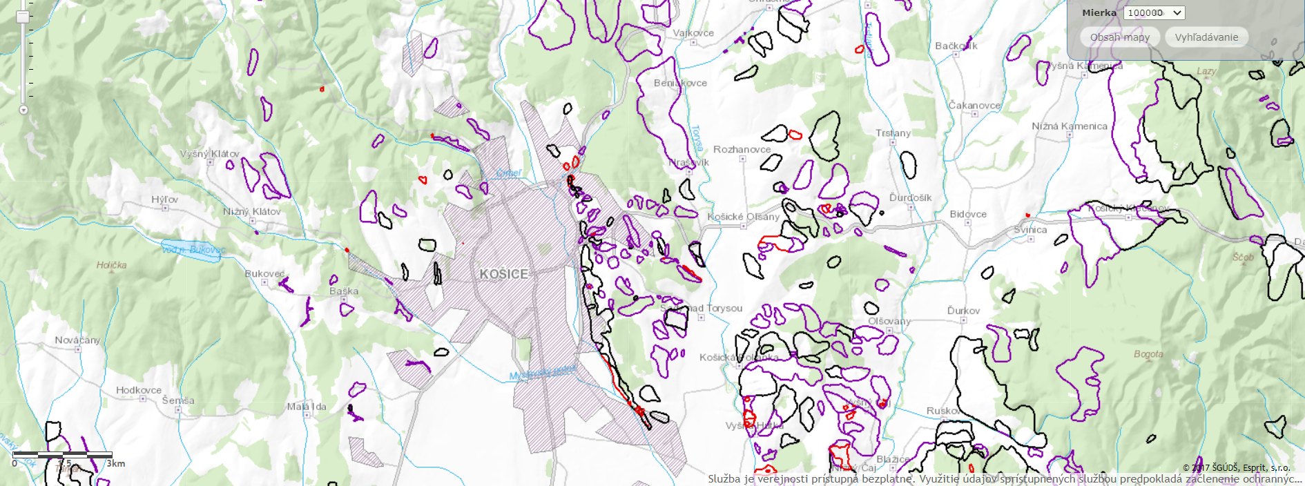

Existing known landslides mapped as polygons by the State Geology Service of Slovakia. (Košice area). <http://apl.geology.sk/atlassd/>

**The solution** should consist of the following parts:

* **Data description and preprocessing:** data properties, extracted features, and so on.
* **Description of the algorithms and methods used:** their principle, used hyperparameters.
* **Evaluation criteria:** the measures of quality of the obtained results, cross-validation, etc.
* **Description of results:** Precision, Recall, F1 score, AUC ROC, training time, output maps of the training sets, output maps of the identified landslides,
* **Interpretation of results:** the final comments and remarks, possible future work.

**Hint:** the examples of possible extracted morphometric parameters are slope angle, slope orientation, curvatures, and so on.