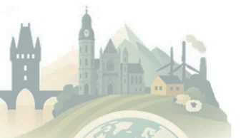
RA2C02 Programme
4th Joint Congress of the Czech and Slovak Geographical Societies · Košice, 7–10 September 2026

Wednesday, 9 September 2026
13:00 – 13:30 · TAKTIK publishing house presentation
13:30 – 15:00 · Workshop
15:00 – 16:00 · Presentation: Map of Victims of Communism, followed by optional museum visit

