ESA STUDY – EXECUTIVE SUMMARY REPORT
ESA Contract No:  4000117034/16/NL/NDe | SUBJECT: Simulating the cooling effect of urban greenery based on solar radiation modelling and a new generation of ESA sensors (SURGE) |  |  | INSTITUTE:  Institute of Geography  Faculty of Science  Pavol Jozef Šafárik University in Košice
ESA Contract No:  4000117034/16/NL/NDe |  | No. of Volumes: 1  This is Volume No: 1 |  | INSTITUTE’S REFERENCE:  SURGE_EXMR
ABSTRACT:
Estimating heat transfer in complex urban environment is a highly demanded task for urban planning as the contemporary climate changes on global scale. Urban greenery has a considerable effect on cooling the urban environment during heat waves. Urban greenery is a dynamic component of the urban land cover which can be observed by the Sentinel 2 (S2) satellite mission in a higher spatial and temporal resolution than is enabled by other similar missions. The SURGE feasibility study aimed to explore the potential of S2 multispectral data in simulating the cooling effect of urban greenery. The main objective was to define a methodical approach for spatial modelling of land surface temperature based on modelling the solar irradiation and parameterizing the land cover properties from S2 data. While solar irradiation can be precisely calculated on a fine scale using virtual 3D city models other important parameters for land surface temperature modelling are difficult to ascertain, such as surface thermal emissivity, broad-band albedo and evapotranspiration. The approach was tested in an area comprising 4 sq. km of the central part of the Košice City in Slovakia. Virtual 3D city model of was generated from airborne lidar and photogrammetric data acquired in a single mission. A time-series of Sentinel 2 data was gathered to be compared with a reference time-series of terrestrial lidar (TLS) data of urban greenery on 4 small sites. Statistical linear relationship was defined between the vegetation metrics derived from S2 and TLS data. A geobotanical database of urban trees was generated based on field survey. Algorithmic structure of a toolbox for modelling the land surface temperature in the open-source GRASS GIS was developed based on the Stefan-Boltzmann law and Kirchhoff rule. This study demonstrated how Sentinel 2 data can be used for estimating broad-band albedo, land surface emissivity and solar transmittance of vegetation. The primary benefits are in the developed algorithm for estimating the land surface temperature in a GIS environment providing a unique platform (i) for integrating various kinds of datasets to become usable in urban planning and (ii) for exploiting the S2 data in mitigation of the urban heat island.
The work described in this report was done under ESA PECS Contract. Responsibility for the contents resides in the author or organisation that prepared it.
Names of authors: Jaroslav Hofierka, Michal Gallay, Ján Kaňuk, Vladimír Sedlák, Katarína Onačillová, Ján Šašak, Jozef Šupinský, Alena Gessert
ESA PECS PROGRAMME MANAGER:
Kay Van Der Made
DIRECTORATE: IPL-ISP

Simulating the cooling effect of urban greenery based on solar radiation modelling and a new generation of ESA sensors (acronym SURGE)

Executive Summary Report

Introduction
This Executive Summary Report (SURGE_EXSMR) document has been issued by the Institute of Geography, Faculty of Science Pavol Jozef Šafárik University in Košice, Slovakia (UPJS) for ESA under the PECS contract 4000117034/16/NL/Nde of the proposal SURGE (SK1-04). This document provides brief synopsis and the core essence of the SURGE project and the Final report (SURGE_FR) grouped into five thematic domains. In summary:
- Research background
- Aims and objectives of the project
- Study area and data
- Monitoring urban trees with terrestrial laser scanning and Sentinel 2
- Simulating the cooling effect of urban greenery

Research background
Estimating heat transfer in complex urban environment is a highly demanded task for urban planning as the contemporary climate changes on global scale. Urban greenery has various positive micro-climate effects including mitigation of urban heat islands (UHI). The primary root of heat islands in cities is in absorption of solar radiation by the mass of building structures, roads and other solid materials. The absorbed heat is subsequently re-radiated into the surroundings and increases ambient temperatures. The vegetation can stop and absorb most of incoming solar radiation mostly via the photosynthesis and evapotranspiration process. This effect is nicely illustrated in Figure 1 depicting the central part of the Košice City, Slovakia. Given the associations between vegetated land cover and the biophysical and social processes in urban systems there exists an ongoing demand for effective urban vegetation mapping and classification techniques (Tooke et al., 2009). The results of the study by Tooke et al. (2011) indicated that trees on average reduce 38% of the total solar radiation received by residential building rooftops. Fogl and Moudrý (2016) found lower effect in the range of 3 - 11% and note that over 50% of the solar radiation loss occurs during the summer time. Radiation received at the urban surface is highly variable in space and time resulting from the complex form and land cover of urban environments. Understanding this variation in intercepted solar radiation is fundamental to determining various components of the urban energy landscape.
Multispectral imagery acquired by space borne sensors is a key data source for earth monitoring programs considering the great advantages that they have. Various techniques were developed to associate spectral response of the land cover surface with biophysical and structural properties of vegetation. In particular, combinations of red and near infra-red bands were used to derive vegetation indices which were proved to be correlated with particular vegetation metrics such as leaf area index, canopy gap fraction, canopy closure, etc. The most popular is the normalized vegetation index (NDVI), which is simple to calculate and provides a proxy for calculating metrics which are difficult to be measured directly from the satellite imagery, such as such as leaf area index (LAI), canopy cover and gap fraction. The multispectral data products of the ESA Sentinel 2 mission have a very promising potential to provide more accurate estimates on spectral response of the land cover, vegetation in particular, given the higher number of spectral bands and higher spatial resolution in comparison with similar Earth observation sensors (e.g. Landsat 8 OLI, Landsat 7 ETM+, ASTER, MODIS). This was proven by several studies prior to the launch of Sentinel 2A which used simulated bands. Despite, Sentinel 2 (S2) and Landsat 8 (L8) provide information on spectral properties of the land cover in relatively high resolution it is insufficient to reliably quantify the land surface temperature in complex urban landscape. However, the main benefit of the S2 and L8 data
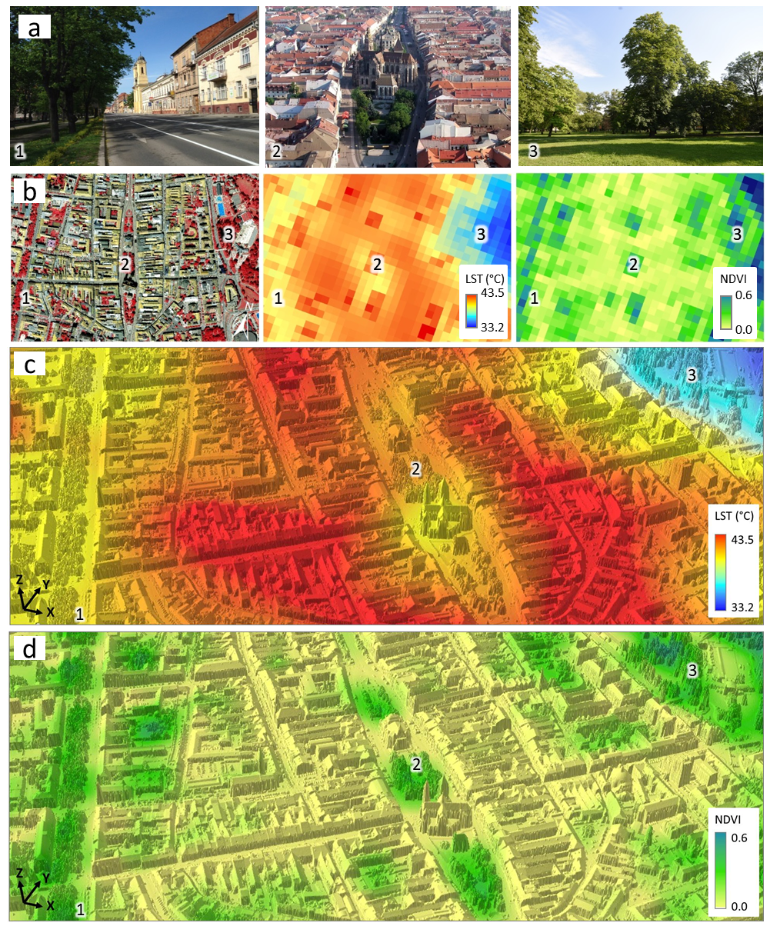
Figure 1. Land surface temperature and NDVI derived from Landsat 8 data acquired on 6 August 2015 in selected areas of the historical city centre of Košice (A): 1 – green alley on Moyzesova Street, 2 – the core of the city-centre, 3 – city park. (B) perspective 3D view of the L8 LST resampled to 0.5 m resolution draped over the lidar based digital surface model. The figure is adopted from Onačillová and Gallay (2018).
is in the relatively high temporal resolution and free data access in comparison with more detailed though more costly alternatives such as airborne laser scanning or photogrammetric datasets.
The hypothesis in the SURGE study was that high accuracy virtual 3D city models can be used for calculating the incident solar energy which can be converted to land surface temperature. For that, certain parameters which change dynamically over time can be estimated from the coarser multispectral satellite datasets such as S2. Despite not having the thermal band, higher resolution metrics can be derived from S2 datasets providing estimates of the thermal emissivity in a finer scale than the Landsat 8 TIRS thermal data.

Aim and objectives of the SURGE project
The aim of the project was to evaluate the feasibility of joint use of virtual 3D city models and Sentinel 2 multispectral satellite imagery for approximating the dynamics of land surface temperature via modelling the spatial distribution of solar irradiation and land cover properties in a complex urban environment. The main objective was to define a methodical approach for spatial modelling of land surface temperature based on modelling the solar irradiation and parameterizing the land cover properties from S2 data. While solar irradiation can be precisely calculated on a fine scale using virtual 3D city models other important parameters for land surface temperature modelling are difficult to ascertain, such as surface thermal emissivity, broad-band albedo and evapotranspiration. The approach was tested in an area comprising 4 sq. km of the central part of the Košice City in Slovakia. Information about the project and its main results are summarized also on the website http://esa-surge.science.upjs.sk.

Study area and data
The SURGE project was elaborated on the case study of Košice which is a typical small post-communist Central European city which has underwent considerable changes of urban landscape induced by transition to capitalism and modern trends in economy (Fig. 2). It is the second largest city in Slovakia with almost 240 000 inhabitants. The project team is based in this city therefore it was meaningful to establish the study on an area within Košice. We selected an area of a feasible size (4 km²) and with sufficient diversity of urban greenery which would be suitable for ground-based mapping, airborne survey and large enough for monitoring by Earth observation satellites such as Sentinel 2A and Landsat 8. The overview of acquired types of data is shown in Fig. 3. Green vegetation covers about 23% of the study area where lawns and deciduous trees dominate.
A time-series of cloud free multispectral imagery of Sentinel 2A and 2B (https://scihub.copernicus.eu/) and Landsat 8 OLI/TIRS (https://earthexplorer.usgs.gov/) was gathered for the year of 2016 and 2017. The assembled time series enabled to demonstrate change of vegetation coverage by the means of true colour composites, near-infrared colour composites, and NDVI. The L8 data were used for analysing the urban heat island phenomenon of in Košice which is described in Onačillová and Gallay (2018) in more detail. LST was found to be in a strong negative correlation with NDVI in the growing season when plants have high chlorophyll content and evapotranspiration has the strongest effect. Even small areas such as tree alleys or small gardens and parks with green vegetation within the urban fabric can mitigate the LST. The results also provided several examples that replacing semi-natural grassland or agricultural land for new shopping centres, commercial zones or industrial parks in the last two decades amplified the UHI effect and contributed to its expansion into suburban zones. Elimination of the UHI effect and the effort for balanced presence of built-up areas and greenery in the further development of the city should be a priority for the upcoming years for the city management in order to the city remains a full-valued environment for its inhabitants.
Mapping the study area in higher resolution was deployed in the large area in cyan outline in Fig. 2. Airborne photogrammetry and airborne laser scanning (ALS) were performed in two single missions in late summer of 2016. ALS data and photogrammetric imagery were used for creation of a virtual 3-D city model consisting of buildings and terrain (Fig. 4). Four smaller test sites covering about a hectare (Fig. 2, red outlines) were selected for detailed mapping of urban vegetation and its geometric change by repeated terrestrial laser scanning (TLS). Each site represents typical urban greenery consisting of various kinds of trees of different height. Interpretation of the TLS point clouds was supported by geobotanical field survey. The generation of the virtual 3D city model is summarized in Hofierka et al. (2017) who also describe the methodical approach of monitoring urban trees as a time series of 3D terrestrial laser scanning data. All the mentioned types of data were involved in developing the approach for simulating the cooling effect of urban greenery. The 3-D city model of the entire study area is a static 3-D representation of the area valid to September 2016 when the main component of spatial data was acquired (ALS, photogrammetry). We generated an interactive 3D web interface for public viewing of the ALS point cloud (https://esa-surge.science.upjs.sk/laspublish/ALS_Kosice.html).

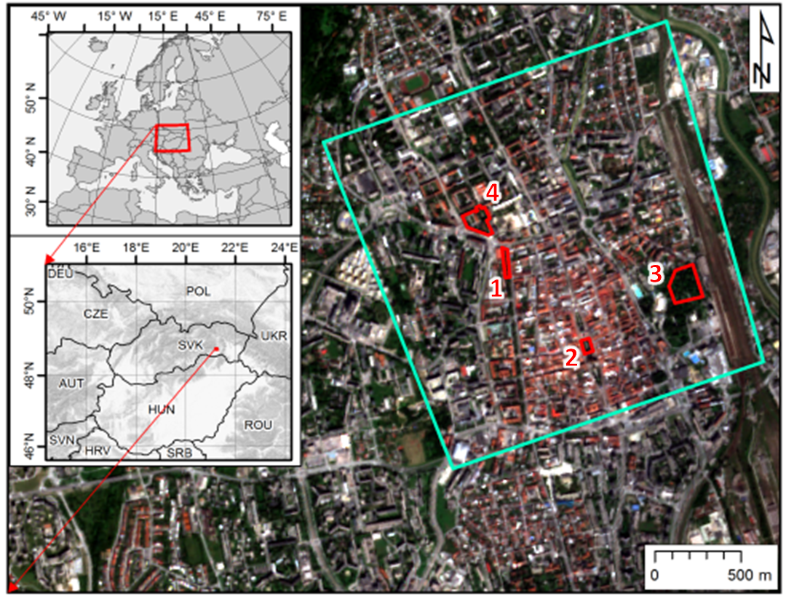 | 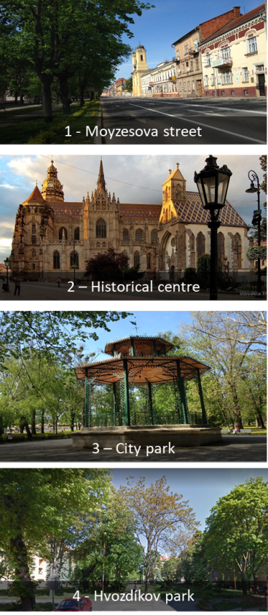
Figure 2. Location of the study area in the Košice City, Slovakia. The cyan line outlines the area subject to airborne lidar and photogrammetric mapping in a single mission, time series of the Sentinel 2 image coverage. The red outline delineates four sites selected for repeated terrestrial laser scanning of urban vegetation. The background maps are © Copernicus, Sentinel 2A image acquired on 7 September 2016.
vectors, (ii) trees as ALS 3-D points, 2-D vector polygons, (iii), terrain as a digital terrain model (2-D raster/grid), (iv) land cover surface as a digital surface model (2-D raster/grid), (v) land cover as a digital orthoimagery in natural and false colours (2-D raster image). In addition, the geodatabase comprises data for the four smaller sites which were subject to high resolution monitoring of vegetation 3D structure by TLS. The city models of the four smaller sites therefore contain a dynamic component, i.e. 3-D models of trees.
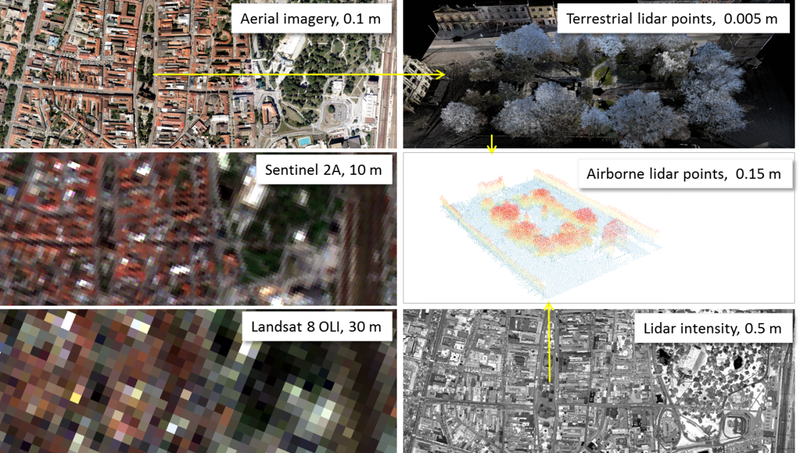
Figure 3. Overview of the acquired spatial data for the study area and associated spatial scales. The images show the central part of the Košice City, Slovakia.
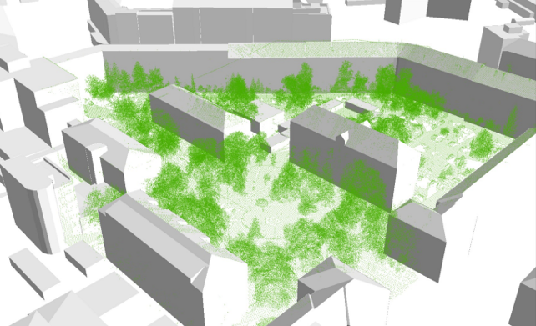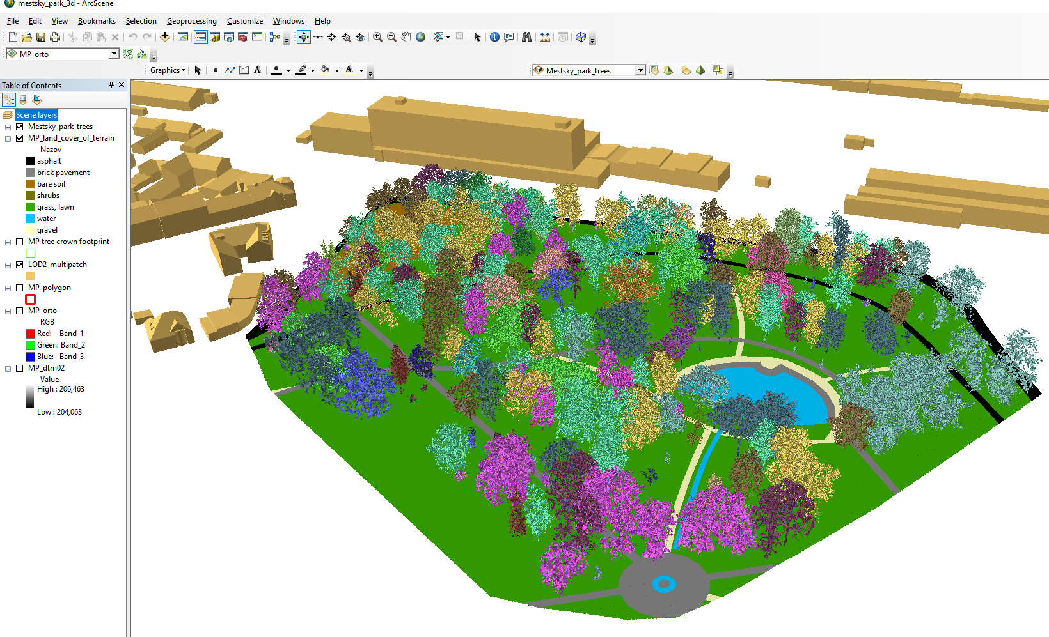
Figure 4. Detailed view of a part of the 3D city model at LoD2 with ALS points representing trees (green) in Hvozdíkov park (left). Graphical interface of the ArcScene project for the small site in Mestský park (City park) showing 3D view of the geodata layers, the 3D trees are coloured according to the plant species (right).

Associating TLS point data with S2 imagery for assessing temporal dynamics of urban greenery

Vegetation in mild climate of Europe manifests considerable annual seasonality which can also contribute to the seasonal change in the cooling effect of the vegetation on the urban climate. Modern methods of high-resolution mapping and new generations of sensors have brought opportunity to record the dynamics of urban greenery in a high resolution in spatial, spectral, and temporal domains. Therefore, we designed and applied a methodology of 3-D mapping and modelling the urban greenery during a single vegetation season of 2016 (Hofierka et al. 2017). The purpose of this monitoring was to capture the change of 3-D geometry of urban greenery in ultra-high resolution and capture the effects of the change on spatial distribution of solar radiation in urban environment. Terrestrial lidar survey with a RIEGL VZ-1000 scanner was conducted on four selected sites within Košice (Fig. 2). Implications of the associated results are manifested in the analysis of shaded area shown in Fig. 5. It is clear that for the selected site and time interval the effect of ground shadowing can be calculated using the generated time series of the meshed 3-D tree models. The time duration of area being shaded depends not only on the sun declination but also on the effect of the tree phenology can is involved.
A 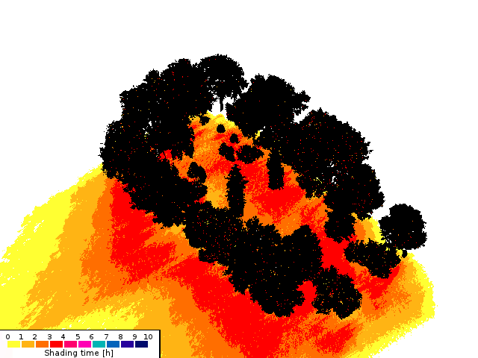 B 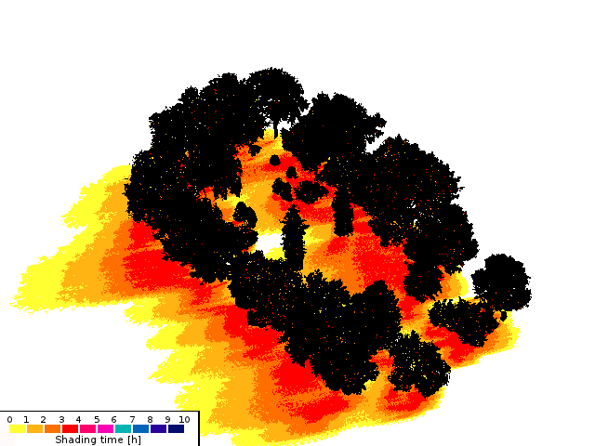
Figure 5. Simulation of time the area is shadowed by trees between 1 p.m. to 4 p.m. using the 3-D meshed tree models in the Shadow Analysis plugin of the SketchUp software for March (A), June (B). Adopted from Hofierka et al. (2017).
In modelling the solar irradiation of urban space, both atmospheric transmittance and geometric structure of urban space were shown to be critical model parameters. For the purposes of assessing the vegetation transmittance, NDVI and other indices based on satellite imagery cannot be directly used. Metrics expressing the nature of solar vegetation transmittance for the solar radiation comprise, for example, leaf area index (LAI), canopy cover, tree canopy closure, canopy gap fraction, etc. However, these are difficult to be measured directly from the satellite imagery. The multispectral imagery acquired by the S2 mission has relatively high spatial, spectral and temporal resolution to capture the dynamic of vegetation phenology.
We studied whether the S2 data could be used as a proxy of the vegetation transmittance on higher resolution and whether the downscaled S2 transmittance could be used in modelling the solar irradiation and for ultimately for modelling the ground surface temperature. The results confirmed that S2 multispectral imagery is strongly applicable for mapping annual phenological changes of vegetation in urban landscape. NDVI was the most suitable metrics to parameterize the urban greenery among the tested ones (SAVI, EVI). The findings indicated that for analysing relation of the selected vegetation metrics derived from lidar datasets and Sentinel 2A imagery NDVI correlated with more complex indices and it was decided to be sufficient for mapping the vegetation by Sentinel 2A. Canopy cover and canopy density derived from TLS and ALS data had weak correlation with NDVI derived from Sentinel 2A data. Estimated LAI (LAI_{e}) based on TLS and ALS most closely correlated with NDVI derived from S2A data (Fig. 6, 7). This correlation was strong in the vegetation season and lower off the season. However, such relationship was not observed on all TLS sites and if the data from sites are merged together per date the relationship was weak (SURGE_FR).
The results opened more issues and questions to address than were answered. One of the most important is whether and how the response of the defined linear models can be improved and if a more suitable set of vegetation metric can be identified for relating the information of S2 with 3D geometry. The lessons learned suggest that more robust statistical models are needed to find closer fit between Sentinel 2 NDVI and TLS derived metrics for downscaling the vegetation transmittance to higher resolutions. The reliability of the prediction of the vegetation transmittance from the Sentinel 2 data based on the reported findings requires further testing.
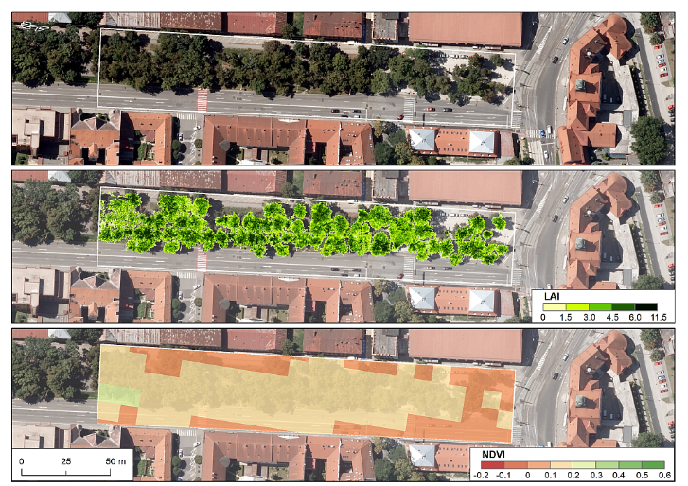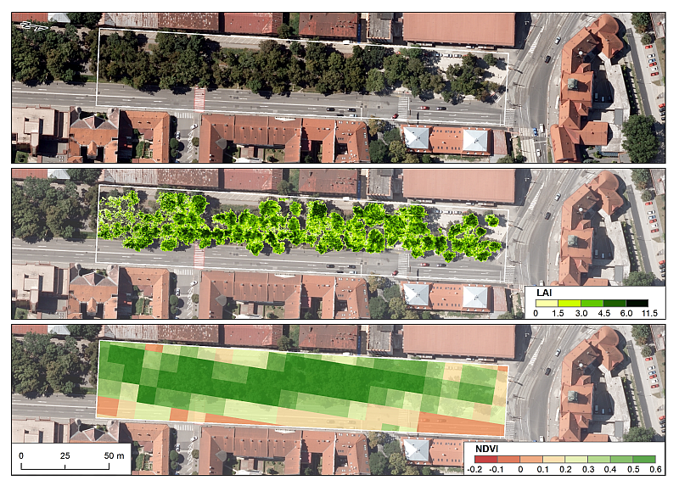
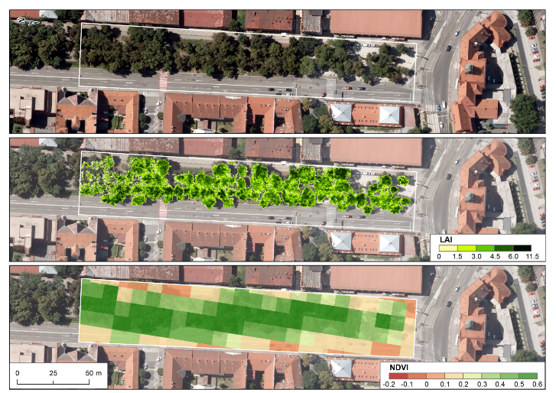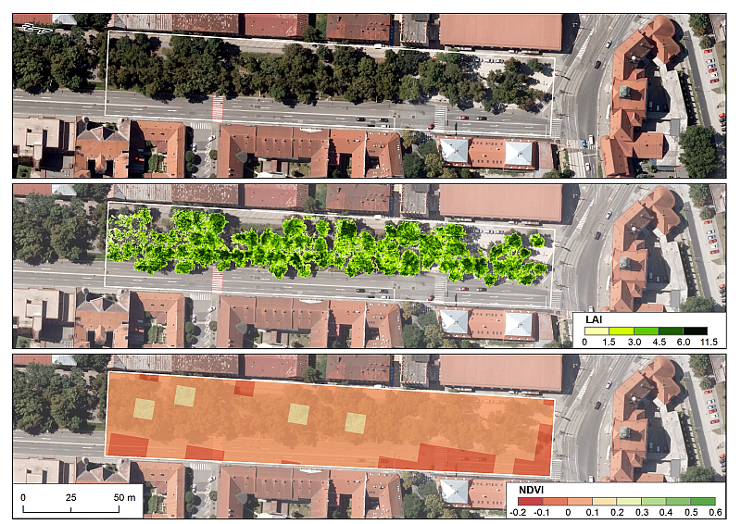
Figure 6. LAI_{e} from TLS data per 0.1 m cell size and Sentinel 2A NDVI for 10 m cell size for the site of Moyzesova street. Data acquisition: 7 April 2016 (top left), 26 July 2016 (top right), 27 August 2016 (bottom right), 23 November 2016 (bottom right).
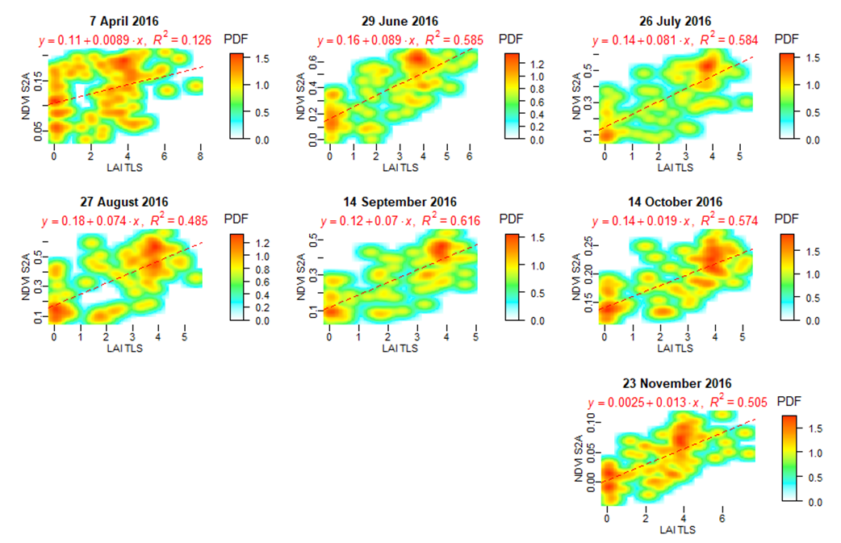
Figure 7. Smoothed scatterplots of Sentinel 2A NDVI and LAI_{e} canopy density calculated at 0.1 m grid cell size for the site of Moyzesova street.

Simulating the cooling effect of urban greenery
The ultimate goal of the SURGE project was to define an algorithm which for demonstrating the positive effects of urban greenery on the micro-climate conditions in a city where land cover undergoes seasonal changes throughout a year. We identified the potential of the Sentinel 2 data for capturing such land cover dynamics in a reasonable temporal, spectral, and spatial resolution. In addition, we wanted to develop a tool which can be easily yet reliably used by non-specialist who use GIS in urban management, planning or other related disciplines. Such a simple-to-use tool has not been available to date. We approached this task by defining an algorithm for spatially distributed and physically based modelling of land surface temperature (LST) in GIS based on joint use of virtual 3D city models and Sentinel 2 multispectral satellite imagery. Land surface temperature (LST) is the key parameter in the physics of land surface processes, combining surface-atmosphere interactions and energy fluxes between the atmosphere and the ground. Over the last two decades numerous studies have been published analysing the associations between solar radiation, reflectance, emissivity and other heat transfer parameters of materials of urban surfaces (Berdahl and Bretz, 1997, Mirsadeghi et al. 2013). LST is generally defined as the radiative skin temperature of the ground. Properties of urban materials, in particular solar reflectance, thermal emissivity, and heat capacity influence the LST inducing the development of UHI as this properties determine how the Sun’s energy is reflected, emitted, and absorbed.

Toolbox for modelling the land surface temperature
The SURGE_D5_ALGOSTRUC report comprises the design of the algorithm, i.e. workflow, of how we approached the modelling of the cooling effect of urban greenery taking into account the information extracted from the S2 mutlispectral imagery. Partial outcomes of this workflow are presented as example output data layers for selected days within a year. The summary of results does not contain output layers derived from all acquired input datasets (TLS or S2 data) or all possible scenarios. During this project we have conducted the following steps that lead to our estimation of LST and surface UHIs including the representation of cooling effects of urban greenery in the Košice city:
- creation of a 3D city model representing urban surfaces such as buildings, roads, urban greenery in the form of digital surface model (digital terrain model + buildings + trees) or a full 3D model;
- evaluation and parameterization of trees for effects on solar radiation (shadows, albedo) and heat transfer using lidar and S2 data;
- preparation of input data in a vector and raster data formats for solar radiation modelling using r.sun/v.sun for the selected time horizons;
- land surface temperature estimation using Stefan-Boltzmann equation using assessment of solar irradiance and irradiation, land cover parameterization and meteorological data;
- evaluation of various scenarios reflecting a different state of urban greenery using GRASS GIS to assess the best ways to mitigate UHIs.
These steps define these major components of the algorithmic structure for the future toolbox:
- Data component: 3D city model (vector format), input GIS data (vector/raster), meteo data (vector-point);
- Simulation/modelling component: r.sun/v.sun solar radiation models a Stefan-Boltzmann land surface temperature model;
- Prediction component: Based on actual data, the simulation component will produce data on predicted LST, thus providing information on expected LST in any location within the city. Evaluation of various scenarios based on different input data parameters will help to better plan counter UHI measures, such as changing roof colour paintings to increase albedo or planting trees in UHI hotspots.;
The suggested toolbox consists of the following tools implemented in GRASS GIS:
- Data component: v.in.gdal, r.in.ascii, r.slope.aspect
- Simulation component: lst.stefan-boltzman.sh (shell script), r.sun, v.sun, r.mapcalc
- Prediction component: r.mapcalc
The workflow used is graphically outlined in Fig. 8. The role of Sentinel 2 data products is highlighted by thick outline. The main contribution of Sentinel 2 data in LST calculation is in the estimation of albedo and thermal emissivity of the land cover surface. The developed algorithmic toolbox can be converted into a more compact kind of tool as plugin for which a roadmap was elaborated. The report SURGE_D6_ROADMAP provides more details for a specialized software toolbox called r.lst to be implemented in open-source GRASS GIS.

Spatial modelling of solar irradiation
Solar radiation received by the urban surface is a key input factor in many urban energy models and sustainable city designs. Examples include thermal and photovoltaic solar energy installations, passive heating systems or urban microclimate designs. However, solar radiation flows over urban surfaces are highly variable due to a complexity of urban morphology and interactions with various components of the urban environment. The use of adequate models and tools is therefore crucial for accurate assessments of spatial and temporal distribution of solar radiation in urban areas. Over the last two decades several solar radiation models integrated with geographical information systems (GIS) were developed. These GIS-based solar radiation models provide estimates of spatial variations of solar radiation over large regions using digital terrain models (DTMs) and selected ground-based or satellite data reflecting atmospheric and land cover conditions (e.g., Dubayah and Rich 1995, Šúri and Hofierka 2004). These solar radiation models can be used for two-dimensional (2-D) surfaces, such as land surface or rooftops. Hofierka and Zlocha (2012) also developed the v.sun model as a full 3-D solar radiation model for complex, three-dimensional (3-D) urban surfaces as an extension of the r.sun model.
The original proposal in this feasibility study was to simulate the cooling effect of urban greenery using the S2 data with the v.sun module. However, we realised that S2 data could be implemented into such a geospatial modelling in a simpler fashion via the r.sun module which will be more convenient for the end user. The main argument for that is the two-dimensionality of Sentinel 2 data products which represent a 2D array of spectral radiance reflected from the earth surface and recorded by the S2 MSI sensor on-board the satellite vehicle. The data products are 2D arrays by nature, i.e. raster datasets, therefore, more suitable for the r.sun module which was developed for 2D raster data.
The r.sun model is implemented in the open-source environment of GRASS GIS as the r.sun module (Neteler and Mitasova 2004) and it is one of the widely used GIS-based solar radiation models. Originally developed as a clear-sky model (Hofierka 197), it was later further substantially improved by Šúri and Hofierka (2004) to include diffuse and reflected components

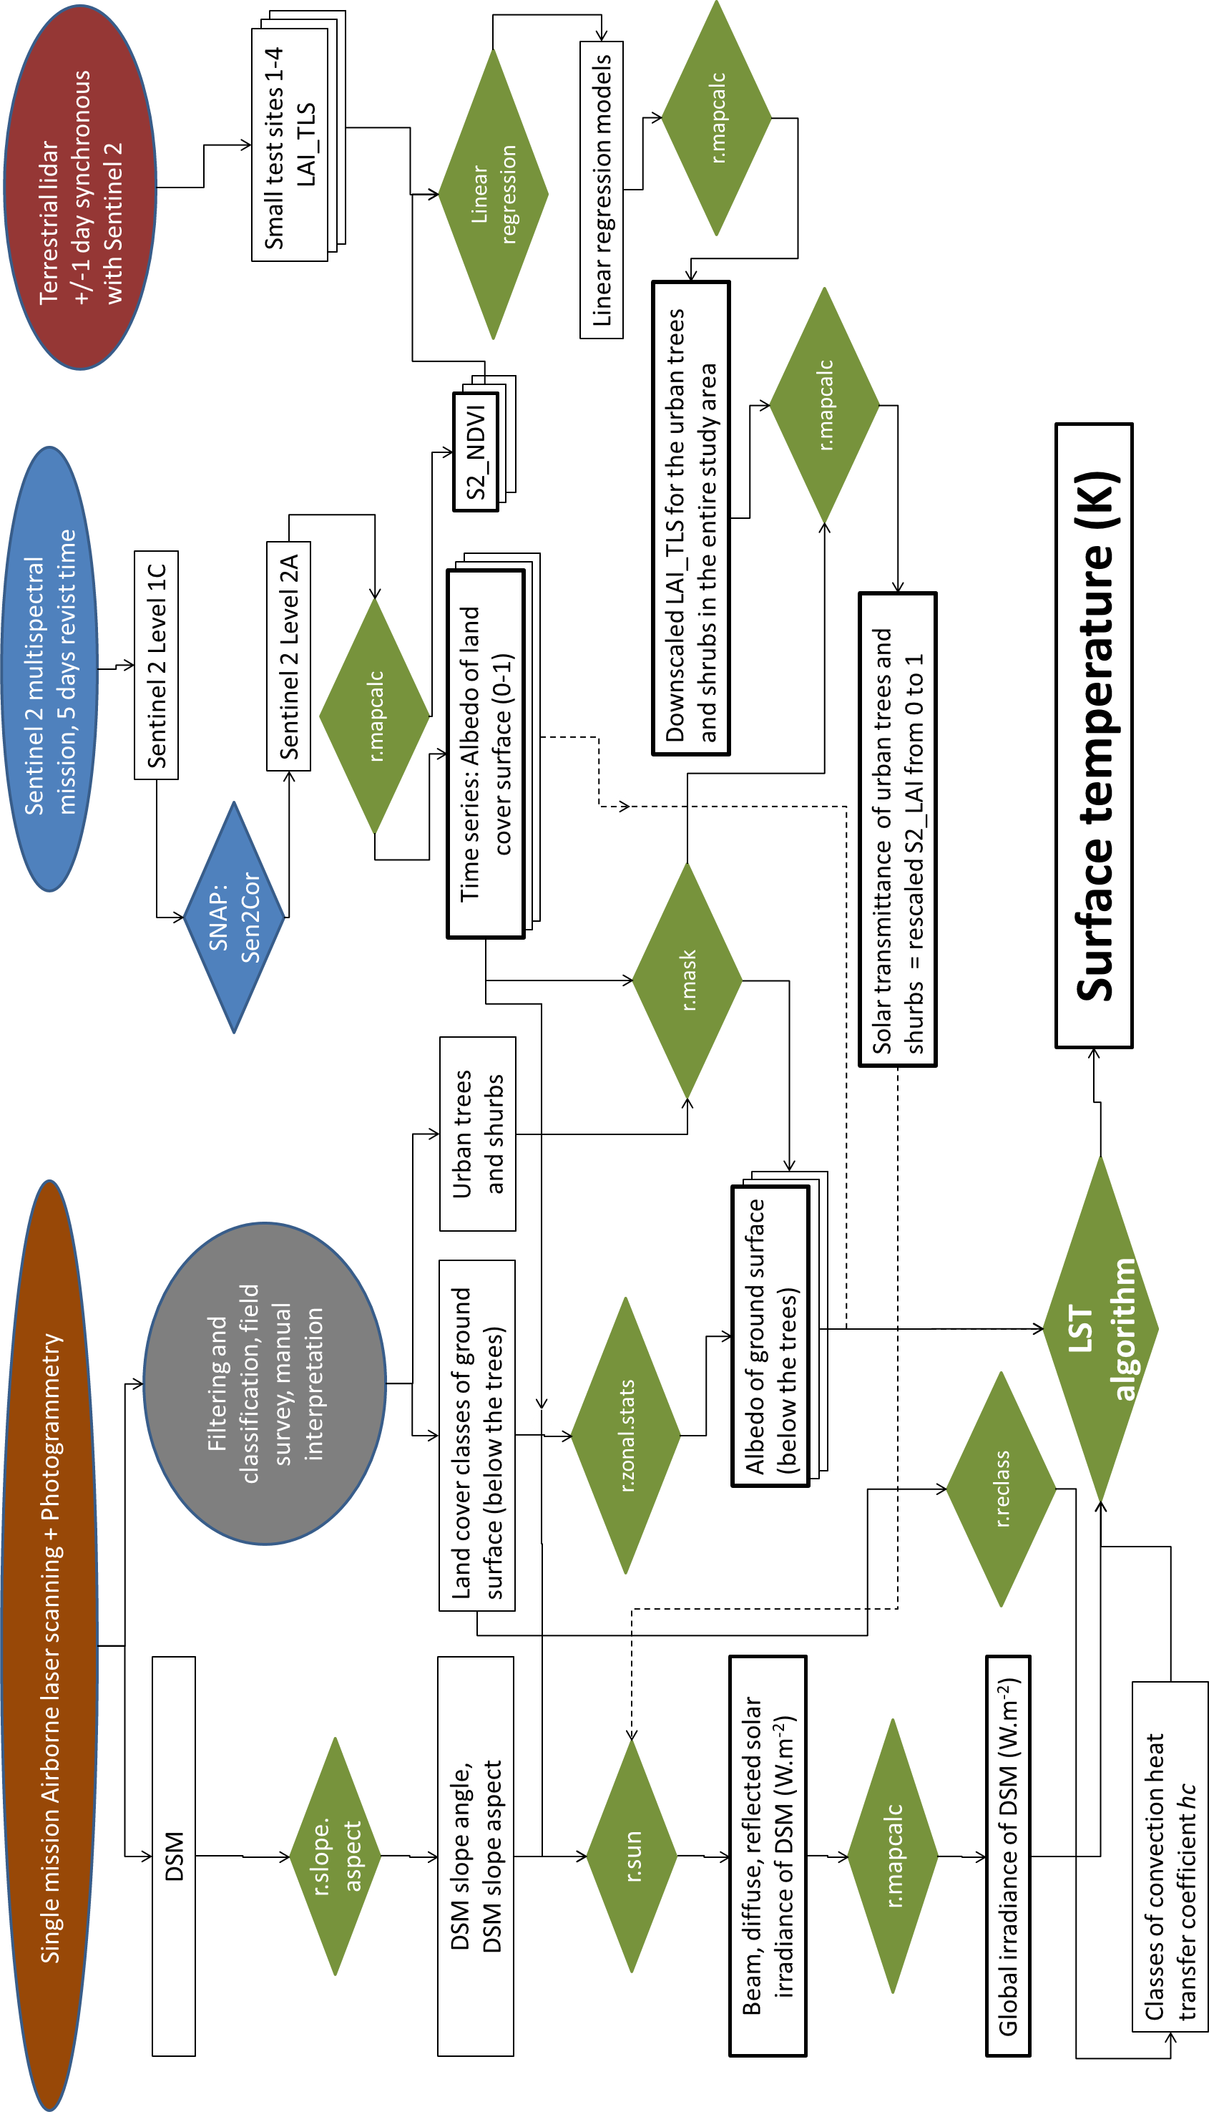
Figure 8. Schematic workflow of preparing the inputs for the land surface temperature modelling. Elipses denote the data acquisition methods, rectangles denote the data layers or products, pinacoids denote processes. Green colour is marks the processes in the GRASS GIS environment, blue colour marks the SNAP environment for processing Sentinel 2 products. Thick outline marks the data layers derived from Sentinel 2 products.
of solar radiation for clear-sky and real-sky conditions. The model is sufficiently robust and flexible over various scales and range of applications.
The effect of urban greenery in cooling the local micro-climate was demonstrated in 4 scenarios on by calculating the land surface temperature for the 182th day of year and 10:20 of zonal time (30 June 2016). This day and time was selected for the availability of cloudless scenes of Landsat 8 for this moment and Sentinel 2 for previous day of 29 June 2016. Grass, lawns and small shrubs are considered as land cover of the ground surface. The calculated global solar irradiance on horizontal surfaces such as roads (orange colour of global irradiance in Fig. 9) corresponds well with the measured global irradiance at the Košice airport weather station on (887.15 W.m⁻²) on 30 June 2016 at 10:00 zonal time. The final output of each of the four scenarios resulted in a sum of the beam, diffuse and reflected component which is the global irradiance raster layer. This dataset is one of the key inputs for modelling the temperature which is described in the following section.

 | 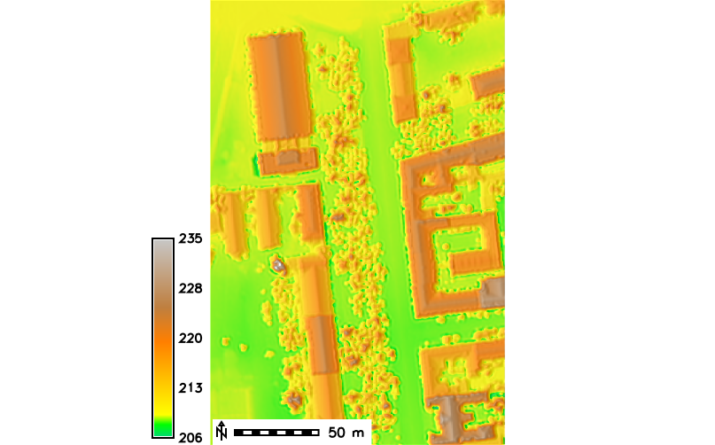 |  | 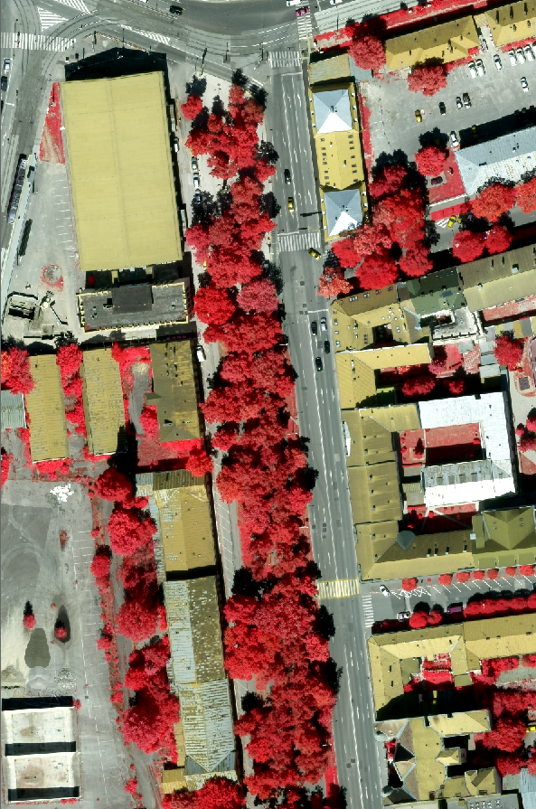 |  | 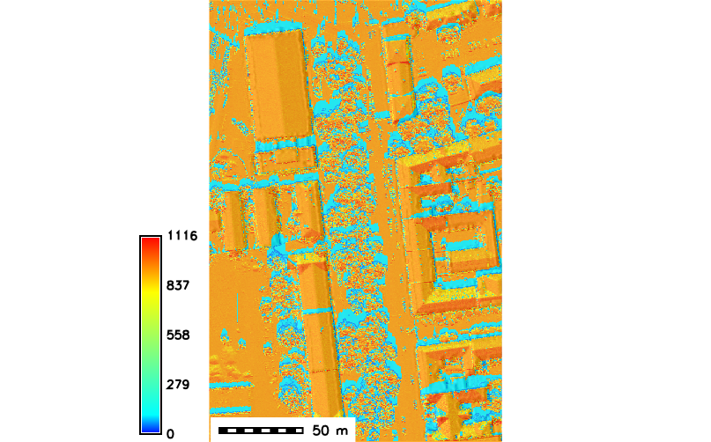
Digital surface model, elevation [ma.s.l.] including vegetation and buildings |  | False colour infrared aerial orthoimage |  | Global clear-sky irradiance [W.m ⁻²]

Figure 9. Lidar based digital surface model (DSM) of the area of Moyzesova street in Košice (site 1 in Fig. 2) including buildings and vegetation used to calculate global solar irradiance (W.m ⁻²) using the r.sun model in GRASS GIS for 30 June at 10:20 zonal time. The area size is 200 m by 400 m. The resulting data layers were derived at 0.50 m spatial resolution.

Spatial modelling of land surface temperature
The land surface temperature was estimated by a novel algorithm combining map algebra in GRASS GIS, the Stefan Boltzmann Law and the Kirchhoff rule using raster input data derived from a virtual 3D city model and Sentinel 2 multispectral imagery. Generally, built-up area exhibits a variable thermal pattern with hot and cold peaks, corresponding to low and high reflectivity, respectively. A solar-reflective surface is typically light in colour and absorbs less sunlight than a conventional dark-coloured surface. Mitigating UHIs requires lowering the average surface temperature of the city so that there is less surface-to-air heat transfer. Urban vegetation is one of key components of this effort as the greenery maintains cooler surface temperatures, mainly by the process of evapotranspiration and shading. For building and pavement surfaces in the sun, surface characteristics such as albedo, emissivity, and roughness, are also relevant. For a surface under the sun and insulated underneath, the equilibrium surface temperature, T_{s} (the modelled LST) is obtained from the equation based on Stefan-Boltzmann Law which describes the power radiated from a black body in terms of its temperature (Bretz et al., 1998):
where is unitless solar-reflectivity or albedo of the surface varying from 0 to 1, I is the total solar radiation incident on the surface in W.m⁻² which is the output from the r.sun model, is the emissivity of surface, is the Stefan-Boltzmann constant, 5.6685 × 10⁻⁸ W.m⁻²K⁻⁴, T_{s} is equilibrium surface temperature, K, T_{sky} is the effective radiant sky temperature, h_{c} convection heat transfer coefficient, Wm⁻²K⁻¹, T_{a} air temperature, K (ASHRAE, 1989).
Using this equation, the surface temperature T_{s} can be approximated by Newton's iteration method which is coded in GRASS GIS using a shell script (SURGE_D5_ALGOSTRUC). The GRASS GIS implementation assumes that ambient air temperature T_{a} and radiant sky temperature T_{sky} are also known. Air temperature is usually measured by meteorological stations, often within the city. Radiant sky temperature can be estimated using one of the available approximation methods published, e.g. in (Algarni, 2015), depending on the cloudiness. In this study (Fig. 10-12), we use fairly simple clear sky and cloudy sky direct temperature models where T_{sky} = T_{a} - 20 under clear-sky conditions (Garg, 1982) and T_{sky} = T_{a} - 6 under cloudy conditions (Whillier, 1967) while constant T_{a} = 293 K was assumed for the study area.
The dominant parameters which determine the maximum LST comprise solar reflectance (albedo), thermal emissivity of the surface and convection heat transfer coefficient h_{c}. Berdahl and Bretz (1997) demonstrated a fairly linear correlation between albedo and thermal emissivity of the surface for typical metal roof coatings and in most cases emissivity can be roughly approximated by . The relationship between albedo and thermal emissivity is generally called Kirchoff's Law saying that surfaces with high reflectivity (or, roughly, high albedo) have low emissivity and vice versa. Despite it is known that this assumption does not rigidly hold it can be used for approximating the emissivity in case other more accurate data do not exist. In this way, emissivity can be calculated from Sentinel 2 data by deriving the broad-band albedo which described in D'Urso and Calera (2006) and applied in Vanino et al. (2018).
The convection coefficient h_{c} is usually the most difficult parameter to estimate. It depends strongly on wind speed and direction, geometry of the building and surroundings objects, height of the roof above ground level, building material texture (roughness) and surface to air temperature difference (Mirsadeghi et al., 2013). In sunlight, with zero wind speed, h_{c} is determined by natural convection. It is a weakly increasing function of temperature difference, and almost independent of surface size. More accurate estimates of h_{c} require complex modelling techniques using 3D city models, data on building material and 3D wind simulation.
In this study, we used a uniform value of h_{c} =10 W.m⁻².K⁻¹ for the whole study area but also spatially differentiated h_{c} based on land cover type to account for spatial differences within the city or between the buildings which was based on expert judgment supported by the values reported by Liu et al. (2015), Vollaro et al., (2015) and Amir et al. (2018). The values are estimated for typical hot summer atmospheric conditions with clear sky, small or no wind. The resulting LST was calculated for four scenarios using the detail of the study area of site 1 as Figure 10-11 demonstrate. These figures also show the cooling effect of urban trees and shrubs.

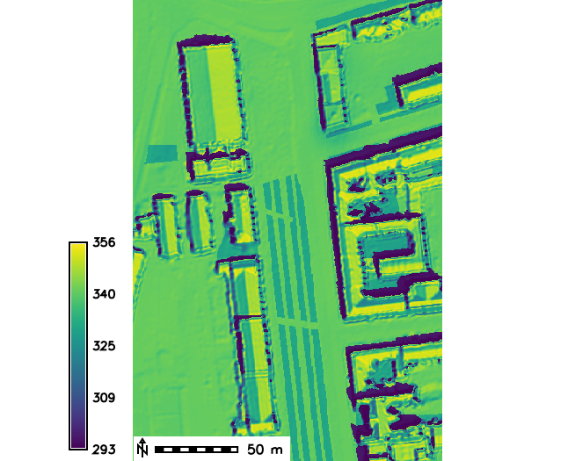 | 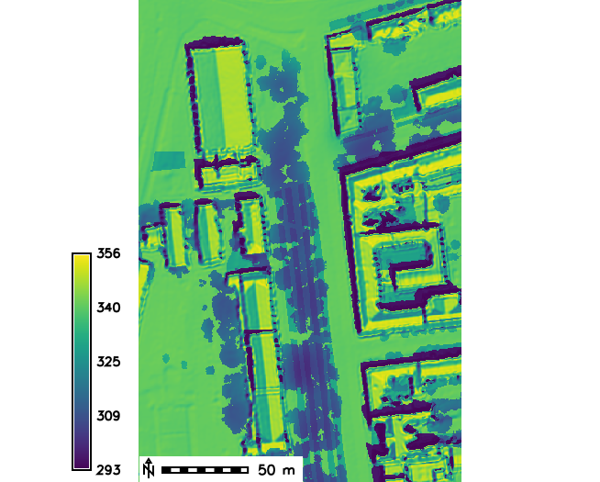 | 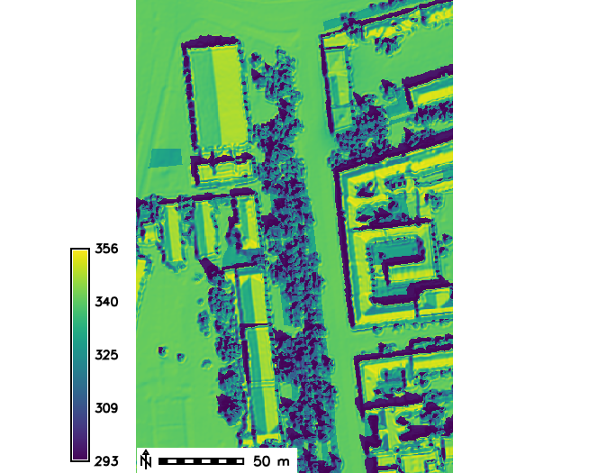 | 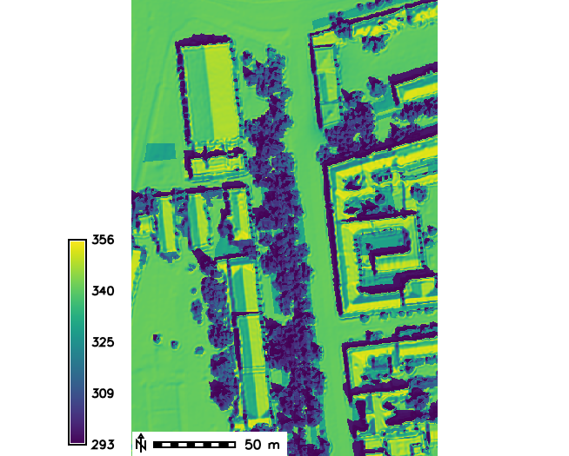
DSM with buildings,  Albedo of ground land cover,  No trees  lst182i1020 | DSM with buildings,  Albedo of ground land cover,  Solar transmittance of trees  lst182i1020r | DSM with buildings and trees,  Albedo of land cover  lstveg182i1020 | DSM with buildings and trees,  Albedo of land cover  Solar transmittance of trees  lstveg182i1020r

Figure 10. Modelled temperature of ground surface (kelvins) in site 1 - Moyzesova street, without and with implementing vegetation transmittance downscaled from linear regression model of S2_NDVI vs. LAI_TLS for 30 June 2016 at 9:20 AM of UTC, 10:20 zonal time. In the first two images DSM of terrain and building surface is used and albedo is derived for the ground land cover below the trees. In the latter two images, DSM of terrain, buildings and trees is used and albedo of the land cover canopy surface was used.

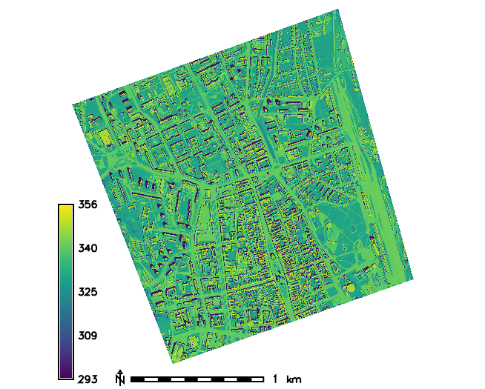
DSM with buildings,  Albedo of ground land cover,  No trees  lst182i1020 | DSM with buildings,  Albedo of ground land cover,  Solar transmittance of trees  lstveg182i1020r
Figure 11. Modelled temperature of ground surface (kelvins) in the entire study area of Košice without and with implementing vegetation transmittance downscaled from linear regression model os S2_NDVI vs. LAI_TLS for 30 June 2016 at 9:20 AM of UTC, 10:20 zonal time.

We recognize that the heat transfer is a complex phenomenon and therefore it is difficult to ascertain realistic values of the input parameters of the proposed approach of converting solar irradiance to land surface temperature. Nevertheless, the algorithm provides means for assessing various scenarios in urban planning for mitigating urban heat island or summer heat waves in general. Most importantly, the outlined approach enables to model the surface temperature on a much finer scale than it is sensed by contemporary thermal sensors such as TIRS of Landsat 8 or SLSTR of Sentinel 3. Both sensors record the LST phenomenon on a different and broader spatial scale than was modelled by the proposed algorithm. The two kinds of LST data products are therefore difficult to compare for the modifiable area unit problem (MAUP) which his demonstrated by Figure 12. Atmospherically corrected LST was derived from a Landsat 8 scene using the approach presented in Onačillová and Gallay (2018). The general patterns can be recognized in both datasets which is expressed also by the distribution of the LST values in the scatterplot showing linear relationship. However, the LST modelled with our approach is heavily overestimated in areas which are generally hot associated with railway station and continuous built-up areas while they are only several degrees underestimated in areas where urban greenery is present. The modelled LST requires further validation with more realistic records of the temperature, for example, airborne thermal data. Nevertheless, a good visual match with the L8 LST supports the viability of the developed approach of LST modelling.

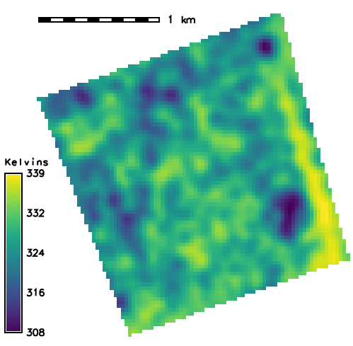 | 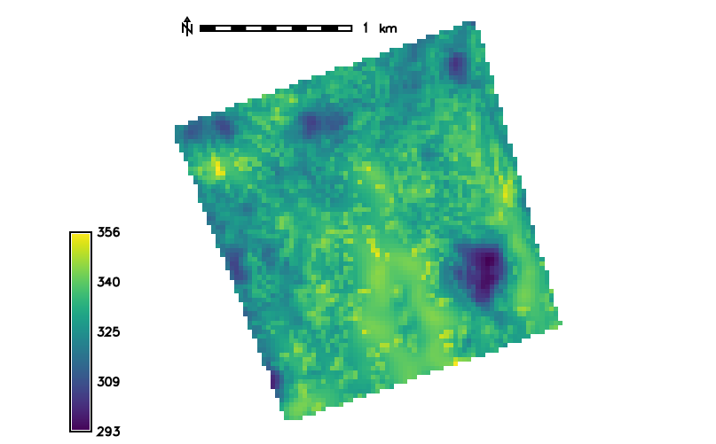
Modelled temperature with main inputs:  DSM with buildings and trees,  Albedo of land cover (including trees)  Calculated at 30 m cell size. | Landsat 8 land surface temperature at the bottom of the atmosphere
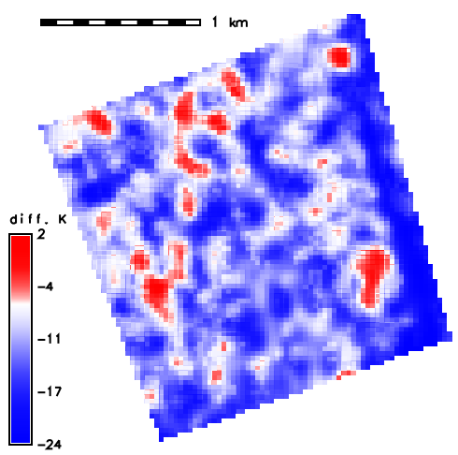 | 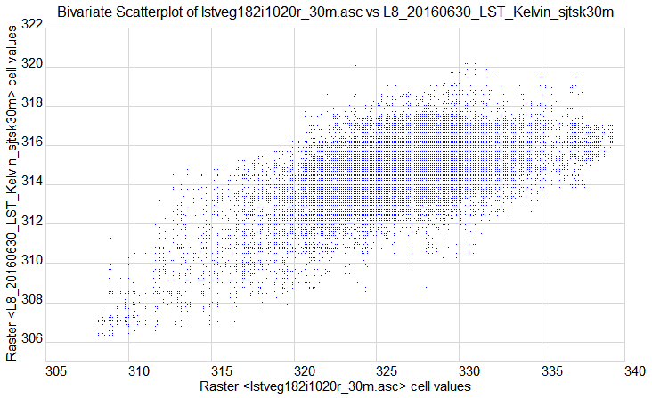
Differences between the Landsat8 observed and modelled temperature in degrees Kelvin | Scatterplot of modelled temperature and temperature sensed by Landsat 8 TIRS Band 11 at 30 m spatial resolution

Figure 12. Modelled temperature of land cover surface (left) derived for 30 June 2016 at 9:20 AM of GMT 10:20 zonal time and land surface temperature at the bottom of the atmosphere (right) as sensed at the same time by Landsat 8 TIRS, band 11. The spatial resolution (raster cell size) is 30 m, the units of temperature are degrees Kelvin.

Conclusion

The interaction of incoming solar radiation with urban surfaces is the
main source of heat energy inducing urban heat islands within a city. Land cover within the city exhibits great spatial and also temporal variations that can be modelled by proper software tools and input data such as Sentinel 2A. Spatial distribution of solar energy income can be modelled based on physical and geometric principles in a relatively straightforward and accurate way. Tools enabling spatially distributed solar modelling are available in contemporary GIS, but no such tools exist to convert the calculated solar energy income into land surface temperature (LST).
We developed an algorithm based on the Stefan-Boltzmann Law, which describes the power radiated from a black body in terms of its temperature. The key inputs of the LST calculation comprise spatially distributed global solar irradiation of a DSM, convective heat transfer coefficient of the surface material, albedo of the surface and the emissivity of the material. While solar energy income can be calculated with a high degree of reliability, the latter three parameters are difficult to be measured directly by remote sensing instruments in such a fine resolution as the solar irradiation can be computed. We used the r.sun module implemented in the open-source GRASS GIS as for calculating the solar energy income on a rasterized virtual 3D city model.
We have demonstrated that Sentinel 2 data can be used in the procedure for LST calculation, particularly in estimating the broad-band albedo, surface material emissivity and urban trees transmittance. In regard to the latter variable, we have tested the NDVI derived from Sentinel 2 data products as a proxy for ascertaining the transmittance of solar energy by urban trees and shrubs. Time series of TLS point clouds were used to parametrize the transmittance by estimated LAI. However, it seems linear regression models do not sufficiently describe this relationship between S2 NDVI and TLS LAI resulting in linear correlation being strong in some places and certain dates while being weak in others. One of the main reasons could be in the modifiable area unit problem as the S2 grid cells are coarse 2D spatial units with respect to 3D points of much higher density. Further testing and more robust geostatistical approaches need to be exploited to describe the relationship more tightly should it exist. Despite this shortcoming, the functionality of the developed toolbox was demonstrated. The proposed approach can be used for testing on any other geographical area or city providing that the following datasets exist: gridded DSM, land cover classification, land cover of the ground (below the trees), spatially distributed broad-band albedo and thermal emissivity, e.g. derived from the Sentinel 2 data products; convective heat transfer coefficient, ambient air temperature, equilibrium surface temperature, and effective radiant sky temperature.
The proposed approach provides means for GIS specialists and urban planners to assess and communicate the impact of measures taken in order to mitigate the urban heat island or communicate the effect of greenery on cooling the urban climate. However, the approach requires further testing in terms of validating the calculated temperature values in respect to more reliable data sets or methods. Linking to the achieved results and lessons learned in the SURGE project, we defined a roadmap for developing a GRASS GIS module for simulating the land surface temperature. The open-source concept of GRASS GIS will stimulate further development of the module and stimulate a wider use of the module including the data form ESA sensors such as Sentinel 2.

References

ASHRAE (1989). Handbook Fundamentals, American Society of Heating, Refrigeration, and Air-Conditioning Engineers, Atlanta, Georgia.
Algarni, S. A. (2015). Modeling Radiation Heat Transfer for Building’s Cooling and Heating Loads: Considering the Role of Clear, Cloudy, and Dusty Conditions in Hot and Dry Climates.Theses and Dissertations. 1231.
Amir, A.K., Katoh, Y., Katsurayama, H., Koganei., M., Mizunuma, M. (2018). Effects of convection heat transfer on Sunagoke moss green roof: A laboratory study. Energy and Buildings 158, 1417-1428.
Berdahl, P., Bretz, S. E. (1997). Preliminary survey of the solar reflectance of cool roofing materials. Energy and Buildings, 25, 149-158.
Bretz, S., Akbari, H., Rosenfeld, A. (1998). Practical issues for using solar-reflective materials to mitigate urban heat islands. Atmospheric Environment, 32, 95-101.
Dubayah, R., Rich, P. M. (1995). Topographic solar radiation models for GIS. International Journal of Geographical Information Systems 9: 405-19
D'Urso, G., Calera, A. (2006). Operative approaches to determine crop water requirements from earth observation data: methodologies and applications. AIP Conf. Proc., 852 (2006), pp. 14-25
EPA, 2008. Reducing urban heat islands: Compendium of strategies. U.S. Environmental Protection Agency. https://www.epa.gov/heat-islands/heat-island-compendium.
Fogl, M., Moudrý, V., 2016. Influence of vegetation canopies on solar potential in urban environments. Applied Geography, 66, pp. 73 - 80.
Gallay, M., Kaňuk, J., Hochmuth, Z., Meneely, J., Hofierka, J., Sedlák, V., 2015. Large-scale and high-resolution 3-D cave mapping by terrestrial laser scanning: a case study of the Domica Cave, Slovakia. International Journal of Speleology, 44(3), pp. 277-291.
Hofierka, J. (1997). Direct solar radiation modelling within an open GIS environment. In Proceedings of the 1997 Joint European GI Conference, Vienna, Austria, 575–584.
Hofierka, J., Zlocha, M. (2012). A New Solar Radiation Model for 3-D City Models. Transactions in GIS, 16, pp. 681-690.
Hofierka, J., Gallay, M., Kaňuk, J., Šupinský, J., Šašak, J. (2017). High-resolution urban greenery mapping for micro-climate modelling based on 3D city models. The International Archives of the Photogrammetry, Remote Sensing and Spatial Information Sciences (ISPRS Archives), XLII-4/W7, 7-12. (3D Geoinfo Conference, Melbourne, Australia.
Neteler, M., Mitasova, H. (2004). Open Source GIS: A GRASS GIS Approach. Second Edition. Boston, Kluwer Academic Publishers.
Liu, J., Heidarinejad, M., Graci, S., Srebric, J. (2015). The impact of exterior surface convective heat transfer coefficients onthe building energy consumption in urban neighborhoods withdifferent plan area densities. Energy and buildings, 86, 449-463.
Mirsadeghi, M., Costola, D., Blocken, B., Hensen, J.L.M. (2013). Review of external convective heat transfer coefficient models in building energy simulation programs: implementation and uncertainty, Applied Thermal Engineering, 56, 134–151.
Onačillová, K., Gallay, M. 2018. Spatio-temporal analysis of surface urban heat island based on LANDSAT ETM+ and OLI/TIRS imagery in the city of Košice, Slovakia. Carpathian Journal of Earth and Environmental Sciences. 13(2), 395 - 408.
SURGE_D1_SOA_MSVT 2016. Report on the reviewed applicability of multispectral satellite imagery. Internal document submitted as the output of the contracted SURGE study.
SURGE_D4_VEGMETR 2018. Deliverable 4 under WP2: Report on derivation of satellite based vegetation metrics and downscaling to high-resolution data. Internal document submitted as the output of the contracted SURGE study.
SURGE_D5_ALGOSTRUC 2018. Deliverable 5 under WP3: Report on definition of algorithmic structure of the toolbox. Internal document submitted as the output of the contracted SURGE study.
SURGE_D6_ROADMAP 2018. Deliverable 6 under WP4: Roadmap report on implementation of the toolbox. Internal document submitted as the output of the contracted SURGE study.
SURGE_FR 2018. Final report 1. Internal document submitted as the output of the contracted SURGE study.
SURGE_PR1 2016. Progress report 1. Internal document submitted as the output of the contracted SURGE study.
SURGE_PR2 2017. Progress report 2 Mid-term report. Internal document submitted as the output of the contracted SURGE study.
SURGE_PR4 2018. Progress report 4 (merged report 3 and 4). Internal document submitted as the output of the contracted SURGE study.
Šúri, M., Huld, T.A., Dunlop, E.D. (2005). PVGIS: a web-based solar radiation database for the calculation of PV potential in Europe. International Journal of Sustainable Energy 24, 55–67.
Tooke, T.R., Coops, N.C., Goodwin, N.R., Voogt, J.A., 2009. Extracting urban vegetation characteristics using spectral mixture analysis and decision tree classifications. Remote Sensing of Environment, 113(2), pp. 398 - 407.
Tooke, T.R., Coops, N.C., Voogt, J.A., Meitner, M.J., 2011. Tree structure influences on rooftop-received solar radiation. Landscape and Urban Planning, 102 (2), pp. 73 - 81.
Tooke, T.R., Coops, N.C. Christen, A., Gurtuna, O., Prévot, A., (2012). Integrated irradiance modelling in the urban environment based on remotely sensed data. Solar Energy, 86(10), pp. 2923-2934.
Vanino, S., Nino, P., De Michele, C., Bolognesi, S. F., D'Urso, G., Di Bene, C., Pennelli, B., Vuolo, F., Farina, R., Pulighe, G., Napoli, R. (2018). Capability of Sentinel-2 data for estimating maximum evapotranspiration and irrigation requirements for tomato crop in Central Italy, Remote Sensing of Environment, 215, 452-470.
Vollaro, A., Galli, G., Vallati, A. (2015). CFD Analysis of Convective Heat Transfer Coefficient onExternal Surfaces of Buildings. Sustainability, 7, 9088-9099.

