ESA STUDY – PROGRESS REPORT 2
ESA Contract No:  4000117034/16/NL/NDe | SUBJECT:  SURGE: Simulating the cooling effect of urban greenery based on solar radiation modelling and a new generation of ESA sensors |  |  | INSTITUTE:  Pavol Jozef Šafárik University in Košice, Institute of Geography
ESA Contract No:  4000117034/16/NL/NDe |  | No. of Volumes: 1  This is Volume No: 1 |  | INSTITUTE’S REFERENCE:  SURGE_PR2
ABSTRACT (Executive Summary of the Project):
The aim of this feasibility study is to assess the applicability of the Sentinel-2A multispectral satellite imagery for approximating the dynamics of solar radiation transmittance of urban greenery leading to its cooling effects via modelling the spatial distribution of solar radiation in a complex urban environment represented by a 3-D city model. The main technical objective of the project is to define the relationship between a high-resolution 3-D geometry of urban greenery and vegetation metrics in selected periods throughout the year. The study will be used to evaluate the proposed approach in the development of a toolbox enabling urban planners and researchers to mitigate heat risk based on solar radiation modelling and Sentinel-2A multispectral data.
The work described in this report was done under ESA PECS Contract. Responsibility for the contents resides in the author or organisation that prepared it.
Names of authors: Michal Gallay, Jaroslav Hofierka
ESA PECS PROGRAMME MANAGER: Maite Trujillo

DIRECTORATE: IPL-ISP

 | Doc. No.  Issue:  Revision:  Date: | 1.  1.  1.  15 June 2017

Simulating the cooling effect of urban greenery based on solar radiation modelling and a new generation of ESA sensors (acronym SURGE)

Progress Report 2

Introduction

The objective of the progress report is to provide all actors with actual information concerning the status of the project “Simulating the cooling effect of urban greenery based on solar radiation modelling and a new generation of ESA sensors (acronym SURGE)” from 01/12/2016 to 31/05/2017.

The aim of this project: This project will serve as a preparatory study to assess the applicability of the multispectral satellite imagery for approximating the dynamics of solar radiation transmittance of urban greenery to assess the cooling effects of the greenery via modelling the spatial distribution of solar radiation in a complex urban environment represented by a 3-D city model.

The main technical objectives: The main technical objective of the project is to define the relationship between 3-D geometry of urban greenery and vegetation metrics in selected periods throughout the year. The imagery to be acquired by the new generation of ESA Sentinel 2-A satellite sensors will be used to derive the vegetation metrics and it will be downscaled to higher resolution datasets. The final outcome of this study will be in the proof-of-concept which identifies critical functions and characteristics of the proposed approach. This study can be used in the future to develop a toolbox enabling urban planners and researchers to mitigate heat risk based on solar radiation modelling and Sentinel-2A multispectral data for urban greenery parameterization.

Highlight Summary
During the last 6 months since the submission of the SURGE PR1 (15 December 2016) we have achieved the following results:
- The acquired airborne laser scanning data, photogrammetric orthoimagery, and vector based 3-D city model were integrated and harmonized into a geodatabase covering the study area. Virtual 3D city model of the study area was generated (D2).
- Multispectral data products of the Sentinel 2A and Landsat 8 sensors were downloaded for the study area and their applicability for the projects was analysed.
- Terrestrial laser scanning of urban vegetation was performed on four smaller sites selected within the study area to extend the time series of ground truth representation of vegetation for particular phenological phases in high resolution and high accuracy.
- Partial results of the SURGE project were presented on international conference GIS Ostrava 2017 in Ostrava and during the 6th Czech Copernicus Users Forum in Prague.
- Mid-term report was generated (D3)
- Milestone 1 as specified according to the contract was achieved by generating D1, D2 and D3. (N.B.: D2 and D3 were associated with Milestone 2 according to the project proposal)

The work is progressing normally according to the plan.

Work Summary Status (during the reporting period)

Work package | Activities | Responsible Person | Status
WP1: Study management | - Meetings of the project team | Jaroslav Hofierka | On-going
WP2: Data, methods and architecture of the system | - Generated 3D city model (D2) | Michal  Gallay | Finished
 | - Generation of 3D time series of urban greenery | Ján  Kaňuk | On-going
 | - Gathering of Sentinel 2A imagery | Michal  Gallay | On-going
 | - Urban greenery field mapping | Alena Petrvalská | On-going
 | - Mid-term report (D3) | Michal  Gallay | Finished

4. Detailed Progress of Work
Provide summary of the work performed. Upcoming TNs

4.1 WP1 – Study management

Over the last 6 months (since December 2016), we had 2 meetings of the project team. The first meeting was held on 23 January 2017 where we reviewed our research plan and specifically activities for the WP2 for the next 5 months period. We decided on personal tasks regarding data processing for 3-D city model as well as integration of the TLS and ALS data with the other 3-D city data. Also, various technical issues such as different reference systems of the datasets and database integration were discussed and resolved.

The second meeting of the project team was held on 10 May 2017 when we discussed details of mid-term progress report and deliverables. Specifically, we decided on items that should be included in the 3-D city model, data formats and other technical specifications of the data package. We also discussed further works regarding 3-D (voxel) representation of urban vegetation (trees) and possible implementation in the v.sun solar radiation model (WP3). The WP leaders discussed the planned presentations of the ongoing results of the project in the 6th Czech Copernicus Users Forum meeting in Prage, and the 3Dgeoinfo 2017 conference in Melbourne (October 2017). Besides this, the project leader had regular meetings with the WP2 leader discussing the ongoing activities as well as various management and financial issues.

The work accomplished within the WP1 to date resulted in the Mid-term Report which is the Deliverable nr. 3. The report summarizes the technical aspects of the work and products generated within WP2 since 1 June 2016 until 30 May 2017 (M1 - M12). The Mid-term Report is submitted with the Progress Report 2 to ESA. The Mid-term Report is available via URL: https://uge.science.upjs.sk/esa_surge_deliverables/, with the following login and password: “user”,”9DQsgmpeLJRS8Fr7Wfmz”.

4.2 WP2 – Data, methods and architecture of the system

The work accomplished since 1 December 2016 until 30 May 2017 (M7-M12) involved the following tasks, which were according to the Flowchart of tasks, their time table with the milestones and deliverables in the SURGE Project Proposal, Section 4. Work description:

Task 3: Generating a high-resolution 3-D city model
Task 4: Generating time series of high-resolution 3-D urban greenery
Task 5: Gathering and analysing time series of Sentinel 2A multispectral imagery
Task 6: Preparing input 3-D data for solar radiation modelling

4.2.1 Study area

The work in the listed tasks relate to the study area which is the central part of the Košice City, which is the second largest city in Slovakia, Europe, with about 240 000 inhabitants. Košice is a typical example of urban landscape in mild climate conditions of Central Europe. Here, we have selected a rectangular area (4 km²) which consists of various types of urban greenery and built-up areas, such as parks, alleys, greenery in residential zones (Fig. 1).

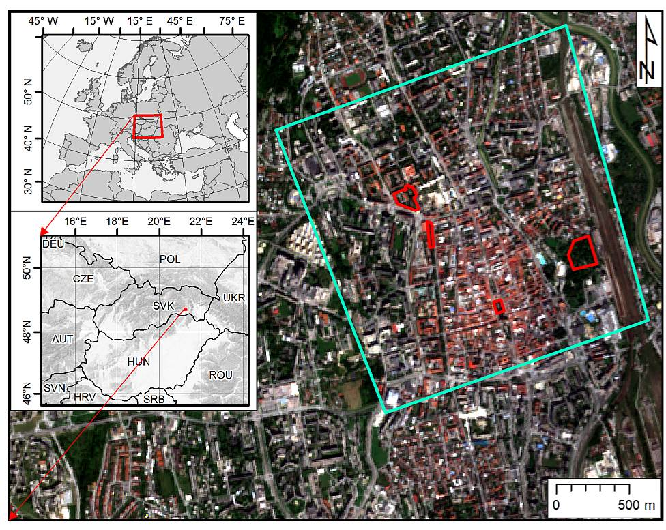
Figure 1. Location of the Košice City within Europe (left) and the study area within the city (right). The cyan line outlines the area subject to airborne lidar and photogrammetric data collection and the line delineates selected sites for repeated terrestrial laser scanning. The background maps are © Copernicus, Sentinel 2A image acquired on 7 September 2016.

4.2.2 Generating time series of high-resolution 3-D urban greenery

This work relates to Task 4 and Task 3. As described in the Progress Report 1, we have selected four smaller test sites covering several hectares (Fig. 1, red outline) for detailed mapping of urban vegetation and its geometric change using repeated terrestrial laser scanning (TLS). The TLS data were systematically collected between April to November 2016 and in March 2017 using the Riegl VZ-1000 scanner equipped with the Nikon D700 camera. The aim of the scanning was to capture vegetation in several phenological phases synchronously with the Sentinel 2A overflight times (+/- 1-2 days) taking into account meteorological conditions. The acquired TLS data were processed in the M7-M12 period resulting in 44 datasets (pointclouds) with total size of 93.8 GB representing the study sites in 11 time horizons during one vegetation period. The point clouds were colourized using the digital RGB imagery acquired immediately after scanning with the integrated camera (Fig. 2). The 11 point clouds were implemented in the 3-D digital city model in the task 3.

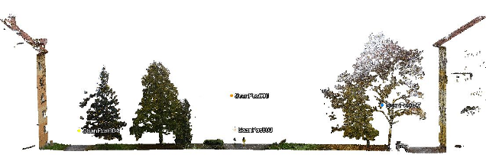
Figure 2. Vertical section of the TLS point cloud in Hvozdíkov park, Košice.

4.2.3 Generating a high-resolution 3-D city model
This work relates to Task 3. The 3-D city model was generated based on the data acquired in the M1 - M6 period. The data acquisition involved airborne laser scanning (ALS) and aerial photogrammetric data acquisition to capture high resolution 3D geometry and multispectral (R, G, B, NIR) orthoimagery for the entire study area (Fig. 1, cyan outline, 4 km²). The points were processed in order to classify them into ground, vegetation, buildings and other returns. Ground returns were used to derive a gridded digital terrain model (DTM) of 0.2 m cell size. The first ALS returns were used to derive a digital model of the land cover canopy (DSM) of 0.2 m cell size. Photogrammetric aerial survey resulted in natural and NIR false colour orthoimagery with spatial resolution of 10 cm. The photogrammetric stereo imagery was used to derive a 3-D city model representing the buildings in the study area with LoD2 (Fig. 3). The mentioned work was partially done in the M1 - M12 period but fully completed in M7 – M12 period.

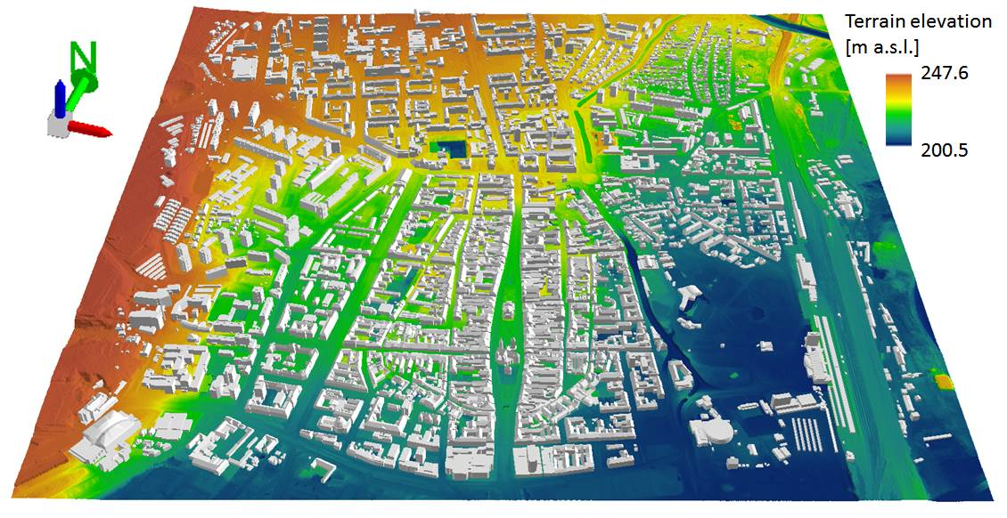
Figure 3: Perspective 3D view of the entire study area (cyan outline in Fig. 1) for which the 3D city model was generated. 3D buildings are displayed on a digital terrain model in the ArcScene software by ESRI.

To supplement the TLS time series (task 4) with upper parts of vegetation, the ALS and TLS point clouds within the four smaller sites (Fig. 1, red outline) were integrated based on identical points present in both types of datasets.

While point clouds accurately represent urban canopy, it is difficult to use them directly in solar radiation or microclimate models for which physical objects as virtual 3-D models are required. Therefore, we explored the following software tools to derive 3-D tree model from point clouds: RiSCAN Pro®, 3D forest, Geomagic Wrap® and ArcScene®.

The result of the data collection was in mutually registered and georeferenced point clouds for particular TLS survey dates. The point clouds were then decimated using the Octree filter with a spatial step of 5 cm. In this way, the georeferenced point clouds became comparable in terms of temporal change of the spatial distribution of points (Fig. 4A). The subsequent automated classification of the point clouds resulted in separating ground (terrain) and above-ground points. The above-ground points included also buildings and other features that had to be filtered out so that vegetation point remained (Fig. 4B).

The point cloud representing just trees was then segmented into point clouds of individual trees by the 3D Forest software. The result of segmentation was exported in the PLY format and meshed in the GeomagicWrap 2015 software to create meshed 3-D tree models as time series (Fig. 4C, 4D, 4E).

The individual 3D models of trees were assigned the information gathered in the geobotanical field survey conducted in the M1 – M6 period within the four smaller sites. These data help to improve interpretation of the lidar point clouds (ALS, TLS) and orthoimagery (Fig. 5).

The 3-D models of trees were then exported in the VRML format and integrated with other 3-D data within the 3-D GIS environment of the ArcScene software (Fig. 6).

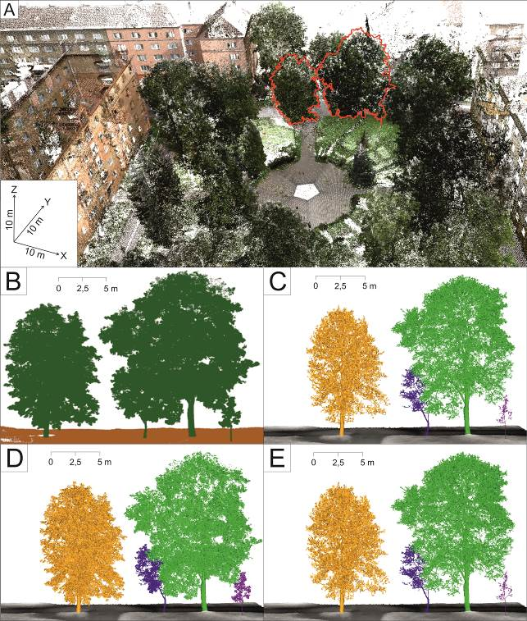

Figure 4. RGB colourized TLS point cloud representing Hovzdíkov park as visualized in the RiScanPRO software with selected trees (A) which are visualized in the 3D Forest software before segmentation (B) and after segmentation and 3-D meshing in the Geomagic Wrap 2015 resulting in time series of segmented individual meshed 3-D tree models integrated with terrain data in the ArcScene GIS software for spring (C), in summer (D) and in autumn (E).

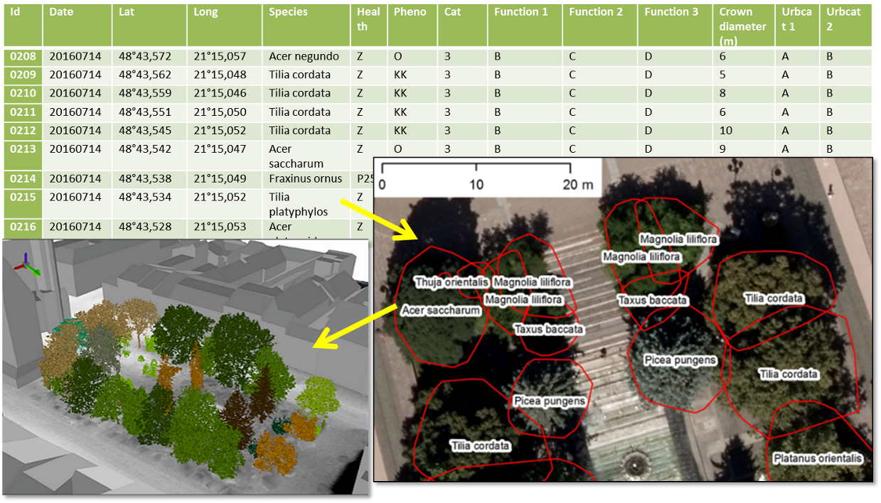
Figure 5: Schematic work flow of assigning tree attributes from field survey to trees as 3D objects in a geodatabase.

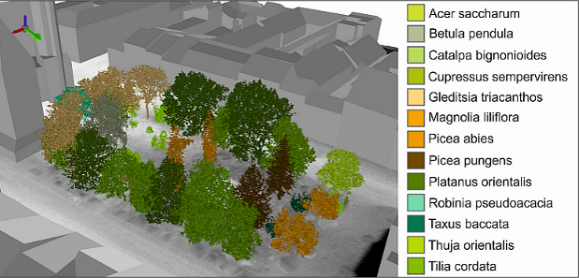
Figure 6. 3-D city model including 3-D meshed trees in the ArcScene software colourized according to the plant species showing the park on Hlavná ulica (Main street).

Description of the generated 3D city model

The Deliverable 2 concerns the generated 3D city of the study area as displayed in Fig. 1 (cyan outline). This model is a static 3-D representation of the entire study area valid to September 2016 when the main component of spatial data was acquired (ALS, photogrammetry). The size of the entire 3D city model is 43 GB therefore the complete model is available via URL https://uge.science.upjs.sk/esa_surge_deliverables/ with the following login and password: “user”,”9DQsgmpeLJRS8Fr7Wfmz”. The data of the complete model are organized in a hierarchical structure of folders which comprise georeferenced data (Fig. 7).
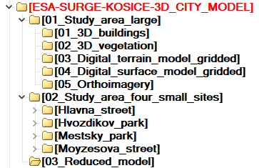
Figure 7: Data structure of the Generated 3-D city model (Deliverable 2).
This model contains 5 digital representations of 4 kinds of objects:
- buildings as 3-D buildings vectors,
- trees as ALS 3-D points, 2-D vector polygons,
- terrain as a digital terrain model (2-D raster/grid),
- land cover surface as a digital surface model (2-D raster/grid),
- land cover as a digital orthoimagery in natural and false colours (2-D raster image).

In addition, we also generated four 3-D city models for the four smaller sites which were subject to repeated TLS survey of vegetation and these models therefore contain a dynamic component, i.e. 3-D models of trees. A project file for 2-D and 3-D visualization is prepared for each of the sites. (Fig. 8, 9).
The main folder D2_ESA-SURGE-KOSICE-3D_CITY_MODEL contains three subfolders. The first subfolder (01_Study_area_large) comprises data for the entire study area (4 km², cyan outline in Fig. 1). The second subfolder (02_Study_area_four_small_sites) comprises data for the four smaller sites which are subject to high resolution monitoring of vegetation 3D structure by TLS. The third subfolder contains a reduced dataset of the 3D city model. The titles of the subfolders on lower level are self-explanatory. The data are compressed with ZIP and RAR formats for more convenient download. The data involved are provided in standard data formats for geographic information systems software (e.g. ArcGIS, Quantum GIS) such as ESRI shapefiles or gridded raster data (TIFF, ASCII, DXF, VRML). Short description of the data in the folders is reported in a metada.txt file.
The data are projected in the Slovak national grid system (EPSG code: 5514, in ArcGIS by ESRI: Projected Coordinate System: SJTSK_Krovak_East_North.
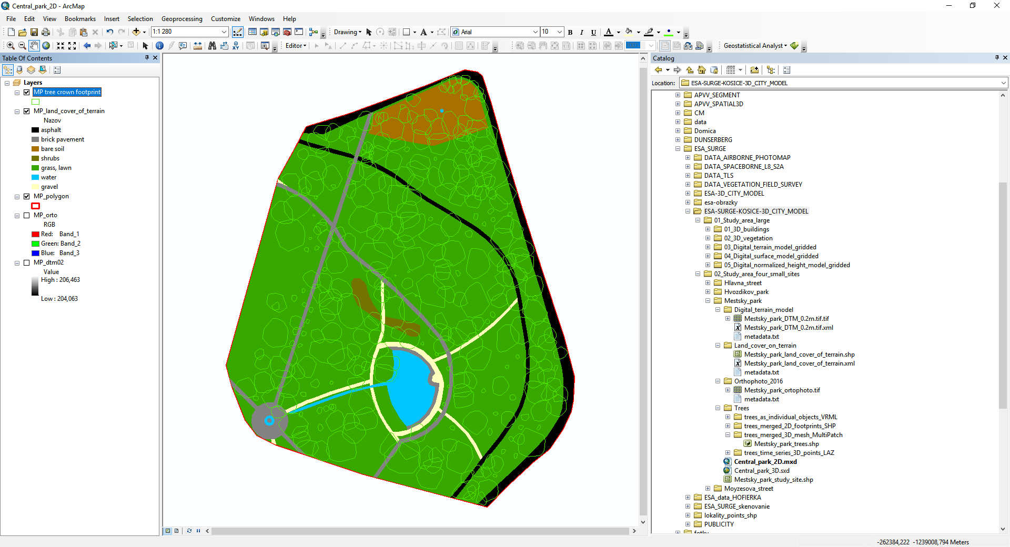
Figure 8. Graphical interface of the ArcMap project for the small site in Mestský park (City park) showing 2D view of the geodata layers.
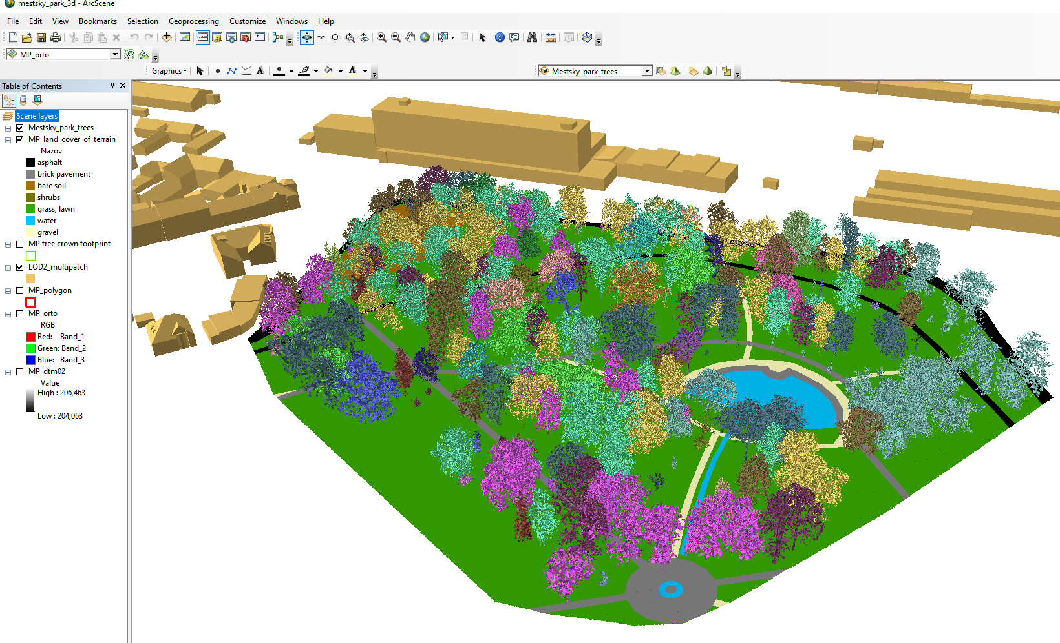
Figure 9. Graphical interface of the ArcScene project for the small site in Mestský park (City park) showing 3D view of the geodata layers. The 3D trees are coloured according to the plant species.

4.2.4 Preliminary analysis of solar transmittance using 3D models of trees

This work relates to Task 5 and 6. Vegetation in the mild climate of Central Europe (especially broad leaved deciduous vegetation) undergoes various changes manifested mostly in tree foliage. This has also impact on solar transmissivity of the canopy and subsequently on microclimate conditions. To capture these changes throughout the vegetation period we generated time-series of point clouds acquired by TLS in four study sites. The accuracy of TLS data registration for these sites and survey days reached a standard deviation of 1-4 cm. The time-series of the scans can be found as images at the project web site http://esa-surge.science.upjs.sk/index.php/study-sites or in the subfolder of D2: 02_Study_area_four_small_sites.

To assess the foliage of the trees in these sites, we used the acquired point clouds later decimated, as described above, to assess volumetric parameters of individual trees. The seasonal differences in tree morphology is demonstrated in Table 2 which reports statistics of TLS point clouds time series for a single tree growing on the Moyzesova street. We consider the mean point density and voxelized tree volume as the most significant parameters as they provide normalized values indicating that the mass of the tree decreases from the summer date through the autumn and it is the lowest in spring when there were no leaves on the tree. Implications of these results are manifested in the analysis of shaded area shown in Fig. 8. It is clear that for the selected site and time interval the effect of ground shadowing can be calculated using the generated time series of the meshed 3-D tree models. The time duration of the area being shaded depends not only on the sun declination but also on the effect of the tree phenology (abundance of leaves and their size).

Table 2. Parameters of a single tree displayed in Fig. 6 for different dates of the TLS survey.
Statistics | 26 July 2016 | 27 October 2016 | 22 March 2017
Point count | 387 500 | 389 916 | 206 631
Mean density (points/m³) | 4 297 | 3 146 | 2 464
Total height (m) | 7.710 | 7.710 | 7.54
Crown max. width (m) | 6.520 | 6.330 | 6.27
Voxelized (25 cm) tree volume (m³) | 99.59 | 94.25 | 81.54
Footprint area (m²) | 36.89 | 36.38 | 35.38

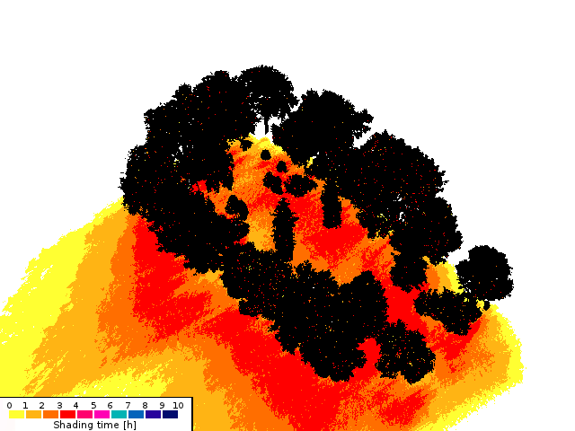 | 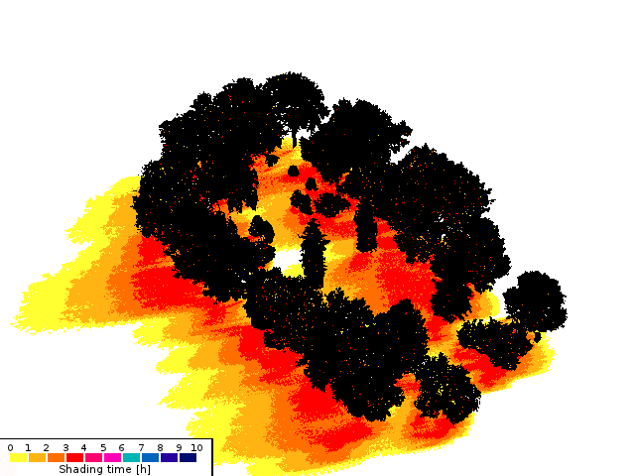

Figure 10. Simulation of time the area is shadowed by trees between 1 p.m. to 4 p.m. using the 3D meshed tree models in the Shadow Analysis plugin of the SketchUp software for March and June 2016.

4.2.5 Analysing the influence of vegetation on urban heat island in Košice

This work relates to Task 5 and Task 6. We conducted analysis of land surface temperature (LST) based on our archive of the Landsat 8 multispectral imagery, Copernicus datasets (Corine Land Cover). The aim was to support the need for implementing the effect urban greenery has on urban heat island in Košice and demonstrate the relation between areas with existing green infrastructure and urban areas with minimal or absent vegetation.

Processing of the selected Landsat images was performed in the ArcGIS software by ESRI. The method of LST calculation applied in this study is described below and the flowchart summarizes the basic steps of this process (Fig. 11).

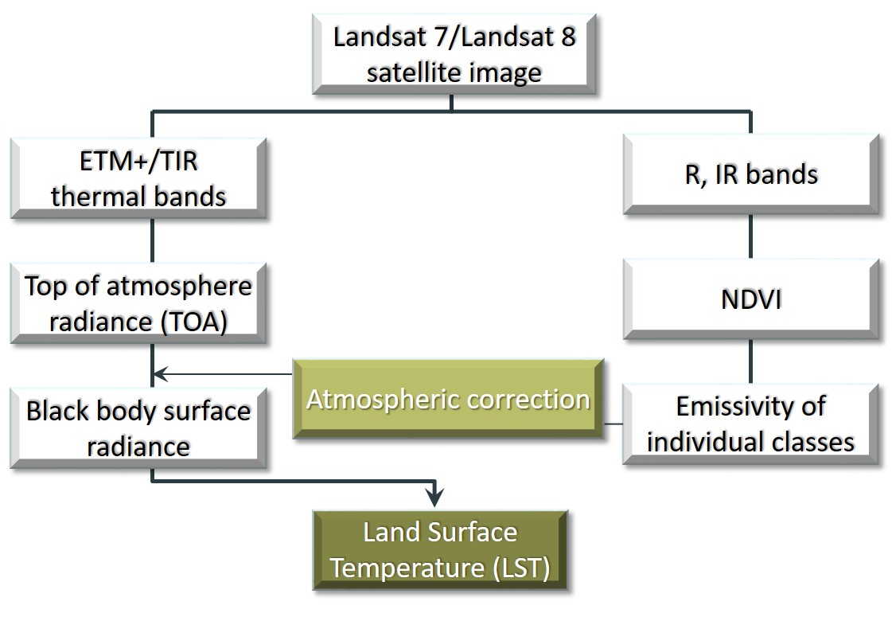
Figure 11. Flowchart summarizing basic steps of LST derivation from imagery

For the purpose of this work, 4 images from Landsat 8 archive available via the USGS https://earthexplorer.usgs.gov were acquired to derive LST values.

A single summer day (August 6, 2015) was selected to assess the pattern of the LST in relation to land cover (Fig. 12A, 12B). The relation between LST and land cover is well depicted in the cross-profile in Fig.13. Local LST minimums correspond with vegetated areas while LST maximums are linked with impervious surfaces. Detailed view in Fig. 14A for the same date and L8 dataset shows how presence of several trees decreases temperature in the city centre which is compared with the NDVI values in Fig. 14B.
Temporal variability of LSTs within the wider area of Košice was assessed using time-series of LST standard deviations (Fig.15). The results show that the urban heat island phenomenon concerns also the Košice City. The areas of contrasting temperature properties were identified supporting the selection of small study sites for monitoring the vegetation with TLS.

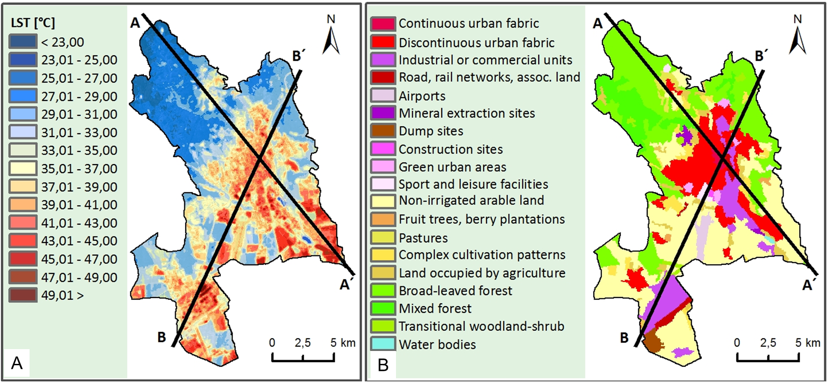
Figure 12. LST on 6 August 2015 (A) and CORINE land cover 2012 data (B) for the entire cadastral territory of Košice with cross lines displayed in Figure 11.

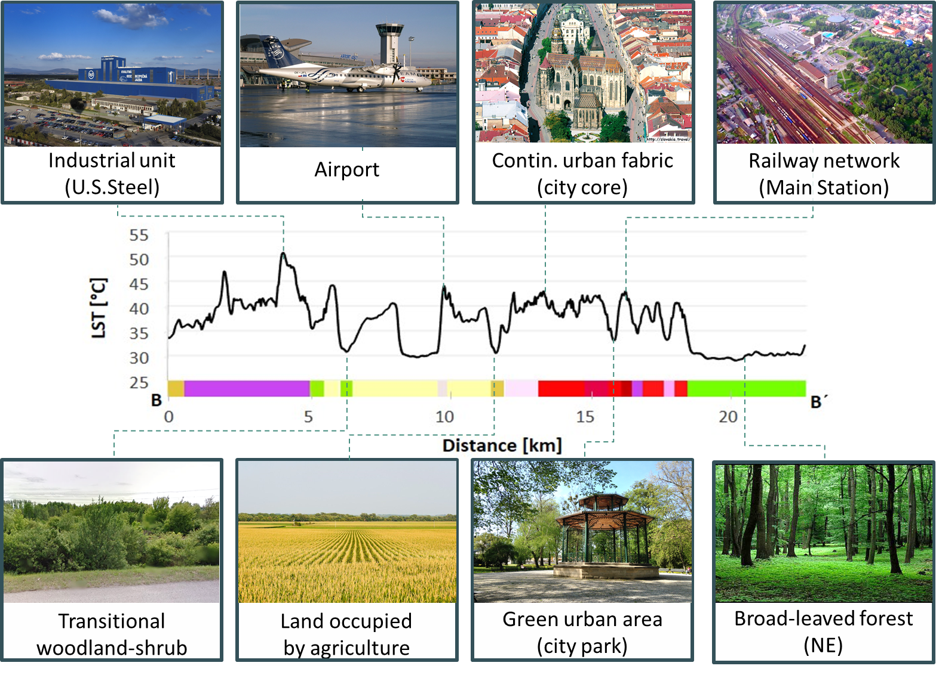
Figure 13: Vertical cross-section profile of the LST surface derived from the Landsat 8 TIRS Band 11 (6 August 2016) with the CORINE Land Cover 2012 classes crossed along the line B-B’ shown in Fig. 10 demonstrating how impervious land cover and green areas influence the urban heat island.

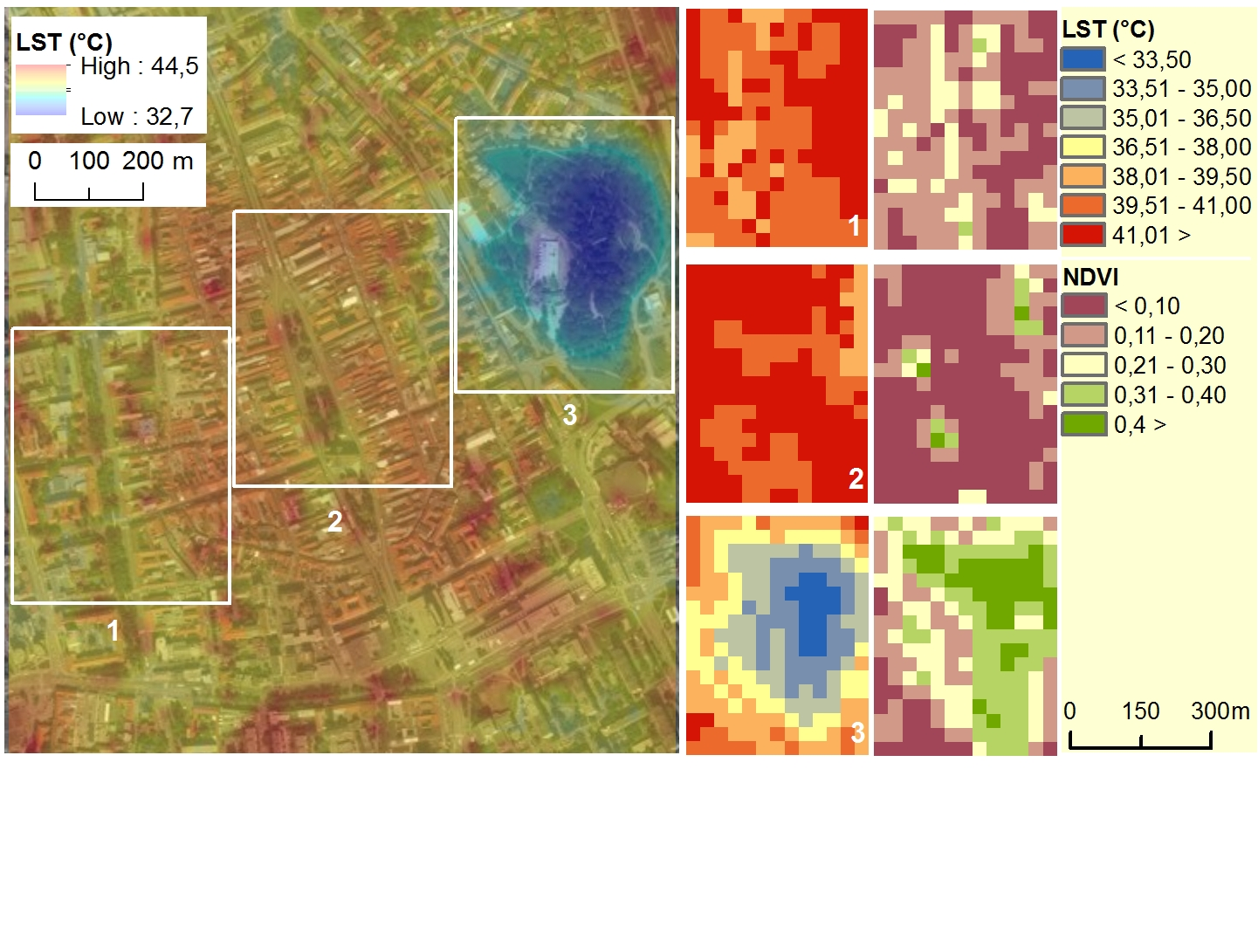

Figure 14. Landsat 8 (B11) land surface temperature on 6 August 2015 overlaid on a orthophotoimage 2016 (A) and comparison (B) of the temperature surface and Landsat 8 (B4, B5) NDVI values in selected areas of the Košice city: 1 – green belt on Moyzesova Street, 2 – historical city centre, 3 – Central Park (Mestský park).

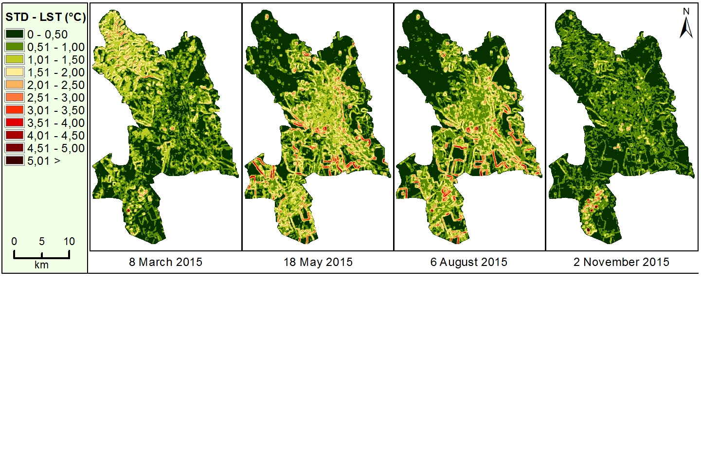
Figure 15. Spatial distribution of LST standard deviations in a 7x7 moving window for selected months in 2015.

Generating the LST surface time-series of Landsat 8 thermal band involved calculation of the time series of the NDVI from the Landsat 8 OLI data. The NDVI layers are going to be compared with NDVI derived from Sentinel 2A data which have been downloaded on a regular basis for the study area of Košice. We conducted preliminary comparison of Landsat 8 and Sentinel 2A derived NDVI and classification (Fig. 16.) which shows the potential of ascertaining solar transmittance of tree cover. The NDVI values from Sentinel 2A apparently vary according to the tree cover closure in the area of the Park Komenského. This information is much diluted in the large pixels of NDVI from the Landsat 8 imagery. Extraction of vegetation cover and land cover classification from the Sentinel 2A data was tested using unsupervised classification by the ISODATA algorithm in ArcGIS (Fig. 17). These tests provided appropriate settings of the classification method to be applied on the Sentinel data in the next period to fulfil the ongoing tasks of the Sentinel 2A and 2B analysis.

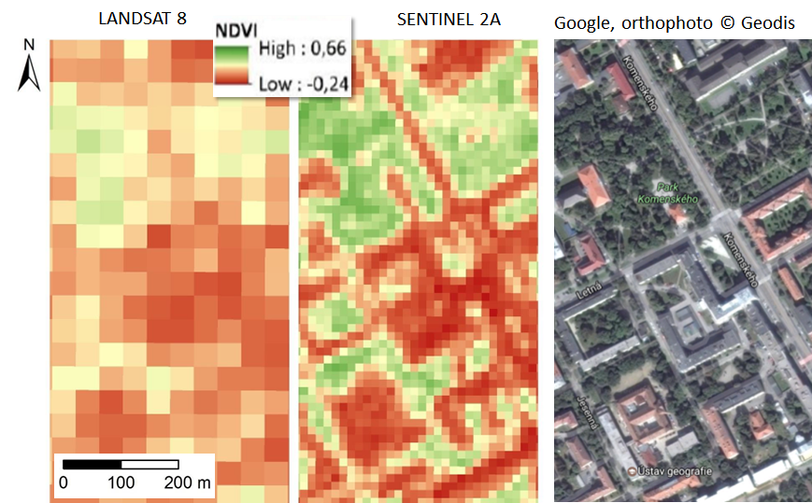

Figure 16. Comparison of NDVI calculated from Landsat 8 and Sentinel 2A for a part of Košice showing potential to ascertain tree cover transmittance from Sentinel 2 data. Both datasets were acquired on 8 August 2016.

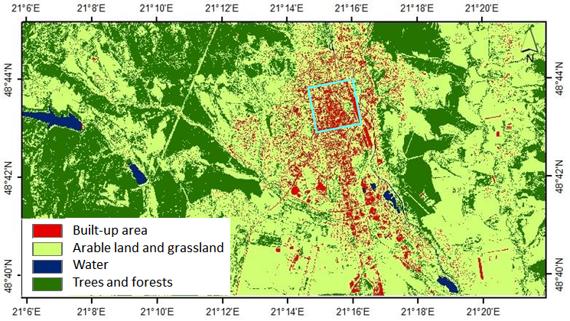
Figure 17. Preliminary result of the unsupervised classification of Sentinel 2A scene from 8 August 2016 into four land cover classes.The cyan square outlines the study area for which 3D city model was generated.

4.2.6 Upcoming tasks

The following monitoring period of M13-M18 will involve the continuation on the following tasks have been already in progress:

WP2, Task 3: Generating a high-resolution 3-D city model
This task is finished by submitting the Deliverable 2. We will further work on representation of the dynamic component of the model which is the vegetation in the four sites subject to TLS monitoring. This part, however, concerns the Task 4 and 6.

WP2, Task 4: Generating time series of high-resolution 3-D urban greenery
This task is still in progress. We will conduct scanning in case it is needed to supplement the existing TLS time series of with additional data within the vegetation season of 2017 finishes (expected in October). If acquired, the data will have to be processed according to the workflow described in PR1.

WP2, Task 5: Gathering and analysing time series of Sentinel 2A multispectral imagery
Gathering of the Sentinel 2 multispectral imagery is still in progress. The reason is to gather as much clear-sky satellite scenes as possible simultaneously with TLS surveys. Meanwhile Sentinel 2B data have become available. This task involves continuation of gathering the Landsat 8 imagery which contains the thermal band reflectance. The Sentinel 2 imagery will be subject to image classification to derive land cover maps and vegetation metrics. Also, these metrics will be correlated with TLS time series to ascertain the correlation between spectral reflectance and solar transmissivity of the TLS data.

WP2, Task 6: Preparing input 3-D data for solar radiation modelling
We conducted preliminary tests with time series of meshed 3-D models of trees to see how this data structure is applicable in modelling the area shadowed. We aim to test other data structures such as point density in voxel volume to represent the vegetation time series in order to model the amount of solar irradiation.

WP3, Task 7: Modification and validation of the v.sun solar irradiation model

The tasks of the third work package will be commenced involving testing, validation and viability of the system/model. Task 7 will include modification of the existing algorithmic structure of the v.sun model which calculates spatial distribution of open-sky solar irradiation on surface of buildings represented by 3-D vector data. To date, the model is not capable of making use of complex geometry of 3-D vegetation models. We will test several ways of integrated use of 3-D vegetation models and 3-D models of buildings, i.e. 3-D city model.

Problems, Issues and Risk Areas

We can confirm that no major problems occurred during the M7 - M12 period (12/2016 – 05/2017). The achieved results comprise the D2 “Generated 3D city model” and D3 “Mid-term Report” which is made available via FTP connection stated in Section 4.1 and Section 4.2.3, respectively. By this means the Milestone 1 was achieved according to the contract.

Meetings

Meeting Name | Description/ Purpose | Location | Planned Date | Actual Date | Attendees
Kick-off meeting | Kick-off meeting of the team | Kosice | 2 June 2016 | 2 June 2016 | Pavol Jozef Safarik University
Regular team meeting | Presentation of progress and discussion of planning and problems | Kosice | 7 September 2016 | 7 September 2016 | Pavol Jozef Safarik University
Regular team meeting | Presentation of progress and discussion of planning and problems | Kosice | 23 January 2017 | 23 January 2017 | Pavol Jozef Safarik University
Progress meeting | Progress meeting | Kosice | June 2017 | 10 May 2017 | Pavol Jozef Safarik University
Final meeting | Final meeting | Kosice | May 2018 |  | Pavol Jozef Safarik University

Deliverables Status

Deliverable Identifier | Title/ Description | Original Delivery Date | Planned Delivery Date | Associated Milestone | Status
D1 | Report on the reviewed applicability of multiscpetral satellite imagery for derivation of vegetation transmittance | Nov-2016 | Nov-2016 | Milestone 1 | Finished
D2 | Generated 3-D city model | May-2017 | May-2017 | Milestone 2  according to the proposal  Milestone 1 according to the contract | Finished
D3 | Midterm report | May-2017 | May-2017 | Milestone 2 according to the proposal  Milestone 1 according to the contract | Finished
D4 | Report on derivation of satellite based vegetation metrics and downscaling to high-resolution data | Nov-2017 | Nov-2017 | Milestone 3 | Planned
D5 | Report on definition of algorithmic structure of the toolbox | Feb-2018 | Feb-2018 |  | Planned
D6 | Roadmap report on implementation of the toolbox | May-2018 | May-2018 | Final | Planned
TDP | Technical data package (containing all approved technical notes) | May-2018 | May-2018 | Final Review | Planned
FPR | Final Project Report | May-2018 | May-2018 | Final Review | Planned
ESR | Executive Summary | May-2018 | May-2018 | Final Review | Planned

Milestone Payment Plan: Status

ID | Description | Amount | Contractual date | Actual/ Expected Date | Status
MP1 | Advance payment: Offset against MS1 | 17500 | Upon signature of the Contract by both Parties | xxx | Paid
 | Progress (MS1): Upon successful completion and delivery of D1 & D2 under WP2 and acceptance of all related deliverables (the remaining part deduced by Advanced payment). | 12500 | June 2017 | June 2017 | Due in June 2017
 | Progress (MS2): Upon successful completion and delivery of D4 under WP2 and acceptance of all related deliverables | 12450 | December 2017 | December 2017 | Not yet Due
 | Final Settlement (MS3): Upon the Agency's acceptance of all deliverables items due under the Contract and the Contractor's fulfilment of all other contractual obligations including submission of the Contract Closure Documentation | 7491 | June 2018 | June 2018 | Not yet Due

Planning
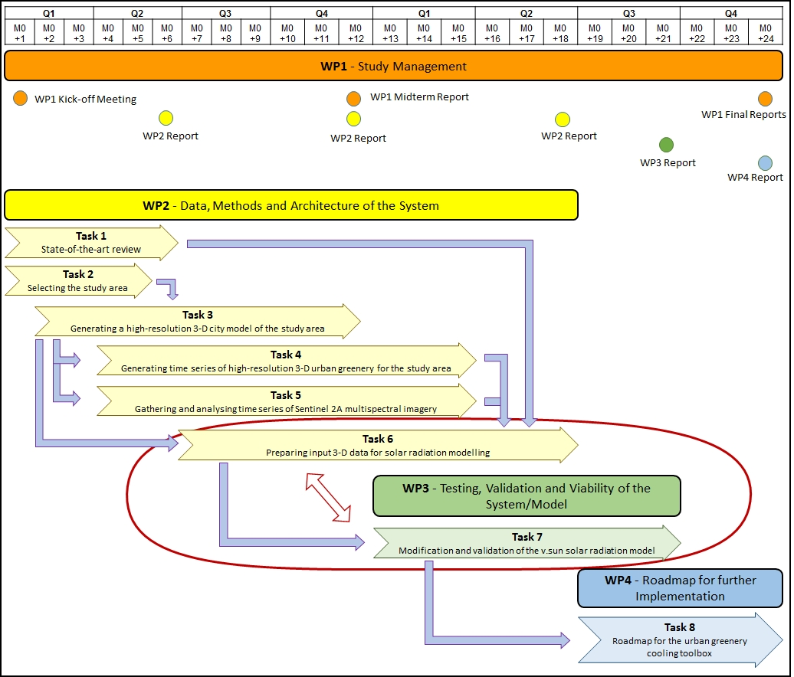

Action Item – Status List

NA

Any other Business

Besides maintaining the project website, two activities towards public promotion of the project were undertaken. GIS Ostrava 2017 was held in Ostrava in 23 March 2017, where Dr. Ján Kaňuk presented the paper published in conference proceedings in Slovak language:

KAŇUK, J., GALLAY, M., HOFIERKA, J., ŠAŠAK, J., ŠUPINSKÝ, J., SEDLÁK, V., GESSERT, A., 2017. Monitoring dynamiky mestskej zelene pre spresnenie modelovania slnečného žiarenia v urbánnej krajine. In: Inspektor, T., Horák, J., Růžička, J. (Eds.) Symposium GIS Ostrava 2017, Geoinformatika v pohybu, 22. - 24. března 2017. VŠB - Technická univerzita Ostrava, ISBN 978-80-248-4029-1, ISSN 1213-239X. Available on:
http://gisak.vsb.cz/GIS_Ostrava/GIS_Ova_2017/sbornik/papers/gis201758949fbdea187.pdf

Dr. Michal Gallay was invited by the Ministry of Environment of the Czech Republic to present the SURGE feasibility study during 6th Czech Copernicus Users Forum (24-25 May, 2017). The event was held in the premises of the European GNSS Agency (GSA) in Prague. A short report of the event is summarized on: http://geo.ics.upjs.sk/index.php/19-zo-zivota-ustavu/404-nas-vyskum-pre-esa-predstaveny-na-copernicus-trainning-day-v-prahe

The public presentations are made available as PDFs at https://esa-surge.science.upjs.sk/index.php/results .

Reasons for slippage and/or

NA

