|  |  |  |  |  |
| --- | --- | --- | --- | --- |
| **ESA STUDY CONTRACT REPORT**  **Deliverable 5 under WP3:**  **Report on definition of algorithmic structure of the toolbox** | | | | |
| ESA Contract No:  4000117034/16/NL/NDe | SUBJECT: **SURGE**: Simulating the cooling effect of urban greenery based on solar radiation modelling and a new generation of ESA sensors | | | CONTRACTOR:  Pavol Jozef Šafárik University in Košice, Institute of Geography |
| * ESA CR( )No: |  | No. of Volumes:. 1  This is Volume No: 1.0 | | CONTRACTOR’S REFERENCE: |
| ABSTRACT:  The observation provided promising outcomes for the Sentinel 2 imagery to be used as a proxy for parameterizing vegetation transmittance in solar irradiation modelling and heat flux estimation in urban space. | | | | |
| The work described in this report was done under ESA Contract. Responsibility for the contents resides in the author or organisation that prepared it. | | | | |
| Names of authors: Jaroslav Hofierka | | | | |
| ** NAME OF ESA STUDY MANAGER:  DIV:  DIRECTORATE: | | | ** ESA BUDGET HEADING: | |

# 1 Introduction

## Contractual

This document has been issued by Institute of Geography, P.J. Šafárik University in Košice for European Space Agency under contract Nr. 4000117034/16/NL/NDe titled “Simulating the cooling effect of urban greenery based on solar radiation modelling and a new generation of ESA sensors (acronym SURGE)”.

## Purpose of the Document

This document presents a roadmap for software toolbox summarizing the findings and developed methods of this project. A product roadmap is an excellent tool for software development and implementation because it acts as a strategic plan that describes the likely development of the software over the next period of time. It supports the product’s goals, vision, and priorities, and helps to keep their developer or stakeholders aligned. The specific goal of this report is to propose further implementation steps for the software toolbox which will account the cooling effects of urban greenery as identified by Sentinel imagery or other sources. Identification of critical functions and characteristics of the proposed concept and defining the implementation steps for the toolbox as well as applicability (proof-of-concept)

## 1.3 Motivation

In this report we propose a roadmap for a specialized software simulating land surface temperature based on publicly available data such as openstreetmap, publicly available municipal data or Sentinel data. Using this software, we can assess the effects of urban greenery (especially trees) on land surface temperature thus also directly influencing the air temperature in urban areas leading to a creation of urban heat islands (UHIs). To make it even more accessible by a wide public, we decided to propose an open-source software module for GRASS GIS (grass.osgeo.org). The mitigation of UHIs requires understanding the factors affecting the land surface temperature during hot sunny days as well as proper tools to simulate various scenarious for urban planning and city management. This software toolbox consists of various software modules implemented in open-source GRASS GIS. The proposed toolbox will be available for users as a single GRASS GIS module with one, integrated user interface, software and data documentation. The advantage of this approach is open software and data concept benefiting the citizens of the cities and countries as well as further development under proper free/open-source software licence. Therefore the implementation phase includes the code submission to GRASS GIS distribution that assures a wider validation and later sustainable and continuous development and improvement. Our previous active involvement in the development of other GRASS GIS modules such as r.sun, v.surf.rst, r.sim,water, and others support this decision.

## 1.4 GRASS GIS

# GRASS GIS (https://grass.osgeo.org/) is a general purpose, cross-platform, open-source geographic information system with raster, vector, 3D raster and image processing capabilities (Neteler and Mitasova 2008). It includes more than 400 modules for managing and analyzing geographical data and many more user contributed modules available in the add-on repository. GRASS GIS modules can be run using a command-line interface (CLI) or a native graphical user interface (GUI) called wxGUI which offers a seamless combination of GUI and CLI native to the operating system. Modules are organized based on the data type they handle and they follow GRASS GIS-specific naming conventions such as r.* for raster-based operations (example: r.sun) or v.* for vector-based operations (v.sun), etc.. Each module has a set of defined options and flags which are used to specify inputs, outputs, or different module settings. Most core modules using GRASS GIS C library are written in C for performance and portability reasons. Other modules and user scripts are written in Python using the GRASS GIS Python Scripting Library which provides a Python interface to GRASS GIS modules.

GRASS GIS software can be downloaded freely from its website (Fig. 1). The download web page offers easy to install binary packages for GNU/Linux, Mac OS X, and Microsoft Windows as well as the source code. The GRASS GIS website also provides additional documentation including manual pages, tutorials, information about the externally developed modules (add-ons) and various publications. Support for developers and users is provided by several mailing lists. The following tutorial provides a quick introduction to GRASS GIS: http://grass.osgeo.org/grass70/manuals/helptext.html.

In this project we have suggested to create a specific GRASS GIS module that will help to simulate the land surface temperature based on publicky available data such as openstreetmap, national geographic databases or even municipal data available online (example: http://webgis.presov.sk/). The suggested module called r.lst will integrate a few other GRASS GIS modules together with the software code developed within this project (Stefan-Boltzman model) in a coherent way, so the user can get results based on interaction via one user interface.

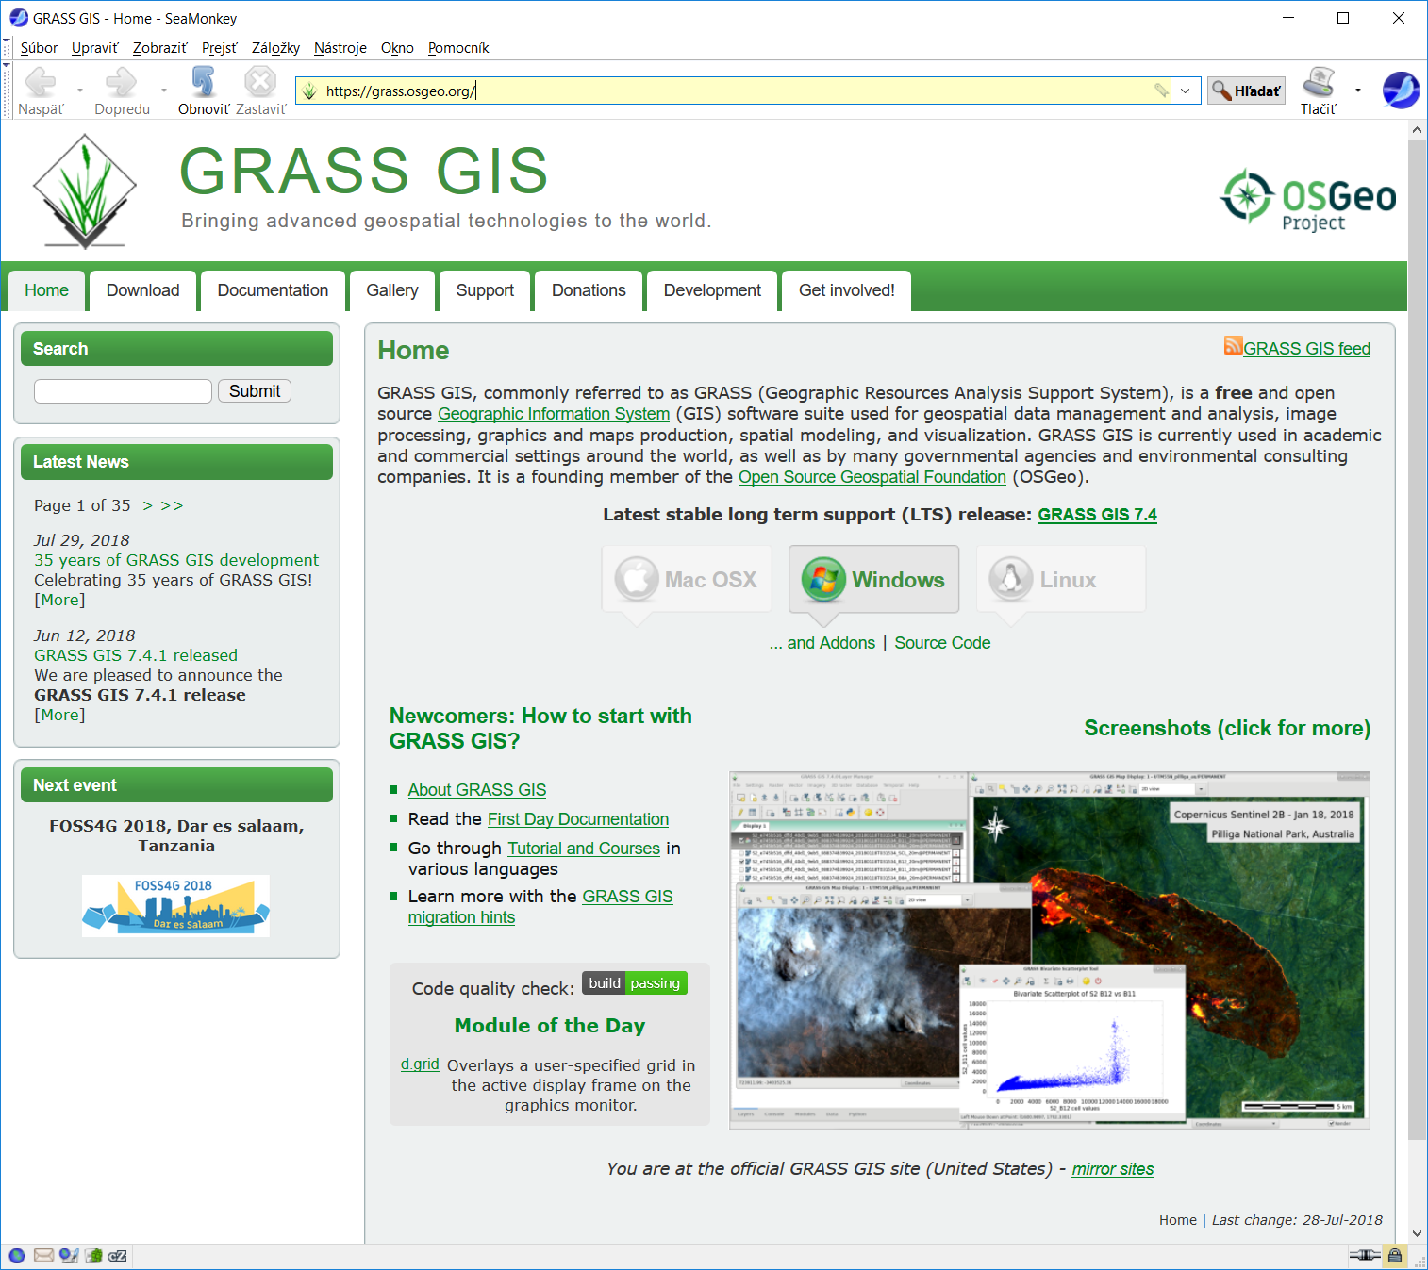

*Figure 1. GRASS GIS official web page.*

# 2 Roadmap



*Figure 2. The r.lst roadmap chart.*

*WP1 - Design and coding*

Module structure and design - This subtask analyzes the results of the feasibility study and allocates a manpower capacity to perform all the tasks. Analyzes a current programing environment of GRASS GIS and recommends final design issues (e.g., use of Python vs. shell script, modification of existing r.sun/v.sun modules, solves the problems with I/O operations, etc.).

Coding - Actual coding of the module with 3 software versions delivered: alpha version that is a working version with almost a full functionality that, however, probably still has lots of bugs that needs to be worked out. Beta version is near completion. All of the features are working and the software can be open up to external testers to test it.There may still be some bugs that need to be fixed that may not shown up in apha testing. Final version is the last stage of the code development with software supposed to be complete and finished.

*WP2 - Testing and verification*

Test data preparation - Based on Module structure and design report, the necessary data required for comprehensive software testing will be prepared. This will include a wide range of data values and situations.

Code testing - The tests will be performed using test data with a wide range of input parameters to test the stability and sensitivity of outputs. The obvious software bugs will be documented, suspsicious software behaviour described to perform further analyiss by programmers.

Output verification - data simulated in the sfotware will be verified using real world data, including field measurements.

*WP3 - Implementation*

Documentation - The documention will done in two parts: a standard manual page for the r.lst module (usually a few pages describing the aim of the module, input, output and operation behavior of the module and a few references for further reading) and a comprehensive pdf documentation describing scientific background of the simulation supplemented by scientific papers when publised. We expect 1-2 scientific papers to be published over the next year or two with findings of this project.

GRASS GIS module submission - the finalized module will be submitted to the add-on repository of GRASS GIS. The access to this repository is available to prof. Hofierka. The submission will be done in two steps: Release candidate version 1, which is expected to be bug-free. However, if any problems and suggestions from a wider user community arise, these will be fixed or implemented to Release Candidate version 2. Soon after relatively short period of time (3-4 months), a final product will be released for public use.

Needed manpower and other resource to implemented toolbox?

Recently, the Tangible Landscape concept was successfuly tested also for urban environment (Petrasova et al., 2018). The idea behind this concept is to use a physical model of the landscape to interact with or change it by hands to see real-time changes simulated by simulation models such as r.sun or r.lst represented by draped color (Figure 3). The output of the r.sun module was used to simulate solar irradiation distribution over small urban area segment with buildings (Fig. 4). This concept provides new form of geospatial data interaction and better understanding of spatial relations. The complex interactions of various factors within UHI phenomena can be also better understood by city managers or general public using this tool.

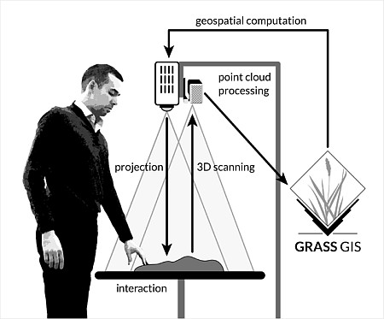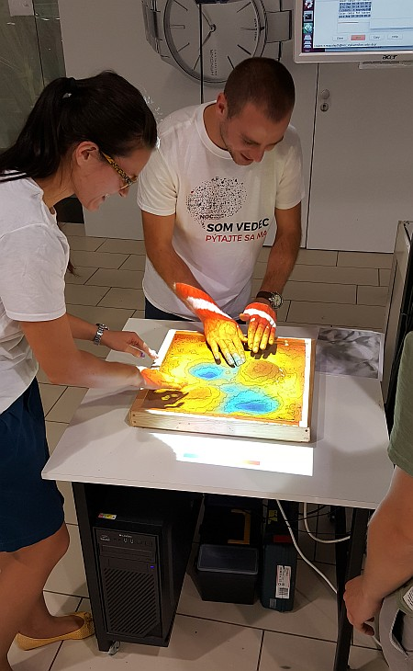

*Figure 3. Tangible Landscape concept.*



Figure 4 Solar irradiation on Tangible Lnadscape physical model (adapted form Petrasova et al., 2018)

# Conclusions

The presented report provides the following findings and solutions:

* xxxxx.
* .

The results show that xxx.

# References

Hofierka, J. (1997). Direct solar radiation modelling within an open GIS environment. In Proceedings of the 1997 Joint European GI Conference, Vienna, Austria, 575–584.

Hofierka, J., Zlocha, M. (2012). A New Solar Radiation Model for 3-D City Models. Transactions in GIS, 16, pp. 681-690.

Neteler, M., Mitasova, H. (2004). Open Source GIS: A GRASS GIS Approach. Second Edition. Boston, Kluwer Academic Publishers.

Petrasova, A., Harmon, B., Petras, V., Tabrizian, P., & Mitasova, H. (2018). Tangible Modeling with Open Source GIS. Cham, Springer.

Šúri, M., Hofierka, J. (2004). A new GIS-based solar radiation model and its application to photovoltaic assessments. Transactions in GIS 8, 175–190.