|  |  |  |  |  |
| --- | --- | --- | --- | --- |
| **ESA STUDY CONTRACT REPORT**  **Deliverable 5 under WP3:**  **Report on definition of algorithmic structure of the toolbox** | | | | |
| ESA Contract No:  4000117034/16/NL/NDe | SUBJECT: **SURGE**: Simulating the cooling effect of urban greenery based on solar radiation modelling and a new generation of ESA sensors | | | CONTRACTOR:  Pavol Jozef Šafárik University in Košice, Institute of Geography |
| * ESA CR( )No: |  | No. of Volumes:. 1  This is Volume No: 1.0 | | CONTRACTOR’S REFERENCE: |
| ABSTRACT:  Urban greenery in moderate climate zones contains many deciduous plant species with leaf-on and leaf-off periods that affect the solar radiation transmittance and thus the cooling effects of greenery in the city which is combined with the more pronounced effect of the solar incidence angle in mid-latitudes. In relation to the Košice city, Slovakia, this report summarises results of spatial and statistical analyses of the relationship between vegetation metrics derived from the satellite imagery of Sentinel 2 mission and the reference vegetation metrics derived from high-resolution 3-D digital representations of urban greenery. The results confirmed that Sentinel 2 multispectral imagery is strongly applicable for mapping annual phenological changes of vegetetation in urban landscape. Normalized difference vegetation index (NDVI) was the most suitable metrics to parameterize the urban greenery among the tested ones. Linear models (least squares regression) were applied to test for the relationship. Importantly, the NDVI derived from the Sentinel 2 imagery markedly correlated with canopy density derived from airborne and terrestrial laser scanning data. This correlation was positive, high and stable (Pearson’s r about 0.8) after development of leaves. It was weak (below 0.4) before onset of the spring bud burst and after autumn senescence. The observation provided promising outcomes for the Sentinel 2 imagery to be used as a proxy for parameterizing vegetation transmittance in solar irradiation modelling and heat flux estimation in urban space. | | | | |
| The work described in this report was done under ESA Contract. Responsibility for the contents resides in the author or organisation that prepared it. | | | | |
| Names of authors: Michal Gallay, Jaroslav Hofierka | | | | |
| ** NAME OF ESA STUDY MANAGER:  DIV:  DIRECTORATE: | | | ** ESA BUDGET HEADING: | |

# 1 Introduction

## Contractual

This document has been issued by Institute of Geography, P.J. Šafárik University in Košice for European Space Agency under contract Nr. 4000117034/16/NL/NDe titled “Simulating the cooling effect of urban greenery based on solar radiation modelling and a new generation of ESA sensors (acronym SURGE)”.

## Purpose of the Document

This document presents our proposal of algorithmic structure of the toolbox. The toolbox should enable urban planners and researchers to mitigate heat risk based on solar radiation modelling and Sentinel-2A multispectral data for urban greenery parameterization. The proposed methods and procedures were tested using our test site in Košice City, Slovakia (Fig. 1). The here presented results address the following technical objectives (TO) as outlined in the proposal of the contract 4000117034/16/NL/NDe:

TO5: Identification of critical functions and characteristics of the proposed approach for implementation as a toolbox for simulating the cooling effect of urban greenery based on solar radiation modelling and defining its applicability (proof-of-concept).

|  |  |
| --- | --- |
|  |  |

*Figure 1. Location of the study area in the Košice City, Slovakia. The cyan line outlines the area subject to airborne lidar and photogrammetric mapping in a single mission, time series of the Sentinel 2 image coverage. The red outline delineates four sites selected for repeated terrestrial laser scanning of urban vegetation. The background maps are © Copernicus, Sentinel 2A image acquired on 7 September 2016.*

## 1.3 Motivation

Mitigation of urban heat islands (UHI) requires understanding the factors affecting the interaction of solar radiation and urban surfaces. Over the last two decades numerous studies have been published analyzing the associations between solar radiation, reflectance, emissivity and other heat transfer parameters of materials of urban surfaces (cit...). The positive impact of urban vegetation on mitigation of urban heat islands is well known and documented. However, much less information is available on quantification of the impact in relation to urban vegetation parameters and temporal variation throughout the year depending on phenological phase of plants.

In this project we summarized supporting material from published studies why and how much vegetation in cities reduces solar radiation received by built-up areas. The most pronounced solar radiation loss determining the cooling of the local climate occurs during the summer time which is related to the full development of plants, especially trees with leaves. The D1 report (SURGE_D1_SOA_MSVT) also showed that the normalized vegetation index (NDVI) is most frequently used for efficient parametrization of vegetation conditions despite the known shortcoming with saturation of high NDVI values. In modelling the solar irradiation of urban space, both atmospheric transmittance and geometric structure of urban space were shown to be critical model parameters. For the purposes of assessing the vegetation transmittance, NDVI and other indices cannot be directly used. Metrics expressing the nature of vegetation transmittance for the solar radiation comprise, for example, leaf area index (LAI), canopy cover, tree canopy closure, canopy gap fraction, etc. However, these are difficult to be measured directly from the satellite imagery. It has been shown by many studies that, into certain extent, NDVI and other indices are correlated with the metrics and can be used as a proxy for their calculation. Tooke et al. (2012) propose that opportunities exist for incorporating additional spectral data, especially for generating estimates of the reflected component of incoming solar radiation. The potential also exists for advancing estimates of radiation transmission by articulating the temporal, spectral and structural dynamics of the local vegetation. The multispectral imagery acquired by the Sentinel 2 mission has relatively high spatial, spectral and temporal resolution to capture the dynamic of vegetation phenology. In the D3 report we analyzed the properties of this data to use it as a proxy of the vegetation transmittance on higher resolution.

In this report (D5) we analyze available solar radiation tools to assess the most important variable of the urban heat island - solar irradiance. Furthermore, we analyze the physical principles of heat transfer and land surface temperature directly impacting the air temperature. The most dynamic factor affecting the process is urban vegetation.

## 2 Methods

## 2.1 The r.sun solar radiation model

Solar radiation received at the urban surface is a key input factor in many urban energy models and sustainable city designs. Examples include thermal and photovoltaic solar energy installations, passive heating systems or urban microclimate designs (e.g., Hofierka and Kaňuk 2009, Ratti et al. 2005, Lindberg and Grimmond 2011). However, solar radiation flows over urban surfaces are highly variable due to a complexity of urban morphology and interactions with various components of the urban environment. The use of adequate models and tools is therefore crucial for accurate assessments of spatial and temporal distribution of solar radiation in urban areas.

Over the last two decades several solar radiation models integrated with geographical information systems (GIS) have been developed. These GIS-based solar radiation models provide estimates of spatial variations of solar radiation over large regions using digital terrain models (DTMs) and selected ground-based or satellite data reflecting atmospheric and land cover conditions (e.g., Hetrick et al. 1993, Dubayah and Rich 1995, Kumar et al. 1997, Fu and Rich 2000, Wilson and Gallant 2000, Šúri and Hofierka 2004). These topographic solar radiation models can be used for two-dimensional (2-D) surfaces, such as land surface or rooftops. Hofierka and Zlocha (2012) also developed a full 3-D solar radiation model for complex, three-dimensional (3-D) urban surfaces.

One of the widely used GIS-based solar radiation models is the r.sun model implemented in the open-source environment of GRASS GIS as the r.sun module (Neteler and Mitasova 2004). Originally developed as a clear-sky model (Hofierka 197), it was later further substantially improved by Šúri and Hofierka (2004) to include diffuse and reflected components of solar radiation for clear-sky and real-sky conditions. The model is sufficiently robust and flexible over various scales and range of applications (e.g., studies by Romero at al. (2008), Steiniger and Hay (2009), Ruiz-Arias et al. (2009), Bergamasco and Asinari (2011)). Perhaps the most popular application is the PVGIS online estimation utility (Šúri et al. 2005) available at http://re.jrc.ec.europa.eu/pvgis/. This web-based utility can be used to estimate a photovoltaic potential of the selected site in Europe and Africa. Hofierka and Kaňuk (2009) used the PVGIS tool and the r.sun methodology to assess a photovoltaic potential of urban areas. The rooftops of buildings in various urban zones have been mapped and analyzed using a simplified 3-D city model for a possible installation of roof-mounted photovoltaic power plants.

The increasing number of applications and natural importance of urban areas has lead to a growing number of urban studies using 3-D city models. This trend is also supported by a wider use of new geospatial data collection methods such as LiDAR and digital photogrammetry that also contribute to a wider availability of 3-D urban data. These technological advances also provide new opportunities for comprehensive 3-D approaches in solar radiation modeling (Carneiro et al. 2009). Moreover, a rapid development and greater use of various solar energy applications in urban areas even more necessitate accurate solar resource assessments including vertical surfaces, such as facades (Hofierka and Kaňuk 2010).

Solar radiation incident at the Earth surface is a very complex phenomenon. The extraterrestrial solar radiation incoming to the atmosphere is attenuated here by scattering and absorption. Then the actual amount of radiation at the particular site at the Earth surface is dependent on the Earth‘s geometry and geographical conditions, such as elevation, surface inclination and orientation and shadowing effects of the surrounding features (terrain, trees, buildings, etc.).

Global solar radiation at the Earth surface has 3 components: direct (beam), diffuse and reflected radiation. The reflected radiation is available only on non-flat areas. In urban areas this component can be quite substantial due to complex morphology and high reflectivity of many urban surfaces (Muneer 2004). A maximum global radiation is obtained when the sky is absolutely clean and dry, relatively less radiation is received when aerosols are also present. Clouds are the strongest attenuates, however, modeling the effects of clouds requires a great deal of information regarding instantaneous thickness, position and number of layers of clouds, as well as their optical properties. Therefore, simple empirical techniques are used to estimate the attenuation by a cloud cover (Šúri and Hofierka 2004). Considering all factors of atmospheric attenuation in a calculation scheme results in real-sky (overcast) conditions. Omitting the cloud attenuation results in clear-sky (cloudless) radiation values. While in most applications we need real-sky radiation values, a study of global radiation under clear skies is still very important and often a part of real-sky radiation estimation schemes.

The adequate GIS-based solar radiation models, such as the r.sun solar radiation model, should provide spatially distributed values of clear-sky as well as real-sky radiation based on the available input data. This model is available in the standard distribution of GRASS GIS as the r.sun module and command (GRASS 2012). The r.sun module uses a raster data model for data input and output, shadowing algorithm and all solar radiation calculations. It can be very effectively used for modeling the spatial distribution of solar radiation over various 2-D surfaces represented by a raster data model. A detailed description of the r.sun model and its methodology can be found in the study by Šúri and Hofierka (2004) with further information about the r.sun module in (Neteler and Mitasova 2004) and manual pages of GRASS GIS.

The solar radiation methodology used in the r,sun and v.sun models is based on the European Solar Radiation Atlas (ESRA) methodology (Scharmer and Greif 2000, Rigollier et al. 2000) also used in the r.sun solar radiation model (Šúri and Hofierka 2004). The calculation of the beam component is quite straightforward, the main difference between the various models available in the literature is the treatment of the diffuse component (Perez et al. 1987). This component depends on climate and regional terrain conditions and is often the largest source of estimation error. The diffuse component implemented in this solar radiation methodology is derived from European climate conditions. The reflected radiation contributes to global radiation only by several percents in open areas and depends strongly on the reflectance of surrounding surfaces. Higher contribution of this component can be expected in areas with insolated vertical surfaces.

The r.sun/v.sun model estimates the beam, diffuse and reflected components of clear-sky radiation after taking into account the attenuation of extraterrestrial radiation by air-mass effects and atmosphere turbidity. The real-sky radiation is approximated from the latter results using the clear-sky index, which represents the attenuation of clear-sky radiation by cloudiness. The spatial distribution of clear-sky index over large areas is usually estimated from ground radiation measurements by interpolation or from satellite-based predictions. Calculations of the irradiance incident on inclined surfaces requires the estimation of the beam and diffuse components of global horizontal radiation. Similarly to the clear-sky index, the ratio of diffuse and global radiation can be derived by spatial interpolation of ground-based data or by models based on satellite data.

The r.sun/v.sun module in GRASS GIS is able to compute instant values of solar irradiance for the specified time or sums of solar radiation over the selected period of time with a specified approximation time step. For example, daily sums of solar radiation can be calculated with an approximation time step of 1 hour which is sufficient for most applications.

The r.sun/v.sun module works in two modes. Mode 1 is for instantaneous calculations, for which vector-based 3-D data of solar irradiance [W/m2] and solar incident angles [degrees] are obtained. In mode 2, the vector-based 3-D data provide daily sums of solar irradiation [Wh/m2] and daily direct-sun duration [minutes]. These are computed from the integration of irradiance values (derived in Mode 1) that are calculated at a user-selected time step from sunrise to sunset. If such option is also selected, the computation can account for sky obstructions (shadowing). These two modes can be used separately or in combination to provide estimates of incident radiation for any desired time step or interval. This is done using a script (e.g., in the Linux operating system).

In summary, the r.sun and v.sun modules have the following key features:

• It is a raster-based (r.sun) and vector-based (v.sun) GIS program with selected solar input parameters defined as spatially variable in a raster/voxel format or as constants.

• It provides all components of clear-sky and real-sky solar radiation for irradiation [Wh/m2] and irradiance values [W/m2].

• Its calculations can be performed assuming a solar or civil time.

• The spatial accuracy of calculation is defined by an easy-to-understand voxel size parameter defining the tessallation of the region volume and polygon elements.

• It is a free, open-source program with available source code for further improvement.

• Integration with the open-source environment of GRASS GIS provides other GIS tools for processing the input and output data directly within a single computing environment.

A growing number of solar energy application in urban areas along with a greater availability of 3-D city models representing a complex urban morphology attracted interest in adequate 3-D solar radiation modeling tools. While the topographic r.sun model can be applied to 2-D surfaces even in urban environment, vertical surfaces, such as facades must be excluded from the analysis, thus greatly limiting the accuracy and completness of the solar resource assessment.

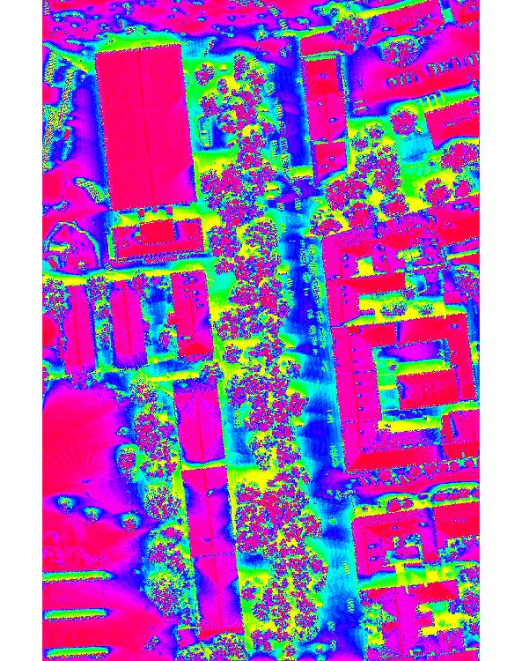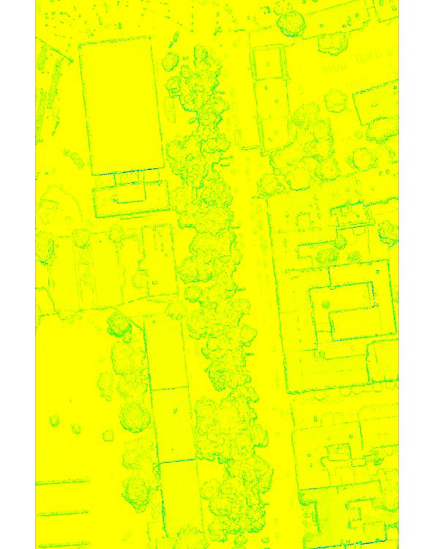

*Figure 2.Beam, diffuse and reflected radiation using r.sun.*

# 2.2 Assessment of land surface temperature of urban surfaces

There are two types of UHIs: surface and atmospheric UHIs. Surface UHIs usually develop during hot, sunny summer days. The sun heats dry, exposed urban surfaces, like roofs and pavement, to temperatures 25 to 50°C hotter than the air in suroundings. The magnitude of surface UHIs varies with seasons, due to changes in the sun’s intensity as well as ground cover and weather. As a result of such variation, surface UHIs are typically largest in the summer. Warmer air in urban areas compared to cooler air in nearby rural surroundings defines atmospheric UHIs. These are usually divided into two different types: canopy layer UHIs which exist in the layer of air where people live, from the ground to below the tops of trees and roofs and boundary layer UHIs that start from the rooftop and treetop level and extend up to the point where urban landscapes no longer influence the atmosphere. This region typically extends no more than 1.5 km from the surface. Surface temperatures have an indirect, but significant, influence on air temperatures, especially in the canopy layer, which is closest to the surface. For example, parks and vegetated areas, which typically have cooler surface temperatures, contribute to cooler air temperatures. Dense, built-up areas, on the other hand, typically lead to warmer air temperatures. Because air mixes within the atmosphere, though, the relationship between surface and air temperatures is not constant, and air temperatures typically vary less than surface temperatures across an area. In this section we focus on surface UHIs and LSTs which directly contribute also to development of atmospheric UHIs.

The most important factor contributing to development of surface UHIs is the amount of solar irradiance. It consists of three components: beam (direct), diffuse and reflected irradiance. The most important component is beam radiation because usually it is about 50-60% of global radiation and even more during sunny days. Beam radiation depends on solar and local surface geometry and therefore it can be computed quite straighforwardly. Diffuse radiation is anisotropic, i.e., it varies over the sky depending on direction of solar rays. The ground-reflected component of solar radiation is usually quite small (e.g., several percents of global radiation). It depends on topography and ground reflectance. The reflectance of urban surfaces is expressed via ground albedo. In flat areas, the ground reflected radiation is almost non-existent, however, it may become significant in urban areas with buildings and vertical walls.

Land surface temperature (LST) is generally defined as the radiative skin temperature of the ground derived from solar radiation. LST is a key parameter in the physics of land surface processes, combining surface-atmosphere interactions and energy fluxes between the atmosphere and the ground. Properties of urban materials, in particular solar reflectance, thermal emissivity, and heat capacity influence the LST and subsequently development of UHIs, as they determine how the sun’s energy is reflected, emitted, and absorbed.

Generally, a built-up area exhibits a variable thermal pattern with hot and cold peaks, corresponding to low and high reflectivity impervious surfaces, respectively. A solar-reflective surface is typically light in color and absorbs less sunlight than a conventional dark-colored one. Mitigating UHIs requires lowering the average surface temperature of the city so that there is less surface-to-air heat transfer. Vegetation, which maintains a cool surface temperature because of evaporation, is one of key components of this effort. For building and pavement surfaces in the sun, surface characteristics such as albedo, emissivity, and roughness, are also relevant. For a surface under the sun and insulated underneath, the equilibrium surface temperature, Ts is obtained from the equation based on Stefan-Boltzmann Law which describes the power radiated from a black body in terms of its temperature (Bretz et al., 1998):



where

 is solar-reflectivity or albedo of the surface, *I* is total solar radiation incident on the surface,W/m2, - emissivity of the surface,  is Stefan-Boltzmann constant, 5.6685 × 10-8 Wm-2K-4, *Ts* is equilibrium surface temperature, K, *Tsky* is the effective radiant sky temperature, *hc* convection coefficient, Wm-2K-1, *Ta* air temperature, K (ASHRAE, 1989).

Using this equation, the surface temperature *Ts* can be approximated by Newton's iteration method. In GRASS GIS using a shell script this approximation has the following form:

#!/bin/sh

echo "Global irradiance file"

read irr

g.copy rast=$irr,gi

echo "Albedo file"

read alb

g.copy rast=$alb,albedo

echo "Convection coefficient file"

read cc

g.copy rast=$cc,h_c

echo "Initial estimation of land surface temperature (e.g., 300)"

read temp0

echo "Ambient air temperature (e.g., 293)"

read T_a

echo "Radiant sky temperature (e.g., 287)"

read T_sky

echo " initialization of parameters..."

r.mapcalc --o "epsilon = 1. - albedo"

r.mapcalc --o "c = -epsilon * 0.000000056685 * $T_sky * $T_sky * $T_sky * $T_sky - h_c * $T_a - (1 - albedo) * gi"

r.mapcalc --o "lst0 = $temp0" #initialization of LST

r.mapcalc --o "y = lst0*lst0*lst0"

r.mapcalc --o "lst = (3*epsilon*0.000000056685*y*lst0 - c)/(4*epsilon*0.000000056685*y+h_c)" #1st iteration

i=2

while [ $i -le 10 ]

do

echo "Iteration" $i

g.copy --o rast=lst,lst0

r.mapcalc --o "y = lst0*lst0*lst0"

r.mapcalc --o "lst = (3*epsilon*0.000000056685*y*lst0 - c)/(4*epsilon*0.000000056685*y+h_c)"

i=`expr $i + 1`

done

echo "Finished."

This approximation requires a first estimation of LST (e.g., roughly close to measured air temperature, sunny, overcast day, etc.). Then 10 iterations produce the results with sufficient accuracy. The GRASS GIS implementation asssumes that ambient air temperature Ta and radiant sky temperature Tsky are also known. Air temperature is usually measured by meteoreological stations, often even within the city. Radiant sky temperature can be estimated using one of the available approximation methods published, e.g. in (Algarni, 2015), depending on the cloudiness. In this study, we use fairly simple clear sky a cloudy sky direct temperature models where Tsky = Ta - 20 under clear-sky conditions (Garg, 1982) and Tsky = Ta - 6 under cloudy conditions (Whillier, 1967). Of course, any other temperature model can be used depending on available data to improve the accuracy of assessment. However, to evaluate the algormithmic structure of our solution it is sufficient to use even these simple formulas. The dominant parameters which determine the maximum LST are solar reflectance (albedo) , thermal enissivity of the surface and convection heat transfer coefficient hc.. Berdahl and Bretz (1997) have shown that there is a fairly linear correlation between albedo and thermal emissivity of the surface for typical metal roof coatings and in most cases emissivity can be roughly approximated by  .

The convection coefficient *hc* is usually the most difficult parameter to estimate. It depends strongly on wind speed and direction, geometry of the building and surroundings, height of the roof above ground level, building material texture (roughness) and surface to air temperature difference (Mirsadeghi et al., 2013). In sunlight, with zero wind speed, *hc*, is determined by natural convection. It is a weakly increasing function of temperature difference, and almost independent of surface size. For example, for *Tsky* - *Ta* = 30 K, estimates give *hc* = 6.6 Wm-2K-1. For wind speeds above about 1 ms-1, the convection coefficient is determined by forced convection, and, *hc* rises from 2.5-3.0 at zero wind speed to about 15-20 Wm-2K-1 at speeds of 7 ms-1 with even higher values for roofs and upwind surfaces (Liu et al., 2015). More accurate estimates of *hc* require complex modeling techniques using 3D city models, building material data and 3D wind simulation. In this study we use a uniform value of hc=10, however, this parameter is defined as spatially distributed parameter, so when available it can be used to account for spatial differences within the city or between the buildings.

For typical condition of Wm-2K-1

*Figure 3. XXX.*

## 3 Results

## 3.1 Application to Kosice test site

vybrane datumy

dni roku 2016:

7.4., 29.6., 26.7., 27.8., 28.8., 14.9., 23.9., 14.10., 27.10., 8.11., 23.11.

popis, priprava dat

vlastnosti vegetacie - parametrizacia

data - albedo, parametrizacia

ukazky vysledkov, porovnanie s L8.

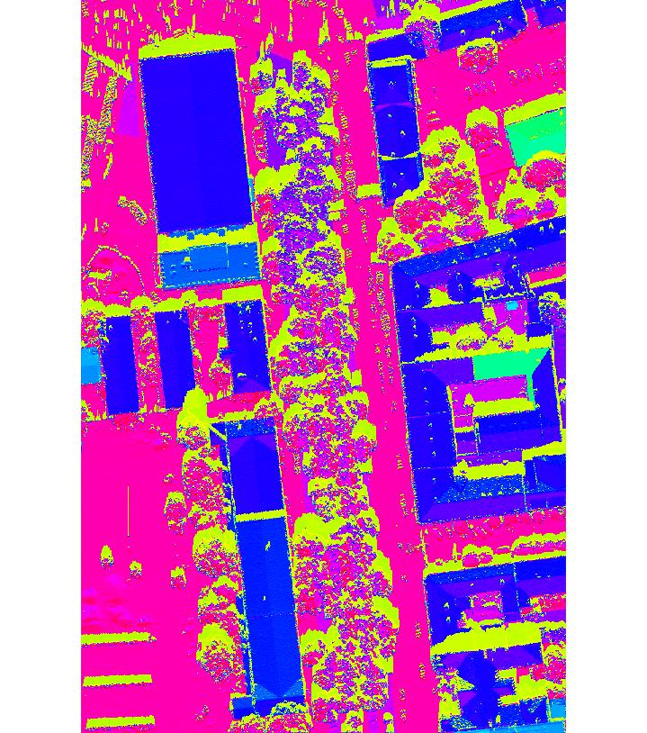

*Figure 3. LST estimated by Stefan-Boltzmann equation.*

Mitigating UHIs:

Most urban surfaces that are not metallic exhibit high emissivity. The most practical parameter in equation (I) to alter on a large scale is albedo. At the same time, it is necessary to avoid low-emissivity materials, such as bare metals and aluminum coatings. Adding vegetation is also an effective means of lowering urban surface temperature.

## 4 Algorithmic structure of toolbox

During the feasibility study we have conducted the following steps that lead to our estimation of surface UHIs:

- 3D city model

- assessment of vegetation

- solar radiation modeling

- land surface temperature estimation

- evaluation of various scenarios in GIS to assess the best ways to mitigate UHIs

Toolbox consists of the following tools implemented in GRASS GIS:

- ddfff

# Conclusions

The presented report provide the following findings and solutions:

* xxxxx.
* .

The results show that xxx.

# References

Alonzo, M., Bookhagen, B., McFadden, J.P., Sun, A., Roberts, D.A. (2015). Mapping urban forest leaf area index with airborne lidar using penetration metrics and allometry. Remote Sens. Environ., 162, pp. 141-153.

Campbell, J.B., Wynne, R.H., (2011). Introduction to Remote Sensing. 5th Edition, The Guilford Press.

Henrich, V., Krauss, G., Götze, C., Sandow, C. (2012): IDB - www.indexdatabase.de, Entwicklung einer Datenbank für Fernerkundungsindizes. AK Fernerkundung, Bochum, 4.-5. 10. 2012.

Hofierka, J., Gallay, M., Kaňuk, J., Šupinský, J. & Šašak, J., 2017. High-resolution urban greenery mapping for micro-climate modelling based on 3D city models. The International Archives of the Photogrammetry, Remote Sensing and Spatial Information Sciences (ISPRS Archives), XLII-4/W7, pp. 7-12.

Huete, A.R. (1988). A soil-adjusted vegetation index (savi). Remote Sens. Environ, 25, 295–309.

Jiang, Z.; Huete, A.R.; Didan, K.; Miura, T. (2008). Development of a two-band enhanced vegetation index without a blue band. Remote Sens. Environ., 112, 3833–3845

Jensen, J.R., (2006). Remote Sensing of the Environment: An Earth Resource Perspective. 2nd edition. Pearson.

Klingberg, J., Konarska, J., Lindberg, F., Johansson, L., Thorsson, S. (2017). Mapping leaf area of urban greenery using aerial LiDAR and ground-based measurements in Gothenburg, Sweden. Urban Forestry and Urban Greening. 26 (2017). pp. 31-40.

Onačillová, K., Gallay, M. (2018). Spatio-temporal analysis of surface urban heat island based on LANDSAT ETM+ and OLI/TIRS imagery in the city of Košice, Slovakia. Carpathian Journal of Earth and Environmental Sciences, 13(2), 395 - 408.

Richardson, J.J., Moskal, L.M., Kim, S.H. (2009). Modeling approaches to estimate effective leaf area index from aerial discrete-return LIDAR. Agric. For. Meteorol., 149, pp. 1152-1160.

Tooke, T.R., Coops, N.C., Goodwin, N.R., Voogt, J.A. (2009). Extracting urban vegetation characteristics using spectral mixture analysis and decision tree classifications. Remote Sensing of Environment, 113(2), pp. 398-407.

Tooke, T.R., Coops, N.C. Christen, A., Gurtuna, O., Prévot, A., (2012). Integrated irradiance modelling in the urban environment based on remotely sensed data. Solar Energy, 86(10), pp. 2923-2934.

Algarni, S. A. (2015). Modeling Radiation Heat Transfer for Building’s Cooling and Heating Loads: Considering the Role of Clear, Cloudy, and Dusty Conditions in Hot and Dry Climates.Theses and Dissertations. 1231.

Hofierka, J., 1997. Direct solar radiation modelling within an open GIS environment. In Proceedings of the 1997 Joint European GI Conference, Vienna, Austria, 575–584

Šúri, M., Hofierka, J., 2004. A new GIS-based solar radiation model and its application to photovoltaic assessments. Transactions in GIS 8, 175–190.

Šúri, M., Huld, T.A., Dunlop, E.D., 2005. PVGIS: a web-based solar radiation database for the calculation of PV potential in Europe. International Journal of Sustainable Energy 24, 55–67.

Hofierka J, Kaňuk J 2009 Assessment of Photovoltaic Potential in Urban Areas Using Open-Source Solar Radiation Tools. Renewable Energy 34: 2206-14

Neteler M, Mitasova H 2004 Open Source GIS: A GRASS GIS Approach. Second Edition. Boston, Kluwer Academic Publishers

Becker S 2001 Calculation of direct solar and diffuse radiation in Israel. International Journal of Climatology, 21: 1561-76

Beyer H G, Costanzo C and Heinemann D 1996 Modifications of the Heliosat procedure for irradiance estimates from satellite images. Solar Energy 56: 207-12

Beyer H G, Czeplak G, Terzenbach U and Wald L 1997 Assessment of the method used to construct clearness index maps for the new European solar radiation atlas (ESRA). Solar Energy 61: 389-97

Cano D, Monget J M, Albuisson M, Guillard H, Regas N and Wald L 1986 A method for the determination of the global solar radiation from meteorological satellite data. Solar Energy 37: 31-9

D’Agostino V and Zelenka A 1992 Supplementing solar radiation network data by co-kriging with satellite images. International Journal of Climatology 12: 749-61

Dubayah R and Rich P M 1995 Topographic solar radiation models for GIS. International Journal of Geographical Information Systems 9: 405-19

Fu P and Rich P M 2000 The Solar Analyst 1.0 User Manual. Helios Environmental Modeling Institute, http://www.hemisoft.com

Gruter J W (ed) 1984 Radiation nomenclature. 2nd Solar Energy Programme of the CEC, Project F, Solar Radiation Data, Brussels, CEC

Hammer A, Heinemann D, Westerhellweg A, Ineichen P, Olseth J A, Skartveit A, Dumortier D, Fontoynont M, Wald L, Beyer H G, Reise Ch, Roche L and Page J 1998 Derivation of daylight and solar irradiance data from satellite observations. Proceedings of the 9th Conference on satellite meteorology and oceanography, Paris, May 1998: 747-50, http://www.satel-light.com/core.htm

Hetrick W A, Rich P M, Barnes F J and Weiss S B 1993 GIS-based solar radiation flux models. American Society for Photogrammetry and Remote Sensing Technical papers. GIS, Photogrammetry and Modeling 3: 132-43

Hofierka J 1997 Direct solar radiation modelling within an open GIS environment. Proceedings of the Joint European GI Conference 1997, Vienna: 575-84

Hofierka J, Parajka J, Mitasova M and Mitas L. 2002 Multivariate iterpolation of precipitation using regularized spline with tension. Transactions in GIS 6: 135-50

Hutchinson M F, Booth T H, McMahon L P, and Nin, H A 1984 Estimating monthly mean values of daily total solar radiation for Australia. Solar Energy 32: 277-90

Hulme M, Conway D, Jones P D , Jiang T, Barrow E M, and Turney C 1995 A 1961-1990 climatology for Europe for climate change modelling and impact applications. International Journal of Climatology 15: 1333-64

Jenčo M 1992 Distribúcia priameho slnečného žiarenia na reoreliéfe a jej modelovanie pomocou komplexného digitálneho modelu reliéfu. Geografický časopis 44: 342-55

Kasten F 1996 The Linke turbidity factor based on improved values of the integral Rayleigh optical thickness, Solar Energy 56: 239-44

Kasten F and Czeplak G 1980 Solar and terrestrial radiation dependent on the amount and type of cloud. Solar Energy 24: 177-89

Kasten F and Young A T 1989 Revised optical air mass tables and approximation formula. Applied Optics 28: 4735-8

Kitler R and Mikler J 1986 Základy využívania slnečného žiarenia. Bratislava, Veda

Krcho J 1990 Morfometrická analýza a digitálne modely georeliéfu. Bratislava, Veda

Kumar L, Skidmore A K, and Knowles E 1997 Modelling topographic variation in solar radiation in a GIS environment. International Journal of Geographical Information Science 11: 475-97

Louche A, Peri G and Iqbal M 1986 An analysis of Linke turbidity factor. Solar Energy 37: 393-6

McKenney D W, Mackey B G and Zavitz B L 1999 Calibration and sensitivity analysis of a spatially-distributed solar radiation model. International Journal of Geographical Information Science 13, 1: 49-65

Mészároš I 1998 Modelovanie príkonu slnečnej energie na horské povodie. Acta Hydrologica Slovaca 1: 68-75

Miklánek P 1993 The estimation of energy income in grid points over the basin using simple digital elevation model. Annales Geophysicae 11 European Geophysical Society, Springer, Suppl. II.

Mitasova H and Mitas L 1993 Interpolation by Regularized Spline with Tension: I. Theory and Implementation. Mathematical Geology 25: 641 – 55

Muneer T 1990 Solar radiation model for Europe. Building Services Engineering Research and Technology 11: 153-63

Muneer T 1997 Solar Radiation and Daylight Models for Energy Efficient Design of Buildings, Oxford, Architectural Press

Neteler M and Mitasova H 2002 Open Source GIS: A GRASS GIS Approach, Kluwer Academic Publishers, Boston

Page J K (ed) 1986 Prediction of solar radiation on inclined surfaces. Solar Energy R&D in the European Community, Series F: Solar Radiation Data, Vol. 3, Dordrecht, D. Reidel Publishing Company

Page J K, Albuisson M, and Wald L 2001 The European solar radiation atlas: a valuable digital tool. Solar Energy, 71: 81-83

Perez R, Seals R, Ineichen P, Steward R and Menicucci D (1987) A new simplified version of the Perez diffuse irradiance model for tilted surfaces. Solar Energy, 39, 221-231.

Rigollier Ch, Bauer O and Wald L 2000 On the clear sky model of the ESRA – European Solar radiation Atlas – with respect to the Heliosat method. Solar Energy 68: 33-48

Rigollier Ch, Lefèvre M and Wald L 2001 Heliosat version 2, Integration and Exploitation of Networked Solar Radiation Databases for Environment Monitoring (SoDa), European Commission Project No. IST-1999-122245, report, http://www.soda-is.com/

Scharmer K and Greif J (eds) 2000 The European Solar Radiation Atlas. Vol. 2: Database and Exploitation Software. Paris, (es Presses de l'École des Mines

Šúri M, Dunlop E D, and Jones A R 2002 GIS-based inventory of the potential photovoltaic output in Central and Eastern Europe. PV in Europe. From PV Technology to Energy Solutions, Conference and Exhibition, 7-11 October 2002, Rome

WMO Meteorological aspects of utilization of solar radiation as an energy source 1981 World Meteorological Organisation Technical Note No. 172, 557, Geneva, Switzerland

Zelenka A, Czeplak G, D’Agostino V, Josefson W, Maxwell E and Perez R 1992 Techniques for Supplementing Solar Radiation Network Data. Technical Report, International Energy Agency, # IEA-SHCP-9D-1, Swiss Meteorological Institute, Switzerland