ESA STUDY – MID-TERM REPORT
ESA Contract No:  4000117034/16/NL/NDe | SUBJECT:  SURGE: Simulating the cooling effect of urban greenery based on solar radiation modelling and a new generation of ESA sensors |  |  | INSTITUTE:  Pavol Jozef Šafárik University in Košice, Institute of Geography
ESA Contract No:  4000117034/16/NL/NDe |  | No. of Volumes: 1  This is Volume No: 1 |  | INSTITUTE’S REFERENCE:  SURGE_D3_MIDTERM_R
ABSTRACT (Executive Summary of the Project):
The aim of this feasibility study is to assess the applicability of the Sentinel-2A multispectral satellite imagery for approximating the dynamics of solar radiation transmittance of urban greenery leading to its cooling effects via modelling the spatial distribution of solar radiation in a complex urban environment represented by a 3-D city model. The main technical objective of the project is to define the relationship between a high-resolution 3-D geometry of urban greenery and vegetation metrics in selected periods throughout the year. The study will be used to evaluate the proposed approach in the development of a toolbox enabling urban planners and researchers to mitigate heat risk based on solar radiation modelling and Sentinel-2A multispectral data.
The work described in this report was done under ESA PECS Contract. Responsibility for the contents resides in the author or organisation that prepared it.
Names of authors: Michal Gallay, Jaroslav Hofierka
ESA PECS PROGRAMME MANAGER: Maite Trujillo

DIRECTORATE: IPL-ISP

 | Doc. No.  Issue:  Revision:  Date: | 1.  1.  1.  15 June 2017

Simulating the cooling effect of urban greenery based on solar radiation modelling and a new generation of ESA sensors (acronym SURGE)

Mid-term Report
(Deliverable 3 under WP1)

Introduction

The objective of the progress report is to provide all actors with actual information concerning the status of the project “Simulating the cooling effect of urban greenery based on solar radiation modelling and a new generation of ESA sensors (acronym SURGE)” from 01/06/2016 to 31/05/2017 (M1 - M12).

The aim of this project: This project will serve as a preparatory study to assess the applicability of the multispectral satellite imagery for approximating the dynamics of solar radiation transmittance of urban greenery to assess the cooling effects of the greenery via modelling the spatial distribution of solar radiation in a complex urban environment represented by a 3-D city model.

The main technical objectives: The main technical objective of the project is to define the relationship between 3-D geometry of urban greenery and vegetation metrics in selected periods throughout the year. The imagery to be acquired by the new generation of ESA Sentinel 2-A satellite sensors will be used to derive the vegetation metrics and it will be downscaled to higher resolution datasets. The final outcome of this study will be in the proof-of-concept which identifies critical functions and characteristics of the proposed approach. This study can be used in the future to develop a toolbox enabling urban planners and researchers to mitigate heat risk based on solar radiation modelling and Sentinel-2A multispectral data for urban greenery parameterization.

Highlight Summary
The following results were achieved during the first 12 months since commencing the work on the SURGE feasibility study (01 June 2016 – 30 May 2017):
- The central part of the Košice City was identified as a suitable study area (4 km²).
- Periodical terrestrial laser scanning of urban vegetation was performed on four smaller sites selected within the study area to acquire ground truth representation of vegetation for particular phenological phases in high resolution and high accuracy.
- Airborne laser scanning data, photogrammetric orthoimagery, and vector based 3-D city model was generated for the study area.
- Multispectral data products of the Sentinel 2A and Landsat 8 sensors were downloaded for the study area and their applicability for the projects was analysed.
- Report on the reviewed applicability of multispectral satellite imagery for derivation of vegetation transmittance was generated (Deliverable 1 under WP2).
- The acquired airborne laser scanning data, photogrammetric orthoimagery, and vector based 3-D city model were integrated and harmonized into a geodatabase covering the study area. Virtual 3D city model of the study area was generated. (Deliverable 2 under WP2).
- The Mid-term report summarising the achieved results and technical aspects was generated (Deliverable 3 under WP1).
- Milestone 1 as specified according to the contract was reached by generating D1, D2 and D3. (N.B.: D2 and D3 were associated with Milestone 2 according to the project proposal)
- The project management was reported in Progress report 1 and Progress report 2 for two consecutive 6 months periods.
- Partial results of the SURGE project were presented on international conference GIS Ostrava 2017 in Ostrava and during the 6th Czech Copernicus Users Forum in Prague.

The work has been progressing normally according to the plan.

Work Summary Status (during the reporting period)

Work package | Activities | Responsible Person | Status
WP1: Study management | - Meetings of the project team | Jaroslav Hofierka | On-going
WP2: Data, methods and architecture of the system | - Review of the state-of-the-art on vegetation transmittance (D1) | Michal  Gallay | Finished
 | - Selection of the study area | Jaroslav Hofierka | Finished
 | - Procurement of services (airborne survey Košice) | Michal Gallay | Finished
 | - Generated 3D city model (D2) | Michal  Gallay | Finished
 | - Generation of 3D time series of urban greenery | Ján  Kaňuk | On-going
 | - Gathering of Sentinel 2A imagery | Michal  Gallay | On-going
 | - Urban greenery field mapping | Alena Gessert (Petrvalská) | On-going
 | - Mid-term report (D3) | Michal  Gallay | Finished

Detailed Progress of Work
Provide summary of the work performed. Upcoming TNs

4.1 WP1 – Study management

Since the official start of the project in June 2016 (M1 – M12), we had 4 meetings of the project team. The kick-off meeting was held on 2 June 2016 where we reviewed our research plan and specifically activities for the WP2 for the first 6 months period. We selected the study area (central part of the Košice City) and we briefly discussed conditions of the procurement of airborne laser scanning and data processing. The procedure of the public procurement of the service on airborne laser scanning and photogrammetry of the central part of the Košice City was started in June 2016. The Photomap s.r.o company settled in Košice was selected among three competitors for supplying this service and the data were delivered on 30 November 2016. The second meeting of the project team was held on 7 September 2016, when we reviewed works done and we suggested a detailed plan for finalisation of the activities in WP2 in the remaining period. We had several short presentations on the preliminary results, specifically regarding periodical terrestrial laser scanning of the study area as well as vegetation mapping and photographic documentation of urban greenery. The SURGE project website was launched for presenting the aims, team, methods, and results of the project for public (Fig. 1).

The third meeting was held on 23 January 2017 where we reviewed our research plan and specifically activities for the WP2 for the M8 - M12 period. We decided on personal tasks regarding data processing for 3-D city model as well as integration of the TLS and ALS data with the other 3-D city data. Also, various technical issues such as different reference systems of the datasets and database integration were discussed and resolved.

The fourth meeting of the project team was held on 10 May 2017 when we discussed details of mid-term progress report and deliverables. Specifically, we decided on items that should be included in the 3-D city model, data formats and other technical specifications of the data package. We also discussed further works regarding 3-D (voxel) representation of urban vegetation (trees) and possible implementation in the v.sun solar radiation model (WP3). The WP leaders discussed the planned presentations of the ongoing results of the project in the 6th Czech Copernicus Users Forum meeting in Prague, and the 3Dgeoinfo 2017 conference in Melbourne (October 2017). Besides this, the project leader had regular meetings with the WP2 leader discussing the ongoing activities as well as various management and financial issues.

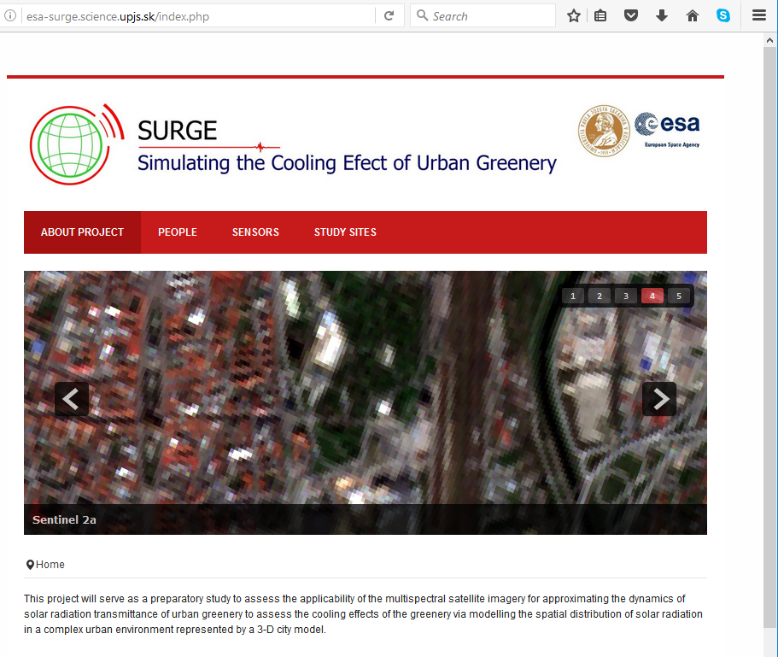
Fig. 1. Print screen of the SURGE project website for disseminating the results and work progress on the project.

4.2 WP2 – Data, methods and architecture of the system

The technical part of the work on the SURGE project is divided into eight tasks which are covered by WP2, WP3, and WP4. The first 12 months period concerned the work on the following tasks under WP2:
Task 1: Report on the reviewed applicability of multispectral satellite imagery for derivation of vegetation transmittance
Task 2: Selecting the study area
Task 3: Generating a high-resolution 3-D city model
Task 4: Generating time series of high-resolution 3-D urban greenery
Task 5: Gathering and analysing time series of Sentinel 2A multispectral imagery
Task 6: Preparing input 3-D data for solar radiation modelling

The work performed under these tasks is more thoroughly described further in the text.

4.2.1 Task 1: Report on the reviewed applicability of multispectral satellite imagery for derivation of vegetation transmittance

This report represents the Deliverable 1 under WP2. The report summarises a review of the published research (state-of-the-art) on derivation of vegetation metrics from multispectral satellite data for characterising the solar radiation transmittance of urban greenery. We focused on the applicability of the Earth Observation sensors which are currently in operation and which provide high resolution in spectral and spatial domain with a high frequency of sensing repetition over the same area. In addition the data should be accessible free of charge via internet for the area of the Košice city Slovakia to be applicable in this contract. Therefore, the selection of sensors included Landsat 7 ETM+, Landsat 8 OLI/TIRS, and Sentinel 2A MSI. The review showed that multiple indices were used for parameterizing vegetation transmittance with multispectral satellite imagery. The most popular is the normalized vegetation index (NDVI), which is simple to calculate and provides a proxy for calculating metrics which are difficult to be measured directly from the satellite imagery, such as such as leaf area index (LAI), canopy cover and gap fraction.

4.2.2 Task 2: Selecting the study area

This feasibility study focuses on the Košice City in Eastern Slovakia as an example of urban space typical for moderate climate of Central Europe. The city is the second largest city in Slovakia with about 240 000 inhabitants. It is a typical example of urban landscape in mild climate conditions of Central Europe. The project team is based in this city therefore it was meaningful to establish the study on an area within Košice. Based on thorough discussions of the team, we selected a study area with a feasible size and sufficient diversity of urban greenery which would be suitable for ground-based mapping, airborne survey and large enough for monitoring by Earth observation satellites such as Sentinel 2A and Landsat 8. Our study area is in the central part of Košice. Here, we have selected a rectangular area (4 km²) which consists of various types of urban greenery and built-up areas, such as parks, alleys, greenery in residential zones (Fig. 2). The overview of acquired types of data is shown in Fig. 3.

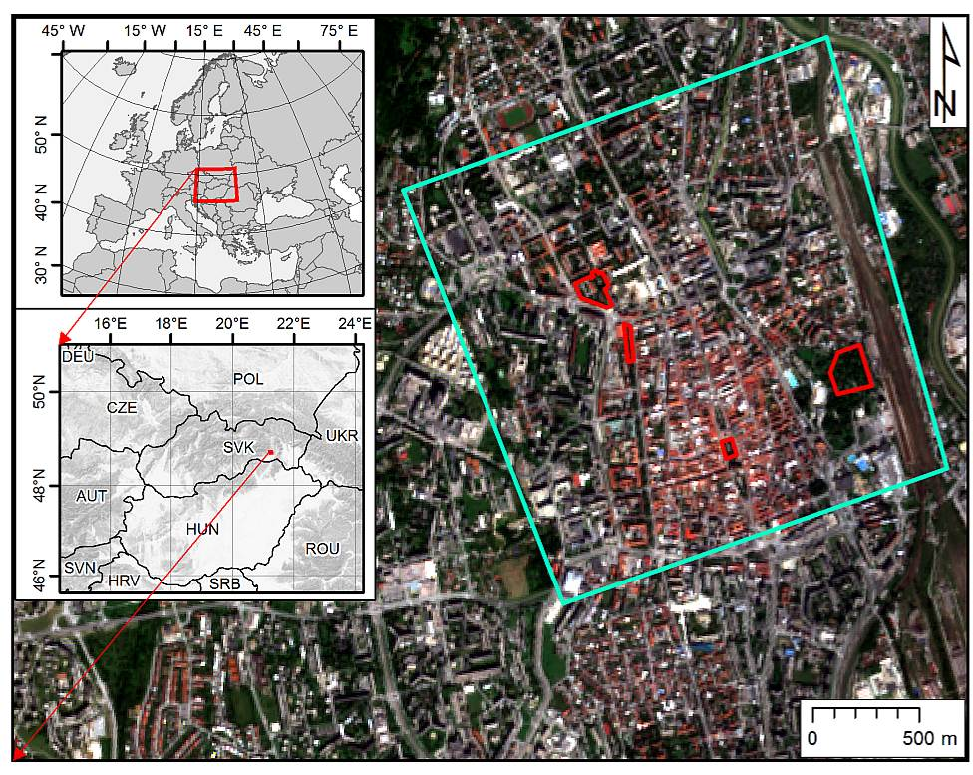
Figure 2. Location of the Košice City within Europe (left) and the study area within the city (right). The cyan line outlines the area subject to airborne lidar and photogrammetric data collection and the line delineates selected sites for repeated terrestrial laser scanning. The background maps are © Copernicus, Sentinel 2A image acquired on 7 September 2016.

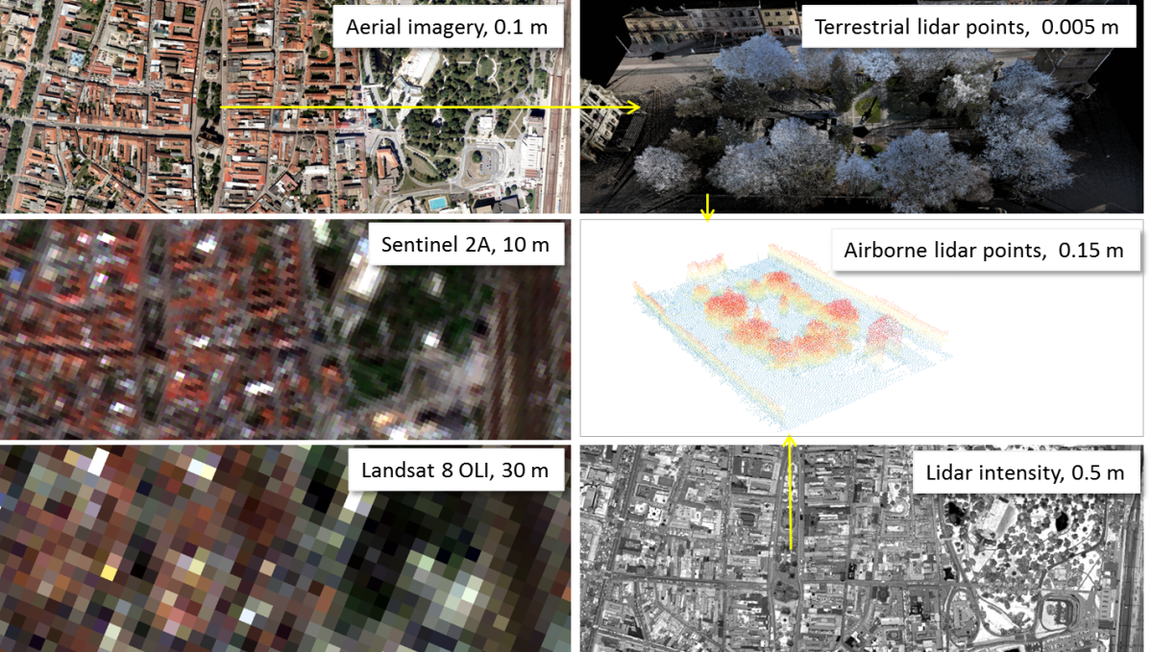
Figure 3. Overview of the acquired spatial data for the study area and associated spatial scales. The images show the central part of the Košice City, Slovakia.
The large area of (Fig. 2, cyan outline) was mapped by airborne photogrammetry and airborne laser scanning (ALS) in two single missions on 09 August and 14 September of 2016, respectively. ALS data and photogrammetric imagery were used for creation of 3-D city model consisting of buildings and terrain. We have selected four smaller test sites covering several hectares (Fig. 2, red outlines) for detailed mapping of urban vegetation and its geometric change using repeated terrestrial laser scanning (TLS). Each site represents typical urban greenery consisting of various kinds of trees of different height. The data were acquired in WGS 1984 and transformed into the Slovak national projection coordinate system JTSK03 and Baltic altitude height system after adjustment (Bpv).

4.2.3 Task 3: Generating a high-resolution 3-D city model
Custom aerial survey was procured to acquire 3D airborne laser scanning (ALS) data and photogrammetric imagery to map urban greenery over the whole study area (Fig. 2, cyan outline). Also 3-D vector models of buildings were supplied within this service. The data were used to generate a 3-D city model of the study area which was performed in the M7 - M12 period. The purpose of airborne laser scanning (ALS) and photogrammetry data acquisition was in capturing 3D geometry and multispectral (R, G, B, NIR) orthoimagery for the entire study area. Both missions were conducted in leaf-on conditions during late summer of 2016.
Leica ALS70 laser scanner was used for ALS. Table 1 reports summary of the ALS data. The points were processed in LAStools to classify them in ground, vegetation, buildings and other returns. Ground returns were used to derive a gridded digital terrain model (DTM) of 0.2 m cell size. Photogrammetric imagery was collected by Vexcel UltracamXp digital camera resulting in two natural and NIR false colour orthoimagery with spatial resolution of 10 cm. The photogrammetric stereo imagery was used to derive a 3-D city model representing the buildings in the study area with LoD2 (Fig. 4). For mapping the urban greenery in the entire study area airborne laser scanning data coupled with NIR false colour photogrammetric imagery was used. The ALS points representing the vegetation were extracted by classification based on point heights and by thresholding the RGB values from the NIR colour composite.

Table 1. Parameters of the ALS mission flown with a Leica ALS70-CM lidar system.
Parameter | Value
Flight height above ground | 1050 - 1087 m
Flight altitude above mean sea level | 1,333 m
Total number of points | 365 million
Total area | 4 km²
Average density of returns (all/ground) | 91 / 15 points per m²
Absolute overall accuracy in open areas | 0.1 m @ 1σ

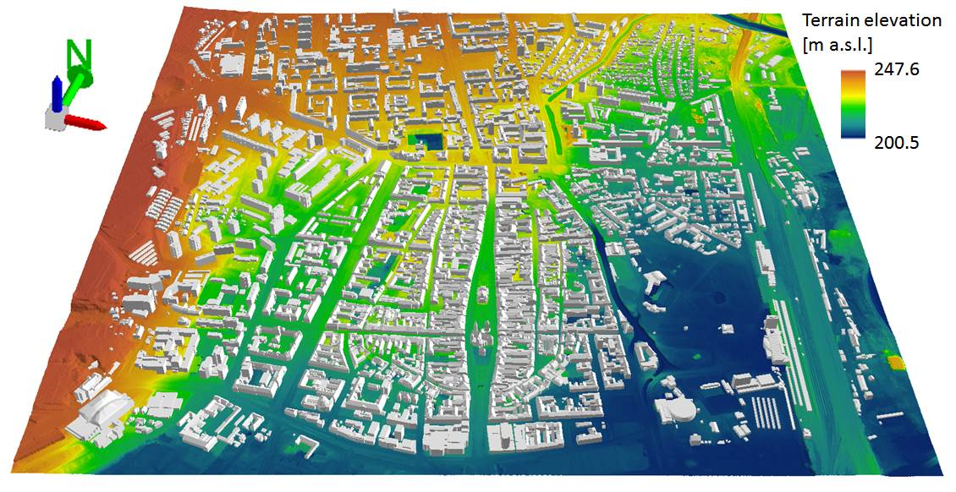
Figure 4. Perspective 3D view of the entire study area (cyan outline in Fig. 1) for which the 3D city model was generated. 3D buildings are dispalyed on a digital terrain model in the ArcScene software by ESRI.

The work on Task 3 also included a geobotanical field mapping when position (latitude, longitude), plant species, basic morphological parameters and health conditions were recorded for each tree within the four smaller sites. These data help to improve interpretation of the lidar point clouds and orthoimagery (Fig. 5, 6). To date (M12), the geobotanical survey has concerned the four smaller sites for which the information is assigned to the 2-D polygon and meshed 3-D models of trees. However, it is planned to assign the plant attributes to all trees in the study area by the end of M19 (December 2017).

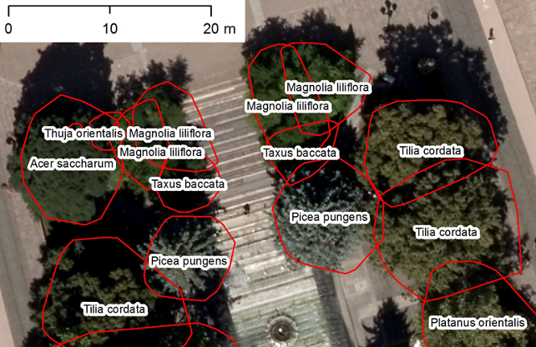
Figure 5. Footprint polygons of trees identified from the ALS point cloud (red outline) with assigned attributes according to the field survey overlaid on top of the aerial orthoimage.

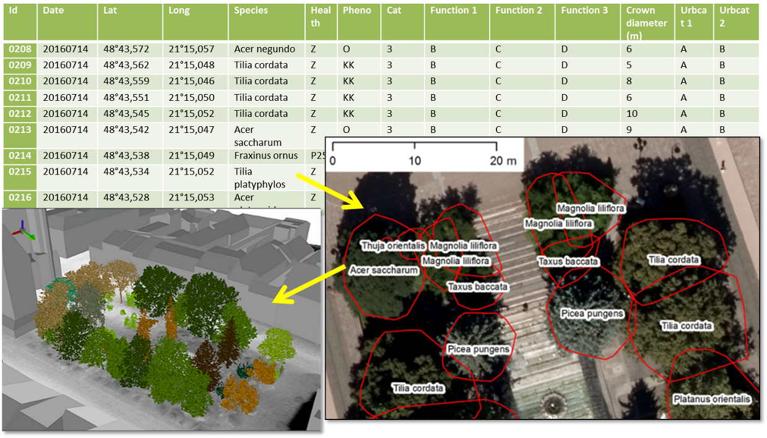
Figure 6: Schematic work flow of assigning tree attributes from field survey to trees as 3D objects in a geodatabase.

The 3-D city model covers the entire study area which is displayed in Fig. 2 (cyan outline) and it represents the Deliverable 2. The model is the result of Task 3 and it contains also some data resulting from Task 4. The 3-D city model of the entire study area is a static 3-D representation of the area valid to September 2016 when the main component of spatial data was acquired (ALS, photogrammetry). The size of the entire 3D city model is nearly 43 GB therefore the complete model is made available via URL: https://uge.science.upjs.sk/esa_surge_deliverables/ with the following login and password: “user”,”9DQsgmpeLJRS8Fr7Wfmz”. The data of the complete model are organized in a hierarchical structure of folders (Fig. 7) which comprise data georeferenced in in the Slovak national grid system (EPSG code: 5514, in ArcGIS by ESRI: Projected Coordinate System: SJTSK_Krovak_East_North).
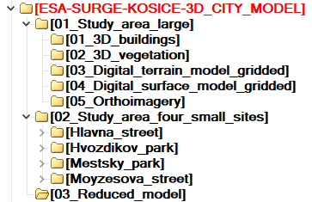

Figure 7: Data structure of the Generated 3-D city model (Deliverable 2).
This model contains 5 digital representations of 4 kinds of objects:
- buildings as 3-D buildings vectors,
- trees as ALS 3-D points, 2-D vector polygons,
- terrain as a digital terrain model (2-D raster/grid),
- land cover surface as a digital surface model (2-D raster/grid),
- land cover as a digital orthoimagery in natural and false colours (2-D raster image).

The main folder D2_ESA-SURGE-KOSICE-3D_CITY_MODEL contains three subfolders. The first subfolder (01_Study_area_large) comprises data for the entire study area (4 km², cyan outline in Fig. 2). It is the 3-D city model itself as the Deliverable 2 under WP2. Figure 4 shows an example of its 3-D perspective visualization.
In addition, the second subfolder (02_Study_area_four_small_sites) comprises data for the four smaller sites which are subject to high resolution monitoring of vegetation 3D structure by TLS. The city models of the four smaller sites therefore contain a dynamic component, i.e. 3-D models of trees. A project file for 2-D and 3-D visualization is prepared for each of the sites (Fig. 8).
The third subfolder contains a reduced dataset of the 3D city model. The titles of the subfolders on lower level are self-explanatory. The data are compressed with ZIP and RAR formats for more convenient download. The data involved are provided in standard data formats for geographic information systems software (e.g. ArcGIS, Quantum GIS) such as ESRI shapefiles or gridded raster data (TIFF, ASCII, DXF, VRML). Short description of the data in the folders is reported in a metada.txt file.
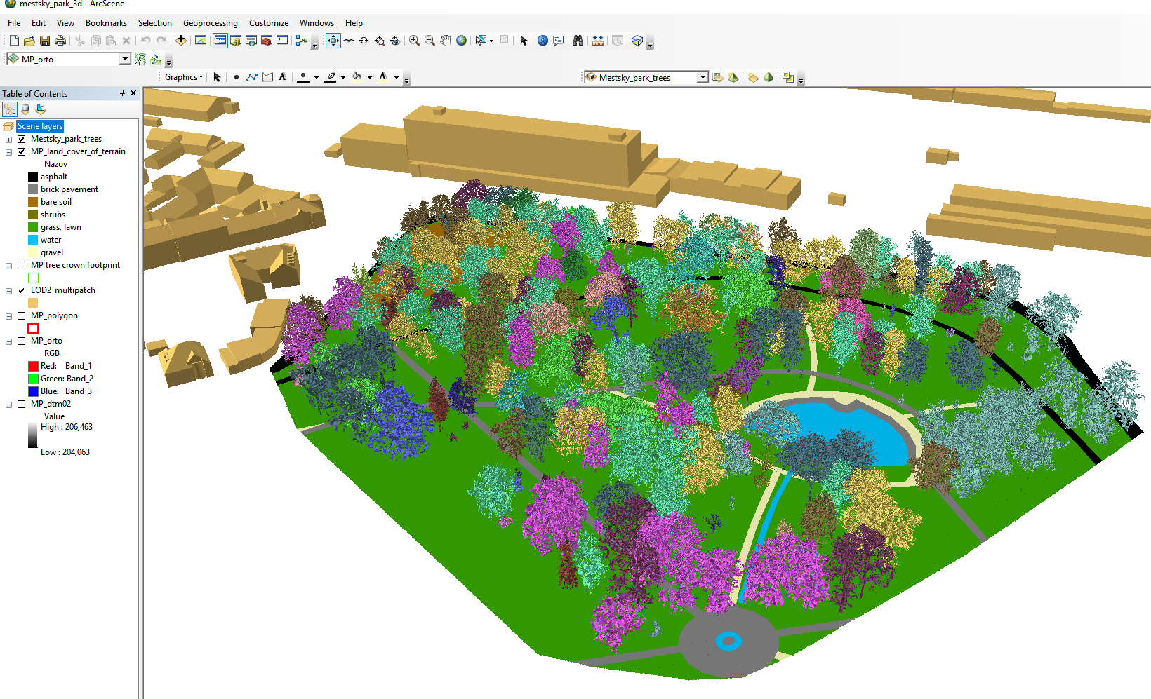
Figure 8. Graphical interface of the ArcScene project for the small site in Mestský park (City park) showing 3D view of the geodata layers. The 3D trees are coloured according to the plant species.

4.2.4 Task 4: Generating time series of high-resolution 3-D urban greenery

We have selected four smaller test sites covering several hectares (Fig. 2, red outlines) for detailed mapping of urban vegetation and its geometric change using repeated terrestrial laser scanning (TLS). Each site represents typical urban greenery consisting of various kinds of trees of different height. The TLS of urban greenery was done in the four study sites during the period April – November 2016 (M-2 – M6) and in March 2017 (M10) using the RIEGL VZ-1000 scanner equipped with the Nikon D700 camera. The aim of the scanning was to capture vegetation in several phenological phases synchronously with the Sentinel 2A overflight times (+/- 1-2 days) taking into account meteorological conditions.
TLS resulted in 44 datasets (point clouds) with total size of 93.8 GB representing the study sites in 11 time horizons during one vegetation period. TLS required selection of appropriate positions of the scanner during the survey in order to minimize data shadows and total number of required positions. At the same time, it was important to ensure a sufficient overlap with the adjacent position. Final mutual registration of individual point clouds was performed using the Multi-Station Adjustment implemented in the RiSCAN Pro software. The point cloud was also colourized using the digital RGB imagery acquired immediately after scanning with the integrated camera (Fig. 9). Overview and images of the TLS time series can be seen on the project website http://esa-surge.science.upjs.sk/index.php/study-sites. A summary is provided in Progress Report 1, Table 1.

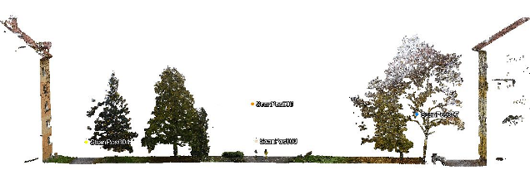
Figure 9. Vertical section of the TLS point cloud in Hvozdíkov park, Košice.

To supplement the TLS time series with upper parts of vegetation, the ALS and TLS point clouds within the four smaller sites (Fig. 2, red outline) were integrated in RiSCAN Pro based on identical points present in both types of datasets. Using the Multi-Station Adjustment the standard deviation of mutual registration reached only 2 cm. Achieving higher accuracy was limited by various factors such as differing accuracy of ALS and TLS or movement of tree branches induce by wind during TLS. While point clouds accurately represent urban canopy, it is difficult to use them directly in solar radiation or microclimate models for which physical objects as virtual 3-D models are required. Therefore, we explored the following software tools to derive 3-D tree model from point clouds: RiSCAN Pro®, 3D forest, Geomagic Wrap® and ArcScene®.
The result of the data collection was in mutually registered and georeferenced point clouds for particular TLS survey dates. The point clouds were then decimated using the Octree filter with a spatial step of 5 cm. In this way, the georeferenced point clouds became comparable in terms of temporal change of the spatial distribution of points (Fig. 10A). The subsequent automated classification of the point clouds resulted in separating ground (terrain) and above-ground points. The above-ground points included also buildings and other features that had to be filtered out so that vegetation point remained (Fig. 10B).

The mentioned procedures were performed in the RiSCAN Pro software. The point cloud representing just trees was then segmented into point clouds of individual trees by the 3D Forest software. The result of segmentation was exported in the PLY format and meshed in the GeomagicWrap 2015 software to create 3-D tree models with the Wrap tool (Fig. 10C, 10D, 10E). These models were then exported in the VRML format and integrated with other 3-D data within the 3-D GIS environment of the ArcScene software (Fig. 11).

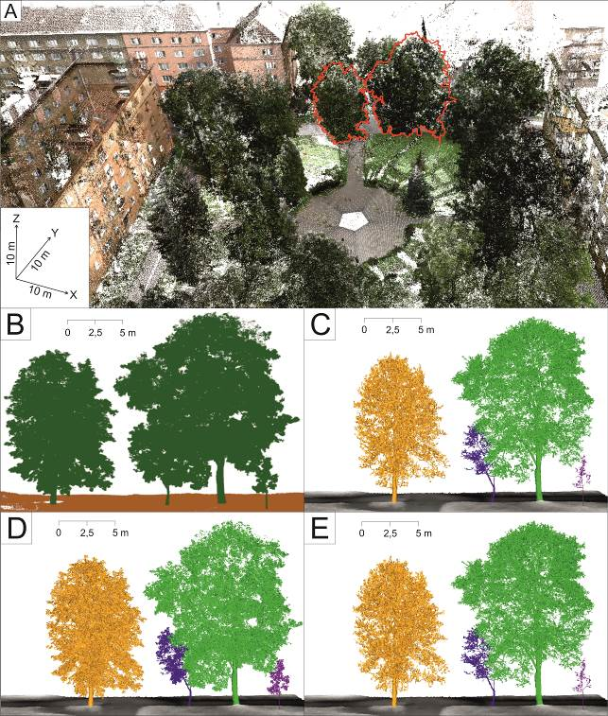

Figure 10. RGB colourized TLS point cloud representing Hovzdíkov park as visualized in the RiScanPRO software with selected trees (A) which are visualized in the 3D Forest software before segmentation (B) and after segmentation and 3-D meshing in the Geomagic Wrap 2015 resulting in time series of segmented individual meshed 3-D tree models integrated with terrain data in the ArcScene GIS software for spring (C), in summer (D) and in autumn (E).

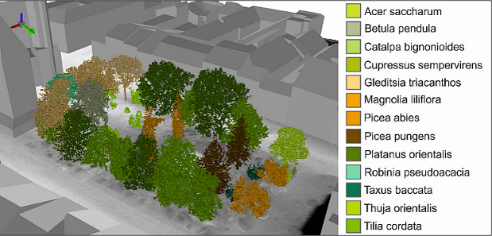
Figure 11. 3-D city model including 3-D meshed trees in the ArcScene software colourized according to the plant species showing the park on Hlavná ulica (Main street).

4.2.5 Task 5: Gathering and analysing time series of Sentinel 2A multispectral imagery

Although the project started 1 June 2016, we started the data acquisition earlier to increase the chance of acquiring data of good quality and in sufficient number of cases. We focused on download of (i) the Sentinel 2A imagery from the Copernicus data hub (https://scihub.copernicus.eu/), (ii) Landsat 8 imagery via the USGS EarthExplorer application (https://earthexplorer.usgs.gov/). We have been continuously downloading, Landsat 8 OLI/TIRS, Sentinel 2A multispectral data from the data hubs and this task is ongoing. The summary of data gathered in the M1-M6 period is provided in Progress Report 1, Table 2-3, Fig. 5. Figure 12 and 13 show the coverage of the study area by the Sentinel 2 and Landsat 8 satellite scenes.

We conducted preliminary analysis and comparison of the satellite imagery with other data sources. The applicability of multispectral satellite imagery for assessing vegetation transmittance was reviewed and a report was generated as the Deliverable 1.

Sentinel 2A (S2A) data are the main source of multispectral imagery for the SURGE project. To date, the work related to Task 5 involved downloading of suitable S2A and L8 imagery with minimal cloud cover and storing the data on our server including the back-up. The assembled time series enabled to demonstrate change of vegetation coverage by the means of true colour composites, near-infrared colour composites, and NDVI (Fig. 14).

We conducted analysis of land surface temperature (LST) in Košice based on our archive of the Landsat 8 multispectral imagery, Copernicus datasets (Corine Land Cover). The aim was to support the need for implementing the effect urban greenery has on urban heat island in Košice and demonstrate the relation between areas with existing green infrastructure and urban areas with minimal or absent vegetation. Processing of the selected Landsat 8 images was performed in the ArcGIS software by ESRI. The method of LST calculation applied in this study is described below and the flowchart summarizes the basic steps of this process (Fig. 15).

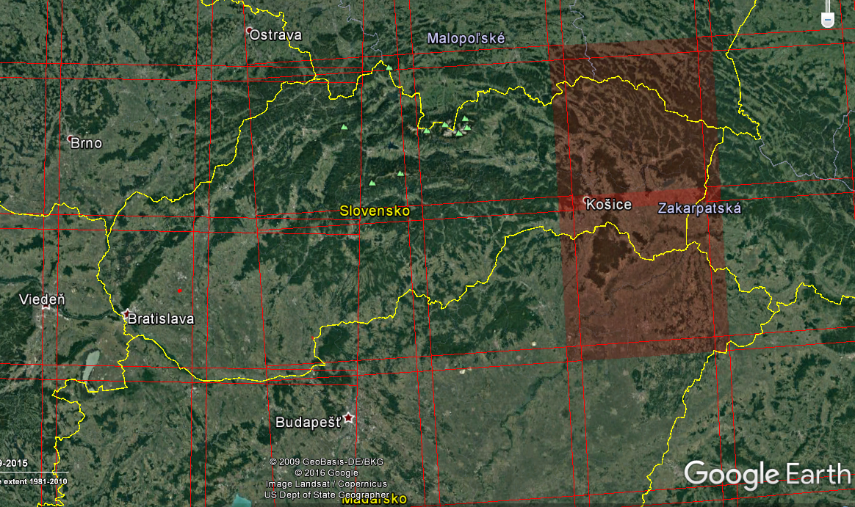

Figure 12. The study area is situated within two Sentinel 2A data granules (34 UEU, 34 UEV).

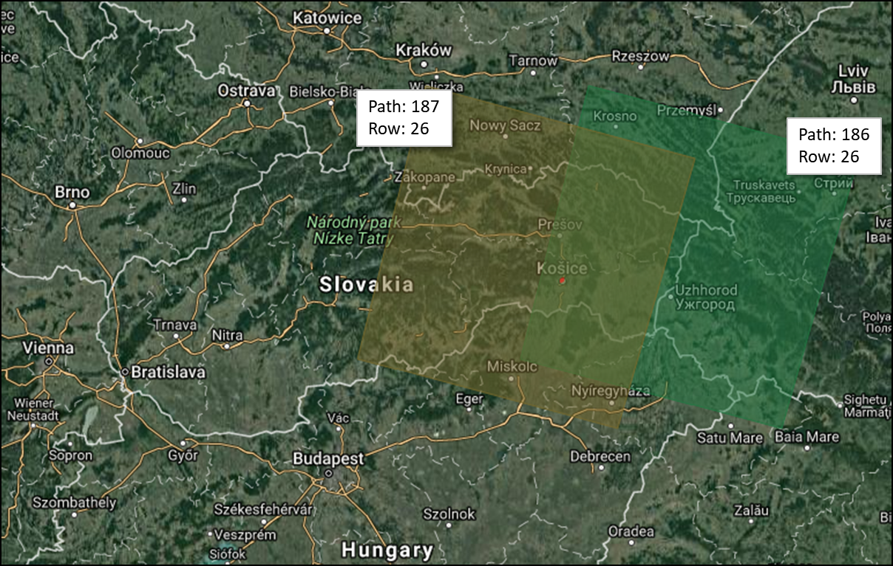
Figure 13. The study area is situated within two Landsat 8 data scenes (186/26,187/26). Background map data © 2017 GeoBasis DE/BKG (© 2009, Google Imagery © 2017 Terra Metrics.

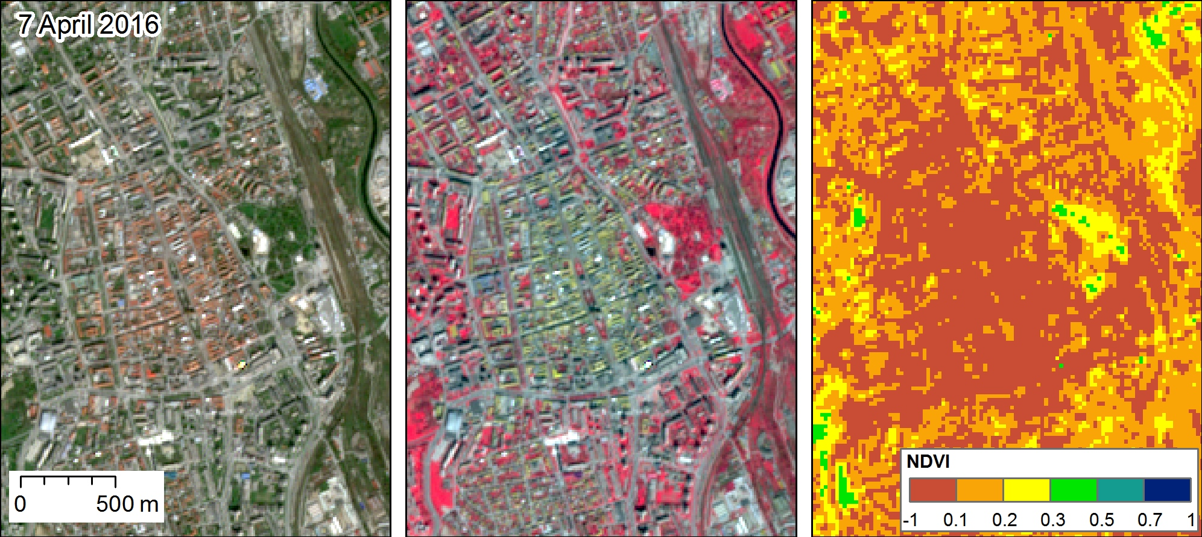
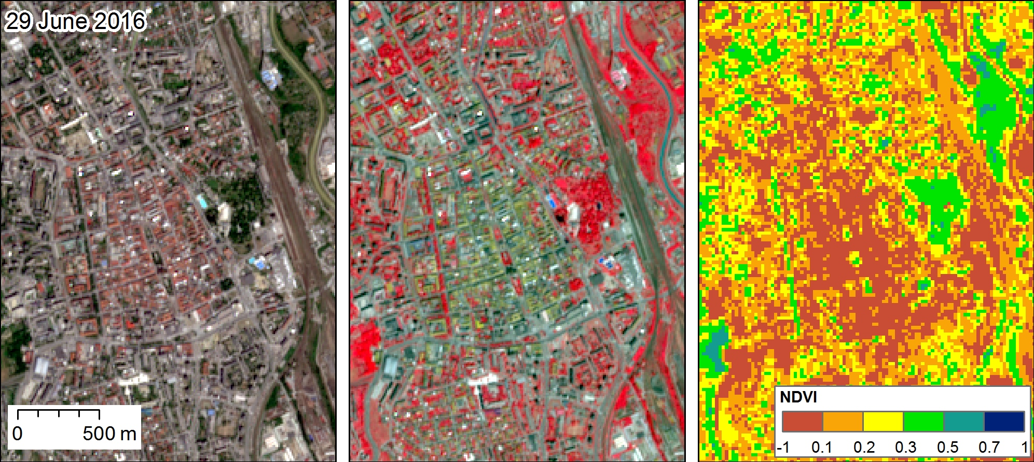
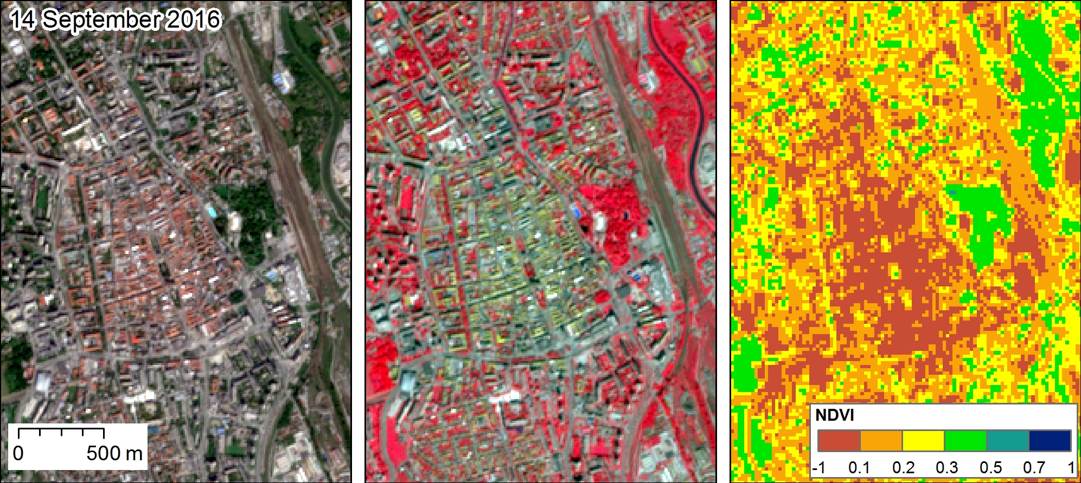
Figure 14. RGB colour composites and NDVI of Sentinel 2A level 1C products for the central part of the Košice City. True colour image (left, bands 4, 3, 2), NIR composite image (middle, bands 8, 4, 3), NDVI (right, calculated from bands 5, 6).

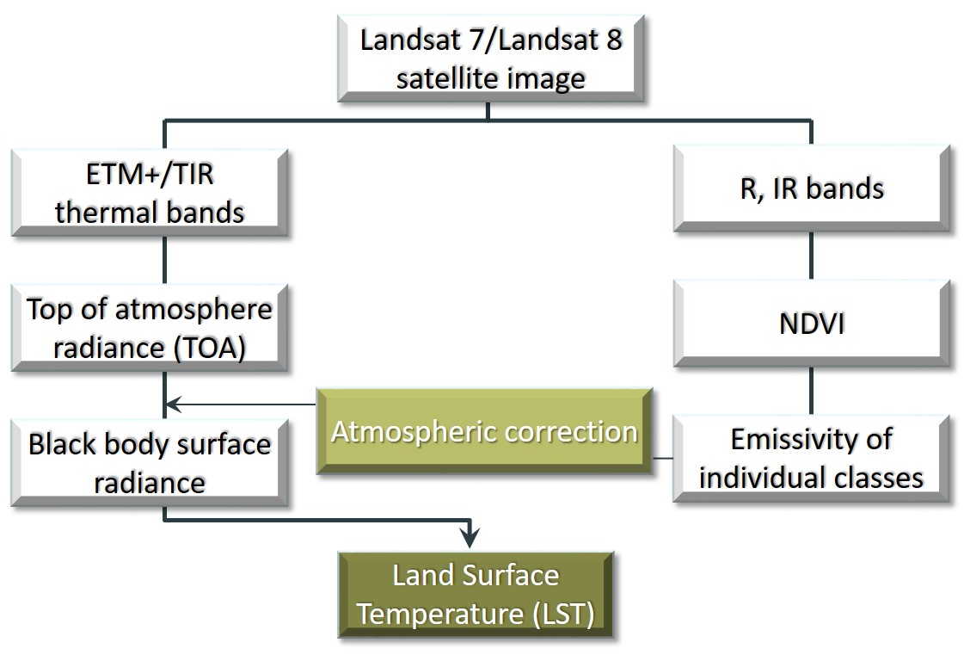
Figure 15. Flowchart summarizing basic steps of LST derivation from imagery

For the purpose of this work, 4 images from Landsat 8 archive available via the USGS https://earthexplorer.usgs.gov were acquired to derive LST values. Due to the fact, that the sensors OLI and TIR of Landsat 8 obtain information on Top of the atmosphere (TOA) brightness temperature and store them in the form of digital numbers (DN) in the range 0-65,536, it was necessary first to convert the DN values ​​to decimal numbers, using data for the gain and bias contained in the metadata using USGS formulas. Then, TOA radiance was transferred to surface leaving radiance by removing atmospheric effects, employing the Atmospheric Correction Parameter Calculator developed by Barsi et al. (2005) that uses the MODTRAN radiative transfer model to calculate the three parameters that are necessary for atmospheric correction: upwelling radiance (L_{u}), downwelling radiance (L_{d}), and transmission coefficient (τ). Land surface emissivity method using NDVI proposed in Liu and Zhang (2011) was used to calculate the emissivity (ε) of a real surface. Afterwards the radiance of a black body surface with kinetic temperature T (L_{T}) was calculated:
L_{T} = |  | L_{TOA} – L_{u} – τ(1-ε)L_{d}
 |  | τε

According to Barsi et al. (2005), uncertainties in LST related to the below method of atmospheric correction should be less than 2 K.

Then, L_{T} radiances were recalculated to surface temperatures in Kelvins (K) using USGS formulas:
LST = |  | K₂
 | ln( | K₁ |  | +1)
 |  | L_{T}

where LST is Land surface temperature (K), L_{T} is surface radiance (Watts/( m2*srad
*μm)), K₁ is Band-specific thermal conversion constant from the metadata, K₂ is Band-specific thermal conversion constant from the metadata. In the last step, degrees Kelvin were converted into degrees Celsius (LST (K) – 273.15).

Normalized difference vegetation index (NDVI) was calculated in the following way:
NDVI = |  | IR –RED
 |  | IR + RED

In which IR represents spectral reflectance in short infrared (L8 Band 5), while RED stands for spectral reflectance in the visible red part of the electromagnetic spectrum (L8 Band 4).

A single summer day (August 6, 2015) was selected to assess the pattern of the LST in relation to land cover (Fig. 16A, 16B). It can be seen that the presence of the urban heat island (UHI) phenomenon in the city is significant (Fig. 16A). The lowest LST values in the cadastral territory are spread across a wide area of Košice forest park in the north-western and north-eastern part of the city, with a significant percentage of vegetation cover and low human intervention to the nature. Low temperature values are distributed also along the Hornád river valley. On the contrary, the highest values that sometimes reach up to 50 °C are visible in the industrial zone U.S. Steel, in the historical city core, areas of recently built shopping centres in the south of the city core, then in the airport area and in areas of urban fabrics on the outskirts of the city. The relation between LST and land cover is well depicted in the cross-profile in Fig.17. Local LST minimums correspond with vegetated areas while LST maximums are linked with impervious surfaces. Detailed view in Fig. 18A for the same date and L8 dataset shows how presence of several trees decreases temperature in the city centre which is compared with the NDVI values in Fig. 18B.

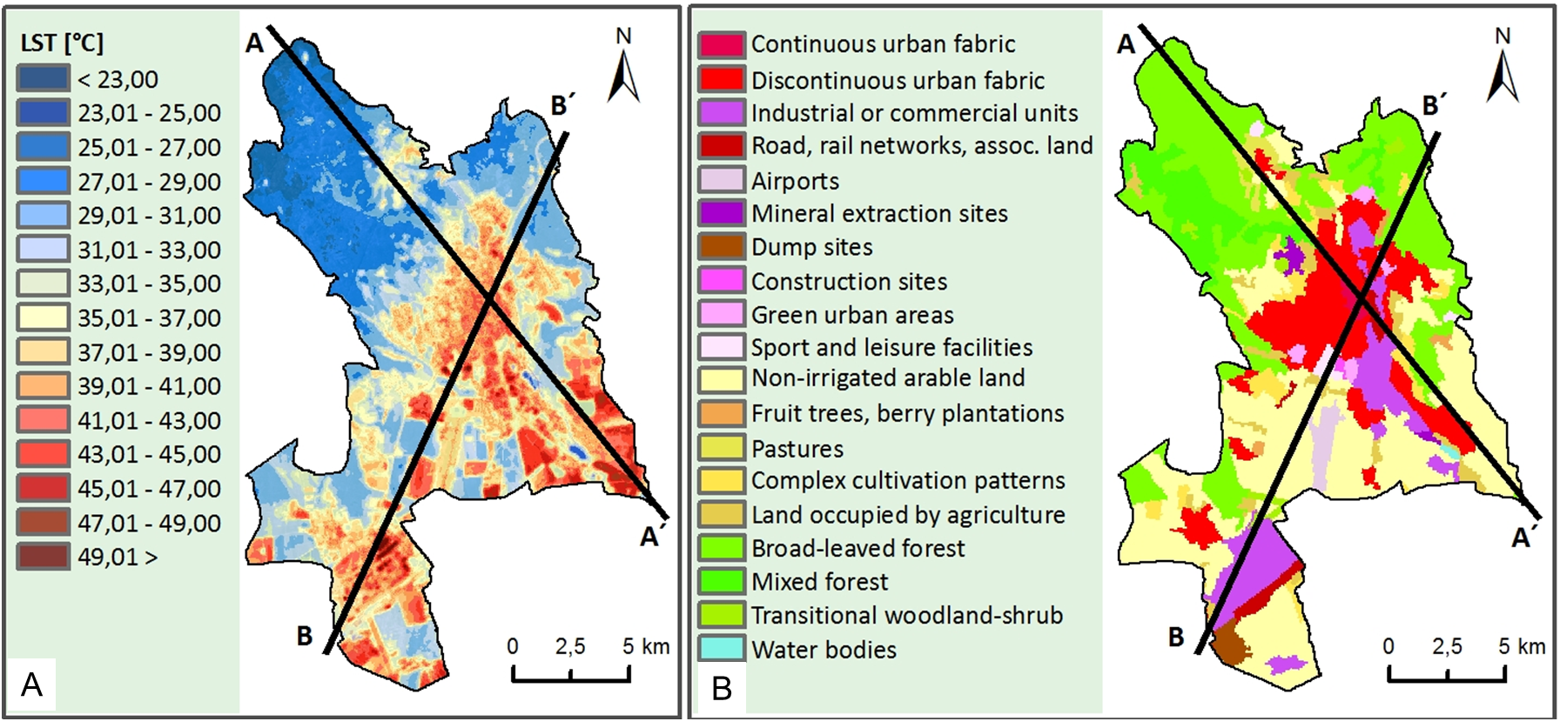
Figure 16. LST on 6 August 2015 (A) and CORINE land cover 2012 data (B) for the entire cadastral territory of Košice with cross profiles. The B-B’ profile is shown in Fig. 17.

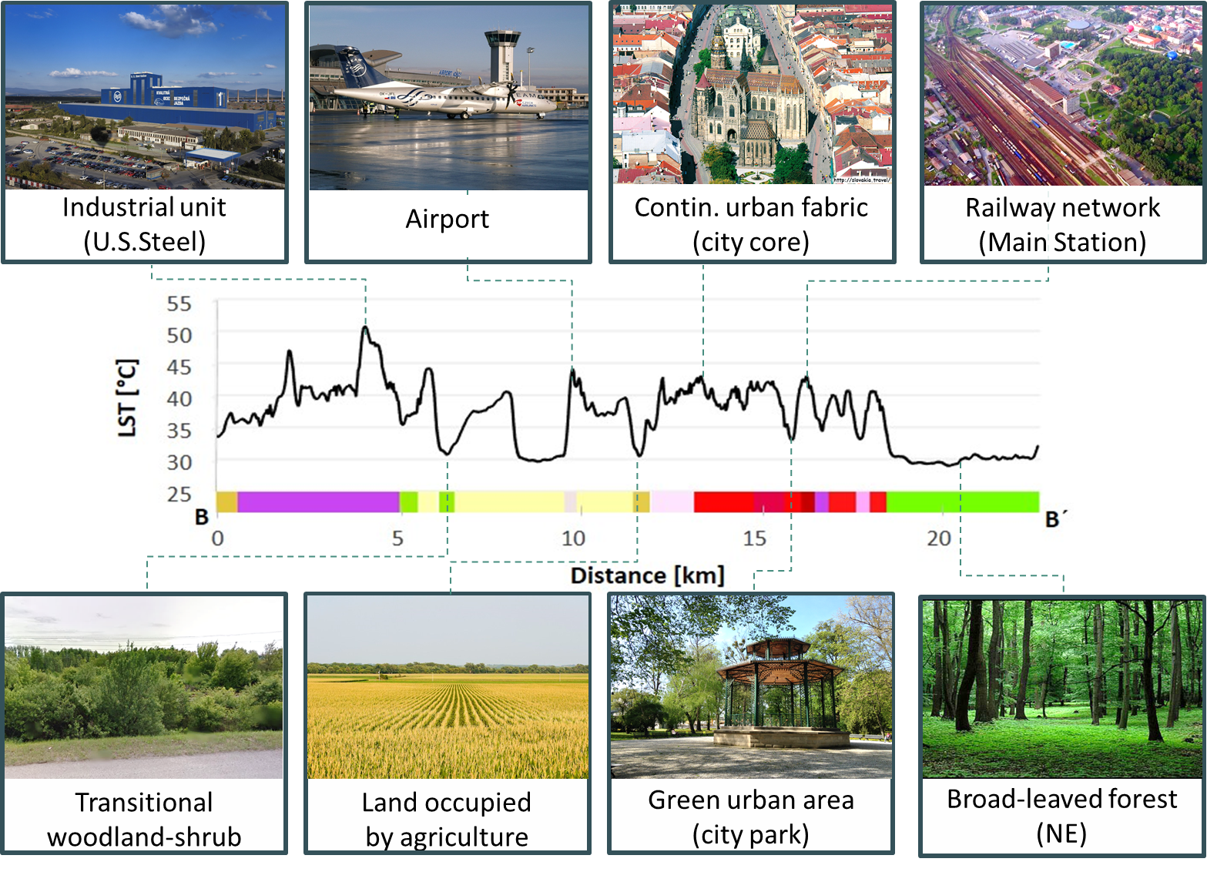
Figure 17. Vertical cross-section profile of the LST surface derived from the Landsat 8 TIRS Band 11 (6 August 2016) with the CORINE Land Cover 2012 classes crossed along the line B-B’ shown in Fig. 16 demonstrating how impervious land cover and green areas influence the urban heat island.

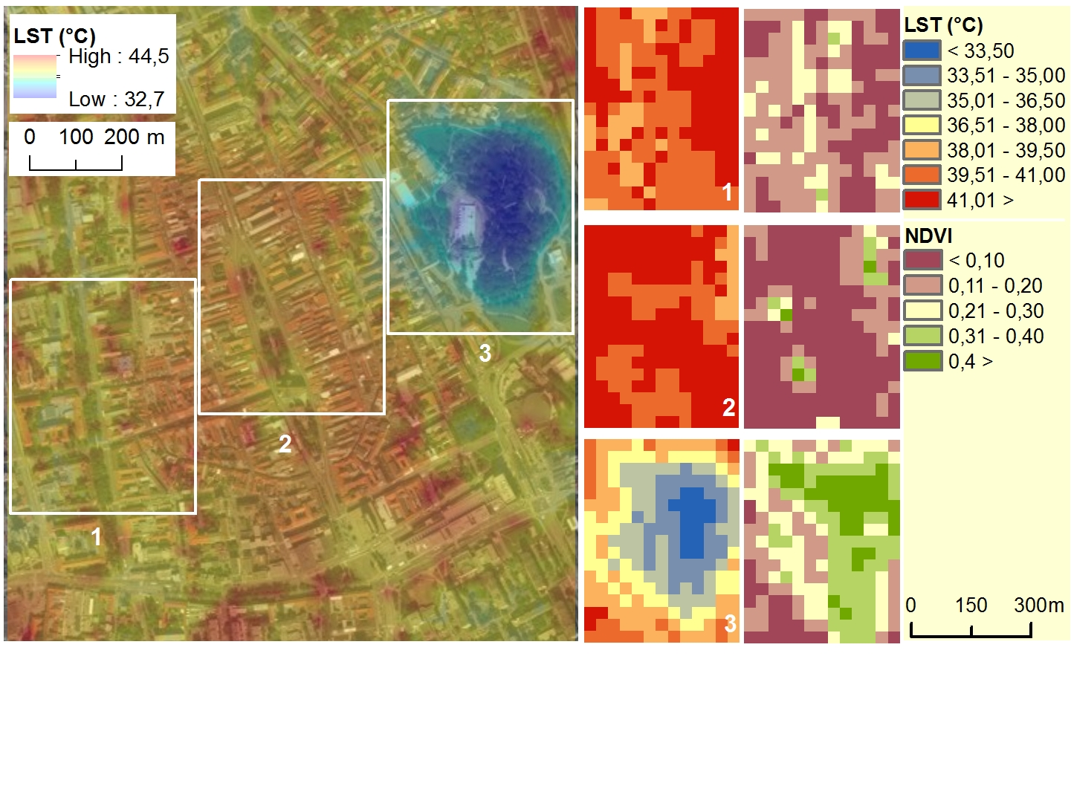

Figure 18. Landsat 8 (B11) land surface temperature on 6 August 2015 overlaid on a orthophotoimage 2016 (A) and comparison (B) of the temperature surface and Landsat 8 (B4, B5) NDVI values in selected areas of the Košice city: 1 – green belt on Moyzesova Street, 2 – historical city centre, 3 – Central Park (Mestský park).
Temporal variability of LSTs within the wider area of Košice was assessed using time-series of LST standard deviations (Fig.19). The deviations were calculated in a 7x7 moving window as focal statistics for selected months in the year of 2015. Majority of the highest temperature differences between areas with high and low vegetation cover - occur in May and August (growing season). Greenery in the city in this period is the most abundant so its impact on the UHI effect is the strongest therefore the temperature differences within the moving window are highest in areas where plots contrast with non-vegetated plots vegetated. On the contrary, low LST differences are related to the dormant season and are visible on November and March when the accumulation of heat by non-vegetated areas is low and similar to vegetated areas with leaves-off.

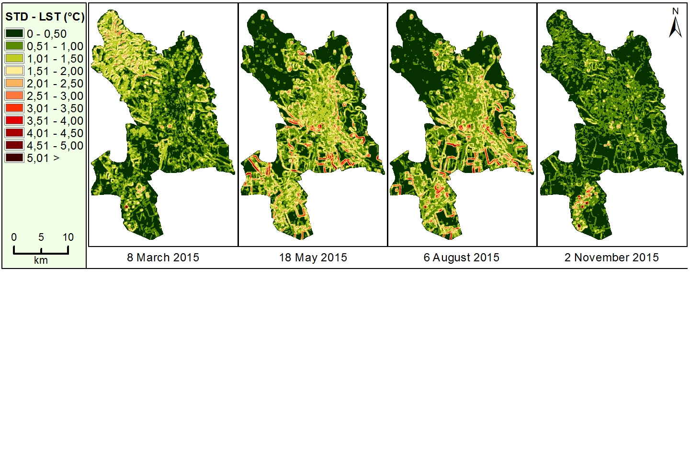
Figure 19. Spatial distribution of LST standard deviations in a 7x7 moving window for selected months in 2015.

The results show that the urban heat island phenomenon concerns also the Košice City. The areas of contrasting temperature properties were identified supporting the selection of small study sites for monitoring the vegetation with TLS. Generating the LST surface time-series of Landsat 8 thermal band involved calculation of the time series of the NDVI from the Landsat 8 OLI data. The NDVI layers are going to be compared with NDVI derived from Sentinel 2A data which have been downloaded on a regular basis for the study area of Košice. We conducted preliminary comparison of Landsat 8 and Sentinel 2A derived NDVI and classification (Fig. 20.) which shows the potential of ascertaining solar transmittance of tree cover. The NDVI values from Sentinel 2A apparently vary according to the tree cover closure in the area of the Park Komenského. This information is much diluted in the large pixels of NDVI from the Landsat 8 imagery. Extraction of vegetation cover and land cover classification from the Sentinel 2A data was tested using unsupervised classification by the ISODATA algorithm in ArcGIS (Fig. 21). These tests provided appropriate settings of the classification method to be applied on the Sentinel data in the next period to fulfil the ongoing tasks of the Sentinel 2A analysis.

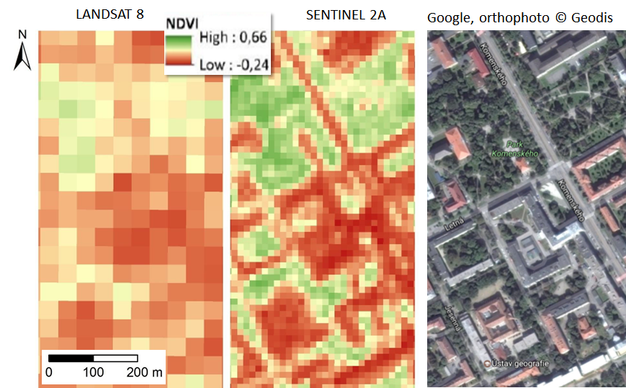

Figure 20. Comparison of NDVI calculated from Landsat 8 and Sentinel 2A for a part of Košice showing potential to ascertain tree cover transmittance from Sentinel 2 data. Both datasets were acquired on 8 August 2016.

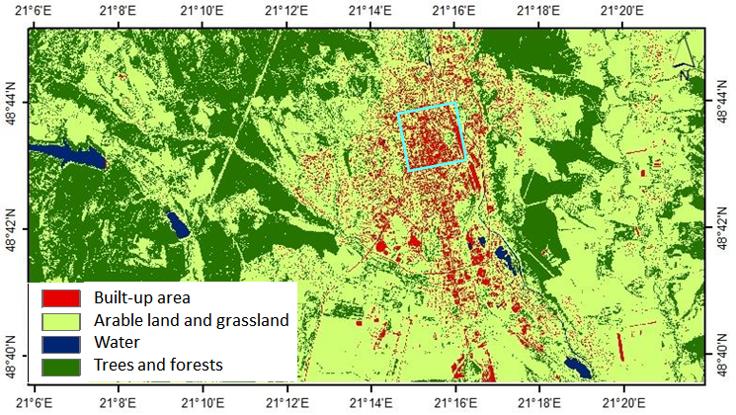
Figure 21. Preliminary result of the unsupervised classification of Sentinel 2A scene from 8 August 2016 into four land cover classes.The cyan square outlines the study area for which 3D city model was generated.

4.2.6 Task 6: Preparing input 3-D data for solar radiation modelling
Vegetation in the mild climate of Central Europe (especially broad leaved deciduous vegetation) undergoes various changes manifested mostly in tree foliage. This has also impact on solar transmissivity of the canopy and subsequently on microclimate conditions. To capture these changes throughout the vegetation period we generated time-series of point clouds acquired by TLS in four study sites. Task 6 is therefore closely related with Task 4 which involves gathering and processing of the time series of urban greenery by TLS.
In the period of M7-M12, we performed a preliminary analysis of solar transmittance using 3D models of trees to assess the foliage of the trees in these sites. We used the acquired point clouds later decimated, as described in Task 4, to assess volumetric parameters of individual trees. The accuracy of TLS data registration for these sites and survey days reached a standard deviation of 1-4 cm. The seasonal differences in tree morphology is demonstrated in Table 2 which reports statistics of TLS point clouds time series for a single tree growing on the Moyzesova street. We consider the mean point density and voxelized tree volume as the most significant parameters as they provide normalized values indicating that the mass of the tree decreases from the summer date through the autumn and it is the lowest in spring when there were no leaves on the tree. Implications of these results are manifested in the analysis of shaded area shown in Fig. 22. It is clear that for the selected site and time interval the effect of ground shadowing can be calculated using the generated time series of the meshed 3-D tree models. The time duration of the area being shaded depends not only on the sun declination but also on the effect of the tree phenology (abundance of leaves and their size).

Table 2. Parameters of a single tree displayed in Fig. 6 for different dates of the TLS survey.

Statistics | 26 July 2016 | 27 October 2016 | 22 March 2017
Point count | 387 500 | 389 916 | 206 631
Mean density (points/m³) | 4 297 | 3 146 | 2 464
Total height (m) | 7.710 | 7.710 | 7.54
Crown max. width (m) | 6.520 | 6.330 | 6.27
Voxelized (25 cm) tree volume (m³) | 99.59 | 94.25 | 81.54
Footprint area (m²) | 36.89 | 36.38 | 35.38

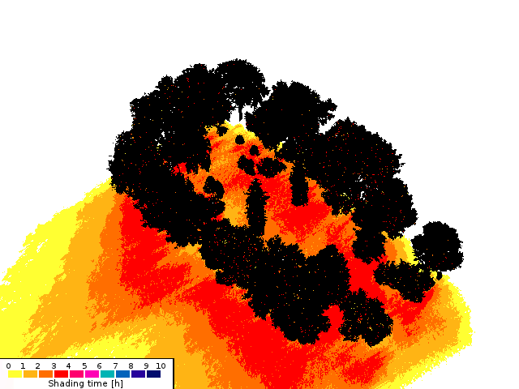 | 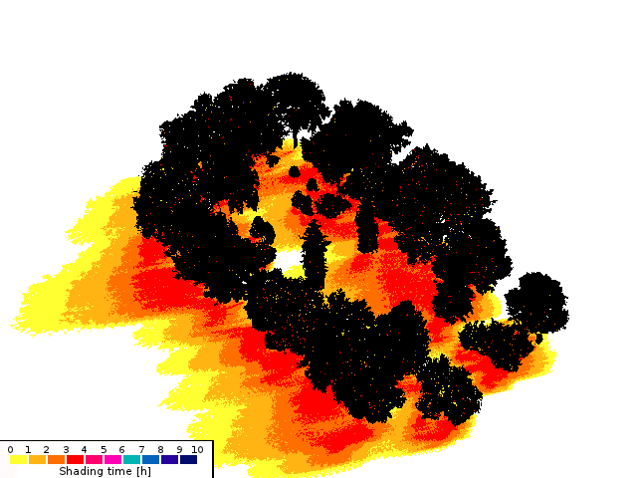

Figure 22. Simulation of time the area is shadowed by trees between 1 p.m. to 4 p.m. using the 3D meshed tree models in the Shadow Analysis plugin of the SketchUp software for March and June 2016.

Problems, Issues and Risk Areas

We can confirm that no major problems occurred during first the 12 months period (06/2016 – 05/2017). The achieved results comprise the D1, D2, D3 under WP2. The deliverables are made available via a FTP connection: https://uge.science.upjs.sk/esa_surge_deliverables/, with the following login and password: “user”,”9DQsgmpeLJRS8Fr7Wfmz”.

We do not foresee any risk areas for the second 12 month period (M13 - M24). There are no external services planned. The remaining work is fully in hands of the project team and it is expected to follow the plan.

Meetings

Meeting Name | Description/ Purpose | Location | Planned Date | Actual Date | Attendees
Kick-off meeting | Kick-off meeting of the team | Kosice | 2 June 2016 | 2 June 2016 | Pavol Jozef Safarik University
Regular team meeting | Presentation of progress and discussion of planning and problems | Kosice | 7 September 2016 | 7 September 2016 | Pavol Jozef Safarik University
Regular team meeting | Presentation of progress and discussion of planning and problems | Kosice | 23 January 2017 | 23 January 2017 | Pavol Jozef Safarik University
Progress meeting | Progress meeting | Kosice | June 2017 | 10 May 2017 | Pavol Jozef Safarik University
Final meeting | Final meeting | Kosice | May 2018 |  | Pavol Jozef Safarik University

Deliverables Status

Deliverable Identifier | Title/ Description | Original Delivery Date | Planned Delivery Date | Associated Milestone | Status
D1 | Report on the reviewed applicability of multispectral satellite imagery for derivation of vegetation transmittance | Nov-2016 | Nov-2016 | Milestone 1 | Finished
D2 | Generated 3-D city model | May-2017 | May-2017 | Milestone 2 | Finished
D3 | Midterm report | May-2017 | May-2017 | Milestone 2 | Finished
D4 | Report on derivation of satellite based vegetation metrics and downscaling to high-resolution data | Nov-2017 | Nov-2017 | Milestone 3 | Planned
D5 | Report on definition of algorithmic structure of the toolbox | Feb-2018 | Feb-2018 |  | Planned
D6 | Roadmap report on implementation of the toolbox | May-2018 | May-2018 | Final | Planned
TDP | Technical data package (containing all approved technical notes) | May-2018 | May-2018 | Final Review | Planned
FPR | Final Project Report | May-2018 | May-2018 | Final Review | Planned
ESR | Executive Summary | May-2018 | May-2018 | Final Review | Planned

Milestone Payment Plan: Status

ID | Description | Amount | Contractual date | Actual/ Expected Date | Status
MP1 | Advance payment: Offset against MS1 | 17500 | Upon signature of the Contract by both Parties | xxx | Paid
 | Progress (MS1): Upon successful completion and delivery of D1 & D2 under WP2 and acceptance of all related deliverables | 12500 | June 2017 | June 2017 | Due in June 2017
 | Progress (MS2): Upon successful completion and delivery of D4 under WP2 and acceptance of all related deliverables | 12450 | December 2017 | December 2017 | Not yet Due
 | Final Settlement (MS3): Upon the Agency's acceptance of all deliverables items due under the Contract and the Contractor's fulfilment of all other contractual obligations including submission of the Contract Closure Documentation | 7491 | June 2018 | June 2018 | Not yet Due

Planning
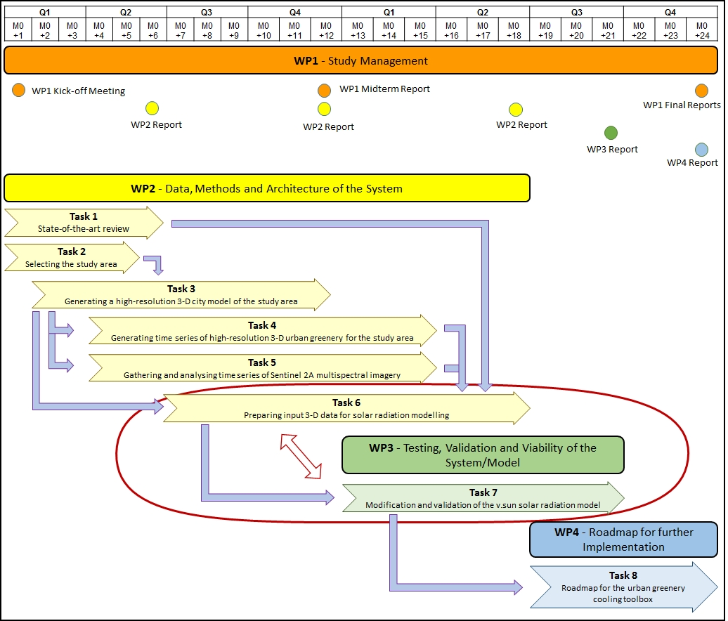

Action Item – Status List

NA

Any other Business

Besides maintaining the project website, two activities towards public promotion of the project were undertaken. GIS Ostrava 2017 was held in Ostrava in 23 March 2017, where Dr. Ján Kaňuk presented the paper published in conference proceedings in Slovak language:

KAŇUK, J., GALLAY, M., HOFIERKA, J., ŠAŠAK, J., ŠUPINSKÝ, J., SEDLÁK, V., GESSERT, A., 2017. Monitoring dynamiky mestskej zelene pre spresnenie modelovania slnečného žiarenia v urbánnej krajine. In: Inspektor, T., Horák, J., Růžička, J. (Eds.) Symposium GIS Ostrava 2017, Geoinformatika v pohybu, 22. - 24. března 2017. VŠB - Technická univerzita Ostrava, ISBN 978-80-248-4029-1, ISSN 1213-239X. Available on:
http://gisak.vsb.cz/GIS_Ostrava/GIS_Ova_2017/sbornik/papers/gis201758949fbdea187.pdf

Dr. Michal Gallay was invited by the Ministry of Environment of the Czech Republic to present the SURGE feasibility study during 6th Czech Copernicus Users Forum (24-25 May, 2017). The event was held in the premises of the European GNSS Agency (GSA) in Prague. A short report of the event is summarized on: http://geo.ics.upjs.sk/index.php/19-zo-zivota-ustavu/404-nas-vyskum-pre-esa-predstaveny-na-copernicus-trainning-day-v-prahe

The public presentations are made available as PDFs at https://esa-surge.science.upjs.sk/index.php/results .

Reasons for slippage and/or

NA

