|  |  |  |  |  |
| --- | --- | --- | --- | --- |
| **ESA STUDY CONTRACT REPORT**  **Deliverable 1 under WP2:**  **Report on the reviewed applicability of multispectral satellite imagery**  **for derivation of vegetation transmittance** | | | | |
| ESA Contract No:  4000117034/16/NL/NDe | SUBJECT: **SURGE**: Simulating the cooling effect of urban greenery based on solar radiation modelling and a new generation of ESA sensors | | | CONTRACTOR:  Pavol Jozef Šafárik University in Košice, Institute of Geography |
| * ESA CR( )No: |  | No. of Volumes:. 1  This is Volume No: 1.0 | | CONTRACTOR’S REFERENCE: |
| ABSTRACT:  This report summarises a review of the published research (state-of-the-art) on derivation of vegetation metrics from multispectral satellite data for characterising the solar radiation transmittance of urban greenery. We focused on the applicability of the Earth Observation sensors which are currently in operation and which provide high resolution in spectral and spatial domain with a high frequency of sensing repetition over the same area. In addition the data should be accessible free of charge via internet for the area of the Košice city Slovakia to be applicable in this contract. Therefore, the selection of sensors included Landsat 7 ETM+, Landsat 8 OLI/TIRS, and Sentinel 2A MSI. The review showed that multiple indices were used for parameterizing vegetation transmittance with multispectral satellite imagery. The most popular is the normalized vegetation index (NDVI), which is simple to calculate and provides a proxy for calculating metrics which are difficult to be measured directly from the satellite imagery, such as such as leaf area index (LAI), canopy cover and gap fraction. | | | | |
| The work described in this report was done under ESA Contract. Responsibility for the contents resides in the author or organisation that prepared it. | | | | |
| Names of authors: Michal Gallay, Jaroslav Hofierka | | | | |
| ** NAME OF ESA STUDY MANAGER:  DIV:  DIRECTORATE: | | | ** ESA BUDGET HEADING: | |

# 1 Introduction

## Contractual

This document has been issued by Institute of Geography, P.J. Šafárik University in Košice for European Space Agency under contract Nr. 4000117034/16/NL/NDe titled “Simulating the cooling effect of urban greenery based on solar radiation modelling and a new generation of ESA sensors (acronym SURGE)”.

## Purpose of the Document

This document presents the review of the state-of-the-art in use of spaceborne multispectral data for deriving vegetation metrics for solar energy transmittance, which will be used in the SURGE contract for simulating the cooling effect of vegetation in urban environment of the Košice City (Fig. 1). The document provides an overview and characterization of the available relevant spaceborne data sets for the study area.

|  |  |
| --- | --- |
|  |  |

*Figure 1. Location of the Košice City study area within Europe (left) and within the city (right). The cyan line outlines the area subject to airborne lidar and photogrammetric data collection and the line delineates selected sites for repeated terrestrial laser scanning. The background maps are © Google.*

## 1.3 Motivation

Given the associations between vegetated land cover and the biophysical and social processes of urban systems there exists an ongoing demand for effective urban vegetation mapping and classification techniques (Tooke et al., 2009). The results of the study by Tooke et al. (2011) indicated that trees on average reduce 38% of the total solar radiation received by residential building rooftops. Fogl and Moudrý (2016) found lower effect in the range of 3 - 11% and note that over 50% of the solar radiation loss occurs during the summer time.

Radiation received at the urban surface is highly variable in space and time resulting from the complex form and land cover of urban environments. Understanding this variation in intercepted solar radiation is fundamental to determining various components of the urban energy landscape. Surface climates (Voogt and Oke, 1997), building electrical and thermal energy demand (Ratti et al., 2005), and human thermal comforts (Lindberg and Grimmond, 2011) are all examples that require detailed estimates of incoming solar radiation (Eliasson, 2000). Tooke et al. (2012) found that representation of trees as opaque objects substantially underestimates solar irradiance across urban landscape, leading up to an 18% underestimate of direct irradiance in residential areas with trees. Both atmospheric transmittance and geometric structure of urban space are also shown to be critical model parameters. Tooke et al. (2012) propose that opportunities exist for incorporating additional spectral data, especially for generating estimates of the reflected component of incoming solar radiation. The potential also exists for advancing estimates of radiation transmission by articulating the temporal, spectral and structural dynamics of the local vegetation. This approach is going to be adopted in the SURGE study by using Sentinel 2 imagery having relatively high spatial, spectral and temporal resolution.

# 2 Requirements for the satellite multispectral data

The requirements for the Earth Observation (EO) data include spatial, spectral and temporal requirements. To investigate the influence of spatial heterogeneity and to be able to compare the simulated data to different EO sensors, EO images with a spatial scale ranging from very high resolution (0.5 cm – 0.5 m pixel size) to low resolution (30-60 m pixel size) are necessary (Fig. 2). The parameters of vegetation can be expressed by various metrics which can be derived from satellite data such as the percentage of canopy cover, leaf area index, or chlorophyll content.

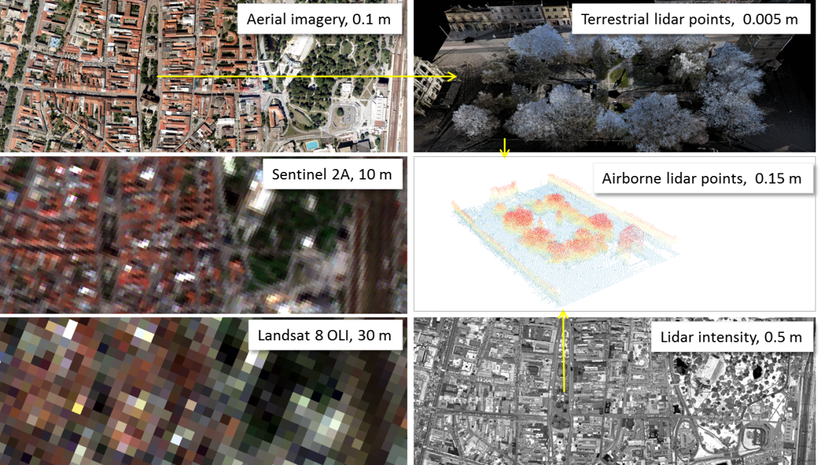

*Figure 2. Overview of the considered Earth Observation sensors (passive multispectral on the left, active lidar on the right) and associated spatial scales. The images show central part of the Košice City, Slovakia.*

We reviewed the published research and applications related to other Earth observation satellites which have been operating before the launch of Sentinel 2-A and focused on derivation of vegetation indices in relation to describing its solar radiation transmittance. This activity provided means for achieving the Technological Objective 1 (TO1): Evaluation of Sentinel-2 data for urban greenery periodic mapping.

# 3 Overview of the vegetation metrics and their estimation

Vegetation transmittance is one of many vegetation properties which can be estimated from the spectral response of vegetation recorded by multispectral sensors. Especially, the green vegetation has a very specific spectral response enabling to distinguish photosynthetically active (green) vegetation from other land cover types (Fig. 3). Various vegetation indices were designed for this purpose which makes use of raster map algebra, band combinations, or thresholding of values recorded in particular band (Jensen, 2006). Table 3 summarizes some of the important vegetation indices used for mapping vegetation transmittance or area covered by vegetation. Once the area covered by vegetation is outlined metrics assessing the spatial pattern of vegetation cover can be used (Tab. 4).

Undoubtedly, the normalized vegetation index (NDVI), and its refined form, enhanced vegetation index (EVI), is the most widely used for continental to global - scale vegetation monitoring because it can compensate for changing illumination conditions, surface slope, and viewing angle (Jensen, 2006). The principle of applying NDVI in vegetation mapping is that vegetation is highly reflective in the near infrared and highly absorptive in the visible red. The contrast between these channels can be used as an indicator of the status of the vegetation.

|  |
| --- |
|  |

*Figure 3. The main idea of vegetation indices, more vegetated green areas absorb more visible light and reflect more near-infrared light back into space. Satellites can detect these relative differences. Source: NASA/NOAA*

NDVI is a biophysical parameter that correlates with photosynthetic activity of vegetation. In addition to providing an indication of the ‘greenness’ of the vegetation, NDVI is also able to offer valuable information of the dynamic changes of specific vegetation species given that multiple-time images are analyzed. Therefore, NDVI is a good indicator to reflect periodically dynamic changes of vegetation groups (Halabuk et al. 2015). Particular vegetation groups can be identified through their unique phenology, or dynamic signals of NDVI. However, NDVI should be interpreted with care as its values exhibit nonlinear relationships with biophysical measures, such as LAI or vegetation fraction. While NDVI reaches a maximum it does not increase despite continued increases in LAI or biomass (Campbell and Wynne, 2011).

Other vegetation indices exist, which provide means for assessing various aspects of vegetation. For example, Havašová et al. (2015) explored several vegetation indices to identify past and actual bark beetle outbreaks. Jensen (2006) or Cambell and Wynne (2011) provide useful summaries of vegetation indices. Galvão et al. (2016) analysed 11 vegetation indices and showed that terrain illumination is a factor of spectral variability in the seasonal analysis of phenological metrics, especially for vegetation indices that are not spectrally normalized.

For the purposes of assessing the vegetation transmittance, NDVI and other indices cannot be directly used. Metrics expressing the nature of vegetation transmittance for the solar radiation comprise, for example, leaf area index (LAI), canopy cover, tree canopy closure, canopy gap fraction, etc. However, these are difficult to be measured directly from the satellite imagery. It has been shown by many studies that, into certain extent, NDVI and other indices are correlated with the metrics and can be used as a proxy for their calculation.

For example, Gómez et al. (2011) evaluated transmittance and LAI of olive trees using spectral vegetation indices such as NDVI, renormalized difference vegetation index (RDVI), simple ratio index (SR), modified simple ratio (MSR) with airborne multispectral CASI images. The r2 were in the range of 0.71 to 0.75 (P < 0.0001) and 0.57 to 0.62 (P < 0.0001) for crown transmittance and LAI, respectively. These methods enable obtaining maps of biophysical parameters in olive trees at farm scale in an operational way demonstrating the validity of the methodology used. Ganguly et al. (2012) summarizes the implementation of a physically based algorithm for the retrieval of vegetation green Leaf Area Index (LAI) from Landsat surface reflectance data. LAI retrievals from the application of this algorithm to aggregated Landsat surface reflectances are consistent with those of MODIS for homogeneous sites represented by different herbaceous and forest cover types.

Tree crown closure is the percentage of forest canopy projected to a horizontal plane over a unit ground area. Pu et al. (2003) estimated tree crown closure from Landsat 5 TM imagery by spectral unmixing techniques based on higher resolution aerial imagery. The method is based on decomposition of pixels into their components when their sizes are smaller than the pixel size. For this purpose, spectral mixture models and their inversion have been proposed. Among these, a linear spectral mixture model (LSM) was extensively applied to extract the abundance of various components within mixed pixels.

Carlson and Ripley (1997) realised that LAI and fractional vegetation cover may not be independent quantities, at least when the former is defined without regard to the presence of bare patches between plants, and that the customary variation of LAI with NDVI can be explained as resulting from a variation in fractional vegetation cover. However, NDVI values for sparse green vegetation tend to be very similar to those of bare soils or dry vegetation due to the similarity of the spectrum in the visible and near-infrared regions for bare soil and dry vegetation.

The effects of the composition and configuration of green space on land surface temperatures (LST) were explored by Maimaitiyiming et al. (2014) using landscape metrics including percentage of landscape (PLAND), edge density (ED) and patch density (PD). The city of Aksu in Northwestern China was used as a case study. The metrics were calculated by moving window method based on a green space map derived from Landsat Thematic Mapper (TM) imagery, and LST data were retrieved from Landsat TM thermal band. A normalized mutual information measure was employed to investigate the relationship between LST and the spatial pattern of green space. The results showed that while the PLAND is the most important variable that elicits LST dynamics, spatial configuration of green space also has significant effect on LST.

The utility of lidar in the development of landscape-scale estimates of forest canopy cover is supported by various studies based on comparison of lidar-based canopy cover to a metrics measured in the field (Morsdorf et al., 2006; Smith et al., 2009; Hopkinson and Chasmer, 2009). Forest canopy cover and gap fraction are commonly used metrics in forest ecology (Korhonen and Morsdorf, 2013). Airborne laser scanning is capable of measuring both very accurately, but slightly different estimation methods should be used as these metrics are defined differently. In canopy cover estimation the proportion of vertical gaps between the crowns is needed for a specific area. Canopy gap fraction includes all gaps observed from a single point with some angular view range. Canopy cover can be estimated with high accuracy as the fraction of first echoes above a specified height threshold, because only the large gaps are considered. In gap fraction estimation also last echoes should be used so that the effect of the smaller gaps within the crowns is considered. Leaf area index (LAI) can be estimated from the gap fraction using a logarithmic model with a single coefficient representing leaf orientation. However, sensor effects have a strong influence on the estimates, and therefore validation with high-quality field data is recommended. Kodar et al. (2011) found that lidar data based LAI estimate on up-scaled map saturated at high values (LAI > 4.5) compared to the LAI estimates based on SPOT-4 HRV-IR red channel. Validation of MODIS LAI product revealed substantial underestimates of LAI compared to the up-scaled field measurements and rather large random noise. ENVISAT MERIS LAI product was more similar to up-scaled field measurements; however, rather large unexpected random variations exist in its time series.

The main impacts of vegetation structure on total canopy scattering of solar energy can be described by spectral invariant theory (Disney and Lewis, 2007). The theory describes a method of expressing photon scattering as a function of purely structural properties of the canopy, the so-called photon recollision probability (p), which is the probability of a scattered photon undergoing further collision rather than escaping the canopy. The escape probabilities in the upward (r) and downward direction (t) also have to be considered. Disney and Lewis (2007) demonstrated that the behaviour of the spectral invariant terms (p, r, t) are superficially similar to cases for simple canopies consisting of reflecting and transmitting disks, particularly for lower LAI/density cases. However, the dominance of trunks in the higher density/LAI cases violates the spectral invariant model assumptions. Disney and Lewis (2007) suggested that it may be possible to consider the scattering behaviour of the trunks and vegetation separately, considering the recollision probabilities p needle and p trunk independently. Lidar data are highly applicable for such tasks.

Delgadido et al. (2011, 2015) simulated spectral behaviour of certain Sentinel 2 bands. Sentinel 2 incorporates three new spectral bands in the red-edge region, which are centred at 705, 740 and 783 nm. Delegido et al (2011) addressed the importance of these new bands for the retrieval and monitoring of two important biophysical parameters: green leaf area index (LAI) and chlorophyll content (Ch). LAI can be derived from a generic normalized difference index (NDI) using hyperspectral data, with 674 nm with 712 nm as best performing bands. These bands are positioned closely to the Sentinel-2 B4 (665 nm) and the new red-edge B5 (705 nm) band. Majasalmi et al. (2016) used ground reference data from 962 forest plots to demonstrate the potential of Sentinel-2 (S2) bands in estimating canopy biophysical properties in boreal forests in Finland. We simulated canopy bidirectional reflectance factors (BRFs) using the PARAS model, which applies photon recollision probability. Results showed that the highest correlation between simulated S2 BRFs and fraction of absorbed photosynthetically active radiation (fPAR) was for the band combination band 7/band 9 (wavelengths 773-793 nm and 935-955 nm, respectively) (the coefficient of determination (R2) was 0.93). For effective leaf area index (LAIe) the best band combination was band 8/band 4 (wavelengths 785-900 nm and 650-680 nm, respectively) (R2 = 0.93). Based on this study, the above-ground biomass (AGB) and S2 band combinations did not show strong relationships (R2 = 0.24). The new inverted red-edge chlorophyll index (IRECI) and Sentinel-2 red-edge position - index (S2REP) showed moderate relationships with fPAR (R2 = 0.61 and R2 = 0.45, respectively) and LAIe (R2 = 0.56 and R2 = 0.30, respectively). This study demonstrated the potential of the S2 data to estimate canopy biophysical properties.

*Table 1. Spectral indices used for parameterizing various vegetation metrics*

|  |  |  |  |  |  |
| --- | --- | --- | --- | --- | --- |
| index ID | Index | Formula | Notes |  | Reference |
| MSI | Moisture Stress Index | B5/B4 | Sensitive to conifer tree health | Landsat 7 ETM+ | Vogelmann (1990) |
| NDMI | Normalised Difference Moisture Index | (B4-B5)/(B4+B5) | Sensitive to green (healthy) vegetation | Landsat 7 ETM+ | Jin & Sader (2005) |
| NDVI | Normalised Difference Vegetation Index | (B4-B3)/(B4+B3) | Sensitive to biomass | Landsat 7 ETM+ | Rouse et al. (1973) |
| VCI | Vegetation Condition Index | B7/B4 | Sensitive to green (healthy) vegetation | Landsat 7 ETM+ | Jakubauskas & Price (1997) |
|  |  |  |  |  |  |
| GBVI | Green Brown Vegetation Index | (R2100 - R2000)/R2000 | Separates green from brown vegetation. Ri is the reflectance at the band centred at a given wavelength i (in nm). dry vegetation is expected to reach positive values (since R2100 < R2000), green vegetation negative values and bare soils around zero | HYMAP airborne hyperspectral sensor | Delegido et al. (2015) |
| NDI674-714 | Generic normalized difference index for green leaf area index approximation | (R674 - R712)/(R674 + R712) | LAI can be derived from a generic normalized difference index (NDI) using hyperspectral data, with 674 nm with 712 nm as best performing bands. These bands are positioned closely to the Sentinel-2 B4 (665 nm) and the new red-edge B5 (705 nm) band. | HYMAP airborne hyperspectral sensor | Delegido et al. (2015) |
| LAI | Leaf area index | 8.452 x (B4 - B5)/(B4 + B5) | LAI estimated wit r2=0.9 for Sentinel 2 | simulated for Sentinel 2 bands 4 and 5 | Delegido et al. (2011) |
| Pv | Fraction of vegetation | [(NDVI - NDVI min) / NDVImax-NDVImin)]^2 | Proportion of green vegetation within the pixel, NDVI max = 0.5, NDVI min = 0.2 |  | Carlson & Ripley (1997) |
|  |  |  |  |  |  |

*Table 2. Spatial pattern metrics used for parameterizing vegetation cover in urban area.*

|  |  |  |  |  |
| --- | --- | --- | --- | --- |
| index ID | Index | Formula | Notes | Reference |
| PLAND | Percetnage of landsacape | $$\frac{100}{A}.\sum_{i=1}^{n}{a_{i}}$$ | Proportional abundance of green patch area *a* in the total landscape area A (%) | Maimaitiyiming et al. (2014) |
| PD | Patch density (PD) | *n*/*A* × 106 | Number of green space patches *n* divided by total landscape area A (n/km2) | Maimaitiyiming et al. (2014) |
| ED | Edge density | $$\frac{10000}{A}.\sum_{i=1}^{n}{e_{i}}$$ | Total length (border not included) of all edge segments of green space *e in the total area* A per hectare (m/ha) | Maimaitiyiming et al. (2014) |

## 3.1 Approaches of image interpretation for vegetation mapping

Mapping vegetation, as any other land cover class, is based on interpretation of the multispectral imagery for which visual techniques or automated techniques can be used. Sometimes the images will be more distinguishable for interpretation if image enhancement is performed, which is aimed to emphasize and sharpen particular image features (i.e. particular species of vegetation) for visualization purpose. The traditional image enhancement include gray scale conversion, histogram conversion, colour composition, colour conversion between red-green-blue (RGB) and hue–saturation–intensity transform (HSI), etc., which are usually applied to the image output for image interpretation.

The traditional methods of automated interpretation employ algorithms of some kind of image classification, such as K-means and ISODATA for unsupervised classification or the maximum likelihood classification (MLC) for supervised classification. These procedures are widely available in image processing and GIS software packages. In mapping vegetation cover using remote sensing images, especially mapping over large regions, clouds refrain from identifying vegetation and thus have to be removed or masked.

Unsupervised classification, in general, is based on assigning an arbitrary initial cluster vector first. In the next step each pixel is classified to the closest cluster. Subsequently, the new cluster mean vectors are calculated based on all the pixels in one cluster. The second and third steps are repeated until the gap between the iteration is small enough. The benefit of applying unsupervised classification methods is to automatically convert raw image data into useful information so long as higher classification accuracy is achieved. Despite its easy application, one disadvantage of the unsupervised classification is that the classification process has to be repeated again if new data (samples) are added.

By contrast, a supervised classification method is learning an established classification from a training dataset, which contains the predictor variables measured in each sampling unit and assigns prior classes to the sampling units. The supervised classification is to assign new sampling units to the priori classes. Thus, the addition of new data has no impact on the established standards of classification once the classifier has been set up.

Characterizing surface reflectances is a prerequisite in deriving higher-level biophysical products like LAI. Spectral reflectances from different sensors show characteristic bias in their magnitude response and orientation in the spectral plane due to differences in: (a) purity of the pixel containing a target (mixture vs. pure classes); (b) spectral differences in the wavelength bandwidth; (c) viewing and illumination geometry; (d) pre-calibration and/or atmospheric correction procedures if any; and (e) geolocation uncertainties. Computation of surface reflectance is a three-step process that involves calculating the initial at-sensor spectral radiance, the top-of-atmosphere (TOA) reflectance, and the surface spectral reflectance after atmospheric correction of TOA reflectance.

While it is always feasible to convert the raw DN values to spectral reflectances, this generic procedure can be reduced to the direct us of DN values in case ratio of bands is used. In rationing two or more bands, the effect of topography, atmosphere, and time cancels out. Therefore, the vegetation indices are very efficient and popular means of land cover mapping, including the vegetation.

# 4 Overview of the multispectral satellite sensors and data

There is a plethora of observation satellites on the Earth’s orbit. Xie et al. (2008) summarized the main features of multispectral image products from different spaceborne sensors available to date (2008). The main focus was given on application in vegetation mapping, though their summary does not include Landsat 8 and Sentinel 2 sensors. In our study, we need to use contemporary records of the urban landscape for which terrestrial lidar data are collected on four sites simultaneously with overpasses of the Sentinel 2A satellite. Furthermore, the Landsat 8 OLI and TIRS data shall be used for ascertaining the land surface temperature and its association with vegetation properties. Therefore, the Sentinel 2A and Landsat 8 multispectral imagery is gradually being downloaded for the purposes of our contract with ESA. The relevance of vegetation indices and parameters derived from the satellite imagery will be validated against higher resolution data acquired in (i) a single mission (leaf-on) with airborne laser scanning and airborne photogrammetry (September 2016), and (ii) multiple missions of terrestrial laser scanning on four selected sites (Fig. 2).

## 4.1 Landsat 7 ETM+ and Landsat 8 OLI/TIRS

The Landsat Program provides the longest continuous space-based record of Earth’s land in existence. Since 1972, Landsat satellites have collected measurements of Earth’s environment. The Landsat Program is jointly managed by the U.S. Geological Survey and NASA (<https://landsat.usgs.gov>).

Landsat 8 carries two improved instruments, the Observational Land Imager (OLI) and the Thermal Infrared Sensor (TIRS), that together observe the same wavelengths of light as earlier Landsat satellites and measure different ranges of frequencies along the electromagnetic spectrum (Tab. 3, Fig. 4, 5). Each range is called a band, and Landsat 8 adds two new bands, 1 and 9. Additional, the single thermal infrared band sensed by previous Landsat instruments is split into two thermal bands to help improve sensitivity to surface temperature. Landsat 8 also improves the radiometric quality of the imagery, for example by increasing the number of bits used to represent each pixel value in an image and using an improved range of 4096 potential grey levels in an image respect to only 256 grey levels in previous 8-bit instruments. The following Figure 5 shows the wavelengths from both Landsat 7 and Landsat 8 and the specifications of the 11 bands.

Landsat 8 satellite images the entire Earth every 16 days in an 8-day offset from Landsat 7. Data collected by the instruments onboard the satellite is available to download from the Landsat Look Viewer within 24 hours of reception. One main drawback of the Landsat 7 ETM+ sensor for contemporary remote sensing is the presence of no-data strips due to the failure of the SLC device in 2003. Therefore, we will prefer to use Landsat 8 OLI/TIRS products in the SURGE project for better data consistency.

*Table 3. Landsat Operational Imager (OLI) and Thermal Infrared Sensor (TIRS).*

|  |  |  |
| --- | --- | --- |
| Band number | Wavelength [μm] | Resolution [m] |
| 1 (OLI) | 0.43 – 0.45 | 30 |
| 2 (OLI) | 0.45 – 0.51 | 30 |
| 3 (OLI) | 0.53 – 0.59 | 30 |
| 4 (OLI) | 0.64 – 0.67 | 30 |
| 5 (OLI) | 0.85 – 0.88 | 30 |
| 6 (OLI) | 1.57 – 1.65 | 30 |
| 7 (OLI) | 2.11 – 2.29 | 30 |
| 8 (OLI) | 0.50 – 0.68 | 15 |
| 9 (OLI) | 1.36 – 1.38 | 30 |
| 10 (TIRS) | 10.60 – 11.19 | 100 |
| 11 (TIRS) | 11.50 – 12.51 | 100 |

Source: (<http://landsat.usgs.gov/band_designations_landsat_satellites.php>

|  |
| --- |
|  |

*Figure 4. Visible to near-infrared spectral sensitivity for the bands 1-9 of the Landsat 8 OLI sensor and spectral reflectance of four land cover categories. Source:* [*https://landsat.usgs.gov/spectral-characteristics-viewer-load*](https://landsat.usgs.gov/spectral-characteristics-viewer-load)

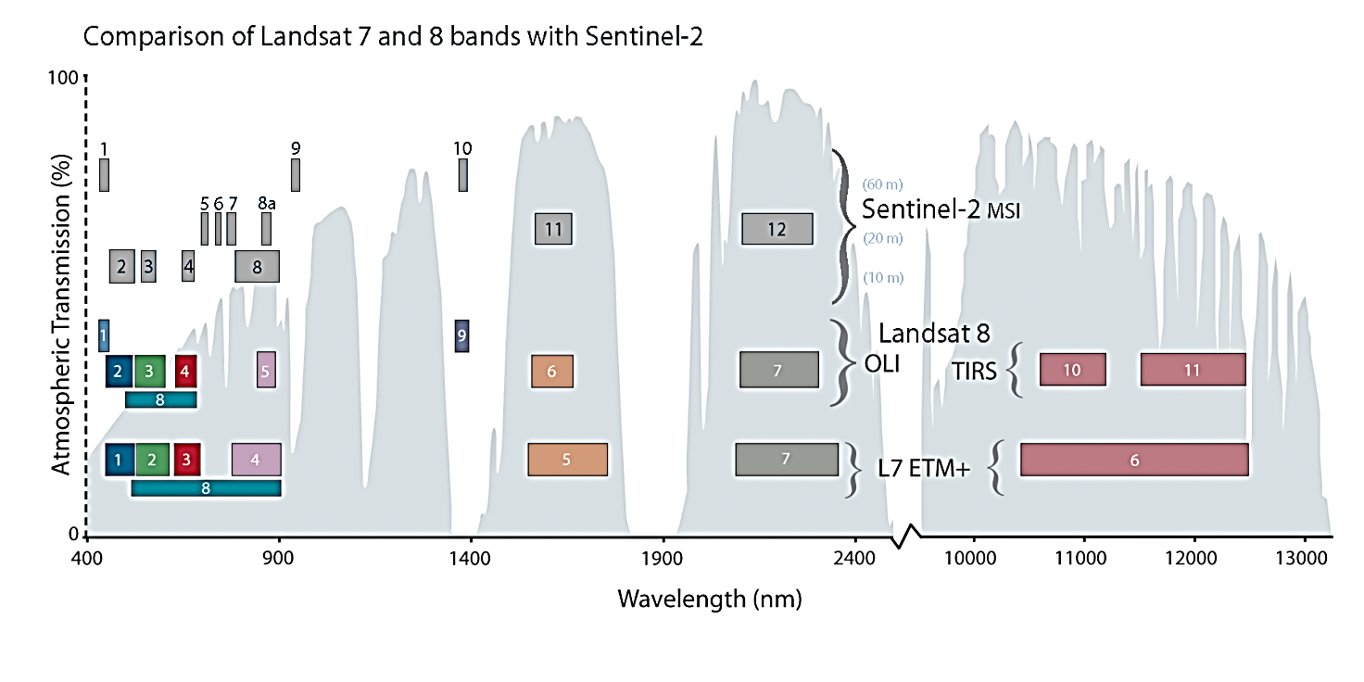

*Figure 5. Comparison of spectral and spatial resolution of the Landsat 7 ETM+, Landsat 8 OLI/TIRS and Sentinel 2 MSI sensors. Source:* [*http://landsat.gsfc.nasa.gov/sentinel-2a-launches-our-compliments-our-complements/*](http://landsat.gsfc.nasa.gov/sentinel-2a-launches-our-compliments-our-complements/)

## 4.2 Sentinel 2A Multi-Spectral Instrument (MSI)

The Sentinel-2 mission is a land monitoring constellation of two satellites that provide high resolution optical imagery and provide continuity for the current SPOT and Landsat missions (<https://sentinel.esa.int/web/sentinel/missions/sentinel-2>). To date, the mission provides a global coverage of the Earth's land surface every 10 days with one satellite (S2A) launched on orbit in June 2015. The full mission specification of the twin satellites flying in the same orbit but phased at 180°, is designed to give a high revisit frequency of 5 days at the Equator. Both satellites are equipped with the state-of-the-art Multi-Spectral Instrument (MSI) that offers high-resolution optical imagery that will sample 13 spectral bands: four bands at 10 m, six bands at 20 m and three bands at 60 m spatial resolution (Tab. 4, Fig. 6, 7). The orbital swath width will be 290 km. The data are distributed via the Copernicus programme data hub as level 1C products (Fig. 8) meaning the pixel values represent the top-of-atmosphere spectral reflectances projected in a cartographic system (UTM/WGS84). The MSI sensor has no thermal bands (Fig. 5); therefore the Landsat 8 TIRS data will be used for defining the relationship of S2 derived data and land surface temperature.

*Table 4. Sentinel 2A Multispectral Instrument (MSI)*

|  |  |  |  |
| --- | --- | --- | --- |
| Band number | Wavelength [μm] | Central Wavelength (µm) | Resolution (m) |
| 1 | 0.430 – 0.457 | 0.443 | 60 |
| 2 | 0.440 - 0.538 | 0.490 | 10 |
| 3 | 0.537 - 0.582 | 0.560 | 10 |
| 4 | 0.646 - 0.684 | 0.665 | 10 |
| 5 | 0.694 - 0.713 | 0.705 | 20 |
| 6 | 0.731 - 0.749 | 0.740 | 20 |
| 7 | 0.769 - 0.797 | 0.783 | 20 |
| 8 | 0.760 - 0.908 | 0.842 | 10 |
| 8A | 0.848 - 0.881 | 0.865 | 20 |
| 9 | 0.932 - 0.958 | 0.945 | 60 |
| 10 | 1.337 - 1.412 | 1.375 | 60 |
| 11 | 1.539 - 1.682 | 1.610 | 20 |
| 12 | 2.078 - 2.320 | 2.190 | 20 |

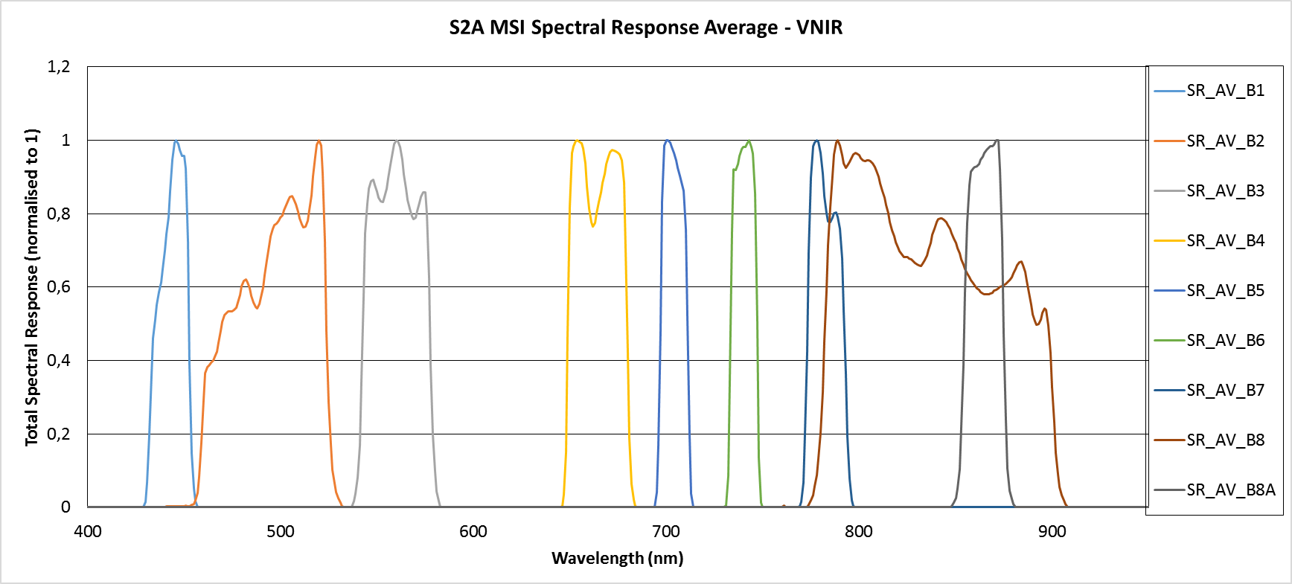

*Figure 6.* *Visible to near-infrared spectral response normalised to 1 for the Sentinel 2A bands 1-8 and 8A. Source:* [*https://sentinel.esa.int/documents/247904/685211/Sentinel-2A+MSI+Spectral+Responses*](https://sentinel.esa.int/documents/247904/685211/Sentinel-2A+MSI+Spectral+Responses)

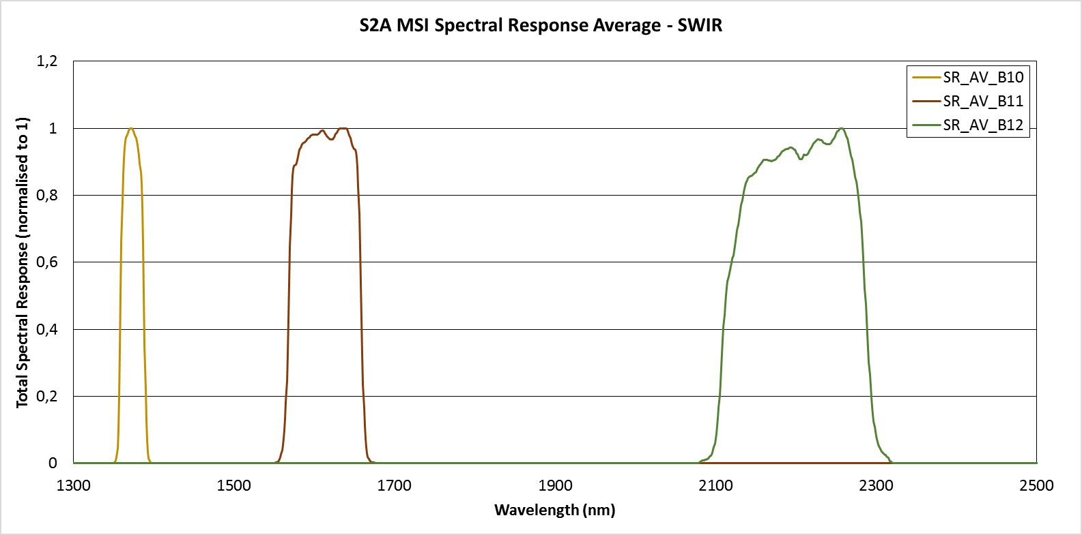

*Figure 7. Shortwave-infrared spectral response normalised to 1 for the Sentinel 2A bands 10, 11, and 12. Source:* [*https://sentinel.esa.int/documents/247904/685211/Sentinel-2A+MSI+Spectral+Responses*](https://sentinel.esa.int/documents/247904/685211/Sentinel-2A+MSI+Spectral+Responses)

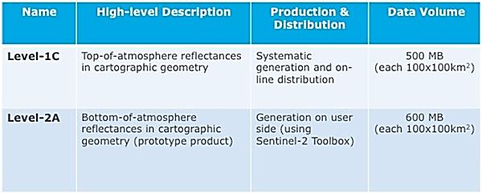

*Figure 8. Sentinel 2 products available for users either generated by the ground segment or by the SENTINEL-2 Toolbox (SNAP). Source:* [*https://sentinel.esa.int/web/sentinel/missions/sentinel-2/data-products*](https://sentinel.esa.int/web/sentinel/missions/sentinel-2/data-products)

# 5 Overview of the data availability for the study area

Although the project started 1 June 2016, we started the data acquisition earlier to increase the chance of acquiring data of good quality and in sufficient number of cases. We focused on download of (i) the Sentinel 2A imagery from the Copernicus data hub (<https://scihub.copernicus.eu/>), (ii) Landsat 8 imagery via the USGS EarthExplorer application (<https://earthexplorer.usgs.gov/>), (iii) single mission airborne lidar and photogrammetry for central part of the Košice city, (iv) terrestrial laser scanning of four smaller sites of typical urban greenery, and (v) identification and location of tree species within the four small sites. The study area is covered by two data grid tiles (Fig. 8). Temporal and other specifications of the datasets assembled to date of this report are reported in Tab. 5-8 and by Figure 9.

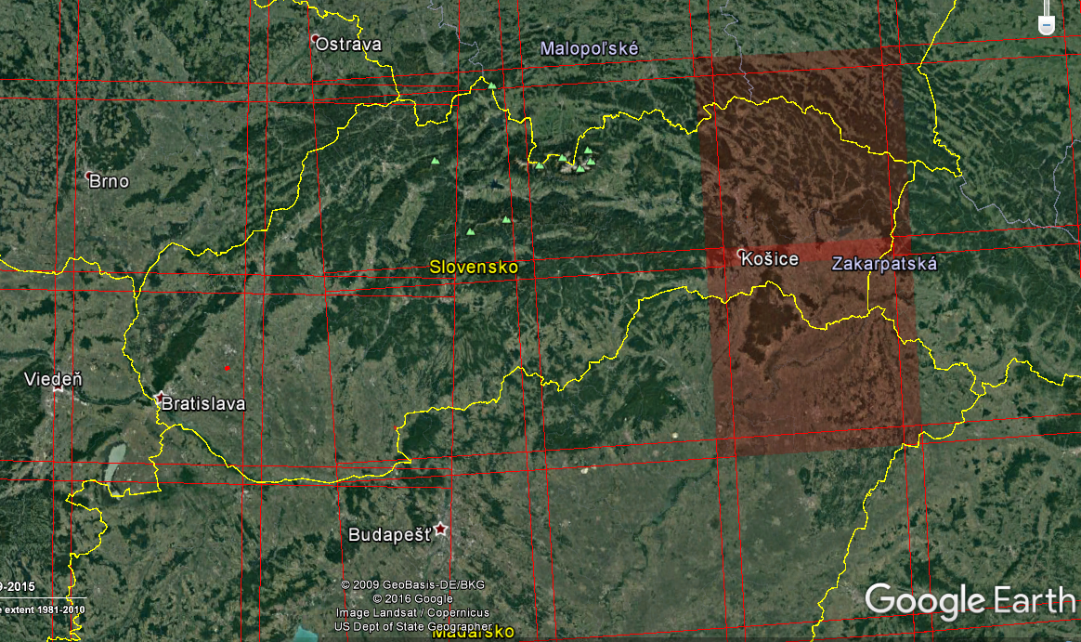

*Figure 8. The study area is situated within two Sentinel 2A data granules (34 UEU, 34 UEV).*

*Table 5. Suitable Sentinel 2A level 1C products downloaded to date for the study area of the Košice City*

|  |  |  |  |  |  |  |  |  |
| --- | --- | --- | --- | --- | --- | --- | --- | --- |
| March | April | May | June | July | August | September | October | November |
| 28.3.2016 | 7.4.2016 | 7.5.2016 | 6.6.2016 | 6.7.2016 | 5.8.2016 | 4.9.2016 | 14.10.2016 | 23.11.2016 |
|  | 17.4.2016 | 10.5.2016 | 9.6.2016 | 9.7.2016 | 8.8.2016 | 7.9.2016 |  | 23.11.2016 |
|  | 20.4.2016 | 20.5.2016 | 16.6.2016 | 16.7.2016 | 15.8.2016 | 14.9.2016 |  | 26.11.2016 |
|  | 27.4.2016 | 27.5.2016 | 19.6.2016 | 26.7.2016 | 18.8.2016 | 24.9.2016 |  |  |
|  | 30.4.2016 |  | 26.6.2016 | 29.7.2016 | 25.8.2016 | 27.9.2016 |  |  |
|  |  |  | 29.6.2016 |  | 28.8.2016 |  |  |  |

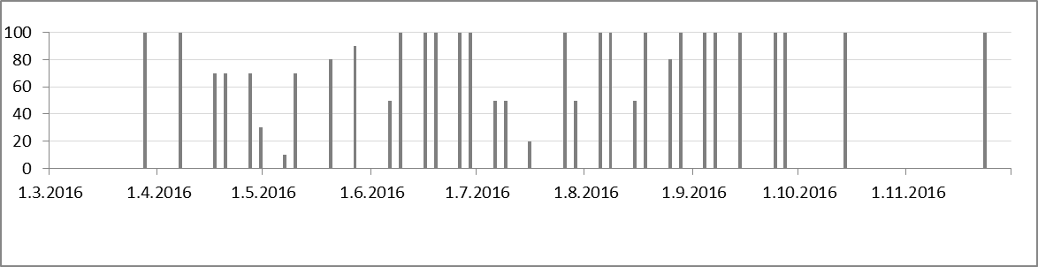

*Figure 9. Estimated clear sky percentage of Sentinel 2A level 1C products downloaded for the Košice City study area in 2016.*

*Table 6. Landsat 8 level 1 products downloaded to date for the study area of the Košice City.*

|  |  |  |  |  |  |
| --- | --- | --- | --- | --- | --- |
| March | April | May | June | July | August |
| 1.3.2016 | 2.4.2016 | 4.5.2016 | 5.6.2016 | 7.7.2016 | 1.8.2016 |
| 10.3.2016 | 11.4.2016 | 13.5.2016 | 16.6.2016 | 16.7.2016 | 8.8.2016 |
| 17.3.2016 | 18.4.2016 | 20.5.2016 | 21.6.2016 | 23.7.2016 |  |
| 26.3.2016 | 27.4.2016 |  | 30.6.2016 |  |  |

*Table 7. Dates of terrestrial laser scanning data collected on four sites in the study area of the Košice City with associated total accuracy of scans registration.*

|  |  |  |  |
| --- | --- | --- | --- |
| **City park (Mestský park)** | **Main street (Hlavná ulica)** | **Moyzesova ulica (street)** | **Hvozdíkov park** |
|  |  |  |  |
| April (0.032m) | April (0.029m) | April (0.062m) | April (0.045m) |
| June (0.023m) | June (0.018m) | June (0.023m) | June (0.038m) |
| July (0.029m) | July (0.014m) | July (0.023m) | July (0.016m) |
| August (0.023m) | August (0.016m) | August (0.025m) | August (0.019m) |
| September 14 (0.026m) | September 14 (0.015m) | September 14 (0.034m) | September 14 (0.018m) |
| September 23 (0.024m) | September 23 (0.016m) | September 23 (0.042m) | September 23 (0.018m) |
| October 14 (0.023m) | October 14 (0.010m) | October 14 (0.034m) | October 14 (0.017m) |
| October 27 (0.020m) | October 27 (0.010m) | October 27 (0.024m) | October 27 (0.018m) |
| November 8 (0.020m) | November 8 (0.008m) | November 8 (0.026m) | November 8 (0.017m) |
| November 23 (0.024m) | November 23 (0.012m) | November 23 (0.028m) | November 23 (0.020m) |

*Table 8. Example of attributes recorded in mapping trees in the Košice City.*

|  |  |  |  |  |  |  |  |  |  |  |  |  |  |
| --- | --- | --- | --- | --- | --- | --- | --- | --- | --- | --- | --- | --- | --- |
| **Id** | **Date** | **Lat** | **Long** | **Species** | **Health** | **Pheno** | **Cat** | **Function 1** | **Function 2** | **Function 3** | **Crown diameter (m)** | **Urbcat 1** | **Urbcat2** |
| 0208 | 20160714 | 48°43,572 | 21°15,057 | Acer negundo | Z | O | 3 | B | C | D | 6 | A | B |
| 0209 | 20160714 | 48°43,562 | 21°15,048 | Tilia cordata | Z | KK | 3 | B | C | D | 5 | A | B |
| 0210 | 20160714 | 48°43,559 | 21°15,046 | Tilia cordata | Z | KK | 3 | B | C | D | 8 | A | B |
| 0211 | 20160714 | 48°43,551 | 21°15,050 | Tilia cordata | Z | KK | 3 | B | C | D | 6 | A | B |
| 0212 | 20160714 | 48°43,545 | 21°15,052 | Tilia cordata | Z | KK | 3 | B | C | D | 10 | A | B |
| 0213 | 20160714 | 48°43,542 | 21°15,047 | Acer saccharum | Z | O | 3 | B | C | D | 9 | A | B |
| 0214 | 20160714 | 48°43,538 | 21°15,049 | Fraxinus ornus | P25 | O | 3 | B | C | D | 7 | A | B |
| 0215 | 20160714 | 48°43,534 | 21°15,052 | Tilia platyphylos | Z | KK | 3 | B | C | D | 13 | A | B |
| 0216 | 20160714 | 48°43,528 | 21°15,053 | Acer platanoides | Z | O | 3 | B | C | D | 15 | A | B |

## 5.1 Example of NDVI time series for the study area

Sentinel 2A (S2A) data are the main source of multispectral imagery for the SURGE project. To date, the work related to S2A data involved downloading of suitable imagery within minimal cloud cover and storage of the data on our server including back-up. The assembled time series enabled to demonstrate change of vegetation coverage by the means of true colour composites, near-infrared colour composites, and NDVI. The data were firstly viewed in the freely available Sentinel 2 toolbox (SNAP tools) (Fig. 10) but the NDVI was derived in the ArcGIS 10.3.1 software by ESRI (Fig. 11). The next steps in the close future will involve testing the relationship of vegetation indices derived from S2A and Landsat 8 imagery with respect to lidar derived vegetation metrics.

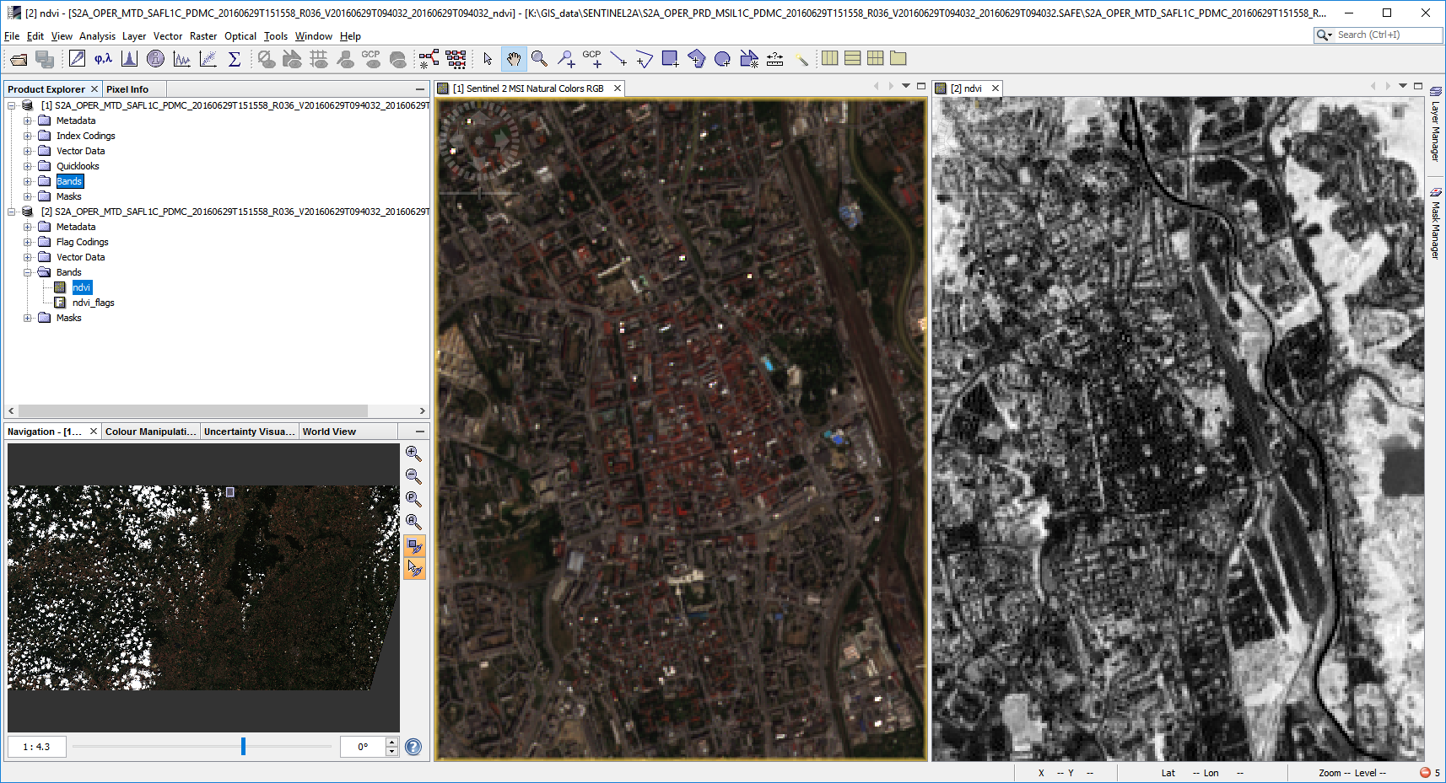

*Figure 10. Central part of the Košice City depicted in a true colour composite (centre) and NDVI (right) generated using the Sentilnel 2 Toolbox for 29 June 2016. Light tones indicate high NDVI values.*

|  |
| --- |
|  |
|  |
|  |

*Figure 11. RGB colour composites and NDVI of Sentinel 2A level 1C products for the central part of the Košice City. True colour image (left, bands 4, 3, 2), NIR composite image (middle, bands 8, 4, 3), NDVI (right, calculated from bands 5, 6).*

# Conclusion

Multispectral imagery acquired by space borne sensors is a key data source for earth monitoring programs considering the great advantages that they have. The most widely used sensors comprise those of the Landsat mission (TM, ETM+, OLI, TIRS), and further MODIS, ASTER, MERIS, SPOT, IKONOS. Such data is easily obtainable via internet connection to produce and update vegetation inventories over large regions if aided by satellite imagery and appropriate imagery analysis. Another advantage is in the high temporal resolution (short revisit period over the same area) ranging between days to few weeks. A growing number of studies have examined a wide variety of vegetative phenomena, including mapping vegetation cover, by using remote sensed data. Various techniques were developed to associate spectral response of the land cover surface with biophysical and structural properties of vegetation. In particular, combinations of red and near infra-red bands were used to derive vegetation indices, such as the most popular NDVI, which were proved to be correlated with particular vegetation metrics such as leaf area index, canopy gap fraction, canopy closure, etc.

Our study focuses on associating spectral response of the land cover recorded by the ESA Sentinel 2A satellite and solar transmittance modelled by high resolution lidar data of urban greenery. The presented review of the contemporary state-of-the art showed that similar tasks were addressed mainly by published studies focusing on forested areas and applications in forestry, some in urban environment. In principle, the strength of the relationship between the information derived from multispectral imagery and the data used as the ground truth of vegetation transmittance strongly depends on the spectral and spatial resolution of the imagery. From this point of view the Sentinel 2A products have potential to provide more accurate estimates of the vegetation transmittance given higher number of spectral bands and higher spatial resolution of some bands in comparison with similar other Earth observation sensors (e.g. Landsat 8 OLI, Landsat 7 ETM+, ASTER, MODIS). This was proven by several studies prior to the launch of Sentinel 2A which used simulated bands. Given the custom high resolution lidar and photogrammetric data sets for the Košice City, we have a good chance to test the real properties of remote sensing with Sentinel 2A MSI in this ESA feasibility study.

# References

Campbell, J.B., Wynne, R.H., (2011). Introduction to Remote Sensing. 5th Edition, The Guilford Press.

Carlson, T.N., Ripley, D.A. (1997). On the relation between NDVI, fractional vegetation cover, and leaf area index. Remote Sens. Environ., 62 (1997), pp. 241–252.

Delegido, J., Verrelst, J., Alonso, L., Moreno, J., (2011). Evaluation of Sentinel-2 red-edge bands for empirical estimation of Green LAI and chlorophyll content, Sensors, 11 (2011), pp. 7063–7081.

Delegido, J., Verrelst, J., Rivera, J.P., Ruiz-Verdú, A., Moreno, J. (2015). Brown and green LAI mapping through spectral indices. International Journal of Applied Earth Observation and Geoinformation, 35, Part B, March 2015, pp. 350-358.

Disney, M., Lewis, P., (2007). Spectral invariant behaviour of a complex 3D forest canopy. In: M. Schaepman, S. Liang, N. Groot, M. Kneubühler (Eds.), Proc. 10th international symposium on physical measurements and signatures in remote sensing (ISPMSRS'07), The International Archives of the ISPRS, Vol. XXXVI (2007), pp. 102–107.

Eliasson, I. (2000). The use of climate knowledge in urban planning. Landscape and Urban Planning, 48 (1-2), pp. 31–44.

Fogl, M., Moudrý, V., (2016). Influence of vegetation canopies on solar potential in urban environments, Applied Geography, 66(January 2016), pp. 73-80.

Kodar, A., Lang, M., Arumäe, T., Eenmäe, A., Pisek, J., Nilson, J.T. (2011). Leaf area index mapping with airborne lidar, satellite images and ground measurements in Järvselja VALERI test site. Forestry Studies, 55, pp. 11-32.

Galvão, L.S., Breunig, F.M., Teles, T.S., Gaida, W., Balbinot, R. (2016). Investigation of terrain illumination effects on vegetation indices and VI-derived phenological metrics in subtropical deciduous forests. GIScience and Remote Sensing, 53 (3), pp. 360-381.

Ganguly, S., Nemani, R.R., Zhang, G., Hashimoto, H., Milesi, C., Michaelis, A., Wang, W., Votava, P., Samanta, A., Melton, F., Dungan, J.L., Vermote, E., Gao, F., Knyazikhin, Y., Myneni, R.B. (2012). Generating global Leaf Area Index from Landsat: Algorithm formulation and demonstration. Remote Sensing of Environment, 122, July 2012, pp. 185-202.

Gómez, J.A., Zarco-Tejada, P.J., García-Morillo, J., Gama, J., Soriano, M.A. (2011). Determining biophysical parameters for olive trees using CASI-airborne and QuickBird-satellite imagery. Agronomy Journal, 103 (3), pp. 644-654.

Havašová M., Bucha T., Ferenčík J., Jakuš R., (2015). Applicability of a vegetation indices-based method to map bark beetle outbreaks in the High Tatra Mountains. Annals of Forest Research. 58(2), pp. 295-310.

Halabuk, A., Mojses, M., Halabuk, M., David, S. (2015). Towards detection of cutting in hay meadows by using of NDVI and EVI time series. Remote Sensing, 7 (5), pp. 6107-6132.

Hopkinson, C., and Chasmer, L. 2009. Testing lidar models of fractional cover across multiple forest ecozones. Remote Sensing of Environment, 113, pp. 275–288.

Jakubauskas, M.E., Price K.P., (1997). Empirical Relationships between Structural and Spectral Factors of Yellowstone Lodgepole Pine Forests. Photogrammetric Engineering & Remote Sensing, 63(1), pp. 1375–1381.

Jensen, J.R., (2006). Remote Sensing of the Environment: An Earth Resource Perspective. 2nd edition. Pearson.

Jin S., Sader S.A., (2005). Comparison of time series tasseled cap wetness and the normalized difference moisture index in detecting forest disturbances. Remote Sensing of Environment: 94(3), pp. 364–372.

Korhonen, L., Morsdorf, F. (2013). Estimation of Canopy Cover, Gap Fraction and Leaf Area Index with Airborne Laser Scanning. In: Forestry Applications of Airborne Laser Scanning, Managing Forest Ecosystems, 27, pp. 397-417.

Lindberg, F., Grimmond, C.S.B. (2011). The influence of vegetation and building morphology on shadow patterns and mean radiant temperatures in urban areas: model development and evaluation. Theoretical and Applied Climatology, 105 (2011), pp. 1–13.

Maimaitiyiming, M., Ghulam, A., Tiyip, T., Pla, F., Latorre-Carmona, P., Halik, T., Sawut, M., Caetano, M. (2014). Effects of green space spatial pattern on land surface temperature: Implications for sustainable urban planning and climate change adaptation. ISPRS Journal of Photogrammetry and Remote Sensing, 89, pp. 59-66.

Majasalmi, T., Rautiainen, M. (2016). The potential of Sentinel-2 data for estimating biophysical variables in a boreal forest: A simulation study. Remote Sensing Letters, 7 (5), pp. 427-436.

Morsdorf, F., Kotz, B., Meier, E., Itten, K.I., and Allgower, B. 2006. Estimation of LAI and fractional cover from small footprint airborne laser scanning data based on gap fraction. Remote Sensing of Environment, 104(1), pp. 50–61.

Pu, R., Xu, B., Gong, P. (2003). Oakwood crown closure estimation by unmixing Landsat TM data. International Journal of Remote Sensing, 24 (22), pp. 4433-4445.

Ratti, C., Baker, N., Steemers, K. (2005). Energy consumption and urban texture. Energy and Buildings, 37(7), pp. 762–776.

Rouse, J.W., Haas, R.H., Schell, J.A., Deering, D.W. (1973). Monitoring vegetation systems in the Great Plains with ERTS. 3rd ERTS Symposium, NASA SP-351, vol. 1, NASA, Washington, DC, pp. 309–317.

Smith, A.M.S., Falkowski, M.J., Hudak, A.T., Evans, J.S., Robinson, A.P., Steele, C.M. (2009). A cross-comparison of field, spectral, and lidar estimates of forest canopy cover. Canadian Journal of Remote Sensing, 35 (5), pp. 447-459.

Tooke, T.R., Coops, N.C., Goodwin, N.R., Voogt, J.A. (2009). Extracting urban vegetation characteristics using spectral mixture analysis and decision tree classifications. Remote Sensing of Environment, 113(2), pp. 398-407.

Tooke, T.R., Coops, N.C., Voogt, J.A., Meitner, M.J. (2011). Tree structure influences on rooftop-received solar radiation. Landscape and Urban Planning, 102 (2), pp. 73-81.

Tooke, T.R., Coops, N.C. Christen, A., Gurtuna, O., Prévot, A., (2012). Integrated irradiance modelling in the urban environment based on remotely sensed data. Solar Energy, 86(10), pp. 2923-2934.

Vogelmann J.E., Xian G., Homer C., Tolk B., (2012). Monitoring gradual ecosystem change using Landsat time series analyses: Case studies in selected forest and rangeland ecosystems. Remote Sensing of Environment, 122, pp. 92–105.

Voogt, J., Oke, T., (1997). Complete urban surface temperatures. Journal of Applied Meteorology, 36 (9), pp. 1117–1132.

Xie, Y., Sha, Z., Yu, M. (2008). Remote sensing imagery in vegetation mapping: a review. Journal of Plant Ecology, 1(1), pp. 9-23.