Physically-based land surface temperature modeling in urban areas using 3-D city models and multispectral satellite data

Jaroslav Hofierka ª, Michal Gallay ª, Katarína Onačillová ª, Jaroslav Hofierka, Jr. ^{b}

ª Institute of Geography, Faculty of Science, Pavol Jozef Šafárik University in Košice, Šrobárova 2, 04001 Košice, Slovak Republic
^{b} Faculty of Mathematics and Physics, Charles University, Ke Karlovu 3, 12116 Prague, Czech Republic

Corresponding author: Jaroslav Hofierka, Institute of Geography, Faculty of Science, Pavol Jozef Šafárik University in Košice, Šrobárova 2, 04001 Košice, Slovak Republic, e-mail: jaroslav.hofierka@upjs.sk

Abstract:
Mitigation of urban heat islands (UHIs) requires understanding of the factors affecting the interaction of solar radiation and urban surfaces. The absorbed heat is manifested via land surface temperature and subsequently re-radiated into the surroundings thus increasing ambient temperatures. In this study, the land surface temperature was estimated by a novel algorithm combining map algebra in GRASS GIS, the Stefan Boltzmann Law and the Kirchhoff rule using raster input data derived from a virtual 3-D city model and Sentinel 2 multispectral imagery. Airborne and terrestrial laser scanning and airborne photogrammetry were used to generate a high-resolution virtual 3-D city model of the Košice City in Slovakia. The model was the source of the urban land surface geometry and land cover properties necessary for high-resolution modelling of solar radiation. The freely available Sentinel 2 data was used to estimate broad-band albedo, thermal emissivity and vegetation transmittance to assess the effects of various urban surfaces on UHIs. The proposed approach provides means for GIS specialists and urban planners to assess and communicate the impact of measures taken in order to mitigate the urban heat island or communicate the effect of greenery on cooling the urban climate.
Keywords: Land surface temperature; Urban heat islands; Solar radiation; GRASS GIS

1. Introduction
Mitigation of urban heat islands (UHI) requires understanding of factors affecting the interaction between solar radiation and urban surfaces. Their relationship is complex and therefore two types of UHI are distinguished: surface and atmospheric UHI (Voogt and Oke, 2003, EPA, 2008). Surface UHI usually develop during hot, sunny summer days. The Sun heats dry, exposed urban surfaces, like roofs, roads and pavements, to temperatures 25 to 50°C higher than the temperature of the ambient air mass. Surface temperatures have a significant influence on air temperatures, especially in the canopy layer between the ground and the tops of trees and roof where the most of the human activity concentrates. For example, parks and vegetated areas typically have cooler surface temperature that contributes to cooler air temperature (Estoque et al., 2017; Soltani and Sharifi, 2017). Dense, built-up areas, on the other hand, typically increase the air temperature which is pronounced during the night. In general, the temperature of air is less variable than the temperature of land surface across an area. The UHI phenomenon is not constrained to big cities, but concerns also relatively small urban settlements (Onačillová and Gallay, 2018).
Over the past two decades, numerous studies were published analyzing the associations between solar radiation, reflectance, emissivity and other heat transfer parameters of urban surface materials (Berdahl and Bretz, 1997; Mirsadeghi et al. 2013). The development and changes in UHIs may vary substantially throughout the day or year depending on radiative and thermal properties of urban surfaces and urban geometry (Soltani and Sharifi, 2017; Hu and Wendel, 2019). Land Surface Temperature (LST) is considered a reliable indicator of the UHI, as there is a strong correlation between the LST and near-surface air temperature for the heat radiating from the surface to the atmosphere (Nichol, 1994; Arrau and Pena, 2010). However, atmospheric mixing induces varying strength of the relationship between land surface and near-surface air temperatures which changes during the day and night (EPA, 2008; Chen et al., 2017). LST is generally defined as the radiative skin temperature of the ground. LST is the key parameter in physics of land surface processes, combining surface-atmosphere interactions and energy fluxes between the atmosphere and the ground. Properties of urban materials, in particular solar reflectance, thermal emissivity, and heat capacity influence the LST and subsequently development of UHI, as they determine how the Sun’s radiation energy is reflected, emitted, and absorbed.
Thermal variability of land surface can be efficiently observed and recorded by thermal remote sensing. For example, Syed et al. (2018) provide a list of the thermal satellite sensors which became increasingly popular for assessing the UHI effect on global scale. Thermal sensors record radiance in spectral ranges associated with typical range of land surface temperature. The radiance is directly converted to brightness (radiometric) temperature (BT) by inversion of Planck’s equation Li et al. (2013). Despite the BT being a very close approximation of the LST, the low spatial (60 m to 1000 m) and temporal resolutions (several hours to days) of satellite observations limit the accurate estimation of LST in urban areas for local studies (Mushore et al., 2017). Strong heterogeneity of urban land cover comprising complex patterns of various types of building, artificial surfaces and urban vegetation leads to strong spatial differentiation of LST over relatively small distances of several meters (Hu and Wendel, 2019) which remains beyond the capabilities of contemporary thermal satellite sensors, such as MODIS, Sentinel 3, ASTER, Landsat 7 ETM+, or Landsat 8 TIRS. Airborne or terrestrial remote sensing can be viewed as alternative for capturing higher spatial resolution of thermal data but it is not feasible to be used for large urban areas with increased periodicity.
- The increasing availability of high-resolution geospatial data for urban areas and adequate modeling techniques provide an alternative approach for estimating the LST in high-resolution. Several studies showed the potential of 3-D city models for estimation of solar radiation in urban areas (Hofierka and Kaňuk, 2009; Biljecki et al. 2014; Hofierka and Zlocha, 2012). However, the suite of available GIS algorithms to date lacks calculation of LST in which the potential of fine scale 3-D urban structure could be exploited.

- Nakata-Osaki et al. (2018) developed a useful ArcGIS GIS tool for calculating the maximum intensity of urban heat island based on 3-D urban geometry data adopting the empirical model of Oke (1981). This model focuses on the effect of building configuration on the UHI rather than calculating physically-based exact values of LST outputs. The properties of vegetation, surface material and shadows remain unconsidered which in turn provides higher speed of the model performance. The mentioned aspects can be potentially addressed by data recorded with the

- satellite mission of Sentinel 2 by ESA. The mission provides 5 day periodicity of global coverage at relatively high resolution of 10-30 meters. The multispectral data could be used to parameterize the surface properties required for LST calculation such as broad-band albedo (e.g., Vanino et al. 2018). Geometry of vegetation, especially of trees, is also an important parameter in realistic modelling the solar irradiance and LST (Tooke et al., 2012; Fogl and Moudrý, 2016; Klingberg et al., 2017; Hu and Welden, 2019). The geometry of trees is a dynamic property especially in mid-latitudes with significant phenologic changes of deciduous tree species (Hofierka et al. 2017). Tooke et al. (2012) estimate solar irradiance in urban areas taking into account radiation transmission through urban vegetation using airborne Light Detection and Ranging (LiDAR) point clouds. The use of LiDAR in estimating canopy cover of trees is also supported by various studies based on a comparison of lidar-based canopy cover data to the metrics measured in the field (Morsdorf et al., 2006; Smith et al., 2009; Richardson et al., 2009).
Hence, coupling data on 3-D urban structure including vegetation, such as lidar data, with data on spectral properties of materials contained in spaceborne multispectral data opens a promising way for more detailed yet simple modelling of LST in urban environment.

The goal of this paper is to present a methodology for calculation of LST in an open-source environment of GRASS GIS using the r.sun solar radiation model, a digital surface model derived from a virtual 3-D city model and input data describing the varying properties of urban greenery derived from airborne and terrestrial LiDAR data and Sentinel 2 multispectral imagery. We present the developed method in two scenarios demonstrating the effect of urban greenery on cooling the urban climate.

2. Methods and data

2.1 The r.sun solar radiation model
Solar irradiance is the main source of energy contributing to LST. It consists of three components: beam (direct), diffuse and reflected irradiance. The most important component is beam irradiance because in average it represents about 50-60% of global irradiance and even more during summer sunny days. Beam irradiance depends on solar and local surface geometry and therefore it can be computed quite easily. Diffuse irradiance is anisotropic, i.e., it varies over the sky depending on the direction of solar rays. The ground-reflected component of solar irradiance is usually quite small (e.g., several percent of global irradiance). It depends on topography and ground reflectance (albedo).
Spatial distribution of solar irradiance across the land surface depends on many factors, such as the Earth's geometry, land surface morphology and atmospheric conditions. These factors can be described by a set of equations creating a complex model such as r.sun (Šúri and Hofierka, 2004) that is capable of estimating the amount of global solar irradiance in all of its components for any point on land surface represented by a digital elevation model (DEM). The r.sun model is one of the most widely used GIS-based solar radiation models that is implemented in the open-source environment of GRASS GIS (Neteler et al., 2012; Neteler and Mitasova 2008). Originally developed as a clear-sky model (Hofierka, 1997), it was later further substantially improved by Šúri and Hofierka (2004) to include diffuse and reflected components of solar radiation for clear-sky and real-sky conditions. It has been used in a wide range of applications at various scales (e.g., Romero et al., 2008, Ruiz-Arias et al., 2009, Bergamasco and Asinari, 2011; Gašparović et al., 2018)
The r.sun module in GRASS GIS works in two modes (GRASS, 2018). Mode 1 is for instantaneous calculations, for which raster-based maps of solar irradiance (W.m⁻²) and solar incident angles (degrees) are obtained. In mode 2, the raster-based maps provide daily sums of solar irradiation (W.h.m⁻²) and daily direct-sun duration (min). These are computed from the integration of irradiance values (derived in mode 1) that are calculated at a user selected time step from sunrise to sunset. The computation can account for sky obstructions (shadowing) by local land surface features.

2.2 The calculation of land surface temperature of urban surfaces
The magnitude of surface UHIs varies with seasons, due to changes in solar irradiance as well as ground cover and weather conditions.; Mitigating UHIs requires lowering the average surface temperature of the city so that there is less surface-to-air heat transfer. Urban vegetation is one of key components of this effort as the greenery maintains cooler surface temperatures, mainly by the process of evapotranspiration and shading. Generally, a built-up area exhibits a variable thermal pattern with hot and cold peaks corresponding to various thermal properties of urban surfaces. For building and pavement surfaces in the sun, surface characteristics such as albedo, emissivity, and roughness, are also relevant. For a surface under the sun and insulated underneath, the equilibrium surface temperature, T_{s} is obtained from the heat balance equation based on the Stefan-Boltzmann law which describes the total power radiated from a body in terms of its temperature (Bretz et al., 1998):
(1)
where is the unitless solar reflectivity or albedo of the surface varying from 0 to 1, I is the global solar irradiance incident on the surface in W.m⁻², which is the output from the r.sun model, is the emissivity of the surface, is the Stefan-Boltzmann constant, 5.6685 × 10⁻⁸ W.m⁻²K⁻⁴, T_{s} is the equilibrium surface temperature in K, T_{sky} is the effective radiant sky temperature, h_{c} is the convection heat transfer coefficient in W.m⁻².K⁻¹ and T_{a} is the air temperature in K (ASHRAE, 1989).
Using this equation, the surface temperature T_{s} can be computed numerically using Newton's iteration method, which is the method of choice for non-linear problems with continuous, non-zero first derivatives due to its fast (quadratic) convergence. Our algorithm has the following form in the GRASS GIS shell script:
#!/bin/sh
#lst.stefan-boltzman.sh

echo "Global irradiance file"
read irr
g.copy --o rast=$irr,gi
echo "Albedo file"
read alb
g.copy --o rast=$alb,albedo
echo "Emissivity file"
read eps
g.copy --o rast=$eps,epsilon
echo "Convection coefficient file"
read cc
g.copy --o rast=$cc,h_c
echo "Initial estimation of land surface temperature (e.g., 300)"
read temp0
echo "Ambient air temperature (e.g., 300)"
read T_a
echo "Radiant sky temperature (e.g., 280)"
read T_sky

echo " initialization of parameters..."

r.mapcalc --o "c = -epsilon * 0.000000056685 * $T_sky * $T_sky * $T_sky * $T_sky - h_c * $T_a - (1 - albedo) * gi"

r.mapcalc --o "lst0 = $temp0" #initialization of LST
r.mapcalc --o "y = lst0*lst0*lst0"
r.mapcalc --o "lst = (3*epsilon*0.000000056685*y*lst0 - c)/(4*epsilon*0.000000056685*y+h_c)" #1st iteration

i=2
while [ $i -le 10 ]
do
echo "Iteration" $i

g.copy --o rast=lst,lst0
r.mapcalc --o "y = lst0*lst0*lst0"
r.mapcalc --o "lst = (3*epsilon*0.000000056685*y*lst0 - c)/(4*epsilon*0.000000056685*y+h_c)"

i=`expr $i + 1`
done

echo "Finished."

This algorithm requires an initial estimation of LST, which is based on the measured air temperature and the weather conditions (sunny, overcast day, etc.). Subsequent 10 iterations produce results with sufficient accuracy. The proposed GRASS GIS implementation assumes that the values of ambient air temperature T_{a} and radiant sky temperature T_{sky} are also known beforehand. The air temperature is usually measured by meteorological stations, often even within the city. The radiant sky temperature can be estimated using one of the available approximation methods published, e.g. in (Algarni, 2015), depending on the cloudiness. In this study, we use simple clear-sky and cloudy-sky direct temperature models where T_{sky} = T_{a} - 20 under clear-sky conditions (Garg, 1982) and T_{sky} = T_{a} - 6 under cloudy conditions (Whillier, 1967). Other temperature models can be used depending on available data to improve the accuracy of assessment. The other parameters of equation (1) are input as spatially distributed raster data layers of solar reflectance (albedo), thermal emissivity of the surface and convection heat transfer coefficient h_{c}. Albedo and emissivity values can estimated from multispectral satellite data (e.g., Vanino et al., 2018) or assigned to individual land cover objects based on published research.
In case that exact values of are not available, the emissivity can be very roughly approximated by . Berdahl and Bretz (1997) demonstrated a linear correlation between the reflectance (albedo) and thermal emissivity of the surface for typical metal roof coatings.
The relationship between albedo and thermal emissivity is described by Kirchhoff's law of heat radiation: surfaces with high reflectivity (or, roughly, high albedo) have low emissivity and vice versa. Based on this law, we assume for an arbitrary freely radiating body in thermodynamic equilibrium with itself that its emissivity at a specific wavelength is equal to its absorptivity of the incoming radiation at the same wavelength (Baltes, 1976). Despite the fact that this does not rigidly hold for spectrally averaged quantities, it can be used for approximating the emissivity in case other more accurate data are not available.

The convection coefficient h_{c} is usually the most difficult parameter to estimate. It depends strongly on wind speed and direction, geometry of the building and surroundings objects, height of the roof above ground level, building material texture (roughness) and surface to air temperature difference (Mirsadeghi et al., 2013). In sunlight, with zero wind speed, h_{c}, is determined by natural convection. It is a weakly increasing function of temperature difference, and almost independent of surface size. For example, for T_{sky} - T_{a} = 30 K, estimates give h_{c} = 6.6 Wm⁻²K⁻¹. For wind speeds above 1 m.s⁻¹, the convection coefficient is determined by forced convection, and, h_{c} rises from 2.5 to 3.0 W.m⁻².K⁻¹ at zero wind speed to about 15 to 20 W.m⁻².K⁻¹ at wind speeds of 7 m.s⁻¹ with even higher values of h_{c} for roofs and upwind surfaces (Liu et al., 2015). Mirsadeghi et al. (2013) provides an extensive overview of available models for h_{c} estimation and concluded that there is considerable uncertainty in the prediction of this parameter. More accurate estimates of h_{c} require complex modelling techniques using 3-D city models, data on building materials and 3-D wind simulations.

2.3 The study area and data
This study focuses on the Košice City in Eastern Slovakia as an example of urban space typical for a moderate climate of Central Europe. The UHI phenomenon was found to exist in the city and its relation with regard to land cover and seasonal effects was analyzed in Onačillová and Gallay (2018). For this study, we selected an area with a feasible size and sufficient diversity of urban greenery which would be suitable for ground-based mapping, airborne survey and large enough for monitoring by Earth observation missions such as Sentinel 2 and Landsat 8. The area comprises 4 km² of the central part of the Košice City as delineated in Figure 1. Within this area, we selected a smaller site (Moyzesova street) representing a typical mixture of urban surfaces and greenery to show a detailed view of input and output data.
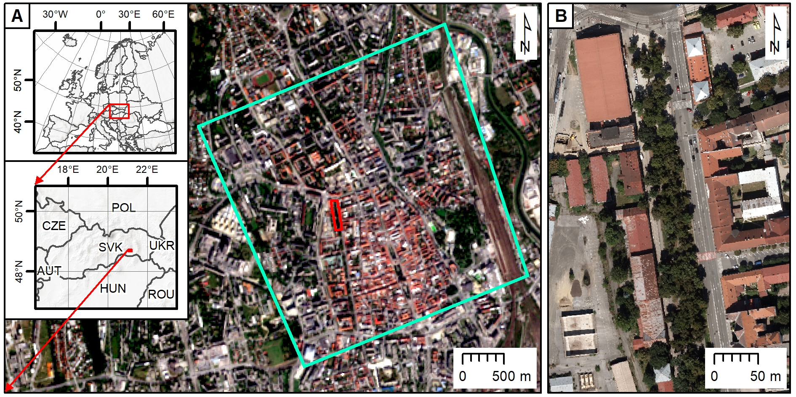
Figure 1. Location of the study area in the Košice City, Slovakia. The cyan line outlines the area subject to airborne lidar and photogrammetric mapping. The red outline delineates the smaller area (Moyzesova street) selected for a detailed view on the right with aerial orthoimage as natural color composite © Photmap s.r.o. The background maps are © Copernicus, Sentinel 2A image acquired on 29 June 2016.

In this study, we have used various data sources. The airborne laser scanning (ALS) and photogrammetry data were used to build a 3-D city model and derive digital surface models and land cover maps, spaceborne multispectral imagery of Sentinel 2A satellite was used to derive input parameters such as albedo for the LST model. Landsat-8 data were used to compare Landsat-derived LST with the results of our modeling of LST.
The airborne laser scanning (ALS) and photogrammetry data were acquired in leaf-on conditions during late summer of 2016 to build 3-D city model consisting of buildings and terrain with a level of detail (LoD) 2 (Fig. 2, 3). Hofierka et al. (2017) provide more details. Leica ALS70 laser scanner was used for ALS resulting in 365 million of points covering the whole area (point cloud density 91/15 all/ground points per m², respectively).
The points were processed in LAStools to classify them in ground, vegetation, buildings and other returns. Ground returns were used to derive a gridded digital terrain model (DTM), vegetation and buildings returns were also used to derive digital surface models (DSMs) of 0.5 m cell size (Fig. 3). The two types of DEM were the main spatial data layers used as inputs for modelling solar irradiance.
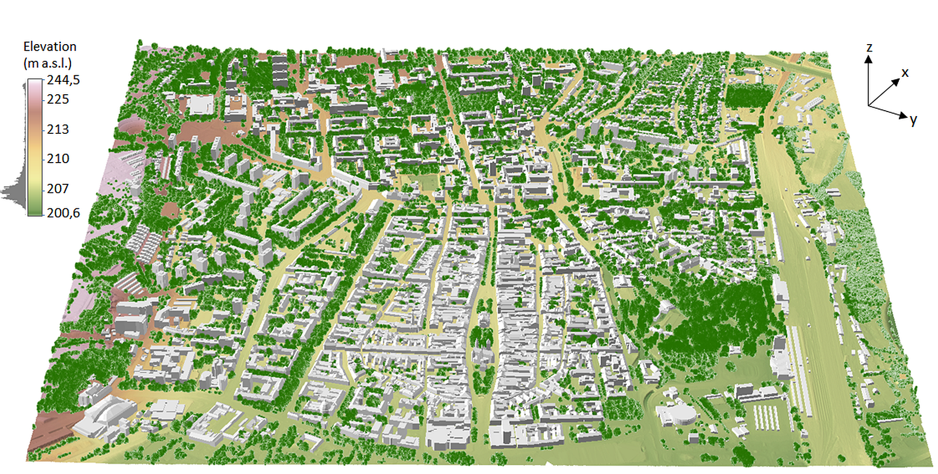
Figure 2. Perspective 3-D view of the entire study area (cyan outline in Fig. 1) with 3-D buildings (grey) and point cloud of trees and shrubs (green points) on a lidar-based digital terrain model colored by elevation.
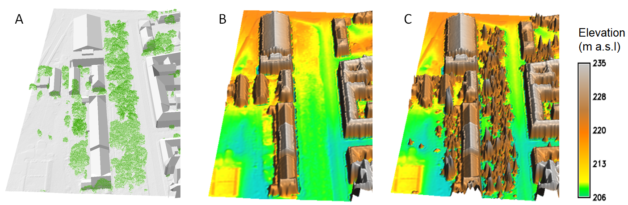

Figure 3. Detailed view of the source data for the smaller site (Moyzesova street) comprising 3-D models of buildings (LoD2), lidar based digital terrain and point cloud of trees and shrubs (green points) (A) which were used to derive a gridded digital surface model (DSM) including buildings (B), and trees and shrubs (C). The area size is 200 m by 400 m. DSM cell size is 0.50 m.

The aerial orthoimagery and inspection of ground cover in the field was used to create a layer of land cover of the ground (i.e. under the canopy of trees and shrubs) and a layer of land cover including coverage of trees and shrubs. We have identified 21 categories of the ground cover completely covering the study area. The two types of land cover layers were visually identified and delineated in a vector data format in ArcGIS (Fig. 4). The land cover categories were used to assess spatial differentiation of convective heat transfer coefficient h_{c} within the city. Table 1 and Figure 4 summarize how we assigned different land cover categories with the values of h_{c} which was based on expert judgment supported by the values reported by Mirsadeghi et al. (2013), Liu et al. (2015), Vollaro et al., (2015) and Amir et al. (2018). The values are estimated for typical hot summer atmospheric conditions with clear sky and moderate wind (2 m.s⁻¹). The resulting data layers were derived at 0.50 m spatial resolution. The data represent ground cover thermal properties, however, they do not account for urban greenery effects.
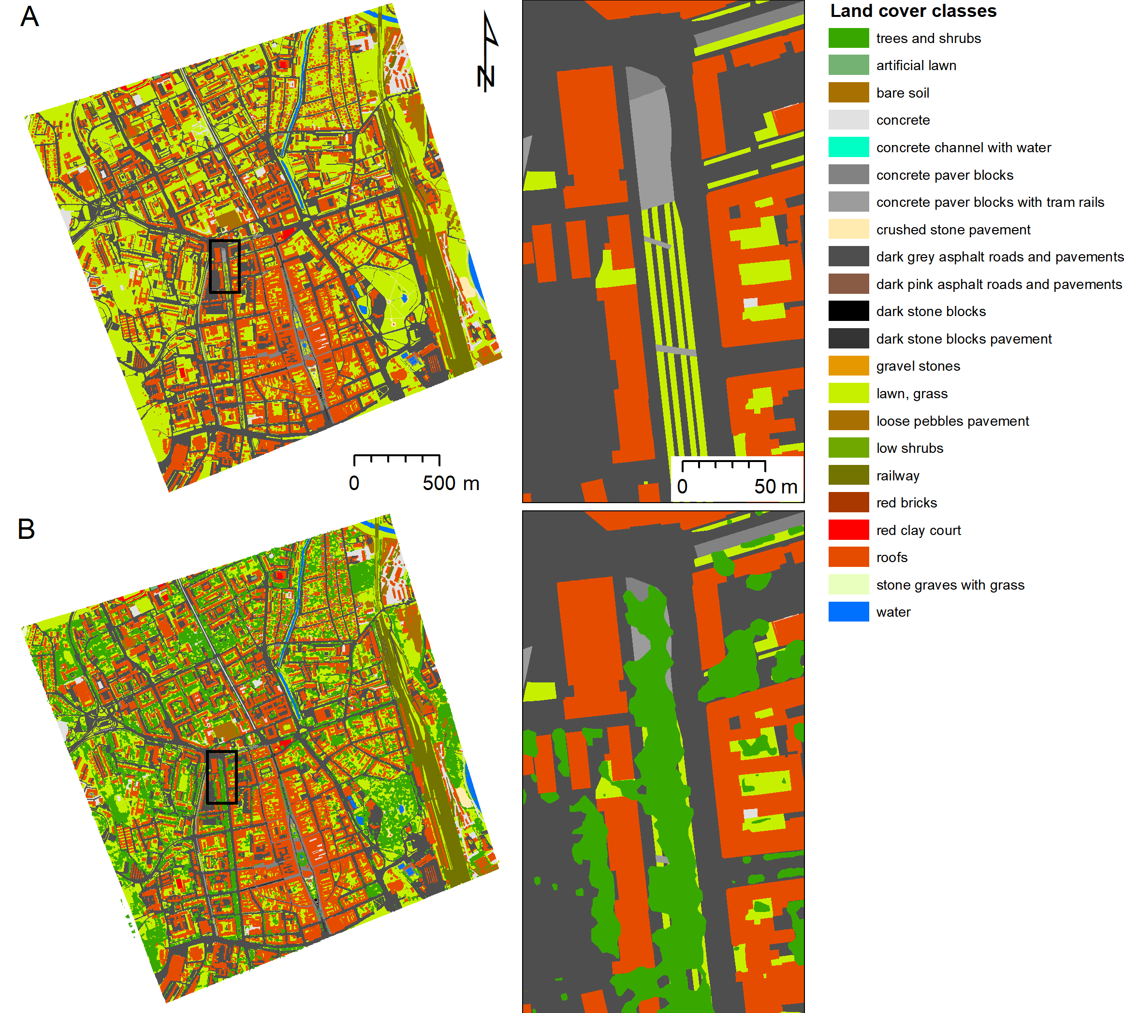
Figure 4. Land cover interpreted from aerial orthoimagery and by field inspection (A) of the ground below the trees and shrubs and (B) including the trees and shrubs in the entire study area and in the smaller site (Moyzesova street) delineated by the black outline.

Table 1. Convective heat transfer coefficient (h_{c}) values assigned to land cover categories in the Košice city
Land cover category | Convective heat transfer  coefficient [W.m⁻².K⁻¹]
roofs | 20
red bricks, concrete, concrete paver blocks, concrete paver blocks with tram rails, crushed stone pavement, dark stone blocks pavement, loose pebbles pavement, gravel stones, red clay courts, railway, stone graves with grass, concrete channel with water, dark grey and dark pink asphalt roads and pavements | 40
bare soil, grass, lawn | 50
low shrubs | 60
water surface | 80

In this study, we have used spaceborne multispectral imagery of Sentinel 2A satellite to derive land surface albedo and specific vegetation metrics. The study area is covered by two Sentinel 2A data granules 34 UEU, 34 UEV which were downloaded for the year of 2016 via Copernicus Open Access Hub (https://scihub.copernicus.eu/dhus/). The time period corresponded with the acquisition of the other datasets. The data were distributed as level 1C product meaning the pixel values (10 m spatial resolution) represent the top-of-atmosphere spectral reflectances projected in a cartographic system (UTM/WGS84).
The albedo was derived as the broadband surface albedo by the approach used in Vanino et al. (2018). The albedo was calculated as the integration of at-surface reflectance across the shortwave spectrum (D'Urso and Calera, 2006), as shown in equation (2).
$α=\sum_{bi}^{n}{\left(ρ_{bi}* ω_{bi}\right)}$ (2)
where is albedo, is surface reflectance for a given band obtained using the ESA's Sen2Cor algorithm (Version 2.3.1) implemented in the SNAP (2018) software utility, is the weighting coefficient representing the solar radiation fraction derived from the solar irradiance spectrum (Thuillier et al., 2003) within the spectral range (spectral response curves) for bands b_{i}. In particular, the bands 2-8 and bands 11-12 were used with the following weights: = 0.1324, = 0.1269, = 0.1051, = 0.0971, ₌ 0.089, = 0.089, = 0.0722, = 0.0167, = 0.0002. The resulting albedo raster layer was resampled from 10 m to 0.5 m resolution by bicubic interpolation and mapped into individual polygon objects of land cover categories as zonal mean per object. Two versions of albedo were generated to show the cooling effect of urban greenery on the LST values (Fig. 5). Figure 5a shows the albedo of the land cover including the surface of trees while Figure 5b displays the albedo per object of the land cover below the trees (ground cover).

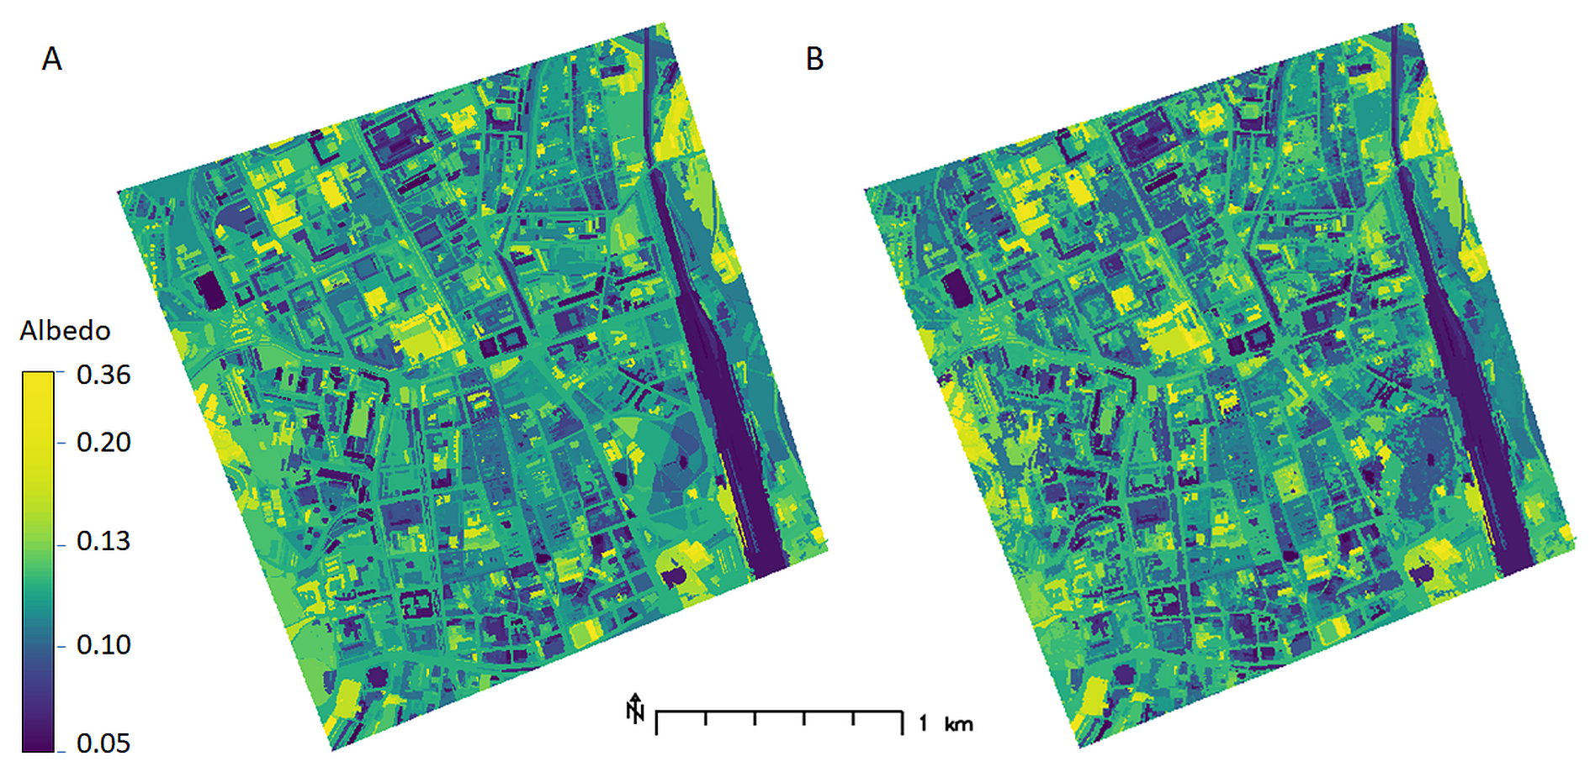
Figure 5. Broad-band albedo derived from atmospherically corrected Sentinel 2A data as a zonal mean for (A) objects of the ground land cover and (B) objects of the land cover (including trees and shrubs). See Fig. 4 for land cover maps.

The attenuation of solar light (solar transmittance τ_{v}) of tree canopy in the entire study area was estimated as a rescaled value of the effective leaf area index LAI_{e} which was calculated by a linear regression model:
LAI_{e} = 11.23* S2_{NDVI} - 1.80 (3)
where S2_{NDVI} is the calculated normalized difference vegetation index from Sentinel 2 spectral bands (as sensed on 29 June 2016) using the Eq. 9. This linear model was defined with LAI_{eTLS} derived from terrestrial laser scanning (TLS) data acquired on 4 smaller sites within the city including our smaller site in Moyzesova street (29 June 2016) as described in Hofierka et al. (2017). For this purpose, LAI_{eTLS} was calculated by the modified approach of Klingberg et al. (2016) based on Beer-Lambert law:
LAI_{eTLS} = - β . ln(R_{ground} / R_{total}) (4)
where R_{ground} is the number of ground returns (including all return types), R_{total} is the number of ground and canopy returns and β is a constant which can be expected to take a value around 2 (Richardson et al., 2009; Klingberg et al. 2016). We calculated the LAI_{eTLS} for grid cells of 10 by 10 metres to match the resolution of Sentinel 2 imagery. τ_{v} was then calculated as:
τ_{v =} (LAI_{e} – LAI_{e,min})/(LAI_{e,max} - LAI_{e,min}) (5)
where LAI_{e,min} and LAI_{e,max} are the lowest and the highest value of LAI_{e} in the study area within the tree canopy mask, respectively.
To assess the effects of trees and shrub vegetation on LST we have used LAI derived from Sentinel 2A data to increase the value of h_{c} proportionaly to the LAI values (hc2 = hc1 * (1+LAI)). This increase in h_{c} effectively results in lower LST values in areas with trees and shrubs (Fig. 6). In fact, this effectively account for moisture and evapotranspiration effects of urban greenery leading to lower LST as documented by xxx (cit).
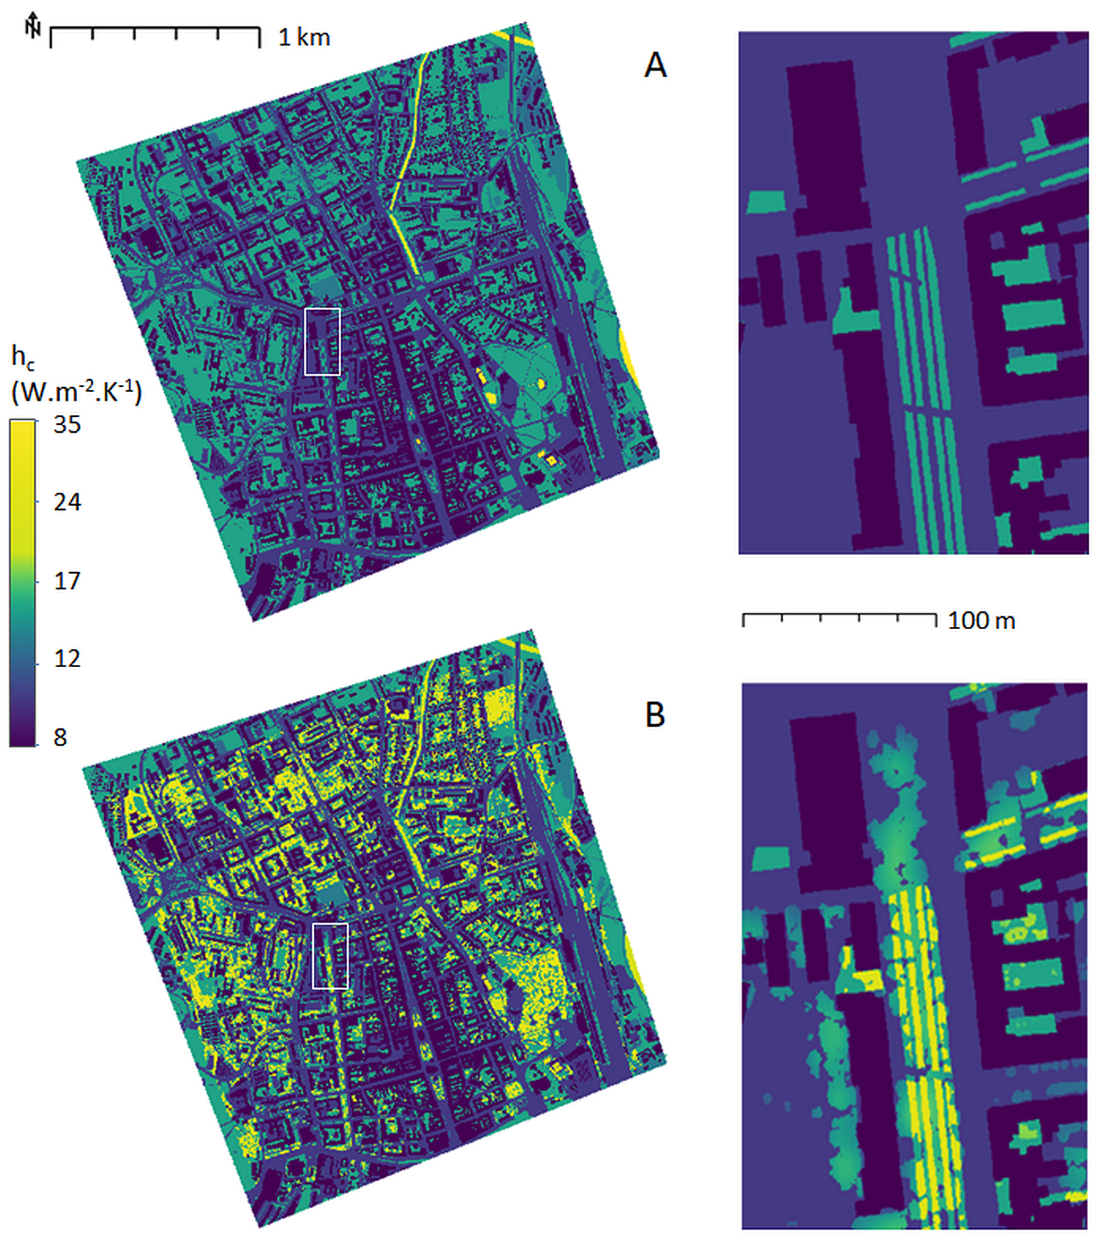
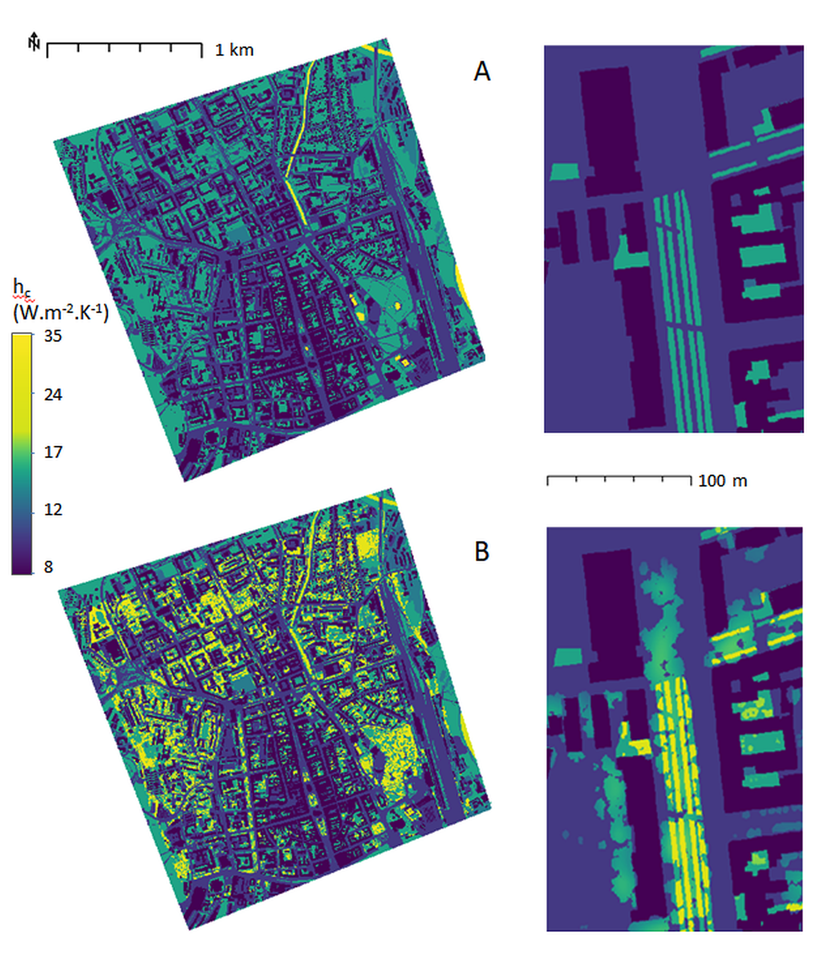
Figure 6. Spatially distributed convective heat transfer coefficient h_{c} for the entire study area and the smaller site (Moyzesova street, delineated by the white outline) assigned to the objects (A) of the land cover of the ground (Table 1) and (B) increased for the tree and shrub vegetation based on leaf area index and expert judgement.

2.4 Land surface temperature derived from Landsat 8 data
There are a number of spaceborne multispectral sensors to date providing multispectral data in visible and thermal infrared spectrum simultaneously. Such data allow for comparing the modelled LST with the brightness temperature recorded by the satellite sensors which can be converted to LST. For our purpose, we opted for the Landsat 8 data which provide the highest possible spatial resolution of thermal band among the deployed missions on the Earth’s orbit. Also there was a favourable temporal coincidence with Sentinel 2 acquisition used in our approach. We used Landsat-8 data L1T product (path 186, row 26, 30 June 2016, scene centre time 9:20:19 GMT) containing data recorded by two instruments - the Operational Land Imager (OLI) and the Thermal Infrared Sensor (TIRS) with a spatial resolution of 30 meters for visible, near infrared and short-wavelength infrared bands (bands 1-7, band 9), 15 meters for panchromatic band 8, and 100 by 30 meters for thermal bands 10 and 11. The data of thermal bands is resampled to 30 by 30 meter pixels in the L1T product which was downloaded from https://earthexplorer.usgs.gov/. Specific wavelengths of the bands are reported for example in Loveland et al. (2016). We used a single channel approach (Li et al. 2013) of Sobrino et al. (2004, 2008) for deriving LST from the TIRS band 10 as the data of band 11 is significantly more contaminated by thermal energy from outside the normal field of view (stray light) than band 10 (Barsi et al., 2014). Sobrino et al. (2004, 2008) developed the approach for Landsat 5 Thematic Mapper thermal band 6 having approximately the same spectral range as the TIRS band 10. A number of subsequent studies have been built on this approach, e.g. Amiri et al. (2009), Chatterjee et al. (2016), Deng et al. (2018).
T_{sL8} was calculated in several steps performed as map algebra operations. First, 16-bit digital numbers (DN) of band 10 were converted to at-sensor spectral radiance L_{λ} (W·m⁻²·sr⁻¹·µm⁻¹) using the radiance scaling factors provided in the metadata file associated with the downloaded satellite scene according to USGS (2018, p. 54). The recorded L_{λ} could be converted to brightness temperature at the top of atmosphere but its values do not accurately express the real land surface skin temperature. The relation of L_{λ} with surface T_{s} can be expressed by:
L_{λ} =[ε*B(T_{s}) + (1－ε) * L_{d}] *τ + L_{u},. (6)
where ε is the land surface emissivity, B(T_{s}) is the radiance of a blackbody (W·m⁻²·sr⁻¹·µm⁻¹) having the real LST T_{s} (K), τ is the atmospheric transmittance for the thermal infrared radiation recorded by band 10 and L_{d} and L_{u} is the atmospheric downward and upward radiance (W·m⁻²·sr⁻¹·µm⁻¹), respectively. Assuming a Lambertian surface, the thermal radiation of a blackbody with the temperature equivalent to the real surface temperature B(T_{s}), can be obtained according to the radiative transfer equation by revising the Eq. (6).
B(T_{s}) = [L_{λ} － L_{u}－ τ*(1－ε) *L_{d}] / (τ*ε), (7)
The three atmospheric correction parameters can be calculated through the online service of NASA (http://atmcorr.gsfc.nasa.gov) developed by Barsi et al. (2005). The following input parameters were entered in our case: latitude = 48.719°, longitude = 21.259°, GMT time = 9:20, altitude = 230 m a.s.l., temperature = 26.7°C, air pressure = 989.6 hPa (mbar), relative humidity = 46.22%. The weather parameters were extracted from the database of the OGIMET service developed by Guillermo Ballester Valor of the Spanish Meteorological Institute (www.ogimet.com) for 30 June 2016 at 9:00 GMT for Košice. The resulting values for the atmospheric correction were interpolated to the set location as follows: τ = 0.76, L_{u} = 1.98 W·m⁻²·sr⁻¹·µm⁻¹, L_{d} = 3.24 W·m⁻²·sr⁻¹·µm⁻¹.
Surface emissivity ε was calculated using the threshold method proposed by Sobrino et al. (2004) based on the normalized difference vegetation index (NDVI) and vegetation coverage P_{v}. The method considered the following three cases. For NDVI < 0.2, the entire land was considered bare soil, and its surface emissivity was the bare land typical emissivity of 0.973. When NDVI 0.2 ≤ NDVI ≤ 0.5, the pixel was regarded as mixed pixels composed of vegetation and bare soil, and its surface emissivity was calculated by the formula expressed in Eq. (8).
ε = 0.004*P_{v} + 0.986. (8)
For NDVI > 0.5, vegetation was considered to be covering the ground completely and its surface emissivity ratio was 0.99. NDVI was calculated from atmospherically corrected surface reflectance derived from the Landsat 8 OLI band 4 (ρ_{red}) and band 5 (ρ_{nir}) using the formula:
NDVI = (ρ_{red} – ρ_{nir}) / (ρ_{red} + ρ_{nir}) (9)
The correction is recommended by Sobrino et al. (2004). It was performed by the Fast Line-of-sight Atmospheric Analysis of Spectral Hypercubes (FLAASH®) algorithm in ENVI software by Harris Geospatial Solutions. The method incorporates the MODTRAN® radiation transfer model and corrects wavelengths in the visible through near-infrared and shortwave infrared regions, up to 3 µm.
Subsequently, P_{v} was calculated by the formula expressed in Eq. (10).
P_{v} = [( NDVI－ NDVI_{s}) / (NDVI_{v}－ NDVI_{s})], (10)
where NDVI_{v} = 0.5 for vegetation and NDVI_{s} = 0.2 for bare soil. After estimating B(T_{s}) the LST was obtained according to the inverse function of Planck’s law with formula:
T_{s}=K₂ / ln[K₁/B(T_{s}) + 1], (8)
where K₁ = 774.8853 W·m⁻²·sr⁻¹·µm⁻¹ and K₂ = 1,321.0789 K as stated in the metadata file of the downloaded scene.

3. Results and discussion
To document the versatility of the presented methodology, we have applied it to 3 different scenarios representing different situations and/or available data. For example, urban planners may want to analyze the effects of growing or cutting trees in a local neighborhood or effects of building renovations with higher albedo coatings or even green roofs. All the scenarios were calculated for June 30, 10:20 zonal time (9:20 GMT) with available Sentinel 2 and Landsat 8 data. In scenario 1 we were interested in exploring the LST for the city with no trees or shrub vegetation. Buildings and other urban surfaces are represented by DSM that includes building structures. Ground surface albedo is derived from land cover classes and mean areal values of albedo are derived from Sentinel 2 for 29 June 2016 (day of year 181, 10:40 zonal time). Grass, lawns and small shrubs were considered as land cover of the ground surface. Scenario 2 includes DSM with buildings, trees and shrub vegetation taller than 1.5 m. Albedo of urban surfaces including trees and shrub vegetation were derived using Sentinel 2 data and averaged for land cover zones, the cooling effect of urban greenery is expressed via heat transfer coefficient as a single parameter. In scenario 3, we were interested in the assessment of LST below the trees, so we assumed a partial transmittance of solar rays through trees and shrub vegetation effectively attenuating the beam solar irradiance on ground surfaces. Mean areal values of albedo for ground surfaces represented by land cover areas were derived from Sentinel 2 for 29 June 2016 (day of year 181, 10:40 zonal time).
The selected day and time corresponds with the availability of cloudless scenes of Landsat 8 for this moment and Sentinel 2 for previous day of June 29, 2016. The key component of LST model, the global solar irradiance I (eq. 1) was calculated using the the r.sun module in GRASS GIS (GRASS, 2018; Šúri and Hofierka, 2004). The input parameters for the r.sun module included elevations of the DSM and Sentinel-derived albedo values. The calculation was performed for clear-sky conditions with Linke's turbidity coefficient set to the typical city atmospheric conditions in June (i.e., 4.3) suggested by the r.sun manual page and using a shadowing option, i.e., the global irradiance was reduced by a beam component in shadows cast by buildings and trees (Figure 7). The calculated global solar irradiance on horizontal surfaces such as roads (orange color of global irradiance in Fig. 7) corresponds well with the measured global irradiance at the Košice airport weather station on (887.15 W.m⁻²) on June 30, 2016 at 10:00 zonal time with weather conditions close to a clear-sky situation.
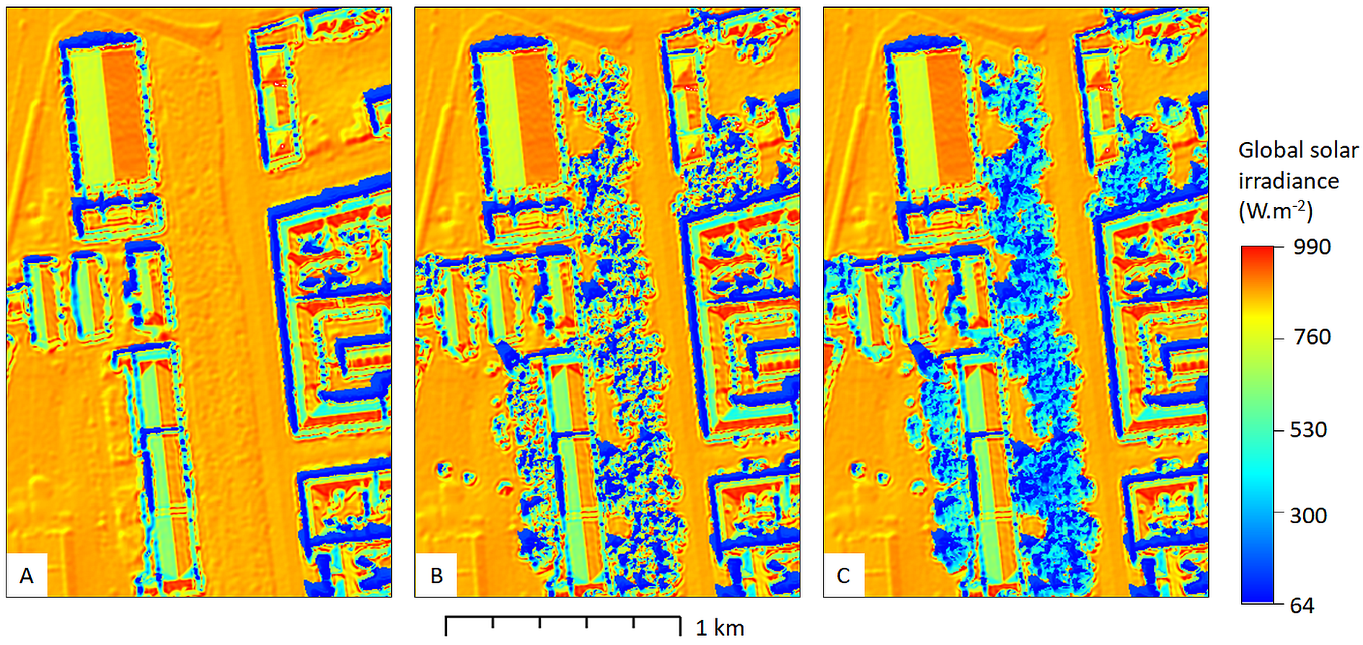

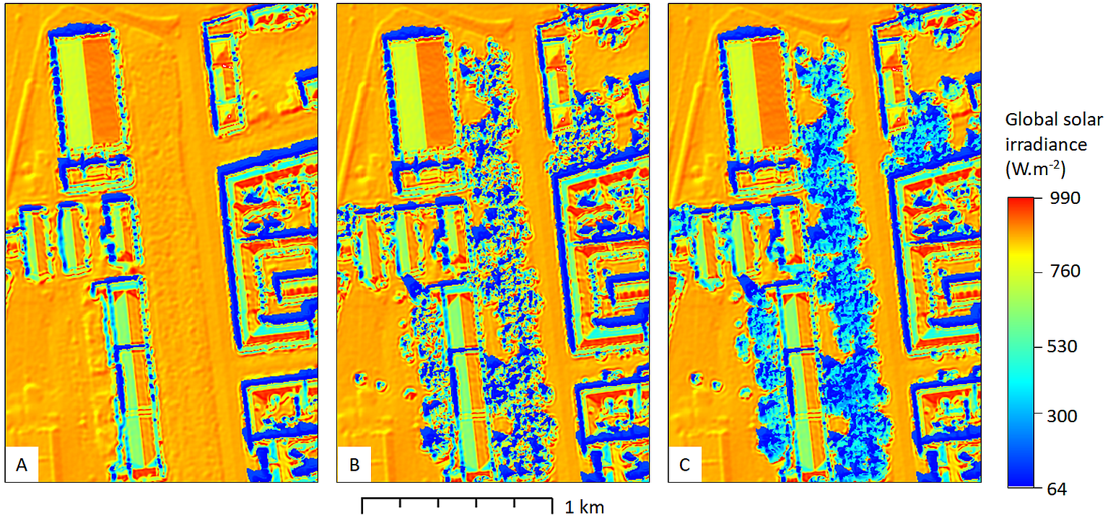
Figure 7. Global solar irradiance (W.m ⁻²) of DSM calculated by the r.sun model for June 30 at 10:20 zonal time for the smaller site as (A) scenario 1, (B) scenario 2, (C) scenario 3. See Fig. 3 for perspective views of the input DSMs and text for explanations of the three scenarios.

The suggested algorithm (lst.stefan-boltzman.sh) implemented as a shell script in GRASS GIS was used to calculate a LST for the three scenarios mentioned above. In all scenarios, we used the following single parameters of the script describing the initial conditions: the initial estimation of the land surface temperature 300 K, the effective radiant sky temperature T_{sky} = 280 K, the air temperature T_{a} = 300 K. The air temperature was taken from the Košice airport weather station. The convection heat transfer coefficient was spatially distributed according to land caver classes (Table 1) and modified for scenario 3 as described above. We have used 10 iterations of the algorithm to get sufficiently accurate results of the LST values. Figure 8 shows the resulting land surface temperature for the three scenarios for the entire study area as well as zoom-in area in site 1. The modelled temperatures are strongly associated with global irradiance, heat transfer coefficient and albedo values. Shadows cast by buildings or trees strongly decrease LST. Low values of heat transfer coefficient increases LST. In our examples, roofs have the lowest values of h_{c} effectively increasing LST for these land cover areas. As expected, higher albedo decreases LST. The scenario 1 has generally higher values of LST with temperatures in the range of xx K. The scenario 2 takes into account urban greenery thus also its cooling effects resulting in generally lower temperatures in these areas (xx K) and a larger range of values across the entire area. Areas with lower values of LST are associated with compact areas of urban greenery such as city parks and trees in residential areas. The scenario 3 represents LST below the trees and shrubs and exhibits the lowest temperatures close to the ambient air temperature.
To validate modelled values of LST, we compared the LST calculated for scenario 2 with the LST sensed by Landsat 8 TIRS Band 10 at 30 m spatial resolution. Due to the fact that we have modelled the LST values at 0.5 m spatial resolution we re-interpolated the modelled LST raster values to a lower spatial resolution of 30 m using v.surf.rst spatial interpolation module in GRASS GIS (GRASS, 2018) using tension=10, smoothing parameter=30 and minimum distance between input points 25 metres to preserve general trends in the data. Figure 9 compares the modelled LST with Landsat 8 LST. The differences in absolute values (lower left picture) shows that modelled values are in a good agreement with Landsat 8 data with a range of differences within a few degrees of K. The Pearson’s correlation coefficient r = 0.867 showing a strong correlation of both datasets. It should be noted that resampling from 0.5m to 30 m results in a substantial information loss and therefore a spatial pattern of the modelled LST in Fig. 9 is strongly dependent on the resampling technique, in this case re-interpolation parameters.
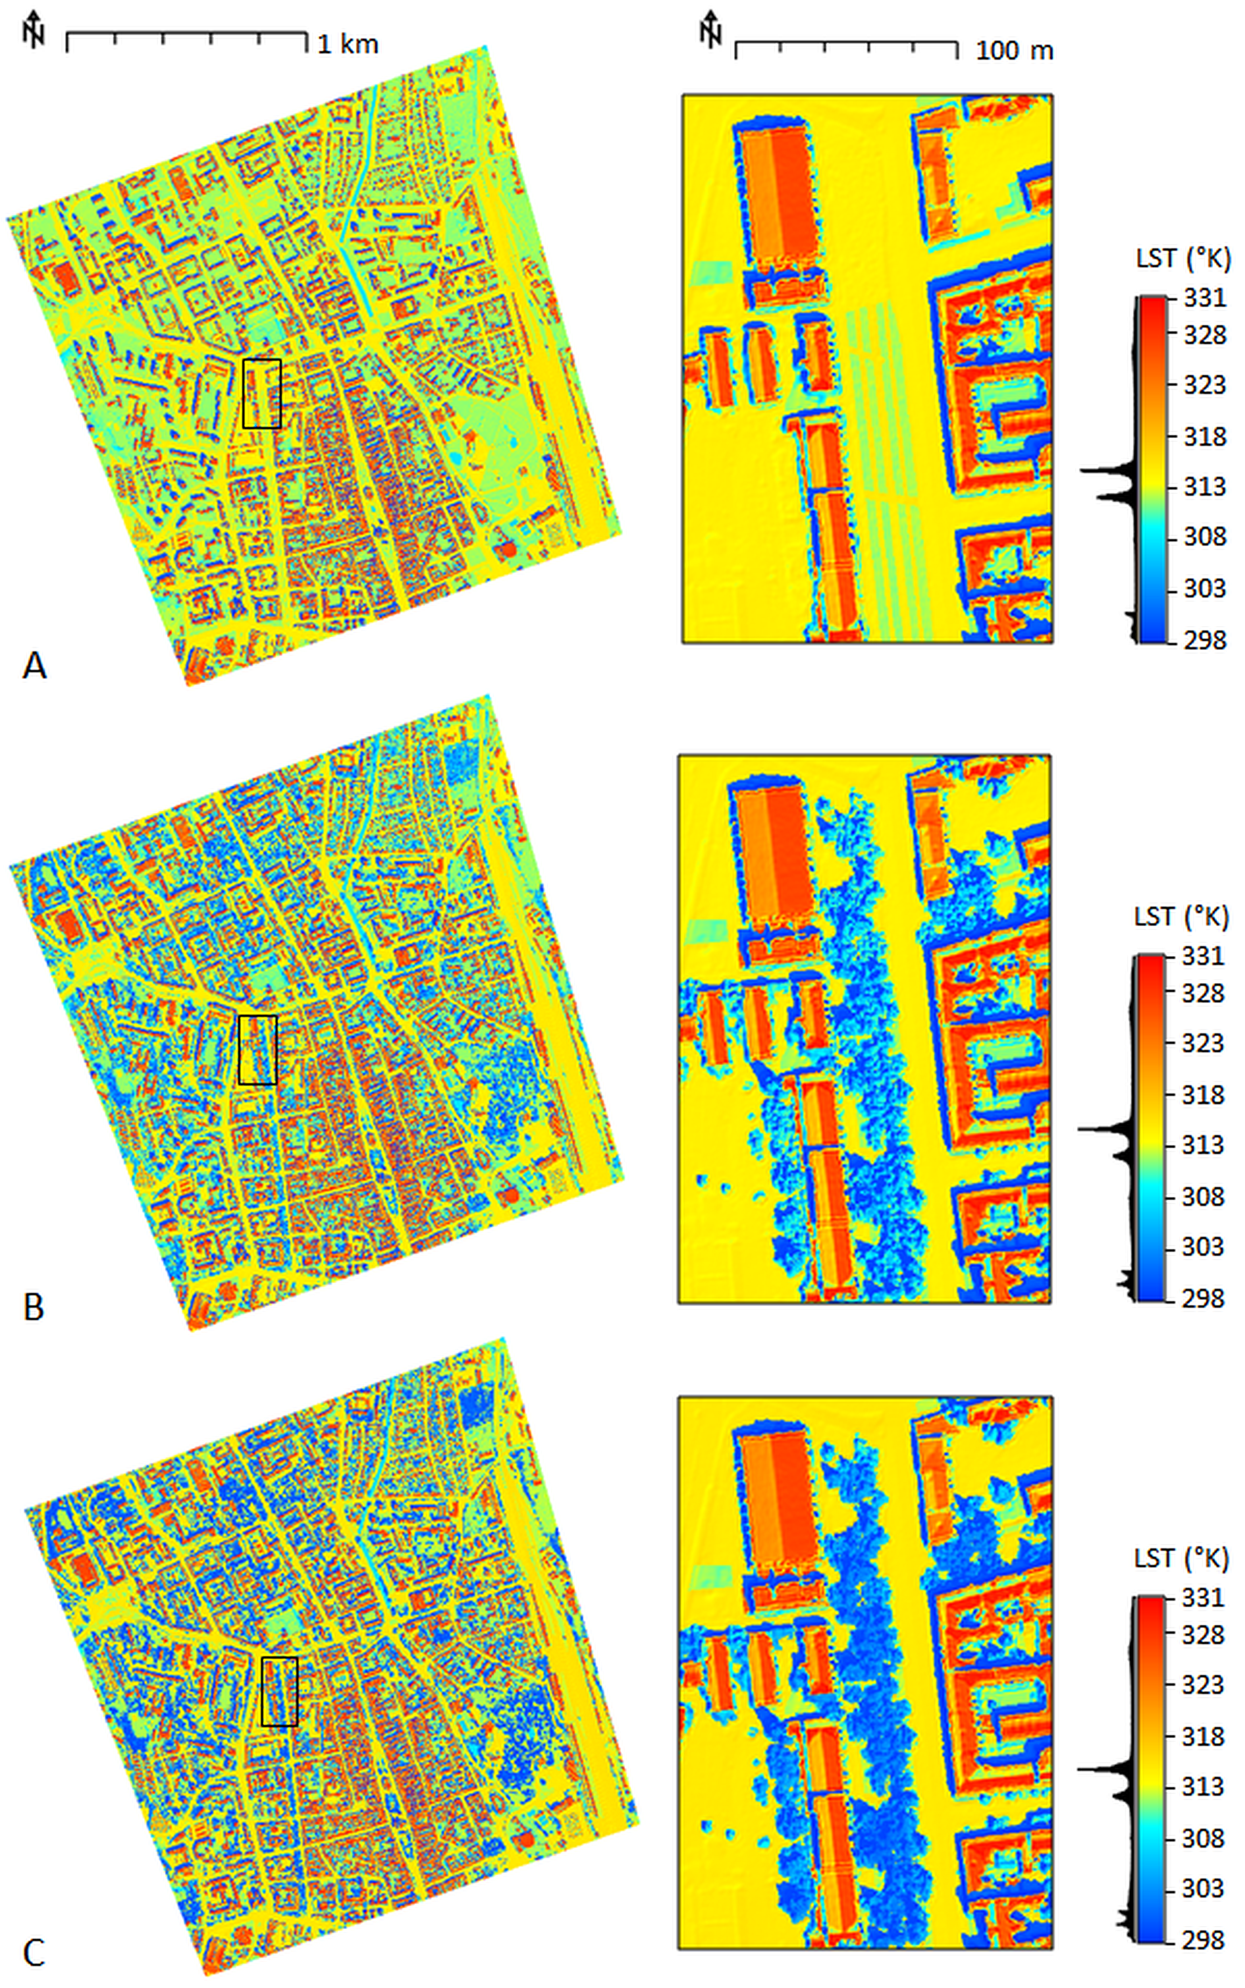
Figure 8. Modelled land surface temperature in degrees Kelvin for the entire study area and the smaller site in the black outline as (A) scenario 1, (B) scenario 2, (C) scenario 3.

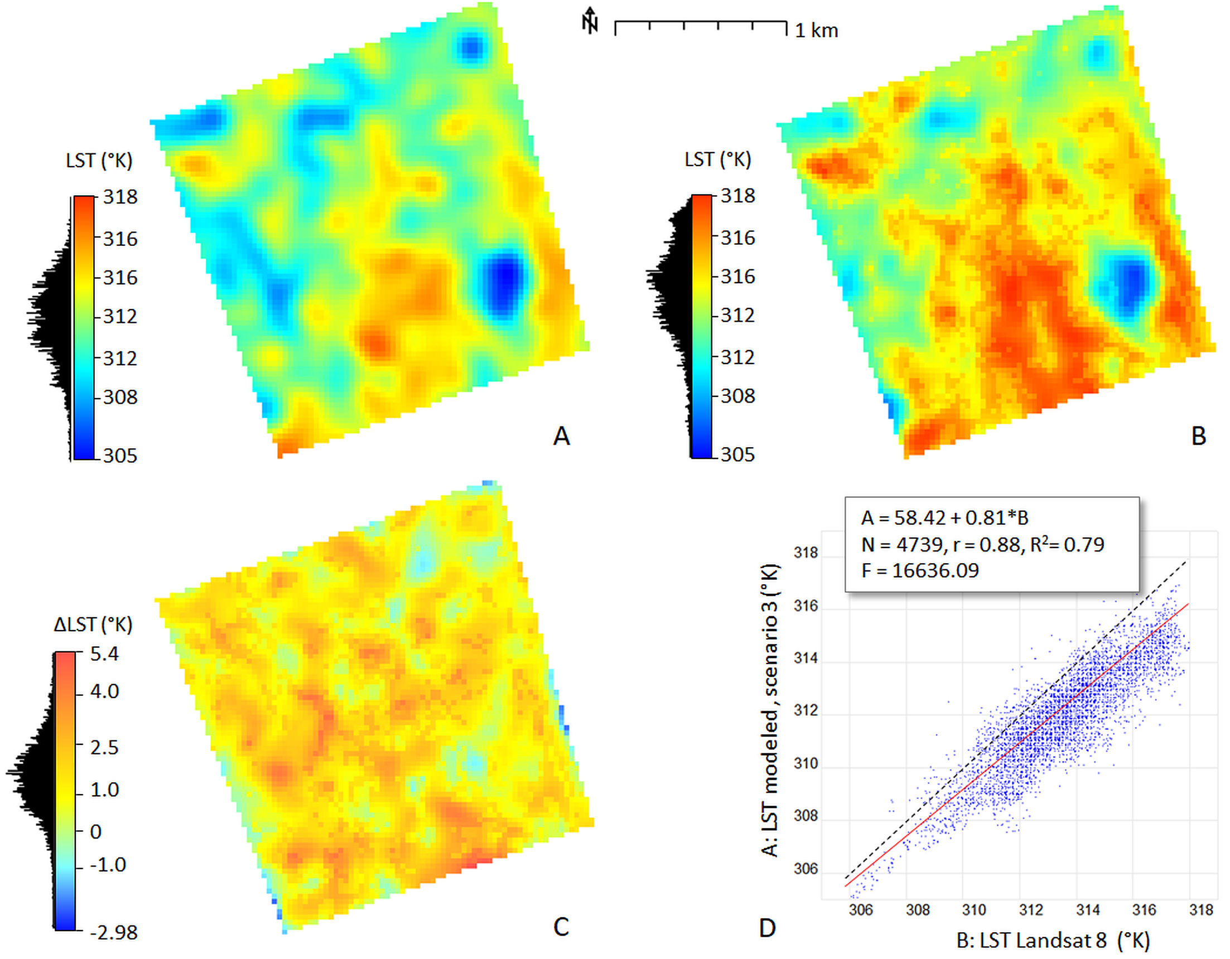
Figure 9. Comparison of (A) the modelled LST as scenario 3 derived for 30 June 2016 at 9:20 AM of GMT 10:20 zonal time and (B) bottom of atmosphere LST as sensed at the same time by the Landsat 8 TIRS sensors with band 10. (C) Differences between the Landsat8 LST and the modelled LST in degrees Kelvin, and (D) their linear relationship portrayed as a scatterplot with regression parameters. Linear trend is shown by the red solid line, black dashed line denotes 1:1 relationship. The spatial resolution of the raster layers is 30 m.

Discussion and comparison with other works.
- hc, emissivity and albedo derived from much coarser data than DEMs
- emissivity roughly estimated, rather than measured
- despite that, the developed method is a tool for LST calculation in any time moment in GIS on a fine spatial scale. Such a tool is suitable for urban planners or decision makers to model the effect of change in urban landscape on LST
- validation of the modeled LST is need to calibrate the model
- the significance of validation with L8 LST is limited for the modifiable area unit problem caused by very different spatial scales of recording the spectral radiance by L8 and modelling the LST with high-resolution DSM.
- Other physical models for LST calculation based on very complex radiative transfer modelling but our tool provides simple yet realistic estimation of LST capable of considering the dynamics of the components contributing to the surface heat budget such as solar irradiance (virtually any time moment), surface material (potentially every 5 days if Sentinel 2 is used).
- The user needs to have DEM of the area,Sentinel data is free of charge.

4. Conclusions
Land surface temperature modeling is a key component of the UHIs analysis using 3-D city models. The interaction of incoming solar radiation with urban surfaces is the main source of urban heat islands within the city. Spatial distribution of solar radiation income can be modelled based on physical and geometric principles in a relatively straightforward and accurate way. We used the r.sun module implemented in the GRASS GIS open-source software as a base for calculating the solar radiation income and we developed an algorithm based on the Stefan-Boltzmann Law, which describes the power radiated from a black body in terms of its temperature. The key inputs of the LST calculation comprise spatially distributed global solar irradiation of a DSM, convective heat transfer coefficient of the surface material, albedo of the surface and the emissivity of the material. While solar radiation income can be calculated with a high degree of reliability, the latter three parameters are difficult to be measured directly by remote sensing instruments in such a fine resolution as the solar irradiation can be computed. We assumed ideal atmospheric conditions for deriving LST in various scenarios with and without urban greenery.
The results of our LST modelling in the city of Košice showed great spatial variations that cannot be captured by current satellite sensors. However, we have demonstrated that it can be modelled by proper software tools and input data such as LiDAR and satellite imagery (e.g., Sentinel 2A). The proposed algorithm is a novel contribution to modelling the land surface temperature in a GIS environment where tools for calculating temperature of surface have not been implemented to our knowledge to date. Despite the input variables, such as convective heat transfer coefficient and surface emissivity, are difficult to ascertain with high degree of certainty and the transfer of heat in the environment being a complex phenomenon, the proposed approach provides means for assessing various scenarios of land cover in urban planning. Importantly, it enables to model surface temperature on a much finer scale than contemporary thermal sensors such as TIRS of Landsat 8 or SLSTR of Sentinel 3 sense it. We have demonstrated that Sentinel 2 data can be used in the algorithm for estimating the broad-band albedo, emissivity of surface material and transmittance of urban trees. It should be emphasized, that the resulting temperature values require validation in respect to more reliable data sets or methods.

Acknowledgement: This work originated within the SK-CN-RD-18-0015, APVV-15-0054 and VEGA 1/0300/19 research projects supported by the Slovak Research and Development Agency and Slovak Research Grant Agency VEGA, respectively and the European Space Agency project No. 4000117034/16/NL/NDe within the ESA/PECS programme.

References
Algarni, S. A., 2015. Modeling Radiation Heat Transfer for Building’s Cooling and Heating Loads: Considering the Role of Clear, Cloudy, and Dusty Conditions in Hot and Dry Climates. Theses and Dissertations. 1231. https://doi.org/10.13140/RG.2.1.4736.8405.
Alonzo, M., Bookhagen, B., McFadden, J.P., Sun, A., Roberts, D.A., 2015. Mapping urban forest leaf area index with airborne lidar using penetration metrics and allometry. Remote Sens. Environ. 162, 141-153. https://doi.org/10.1016/j.rse.2015.02.025.
Amir, A.K., Katoh, Y., Katsurayama, H., Koganei., M., Mizunuma, M., 2018. Effects of convection heat transfer on Sunagoke moss green roof: A laboratory study. Energy and Buildings 158, 1417-1428. https://doi.org/10.1016/j.enbuild.2017.11.043.
Amiri, R., Weng, Q., Alimohammadi, A., Alavipanah, S.K., 2009. Spatial-temporal dynamics of land surface temperature in relation to fractional vegetation cover and land use/cover in the Tabriz urban area, Iran. Remote Sensing of Environment 113, 2606-2617. https://doi.org/10.1016/j.rse.2009.07.021.
Arrau, C.P., Pena, M.A., 2010. The Urban Heat Island (UHI) Effect. Available online at: http://www.urbanheatislands.com (accessed 20 October 2010).
ASHRAE, 1989. Handbook Fundamentals, American Society of Heating, Refrigeration, and Air-Conditioning Engineers, Atlanta, Georgia.
Baltes, H. P., 1976. On the validity of Kirchhoff’s law of heat radiation for a body in a nonequilibrium environment. In: Wolf, E. (Ed.), Progress in Optics. Elsevier, 1–25. https://doi.org/10.1016/S0079-6638(08)70017-9.
Barsi, J.A., Schott, J.R., Palluconi, F.D., Hook. S.J. 2005. Validation of a Web-Based Atmospheric Correction Tool for Single Thermal Band Instruments. Earth Observing Systems X, Proc. SPIE Vol. 5882, August 2005, San Diego, CA. https://doi.org/10.1117/12.619990.
Barsi J.A., Schott J.R., Hook S.J., Raqueno N.G., Markham B.L., Radocinski R.G. 2014. Landsat-8 thermal infrared sensor (TIRS) vicarious radiometric calibration. Remote Sensing 6, 11607-11626. https://doi.org/
10.1117/12.619990.
Berdahl, P., Bretz, S. E., 1997. Preliminary survey of the solar reflectance of cool roofing materials. Energy and Buildings 25, 149-158. https://doi.org/10.1016/S0378-7788(96)01004-3.
Bergamasco, L., Asinari, P., 2011. Scalable methodology for the photovoltaic solar energy potential assessment based on available roof surface area: Application to Piedmont Region (Italy). Solar Energy 85, 1041–1055. https://doi.org/10.1016/j.solener.2011.02.022.
Biljecki, F., Stoter, J., Ledoux, H., Zlatanova, S., Çöltekin A., 2015. Applications of 3-D city models: State of the art review. ISPRS International Journal of Geo-Information, 4 (4), 2842-2889.
Bretz, S., Akbari, H., Rosenfeld, A., 1998. Practical issues for using solar-reflective materials to mitigate urban heat islands. Atmospheric Environment 32, 95-101. https://doi.org/10.1016/S1352-2310(97)00182-9.
Chatterjee, R.S., Singh, N., Thapa, S., Sharma, D., Kumar, D., 2016. Retrieval of land surface temperature (LST) from landsat TM6 and TIRS data by single channel radiative transfer algorithm using satellite and ground-based inputs. International Journal of Applied Earth Observation and Geoinformation, 58, 264-277. https://doi.org/10.1016/j.jag.2017.02.017.
Chen, Y.-C., Chiu, H.-W., Su, Y.—F., Wu, Y.-C., Cheng, K.-S., 2017. Does urbanization increase diurnal land surface temperature variation? Evidence and implications. Landscape and Urban Planning, 157, 247-258.
https://doi.org/10.1016/j.landurbplan.2016.06.014.
Deng, Y., Wang, S., Bai, X., Tian, Y., Wu, L., Xiao, J., Chen, F., Qian, Q., 2018. Relationship among land surface temperature and LUCC, NDVI in typical karst area. Scientific Reports 8, art. no. 641. https://doi.org/10.1038/s41598-017-19088-x.
EPA, 2008. Reducing urban heat islands: Compendium of strategies. U.S. Environmental Protection Agency. https://www.epa.gov/heat-islands/heat-island-compendium.
Estoque, R.C., Murayama, Y., Myint, S.W., 2017. Effects of landscape composition and pattern on land surface temperature: An urban heat island study in the megacities of Southeast Asia. Science of The Total Environment,
577, 349-359. https://doi.org/10.1016/j.scitotenv.2016.10.195.
Fogl, M., Moudrý, V., 2016. Influence of vegetation canopies on solar potential in urban environments. Applied Geography, 66, 73-80. https://doi.org/10.1016/j.apgeog.2015.11.011.
Garg, H. P., 1982. Treatise on solar Energy, vo1: Fundamental of solar energy. Chichester: John Wiley & Sons.
Gašparović, I., Gašparović, M., Medak, D., 2018. Determining and analysing solar irradiation based on freely available data: A case study from Croatia. Environmental Development, 26, 55-67. https://doi.org/10.1016/j.envdev.2018.04.001
.
Gill, S.E., Handley, J.F., Ennos, A.R., Pauleit, S., 2007. Adapting Cities for Climate Change: The Role of the Green Infrastructure. Built Environment 33, 115-113. https://doi.org/10.2148/benv.33.1.115.
GRASS, 2018. GRASS GIS [online]. http://grass.osgeo.org/, December 2018.
Hofierka, J., 1997. Direct solar radiation modelling within an open GIS environment. In Proceedings of the 1997 Joint European GI Conference, Vienna, Austria, pp. 575–584.
Hofierka, J., Gallay, M., Kaňuk, J., Šupinský, J., Šašak, J. (2017). High-resolution urban greenery mapping for micro-climate modelling based on 3-D city models. The International Archives of the Photogrammetry, Remote Sensing and Spatial Information Sciences (ISPRS Archives), XLII-4/W7, pp. 7-12. https://doi.org/10.5194/isprs-archives-XLII-4-W7-7-2017.
Hu, L. & Wendel, J., 2019. Analysis of urban surface morphologic effects on diurnal thermal directional anisotropy. ISPRS Journal of Photogrammetry and Remote Sensing, 148, pp. 1-12. https://doi.org/10.1016/j.isprsjprs.2018.12.004.
Jensen, J.R., 2006. Remote Sensing of the Environment: An Earth Resource Perspective. 2nd edition. Pearson.
Klingberg, J., Konarska, J., Lindberg, F., Johansson, L., Thorsson, S., 2017. Mapping leaf area of urban greenery using aerial LiDAR and ground-based measurements in Gothenburg, Sweden. Urban Forestry and Urban Greening 26, 31-40. https://doi.org/10.1016/j.ufug.2017.05.011.
Korhonen L., & Morsdorf F., 2014. Estimation of Canopy Cover, Gap Fraction and Leaf Area Index with Airborne Laser Scanning. In: Maltamo M., Næsset E., Vauhkonen J. (eds) Forestry Applications of Airborne Laser Scanning. Managing Forest Ecosystems, vol 27. Springer, Dordrecht, 397-417. https://doi.org/10.1007/978-94-017-8663-8_20.
Liu, J., Heidarinejad, M., Graci, S., Srebric, J., 2015. The impact of exterior surface convective heat transfer coefficients on the building energy consumption in urban neighborhoods with different plan area densities. Energy and buildings 86, 449-463. https://doi.org/10.1016/j.enbuild.2014.10.062.
Loveland, T.R. & Irons, J.R., 2016. Landsat 8: The plans, the reality, and the legacy. Remote Sensing of Environment 185, 1-6. https://doi.org/10.1016/j.rse.2016.07.033.
Li, Z.-L., Tang, B.-H., Wu, H., Ren, H., Yan, G., Wan, Z., Trigo, I.F., Sobrino, J. A., 2013. Satellite-derived land surface temperature: Current status and perspectives, Remote Sensing of Environment 131, 14-37. https://doi.org/10.1016/j.rse.2012.12.008.
Ma, Y., Kuang, Y., Ningsheng, H., 2010. Coupling urbanization analysis for studying urban thermal environment and its interplay with biophysical parameters based on TM/ETM+ imagery. International Journal of Applied Earth Observation and Geoinformation 12, 110-118. https://doi.org/10.1016/j.jag.2009.12.002.
Morsdorf, F., Kötz, B., Meier, E., Itten, K.I., Allgöwer, B., 2006. Estimation of LAI and fractional cover from small footprint airborne laser scanning data based on gap fraction. Remote Sensing of Environment 104, 50-61. https://doi.org/10.1016/j.rse.2006.04.019.
Mirsadeghi, M., Costola, D., Blocken, B., Hensen, J.L.M., 2013. Review of external convective heat transfer coefficient models in building energy simulation programs: implementation and uncertainty, Applied Thermal Engineering 56, 134–151. https://doi.org/10.1016/j.applthermaleng.2013.03.003.
Muneer, T., 1990. Solar radiation model for Europe. Building Services Engineering Research and Technology 11, 153-63. https://doi.org/10.1177/014362449001100405.
Mushore, T.D., Odindi, J., Dube, T., Matongera, T.N., Mutanga, O., 2017. Remote sensing applications in monitoring urban growth impacts on in-and-out door thermal conditions: A review. Remote Sensing Applications: Society and Environment, 8, 83-93. https://doi.org/10.1016/j.rsase.2017.08.001.
Nakata-Osaki, C.M., Souza, L.C.L., Rodrigues,D.S., 2018. THIS – Tool for Heat Island Simulation: A GIS extension model to calculate urban heat island intensity based on urban geometry. Computers, Environment and Urban Systems, 67, 157-168. https://doi.org/10.1016/j.compenvurbsys.2017.09.007.
Neteler, M., Bowman, M. H., Landa, M., Metz, M., 2012. GRASS GIS: A multi-purpose open source GIS, Environmental Modelling & Software 31, 124–130. https://doi.org/10.1016/j.envsoft.2011.11.014.
Neteler, M., Mitasova, H., (2008). Open Source GIS: A GRASS GIS Approach. Third Edition. The International Series in Engineering and Computer Science, Volume 773, Springer, New York.
Nichol, J.E., 1994. A GIS-Based Approach to Microclimate Monitoring in Singapore’s High-Rise Housing Estates. Photogrammetric Engineering and Remote Sensing 60, 1225-1232.
Oke, T.R., 1981. Canyon geometry and the nocturnal urban heat island: comparison of scale model and field observations. Journal of Climatology, 1, 237-254.
Onačillová, K., Gallay, M., 2018. Spatio-temporal analysis of surface urban heat island based on LANDSAT ETM+ and OLI/TIRS imagery in the city of Košice, Slovakia. Carpathian Journal of Earth and Environmental Sciences 13, 395 - 408. https://doi.org/10.26471/cjees/2018/013/034.
Richardson, J.J., Moskal, L.M., Kim, S.H., 2009. Modeling approaches to estimate effective leaf area index from aerial discrete-return LIDAR. Agric. For. Meteorol. 149, 1152-1160. http://doi.org/10.1016/j.agrformet.2009.
02.007.
Romero, L. F., Tabik, S., Vías, J. M., Zapata, E. L., 2008. Fast clear-sky solar irradiation computation for very large digital elevation models. Computer Physics Communications 178, 800–808. https://doi.org/10.1016/
j.cpc.2008.01.048.
Ruiz-Arias, J. A., Tovar-Pescador, J., Pozo-Vázquez, D., Alsamamra, H., 2009. A comparative analysis of DEM-based models to estimate the solar radiation in mountainous terrain. International Journal of Geographical Information Science 23, 1049–1076. https://doi.org/10.1080/13658810802022806.
SNAP (2018). SNAP - ESA Sentinel Application Platform v6.0.0, Available online: http://step.esa.int/main/download/.
Smith, A.M.S., Falkowski, M.J., Hudak, A.T., Evans, J.S., Robinson, A.P., Steele, C.M., 2009. A cross-comparison of field, spectral, and lidar estimates of forest canopy cover. Canadian Journal of Remote Sensing 35, 447-459. https://doi.org/10.5589/m09-038.
Sobrino, J.A., Jimenez-Munoz, J.C., Paolini, L., 2004. Land surface temperature retrieval from LANDSAT TM 5. Remote Sensing of Environment 90, 434-440. https://doi.org/10.1016/j.rse.2004.02.003.
Sobrino, J.A., Jiménez-Muñoz, J.C., Sòria, G., Romaguera, M., Guanter, L., Moreno, J., Plaza, A., Martínez, P., 2008. Land surface emissivity retrieval from different VNIR and TIR sensors. IEEE Trans. Geosci. Rem. Sens. 46, 316-327. https://doi.org/10.1109/TGRS.2007.904834.
Soltani, A., Sharifi, E., 2017. Daily variation of urban heat island effect and its correlations to urban greenery: A case study of Adelaide, Frontiers of Architectural Research, 6(4), 529-538. https://doi.org/10.1016/j.foar.2017.08.001.
Syed, T.H., Riyas, M.J., Kuenzer, C., 2018. Remote sensing of coal fires in India: A review. Earth-Science Reviews, 187, 338-355. https://doi.org/10.1016/j.earscirev.2018.10.009.
- Šúri, M., Hofierka, J., 2004. A new GIS-based solar radiation model and its application to photovoltaic assessments. Transactions in GIS 8, 175–190. https://doi.org/10.1111/j.1467-9671.2004.00174.x.

Tooke, T.R., Coops, N.C. Christen, A., Gurtuna, O., Prévot, A., 2012. Integrated irradiance modelling in the urban environment based on remotely sensed data. Solar Energy 86, 2923-2934. https://doi.org/10.1016/
j.solener.2012.06.026.
USGS, 2018. Landsat 8 (L8) Data Users Handbook. LSDS-1574 Version 3.0, 18 October 2018. Department of the Interior U.S. Geological Survey. EROS, Sioux Falls, South Dakota, USA. Accessed online: 21 Dec. 2018. https://www.usgs.gov/media/files/landsat-8-data-users-handbook.
Vanino, S., Nino, P., De Michele, C., Bolognesi, S. F., D'Urso, G., Di Bene, C., Pennelli, B., Vuolo, F., Farina, R., Pulighe, G., Napoli, R., 2018. Capability of Sentinel-2 data for estimating maximum evapotranspiration and irrigation requirements for tomato crop in Central Italy, Remote Sensing of Environment 215, 452-470. https://doi.org/10.1016/j.rse.2018.06.035.
Voogt, J.A., Oke, T.R., 2003. Thermal remote sensing of urban climates. Remote Sensing of Environment 86, 370-384. https://doi.org/10.1016/S0034-4257(03)00079-8.
Vollaro, A., Galli, G., Vallati, A., 2015. CFD Analysis of Convective Heat Transfer Coefficient onExternal Surfaces of Buildings. Sustainability 7, 9088-9099. https://doi.org/10.3390/su7079088.
Whillier, A., 1967. Design factors influencing solar collectors in low temperature engineering applications of solar energy. ASHRAE, New York.
Yuan, F., Bauer, M.E., 2007. Comparison of impervious surface area and normalized difference vegetation index as indicators of surface urban heat island effects in Landsat imagery. Remote Sensing of Environment 106, 375-386. https://doi.org/10.1016/j.rse.2006.09.003.

Table captions
Table 1. Convective heat transfer coefficients assigned to land cover categories in the Košice city.

Figure captions
Fig. 1. Location of the study area in the Košice City, Slovakia. The cyan line outlines the area subject to airborne lidar and photogrammetric mapping. The red outline delineates a site (Moyzesova street) selected for a detailed view on the right with aerial orthoimage as natural color composite. The background maps are © Copernicus, Sentinel 2A image acquired on 29 June 2016.
Fig. 2. Perspective 3-D view of the entire study area (cyan outline in Fig. 1) for which the 3-D city model was generated. 3-D buildings are dispalyed on a digital terrain model in the ArcScene software by ESRI.
Fig. 3. A detailed view of 3-D city model (left) and lidar based digital surface models (DSM) for the smaller site (Moyzesova street) including buildings (middle) and vegetation (right). The area size is 200 m by 400 m. DSM cell size is 0.50 m.
Fig. 4. Land cover in 21 categories representing the material of the ground below the trees and shrub for the entire study area and smaller site (Moyzesova street).
Fig. 5. Broad-band albedo derived from atmospherically corrected Sentinel 2A data for (a) land cover classes including trees and (b) ground cover (without trees). The land cover classes were derived by manual interpretation of aerial orthoimagery and field survey.
Fig. 6. Spatially distributed convective heat transfer coefficient hc (W.m-2.K-1) for the entire study area and smaller site (Moyzesova street) based on land cover of the ground (upper row) (Table 1) and increased for the tree and shrub vegetation based on leaf area index and expert judgement (bottom row).
Fig. 7. Global solar irradiance (W.m -2) calculated by the r.sun model for June 30 at 10:20 zonal time for the smaller site and a) scenario 1, b) scenario 2, c) scenario 3.
Fig. 8. Modelled land surface temperature for the entire study area and smaller site and a) scenario 1, b) scenario 2, c) scenario 3.
Fig.9. Modelled temperature of land cover surface (left) derived for 30 June 2016 at 9:20 AM of GMT 10:20 zonal time and land surface temperature at the bottom of the atmosphere (right) as sensed at the same time by Landsat 8 TIRS, band 11. The spatial resolution (raster cell size) is 30 m, the units of temperature are degrees Kelvin.

