Visualizing space-time dynamics of terrain micromorphology online
Ján Šasak et al.

Manuscript in preparation to
Earth surface processes and landforms
or International Journal of Digital Earth
Introduction
The landscape is a complex structure that is developing dynamically under the influence of natural and anthropogenic factors (Butler and Berglund, 2012). Landscape development is a variable process in which certain trends can be observed, depending on the observed time horizon and the range of the studied area (Higgins et al., 2012). To properly understand the processes affecting the landscape dynamics, it is necessary to monitor these processes at certain temporal and spatial scales (Houet et al., 2010). Periodic mapping can identify natural or anthropogenic factors that are critical to landscape dynamics and possibly predict their further potential impact (Antrop, 1998). The landscape dynamics often manifest themselves in the form of slope movements such as landslides, which not only change the terrain morphology but also affect the spatial distribution of objects on the terrain. Landslides are conditioned by endogenous, but especially exogenous processes, the action of which manifests itself in the form of erosion, transport and accumulation of material (Clague and Stead, 2012; De Blasio, 2011). By analyzing the mentioned processes, it is possible to evaluate the volume changes of the landslide and the influence of various phenomena (meteorological, hydrological, anthropogenic) on the landslide dynamics (Barbarella et al., 2015; Martha et al., 2010). In recent years, modern mapping methods such as laser scanning (Barbarella and Fiani, 2017; Prokop and Panholzer, 2009; Oppikofer et al., 2009) or UAV photogrammetry (Peternel et al., 2017; Lindner et al., 2016; Eker et al., 2018) have also been used to monitor landslides. Terrestrial laser scanning (TLS) produces dense 3D point clouds that capture terrain and objects on it at a high level of detail - on a micro-scale (Lague et al., 2013). The advantage of TLS is in the capability of mapping the terrain surface underneath the vegetation canopy what is very restricted with the UAV photogrammetry (Bitelli et al., 2004). The level of detail captured enables to evaluate the volume changes of the material very accurately that and at the same time to analyze the factors that cause these volume changes. Acquiring representation of the terrain micromorphology allows for upscaling the terrain model (decreasing its spatial resolution) thus studying the landslide on a multiple-levels of scale.
Current research in the field of landslide mapping focuses on the analysis of their dynamics by various methods and mapping devices (Jaboyedoff et al., 2012; Longoni et al., 2016; Niethammer et al., 2012). Starek et al. (2013) evaluated volume changes on a small shoreline by repeated mapping using the TLS method. They also dealt with the possibilities of effective visualization of dynamic 3D processes in the landscape using a space-time cube, as well as the possibilities of visualization of volume changes in landslides. In contrast, UAV photogrammetry was used by Andriolo et al. (2020) for mapping the beach dunes dynamic. Based on the three detailed digital terrain models (DTMs) derived from UAV photogrammetry data, they analyzed the changes in elevation and slope of the dunes. UAV photogrammetry and TLS make it possible to capture the terrain in great detail, but with a small number of measurements performed in a short time, it is difficult to objectively evaluate the dynamics of landslide areas, or predict their further evolution. Landslides in general are often conditioned by other factors (rainfalls, surface runoff, anthropogenic activity), which affect their initialization and subsequent progress. Therefore, it is necessary to evaluate the dynamics of landslides, as well as other erosion and accumulation processes in correlation with the phenomena that condition them. Longoni et al. (2016) in their work focused on mapping the erosion of the Alpine riverbed in four small localities (several m²). They used the TLS method and mapped each site from a single scanning position, ensuring data homogeneity. However, with this mapping method, data shadows may appear in the resulting data due to terrain and other object configurations. Longoni et al. (2016) derived the DTMs from the TLS data and calculated the volume changes between measurements. These then correlated with the amount of precipitation that fell in the area during the observed period. Such a methodological procedure makes it possible to evaluate the effect of precipitation on terrain erosion. A different approach to landslide mapping is presented by Pfeiffer et al. (2019), who combines the airborne laser scanning (ALS), TLS and UAV based laser scanning (ULS) methods for mapping a slope displacement in the Alps and compares the obtained data in terms of accuracy and level of detail. Based on TLS data, they further analyzed the level of erosion and accumulation of material, which they visualized in the form of digital models of difference (DoDs). The wide range of available software nowadays allows to efficiently process and analyze big data from laser scanning or UAV photogrammetry, which capture dynamic phenomena in the country. On the other hand, the visualization of this data can be problematic, as it is necessary to visualize not only the 3D phenomenon they represent but also the change of this phenomenon over time. Tools implemented in GIS software, but also in the online environment enable various forms of visualization of dynamic phenomena, whether in the form of static images or dynamic animations. For visualizing the landslides dynamic, profiles guided through a series of DTMs and DoD showing elevation changes over time are widely used. Very effective static visualization of dynamic phenomena is enabled by the so-called space-time cubes (Starek et al. 2013; Hardin et al. 2014; Mitasova et al. 2012). A space-time cube is a visualization tool where 3D data, e.g. DTMs with X, Y, Z coordinates are displayed as a vertical voxel structure. The individual DTMs are stacked vertically with a certain spacing, which represents the time and the space between them is interpolated. This creates a continuous object with which the change of the displayed phenomenon over time can be represented through sections or the selection of certain values. In this way, dynamic 3D data can be displayed statically. Relevant publications dealing with similar topics are presented in Table 1. The data from a periodic mapping of the landslide of the Belá Riverbank have already been partially published in the article by Rusnák et al. (2020). This article was focused on the evaluation of landslide volume changes and the analysis of the mutual relationship between the riverbed and the landslide based on network analysis. In our article, we will work with a longer time series of measurements, which allows us to more accurately reconstruct the landslide evolution and roughly sketch its further development.
author | mapping method | number of measure-ments | observation time | area (hectare) | landscape type
Starek et al. | TLS | 8 | 20 months | 0,004 | meandering river
Anders et al. | TLS | 2967 | 4 months | 22,50 | beach dune
Longoni et al. | TLS | 7 | 14 months | 0,003 - 0,026 | alpine river
Eker et al. | UAV photogrammetry | 3 | 12 months | 7,46 | landslide
Andriolo et al. | UAV photogrammetry | 3 | 4 months | 5,00 | beach dune
Huff et al. | TLS | 5 | 11 months | - | marsh

This article aims to present a complex methodological procedure focused on detailed and precise periodical mapping of the river bank landslide by the TLS mapping method. An important part of this study will also be the analysis of volume changes based on DTMs and the correlation with flow discharge and precipitation values. Finally, we will also focus on advanced 3D visualization of landslide dynamics using the space-time cube method.
The studied landslide affects human activities in the landscape and poses a potential threat to agricultural and water management activities. Proper understanding and interpretation of the geomorphological processes taking place on a given landslide will allow more effective planning of anthropogenic activities in the country and also protect human health and lives.

Area of interest

The area of interest represents a slope landslide on the left bank of the Belá River in the cadastral area of ​​the Vavrišovo village, in the Liptov region in northern Slovakia (Fig. 1). The Belá River originates at the confluence of the Tichý and Kôprovský Potok streams, which originate in the High Tatras and drain the western part of the High Tatras and the eastern part of the Western Tatras. The catchment area of ​​the Belá river covers an area of ​​244 km² with an altitude from 627 m a.s.l. at the confluence with the Váh River up to 2494 m above sea level in spring areas. The tributaries of the Belá River are mainly mountain streams springing in the Western and High Tatras, which are relatively short but overcome a large elevation gain, which means that they have high kinetic energy and the ability to transport material. A large part of the Belá River basin lies in the Tatra National Park and its protected zone. The highest parts of the basin form the national nature reserves Tichá and Kôprová Dolina valleys with the highest degree of nature protection. The geological structure of the area is diverse. The mountain massifs of the Western and High Tatras are made up mainly of granites and granodiorites, while in the lower parts of the Belá River valley various types of sediments predominate - glacigenous, glacifluvial to deluvial and fluvial. The area of ​​the landslide itself lies at the interface of deluvial and glacifluvial sediments, which form the terrace of the Belá River. The eroded slope is formed by claystone and near the riverbed, there are fluvial sediments. The geological structure and properties of the rocks together with other factors (precipitation activity, undercutting of the slope by the Belá River) cause instability of the area and its increased erosion. Erosion is partially slowed down by tree vegetation, which is located on a terrace at the upper edge of the landslide. The vegetation cover here consists mainly of pines and spruces, which are characterized by a shallow root system, so their impact on the cohesion of the subsoil is small. The same species composition of tree vegetation is also found on the opposite bank of the Belá River, where it is sporadically supplemented by deciduous trees such as willows, poplars and birches. The Liptovská kotlina basin, which also includes the area of ​​interest, is characterized by a moderately cold climate with an average annual air temperature of 4 - 6 °C in the lower areas. As the altitude increases, the air temperature decreases and the total precipitation increases. It is the amount of precipitation that falls in the Belá River basin that affects the values ​​of surface runoff and thus also the values ​​of the flow in the riverbed. There are two gauging stations on the Belá River. At the Podbanské station, the average annual flow is 3.5 m³.s⁻¹, at the Liptovský Hrádok station it is already 6.8 m³.s⁻¹. In addition to precipitation, the flow is also affected by the melting of snow in the Tatra Mountains in the spring and early summer, or by summer storms.
Figure 1. Location of the area of interest with a detailed view of the landslide.

Data and Methods
The area of interest has been periodically mapped from 2016 until 2019 every three months, i.e. in March/April, June, September and November. The time moments were selected to capture the state of the terrain morphology at typical phases of vegetation and local hydrologic annual regime. The terrestrial laser scanning (TLS) method was used to capture the geometric structure of the mapped landslide, which was supplemented by measurements with the GNSS receiver Topcon Hyper II used to align the ground control points which served for transforming TLS point cloud from the local coordinate system into the national coordinate system. The mapping devices were carried to the landslide by walk, as the access road does not lead directly to the mapping site.

Periodic monitoring of the landslide was preceded by reconnaissance of the terrain, as it is an unstable area where health and life may be endangered. In the first step, the available data were analyzed, especially satellite and aerial orthophoto images, based on which we approximately determined the extent of the mapped area. In the second step, we proceeded to the field inspection of the landslide directly in the area of interest, where the positions of the laser scanner were determined, from which the landslide was then mapped using TLS. The location of the laser scanner position in the upper part of the landslide (on its edge) has changed over time, as the landslide is very dynamic and its edge gradually erodes and the material is carried to the lower parts of the slope, respectively up to the Belá River. The complete workflow shows figure 2.
Figure 2. Schematic workflow of TLS mapping and data processing as well as volume changes computation and visualization.
Terrestrial laser scanning and GNSS measurements
The TLS technique involves identifying topographic terrain and building a 3D point cloud under vegetation canopy to create a digital terrain model (DTM). Data were collected using a Riegl VZ-1000 scanner with data capture up to 450 m and 300 MHz pulse rate frequencies. The survey strategy was designed to systematically monitor the cut-bluff. The initial campaign was performed in March 2016, and systematic surveys continued on average every three months until June 2020. During the campaigns, 10 scan positions (7 located on the upper scarp edge of the cut-bluff slope and 3 opposite the landslide on the gravel point bar) were used (Fig. 3). Individual positions were adapted to local conditions during scanning and terrain/vegetation configuration. At the start of the study, the upper scarp edge was covered by vegetation and tall trees which prevented the laser from reaching the ground. Therefore, the scanning positions were placed at smaller intervals to model the entire cut-bluff and improve co-registration of individual scans. Individual scanning campaigns were processed sequentially to create a time-series database of the DTM. Processing a single campaign consisted of several steps. First, mutual scanning positions were registered in the project’s coordinate system. This involved coarse registration by manual identification of corresponding points followed by automatic alignment using multi-station adjustment (MSA) tool implemented in RiSCAN Pro software to improve registration accuracy. Automatic MSA registration uses the iterative closest point (ICP) algorithm to minimize deviations between identical planes derived from each scan position. To evaluate volumetric changes in the study site, it was necessary to locate each scan campaign within a single unified coordinate system; in this case, the S-JTSK national coordinate system (EPSG code 5514) and the Baltic Sea geodetic reference system after adjustment were used. During the scan campaigns, 20 to 30 ground control points (used for registration within the unified coordinate system) were measured by GNSS, temporarily placed around scanners, and signalized by black-white checkerboards. The next step was to classify point clouds and extract points representing the ground surface. The point cloud classification was performed in two ways: first, automatically and then manually. Points representing ground and vegetation were identified using the vegetation filter tool implemented in RiSCAN Pro software. Then, the point cloud thus classified was visually checked to see if the class was accurately identified using the automatic approach. Problems with automatic classification were noticeable in the vicinity of abrupt vertical changes in slope such as cliffs, overhangs, and escarpments. Overall, more than 70% of all points were removed by filtration because only points representing ground were required to further process the data. To remove redundant points and increase homogenization of spacing between points, the points representing ground were optimized by reducing the number. The resulting time-series point cloud database was used to evaluate surface volume changes. Quantification of volumetric changes at the study site over time was carried out by Cloud2Cloud and M3C2 tools in CloudCompare software. The results from the two different analyses were identical. To interpret the results of the analysis of volumetric change, it is necessary to specify the standard deviation error (SDE) that accumulated during data collection and processing. Table 2 shows the total SDE for each scan campaign based on the precision of the TLS device, the SDE of GNSS measurements, the SDE of project coordinate system registration, and the SDE of global coordinate system registration. The SDE of volumetric changes is the maximum limit for determining the volume change due to the accumulation of measurement and data processing errors. Thus, a change of less than the calculated limit may not represent a volume change between survey periods. The standard deviation of the volume change was calculated by multiplying the total standard deviation of the measurement by the landslide area, which is approximately 5,970 m². celá podkapitola copy – paste zo spoločného článku so SAVkou
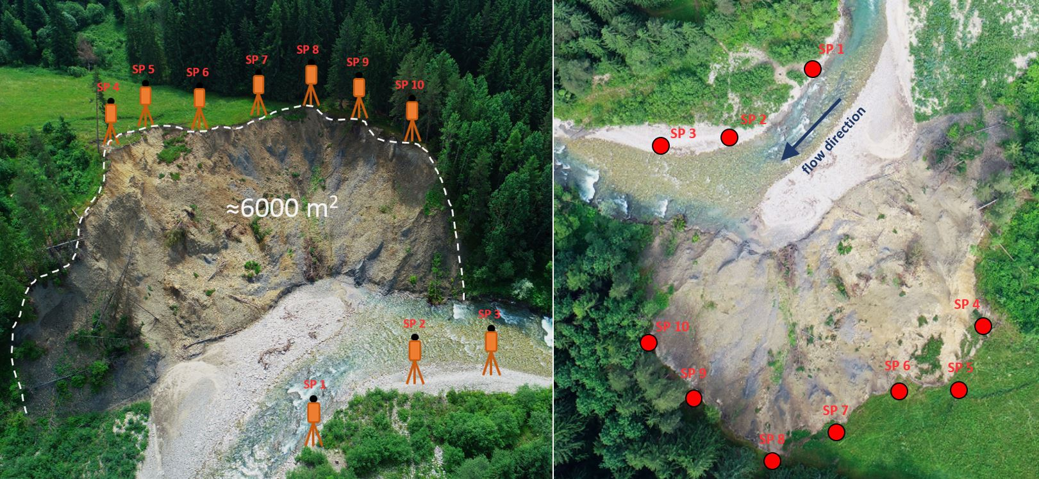
Figure 3. Terrestrial laser scanner positions around the landslide.
Generating digital terrain models
The resulting point cloud, which was created by processing raw TLS data, was used to derive digital terrain models (DTM). The point density of all point clouds used to derive the DTM was approximately the same and reached an average of 1000 points/m². However, the real point density changed with increasing distance from the laser scanner. The point density around the scanner was also a few 100 thousand points/m², in the farthest places from the scanner it was only a few hundred points/m². Nevertheless, the point density is sufficient to derive detailed DTMs with a spatial resolution of the order of centimeters. Despite their high density, point clouds represent a discontinuous structure, so they are not very suitable for the analysis of surface parameters that these point clouds represent (e.g. terrain, land cover, etc.). In the GIS environment, continuous digital raster models were used for these types of analysis. TLS data obtained by periodic landslide mapping were used to derive DTMs at a spatial resolution of 0.1 m.
The blas2dem tool which is part of the LAStools software package was used to create DTMs. Blas2dem tool creates a triangulated irregular network (TIN) from the input point cloud. TIN is then interpolated to the raster model using linear interpolation.
Analysis of terrain microstructure and volumetric changes
The terrain changes were evaluated from a series of high-resolution DTMs derived from TLS data. The DTMs themselves show the structure of the terrain at a certain point in time, thus they do not provide data about terrain changes over the observed period. To evaluate the terrain changes, it was necessary to create digital models that would statically express the terrain changes in the time between the two mapping campaigns of the area of interest. For this purpose, digital models of elevation differences (DoD) were derived. DoDs were created by subtracting the DTM from the new mapping from the DTM from the previous mapping (e.g. DTM September 2019 - DTM November 2019). In this way, we obtained a series of raster DoDs, which for each raster cell show the value of the change in altitude, thus its decrease or increase due to erosion and accumulation of material in the area of interest. By multiplying each DoD by the pixel size (0.1x0.1 m) we created digital models of volumetric changes. doplniť text o analýze mikroštruktúry + do výsledkov

Results
Landslide activity on the Belá River was analyzed based on erosion and accumulation values, respectively the absolute material flow by the Belá River, which reflects the volume changes of the landslide. The most significant influence on the landslide activity has the river itself, which with its kinetic energy causes lateral erosion at the points of contact with the river bank. The riverbed of the Belá River moved during the observed period. Main movements occurred during the periods of high water levels and floods, but also due to the transport of a large volume of material from the upper part of the landslide to the riverbed. For this reason, the position of the place where the river with its kinetic energy has the greatest effect on the landslide (inflection point), also changed. During the observed period (2016 - 2020), the spatial location of the inflection point changed several times. This also had an impact on the change in the place of action of erosion and accumulation processes. Figure 4 shows the position of the riverbed and the inflection point during the first measurement (March 2016) and during the last measurement in April 2020.

Figure 4. Spatial changes of the riverbed between the first and the last mapping campaign.
Erosion and accumulation of rock material are quantified by calculated volume changes and their localization can be visualized based on digital models of volume changes, which show places with predominant erosion, respectively accumulation between individual mapping campaigns. To evaluate volume changes, it is necessary to know the level of accuracy with which the volume changes were calculated. In this case, we used the parameter of the standard deviation of volume changes, which was calculated for each mapping campaign separately (Table 2). A modified formula from Collins et al. (2012) was used to calculate standard deviations.
SD _{total} = √ SD_{TLS}² + SD_{co-registration}² + SD_{GNSS}² + SD_{coordinate transformation}²
SD_{TLS} express precision of the terrestrial laser scanner, SD_{co-registration} express standard deviation of the mutual orientation of individual scan positions within a single mapping campaign. SD_{GNSS} parameter determines the accuracy of the GNSS measurements and SD_{coordinate transformation} express standard deviation of the coordinate system transformation from roughly WGS 84 coordinates (measured by TLS) to Slovak national coordinate system S-JTSK (EPSG: 5514).

Table 2. The standard deviation of used mapping devices and volumetric changes of the landslide.

Mapping campaign date | SD TLS (m) | SD co-registration (m) | SD GNSS (m) | SD  coordinate  transformation (m) | overall SD  (m) | SD volumetric changes (m³)
13 March 2016 | 0,001 | 0,003 | 0,011 | 0,008 | 0,014 | 83,4
10 June 2016 | 0,001 | 0,004 | 0,018 | 0,029 | 0,034 | 205,3
15 September2016 | 0,001 | 0,004 | 0,011 | 0,028 | 0,030 | 181,3
25 November 2016 | 0,001 | 0,005 | 0,017 | 0,019 | 0,026 | 155,2
16 March 2017 | 0,001 | 0,010 | 0,017 | 0,029 | 0,035 | 209,5
14 June 2017 | 0,001 | 0,004 | 0,016 | 0,013 | 0,021 | 125,5
14 September2017 | 0,001 | 0,007 | 0,017 | 0,038 | 0,042 | 252,1
28 November 2017 | 0,001 | 0,004 | 0,012 | 0,033 | 0,035 | 211,1
04 April 2018 | 0,001 | 0,030 | 0,019 | 0,035 | 0,050 | 297,7
21 June 2018 | 0,001 | 0,019 | 0,016 | 0,027 | 0,037 | 219,1
17 September 2018 | 0,001 | 0,005 | 0,016 | 0,021 | 0,027 | 160,5
17 November 2018 | 0,001 | 0,016 | 0,013 | 0,017 | 0,027 | 159,6
08 April 2019 | 0,001 | 0,006 | 0,014 | 0,020 | 0,025 | 150,2
21 June 2019 | 0,001 | 0,016 | 0,015 | 0,026 | 0,034 | 203,2
18 September 2019 | 0,001 | 0,005 | 0,013 | 0,021 | 0,025 | 150,6
26 November 2019 | 0,001 | 0,007 | 0,010 | 0,015 | 0,019 | 115,6
07 April 2020 | 0,001 | 0,005 | 0,016 | 0,032 | 0,036 | 215,8
24 June 2020 | 0,001 | 0,020 | 0,011 | 0,025 | 0,034 | 202,2

The values of the standard deviations show that the calculated volume changes are to some extent influenced by the accuracy of the mapping. Therefore, volume changes that do not exceed the standard deviation values in a given period cannot be considered relevant, as they can only represent a measurement error, not real volume changes. The values of volume change mean erosion, accumulation and their differences are given in table 3.
Table 3. Volume changes between successive TLS surveys

Period | Accumulation (m³) | Erosion (m³) | Min value | Max value | Net (m³)
Mar 2016 - Jun 2016 | 525,400 | 631,538 | -0,041 | 0,052 | -106,137
Jun 2016 - Sep 2016 | 323,094 | 784,906 | -0,050 | 0,051 | -461,812
Sep 2016 - Nov 2016 | 430,574 | 285,637 | -0,051 | 0,021 | 144,938
Nov 2016 - Mar 2017 | 181,802 | 486,417 | -0,017 | 0,054 | -304,616
Mar 2017 - Jun 2017 | 366,039 | 3567,299 | -0,061 | 0,047 | -3 201,261
Jun 2017 - Sep 2017 | 921,580 | 938,459 | -0,038 | 0,054 | -16,879
Sep 2017 - Nov 2017 | 316,378 | 2630,204 | -0,067 | 0,040 | -2 313,826
Nov 2017 - Apr 2018 | 219,708 | 514,650 | -0,049 | 0,043 | -294,942
Apr 2018 - Jun 2018 | 881,462 | 3263,071 | -0,093 | 0,047 | -2 381,609
Jun 2018 - Sep 2018 | 642,432 | 3328,395 | -0,064 | 0,039 | -2 685,963
Sep 2018 - Nov 2018 | 663,029 | 730,405 | -0,049 | 0,037 | -67,376
Nov 2018 - Apr 2019 | 914,913 | 1100,524 | -0,057 | 0,048 | -185,611
Apr 2019 - Jun 2019 | 234,766 | 383,303 | -0,049 | 0,039 | -148,537
Jun 2019 - Sep 2019 | 186,841 | 194,723 | -0,040 | 0,047 | -7,882
Sep 2019 - Nov 2019 | 219,074 | 429,459 | -0,047 | 0,046 | -210,384
Nov 2019 - Apr 2020 | 310,538 | 194,790 | -0,045 | 0,042 | 115,748
Apr 2020 - Jun 2020 | 353,651 | 325,635 | -0,040 | 0,045 | 28,016

The amount of eroded and accumulated material was derived from digital models of volume changes. Based on the values in Table 3, it can be said that erosion prevailed over accumulation throughout the observed period. In 2016, almost 2200 m³ of the material was eroded, mostly from the landslide slope. The material accumulated in the lower parts of the landslide - in contact with the riverbed - was in the volume of approximately 1400 m³. However, compared to the following years, these values are relatively low, which may be influenced by several factors, in particular precipitation, flow discharge and the configuration of the riverbed concerning landslides. In the period from November 2016 to March 2017, the lowest accumulation was recorded for the entire monitored period. The most significant volume changes occurred in 2017 and 2018. In the period from March to June 2017, the amount of eroded material was at the level of 3567 m³, which is the highest recorded value of erosion. During this period, erosion activity took place mainly in the central and northeastern part of the landslide, while the most intense was in the lower parts of the landslide, in contact with the riverbed. On the contrary, in the period from September to November 2017, the upper parts (upper edge) of the landslide were the most eroded. To a lesser extent, the entire slope of the landslide was also eroded outside the central part where accumulation processes predominated. In 2017, the landslide reduced its volume by almost 6000 m³ of material, which was transported from the area of interest downstream of the Belá River. The year 2018 was again specific to the prevailing erosion processes, even in a larger volume than in 2017. From April to June 2018, significant removal of material from the eastern, southeastern and central parts of the landslide was recorded. Part of the eroded material accumulated on the slope of the landslide, but more than 2000 m³ was carried downstream of the Belá River. A similar course was recorded in the next monitored period (June - September 2018), when almost the entire landslide area was affected by erosion, only in the central part, the accumulation of material prevailed. After this period, due to the change in the configuration of the riverbed concerning the landslide, the activity of erosion and accumulation gradually decreases. At the turn of 2018 and 2019, the eastern part of the upper edge of the landslide was even more eroded, but after this period there are no major volume changes. In 2019 there is a slight erosion and accumulation, which is more influenced by precipitation than the kinetic energy of the Belá River. In the last observation period (April - June 2020) there was a slight increase in erosion and accumulation activity in the lower parts of the western side of the landslide. In these places, there is currently an inflection point, where the riverbed of the Belá River changes its direction and the kinetic energy of the river is the strongest. While maintaining the current configuration of the riverbed to the landslide, it can be assumed that this (western) part of the landslide will be formed in the future by erosion and accumulation processes.

Figure 5. Volumetric changes are shown as erosion and accumulation of material at landslide and riverbed.
Effect of hydrological factors on the landslide activity
The activity of the investigated landslide is directly related to the hydrological conditions in the Belá River basin. Therefore, calculated volume changes were correlated with the flow discharge data of the Belá River and with precipitation in the wide area. Figure 6 shows graphs with precipitation and flow discharge values on the Belá River in 2016 - 2019 and landslide volume changes from the same period. Columns showing precipitation values from gauging stations in Liptovský Hrádok and Podbanské have almost the same course for the entire monitored period. Minimal precipitation activity is recorded mainly in the winter, respectively at the end of winter and at the beginning of spring (January - March). On the contrary, the maximum values are typical for the summer and autumn months and are mainly related to the occurrence of storms and frontal precipitation in the studied area. The highest precipitation totals were recorded in July 2016 and September 2018, when the daily total exceeded 55 mm.
From the curve showing the flow discharge of the Belá River, it is clear that the values ​​of the flow discharge partially correlate with the values ​​of precipitation values from gauging stations. However, in some cases, the flow discharge is relatively high, but the total precipitation in the period is low. This disproportion is caused by the extent of the Belá River basin. A large part of the Belá River basin lies in the mountainous area of ​​the High and Western Tatras, where precipitation conditions are significantly different than in the valley area, where the gauging stations are located. This is because higher total precipitation is typical for mountainous areas and local precipitation also occurs in these areas, which does not interfere with the lower valley areas. The local precipitation increased the level and flow discharge of the Belá River and seemingly create a discrepancy between the measured values ​​of flow discharge and total precipitation. The highest discharges were measured in July 2018, when during heavy rainfall in the Tatras, but also the rest of the basin, the flow discharge of the Belá River jumped from less than 5 m³. s⁻¹ to almost 120 m³. s⁻¹.
In connection with the volume changes at the investigated landslide, a correlation can be observed with the flow discharge and also with the total precipitation. The comparison includes volume changes in the years 2016 - 2019 and also hydrological data available for this period. The most significant volume changes occurred in 2017 and 2018 when the maximum of the total amount of flow discharge and precipitation was also identified. It is also clear in Figure 5 that erosion predominates over accumulation. From the entire monitored period, i.e. from 2016 to mid-2020, more than 12 000 m³ of the material was removed from the area of ​​interest with an area of ​​almost 6 000 m². On the contrary, the accumulated material was in a volume of less than 300 m³. It is not entirely clear from the presented data which factor (precipitation or flow discharge) has a greater influence on the landslide activity. Water from precipitation infiltrates the soil and the non-compact bedrock, which further disrupting their consistency and initiating their movement. On the other hand, the Belá River causes lateral erosion of the riverbank in places where the investigated landslide is located and thus directly affects the mechanical disruption of the river bank and the subsequent transport of material to the riverbed.
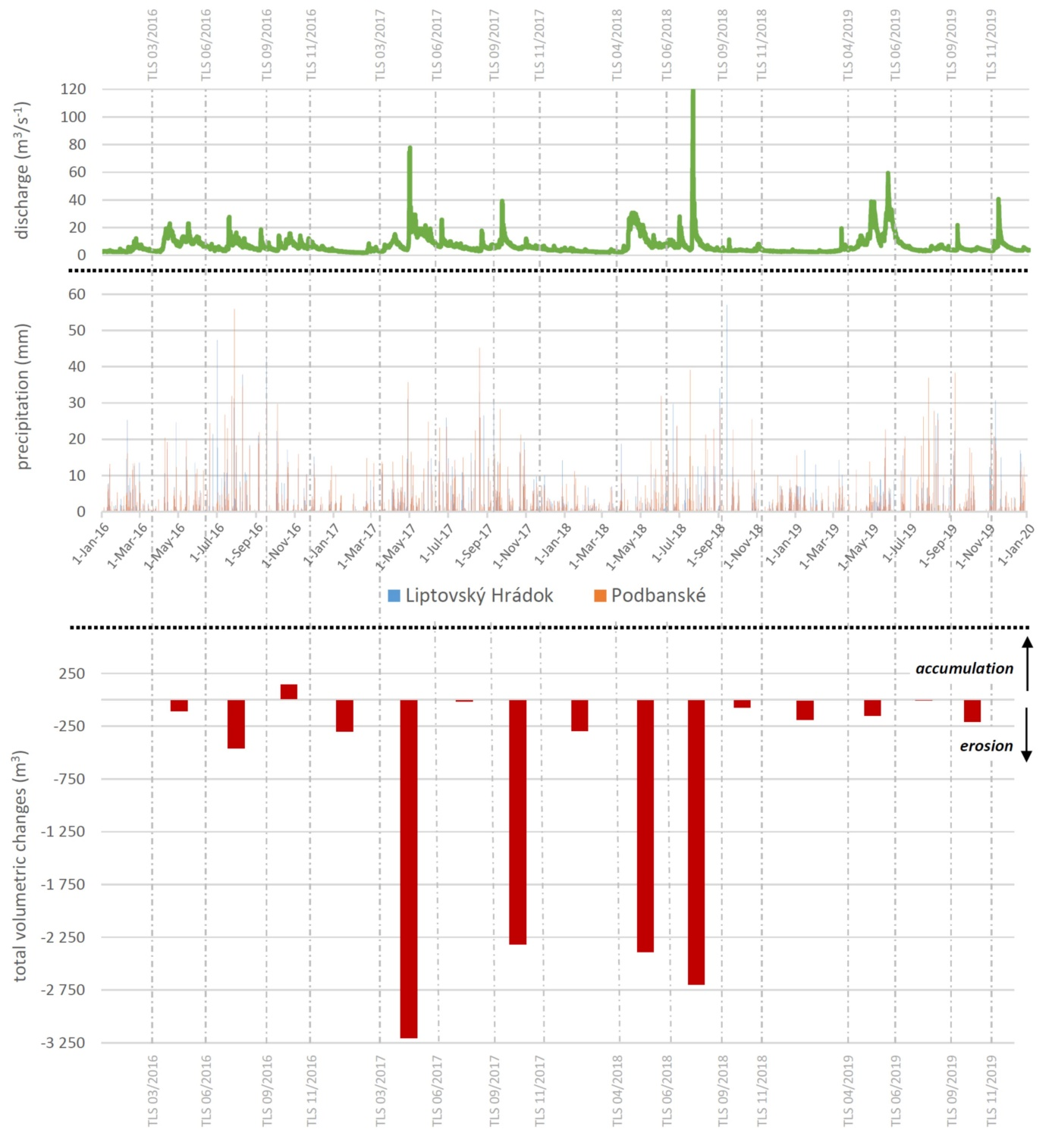
Figure 6. The relation between flow discharge, precipitation and volumetric changes of the landslide.
Visualization of digital terrain models time series
The space-time cube (STC) method was used to visualize the development of morphology and elevation ratios of the investigated landslide. The STC allows visualizing a change in a certain parameter (elevation) over time in a 3D perspective. The advantage of the STC is especially the ability to visualize the change in elevation over the entire monitored period. Conventional visualization methods such as cross-sections can only show the change in a certain place - the selected profile. The resulting image may be confusing and obscure when using the large time series of input data. On the contrary, continuous raster models such as DoDs show the change continuously in the whole area of interest, but only between the two compared DTMs. For these reasons, the use of STC is, therefore, a suitable alternative to conventional visualization methods.
Figure 7 shows two ways to visualize a series of spatial data in the form of STC, which is enabled by GRASS GIS software. Vertical sections through STC (Fig. 7.1) represent the XY position of pixels with a certain value of elevation and its change over the observed period. On the given sections it is possible to observe the movement of the material along the slope of the landslide (increase or decrease of the material in the given place) as well as the spatial changes of the riverbed. The isosurfaces in Figure 7.2 in turn show the spatial variability of the selected altitude value during the entire observed period (March 2016 - June 2020). The individual shades of the color scale represent the date when the landslide mapping was performed and to which the displayed data belong. On all vertical sections in the first half of 2017, we observe a sudden change in the area of contact between the riverbed and the landslide slope. This change indicates significant erosion activity, which prevailed in this part of the area of interest in the given period. The same trend is visible in Figure 7.2 (view A), where at an elevation of 700 m above sea level there are horizontal shifts of the surface inwards (towards the slope), which indicates a decrease of material, i.e. erosion activity in the first half of 2017. In some parts, on the contrary, there are horizontal shifts of the surface outwards (from the slope), which in turn indicates an increase - material accumulation. The terrain changes observed on the STC correlate with the calculated volume changes shown in Figure 5.
Figure 7. Space-time cube visualization: vertical slices extracted from the voxel model passing through whole time series of DTMs (1) and isosurfaces of selected elevation and its change during the observed period.
- doplniť video(animáciu)

Discussion
The analysis of dynamic landscape elements such as active landslides is based on the periodic data acquisition about their changing topography. Small landslides (less than 1 hectare) are difficult to identify from the currently available data. The reason is the low level of detail of these data, which were obtained by various mapping methods, predominantly designed for mapping large areas. The problem is also the low periodicity of mapping, which makes it impossible to obtain relevant data such as contours or point clouds. For the area of interest, satellite images from satellites such as LANDSAT 8 or Sentinel 2 are available at regular intervals. However, the level of detail of the satellite images is too low for detailed mapping (few meters to tens of meters), and in the areas with vegetation cover is difficult to extract data about terrain morphometry. For the detailed mapping of such specific areas (low range, partial vegetation cover) the optimal mapping method is laser scanning, which produces accurate data about terrain geometry at a high level of detail. At present, a nationwide airborne laser scanning of Slovakia is underway, which brings new possibilities for landscape analysis. Since it is a disposable mapping action, the data obtained from the ALS will not be possible to use for the exact analysis of the terrain volume changes. However, ALS data are a suitable input dataset for digital modeling of the terrain morphometric parameters and various processes (surface runoff, erosion) that take place in the country. In our case, the ALS data could be used to create a DTM of a wider area around the investigated landslide that is no longer covered by the TLS data. The created DTM would allow us to model and analyze drainage conditions in the Belá River basin and their impact on landslide activity. ALS data is characterized by slightly lower vertical and horizontal accuracy than TLS data. Also, the density (level of detail) of ALS data is lower compared to TLS data, which in turn affects the accuracy and level of detail of the DTM created from the ALS data (ALS-DTM). Figure 8 illustrates parts of the DTMs created from TLS and ALS data where evident differences in models detail can be observed. Both models are created in a spatial resolution of 0.1 m, but at ALS-DTM, it is obvious that the point cloud density is not sufficient to create such a detailed DTM. To generate the DTM from TLS data (TLS-DTM) it was used over 21 million points, but to generate ALS-DTM was used only approximately 170 thousand, which is only a small amount compared to TLS data. To analyze the volume changes of the studied landslide, it is, therefore, most appropriate to use DTMs derived from TLS data, which together with hydrological data provide comprehensive information about landslide dynamics.
Figure 8. Level of detail differences between DTM from TLS data (A) and DTM from ALS data (B) when using the same interpolation method and spatial resolution.
From the comparison of hydrological data and values ​​of volume changes, it is clear that hydrological factors have a fundamental influence on landslide activity. For the entire monitored period (2016 - 2020), erosion prevailed over accumulation. Only in three cases was accumulation the dominant process, which may appear as a measurement error. Positive values ​​of volume changes (accumulation of material) can be caused by sediment deposition by the Belá River and the formation of gravel bar during increased water levels when the river also has an increased transport capacity. However, this theory ignores the fact that increased water level also results in increased material erosion. Positive values ​​of volume changes are therefore probably due to different water levels in the individual mapping campaigns. Namely, during each mapping campaign, the Belá River had a certain level height, which on the one hand defined the extent of the mapped area and thus the extent of the acquired data. The laser scanner used for the mapping can only partially penetrate the water surface, so the water forms a barrier for the mapping. When changing the water level, e.g. when it is reduced, a part of the terrain is revealed and during further mapping campaign, it can already be captured by a laser scanner (Fig. 9). This effect is subsequently reflected in the data by the increased accumulation of material and thus by the positive values ​​of the total volume changes.
Figure 9. The effect of different water levels on the range of the mapped area.
Conclusion
The rivers by their activities partially cause the dynamics of the landscape, which is presented mainly by the morphological changes of the river banks and riverbeds. These changes cause erosion and accumulation processes, the activity of which can lead to the formation of very dynamic landslides and thus to an overall change in the landscape around the river. For the correct interpretation of the river bank landslides, their detailed periodic mapping is necessary, which is also pointed out in the presented study. The TLS mapping technique provides the flexibility needed to periodically monitor small dynamic areas. The studied landslide was periodically mapped using TLS over a period of four and a half years. A dataset of 18 high-resolution DTMs was produced from TLS data for the identification of the landslide volumetric changes. By comparing the volume changes with the values of flow discharge and precipitation in the given area, a significant correlation was found between these data. During the years 2016 - 2020, 19,800 m³ of the material was eroded from the area of interest with an area of almost 6,000 m². Part of the eroded material in the volume of 7,700 m³ was subsequently accumulated directly on the landslide slope. The rest of the eroded material in the volume of 12,100 m³ was transported away from the area of interest by the Belá River. Spatial changes in the Belá riverbed have caused a decline in landslide activity in the last months under review. This was reflected in the values of volume changes, but also in the derived digital models of volume changes. Spatio-temporal changes in landslide morphology were visualized in the form of a space-time cube, which allows the visualization of dynamic 3D objects and monitors their change over time. Further research will focus on…
Funding
This research was funded by the Slovak Research and Development Agency within the project APVV/SK-CN-RD-18-0015: Key Technologies on the Integration of Multi-GNSS, LiDAR and Oblique Photogrammetry in 3D High-Quality Reconstruction of Smart City (3DSMARTCITY) and also by the grant of the Ministry of Education, Science, Research and Sport of the Slovak Republic within the project VEGA 1/0798/20: Synergistic use of multisource remote sensing data in Earth system research.
References
Andriolo, U., Goncalves, G., Sobral, P., Fontán-Bouzas, Á., Bessa, F. (2020). Beach-dune morphodynamics and marine macro-litter abundance: An integrated approach with Unmanned Aerial System. Science of the Total Environment. 749, 141474.
Antrop, M. (1998). Landscape change: Plan or chaos?. Landscape Urban Planning. 41(3-4), 155-161.
Barbarella, M., Fiani, M., Lugli, A. (2015). Landslide monitoring using multitemporal terrestrial laser scanning for ground displacement analysis. Geomatics, Natural Hazards and Risk. 6(5-7), 398-418.
Barbarella, M., Fiani, M. (2017). Monitoring of large landslides by Terrestrial Laser Scanning techniques: field data collection and processing. Europena Journal of Remote Sensing. 46(1), 126-151.
Bitelli, G., Dubbini, M., Zanutta, A. (2004). Terrestrial Laser Scanning and digital photogrammetry techniques to monitor landslide bodies. ISPRS Archives. 35, 246-251.
Butler, A., Berglund, U. (2012). Landscape Character Assessment as an Approach to Understanding Public Interests within the European Landscape Convention. Landscape Research. 39(3), 219-236.
Clague, J.J., Stead, D. (2012). Landslides: Types, Mechanisms and Modeling. 420 p.
Collins, B., Corbett, S., Fairly, H., Minasian, D., Kayen, R., Dealy, T., Bedford, D. (2012). Topographic Change Detection at Select Archeological Sites in Grand Canyon National Park, Arizona, 2007–2010. US Geologic Survey Scientific Investigations Report 2012–5133, 77 pp.
De Blasio, F.V. (2011). Introduction to the Physics of Landslides: Lecture notes on the dynamics of mass wasting. 408 pp.
Eker, R., Aydin, A., Hübl, J. (2018). Unmanned aerial vehicle (UAV)-based monitoring of a landslide: Gallenzerkogel landslide (Ybbs-Lower Austria) case study. Environmental monitoring and assessment. 190(28).
Hardin, E., Mitasova, H., Tateosian, L., Overton, M. (2014). GIS-based Analysis of Coastal Lidar Time-Series. Springer, 84 pp.
Higgins, S., Mahon, M., McDonagh, J. (2012). Interdisciplinary interpretations and applications of the concept of scale in landscape research. Journal of Environmental Management. 113, 137-145.
Houet, T., Verburg, P.H., Loveland, T.R. (2010). Monitoring and modelling landscape dynamics. Landscape Ecology. 25(2), 163-167.
Jaboyedoff, M., Oppikofer, T., Abellán, A., Derron, M.H., Loye, A., Metzger, R., Pedrazzini, A. (2012). Use of LIDAR in landslide investigations: a review. Natural Hazards. 61, 5-28.
Lague, D., Brodu, N., Leroux, J. (2013). Accurate 3D comparison of complex topography with terrestrial laser scanner: application to the Rangitikei canyon (N-Z). ISPRS Journal of Photogrammetry and Remote Sensing. 82, 10-26.
Lindner, G., Schraml, K., Mansberger, R., Hübl, J. (2016). UAV monitoring and documentation of a large landslide. Applied Geomatics. 8(1), 1-11.
Longoni, L., Papini, M., Brambilla, D., Barazzetti, L., Roncoroni, F., Scaioni, M., Ivanov, V.I. (2016). Monitoring Riverbank Erosion in Mountain Catchments Using Terrestrial Laser Scanning. Remozte Sensing. 8(3), 241.
Martha, T.R., Kerle, N., Jetten, V., van Westen, C.J., Vinod Kumar, K. (2010). Landslide Volumetric Analysis Using Cartosat-1-Derived DEMs. IEEE Geoscience and Remote Sensing Letters. 7(3), 582-586.
Mitasova, H., Harmon, R.S., Weaver, K.J., Lyons, N.J., Overton, M.F. (2012). Scientific visualization of landscapes and landforms. Geomorphology. 137(1), 122-137.
Niethammer, U., James, M.R., Rothmund, S., Travelletti, J., Joswig, M. (2012). UAV-based remote sensing of the Super-Sauze landslide: Evaluation and results. Engineering Geology. 128, 2-11.
Oppikofer, T., Jaboyedoff, M., Blikra, L., Derron, M.H., Metzger, R. (2009). Characterization and monitoring of the Åknes rockslide using terrestrial laser scanning. Natural Hazards and Earth System Sciences. 9(3), 1003-1019.
Peternel, T., Kumelj Š., Oštir, K., Komac, M. (2017). Monitoring the Potoška planina landslide (NW Slovenia) using UAV photogrammetry and tachymetric measurements. Landslides. 14, 395-406.
Pfeifer, J., Zieher, T., Rutzinger, M., Bremer, M., Wichmann, V. (2019). Comparison and time series analysis of landslide displacement mapped by airborne, terrestrial and unmanned aerial vehicle based platforms. ISPRS Annals of the Photogrammetry, Remote Snesing and Spatial Information Sciences. 4(2), 421-428.
Prokop, A., Panholzer, H. (2009). Assessing the capability of terrestrial laser scanning for monitoring slow moving landslides. Natural Hazards and Earth System Sciences. 9(6), 1921-1928.
Rusnák, M., Kaňuk, J., Kidová, A., Šašak, J., Lehotský, M., Pöppl, R., Šupinský, J. (2020). Channel and cut-bluff failure connectivity in a river system: Case study of the braided-wandering Belá River, Western Carpathians, Slovakia. Science of The Total Environment. 733, 139409.
Starek, M.J., Mitasova, H., Wegmann, K.W., Lyons, N. (2013). Space-Time Cube Representation of Stream Bank Evolution Mapped by Terrestrial Laser Scanning. IEEE Geoscience and Remote Sensing Letters. 10(6), 1369-1373.

https://vcg.informatik.uni-rostock.de/~ct/timeviz/timeviz.html?2D=0

