Institute of Geography, Faculty of Science, Pavol Jozef Šafárik University in Košice

Project: URBANA: Development and Verification of Urban Analytics (Contract No.: AO/1-11889/23/I-DT)

The URBANA (URBan ANAlytics) project is an ESA-funded initiative led by GMATICS, focused on the development of innovative analytical tools to support urban planning and the assessment of urban environmental parameters and their impacts on people and infrastructure. The project responds to the growing need to integrate satellite and spatial data into public administration processes, with the aim of strengthening analytical capacities and supporting informed decision-making in urban environments. Developed and tested in collaboration with the cities of Rome, Milan, Pesaro, Zurich, Barcelona, Hamburg, Bratislava, and Košice, URBANA promotes the use of Earth observation data for building more sustainable, resilient, and responsive cities.

Our task within the URBANA project was the development and testing of the B.3 – Thermal Stress Assessment service, focused on producing high-resolution urban heat stress maps through the integration of satellite imagery, vector data, LiDAR point clouds, population grids, and meteorological (SYNOP) forcing data. Using advanced preprocessing workflows and ENVI-met modelling, we derived key thermal stress indices (PET, SET, UTCI), which were subsequently analysed in relation to the spatial distribution of urban populations. The objective was to support evidence-based urban adaptation and mitigation planning by providing scalable, transferable methodologies applicable to different cities with available data, with pilot implementations carried out for the municipalities of Bratislava and Košice.

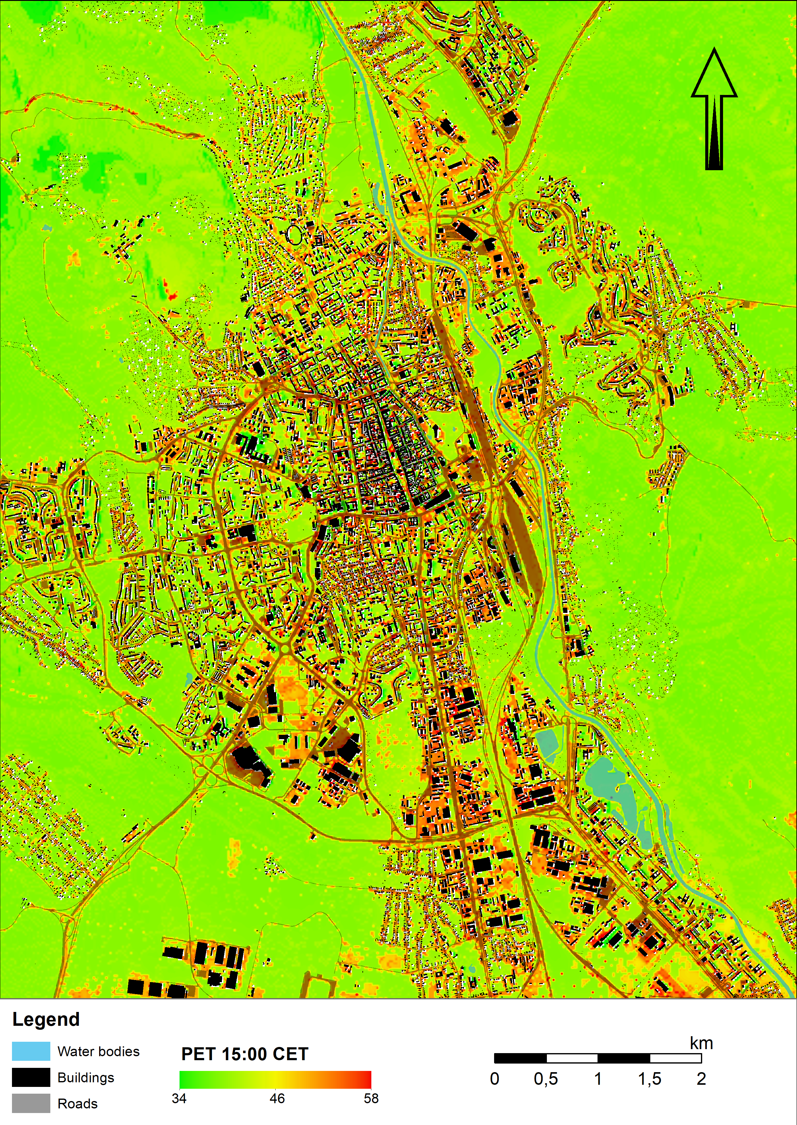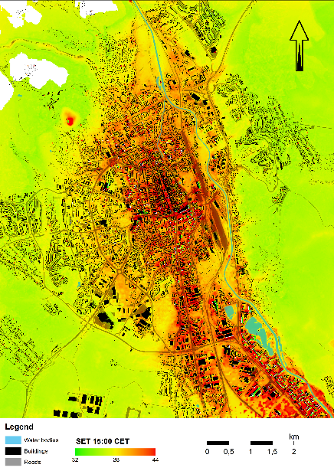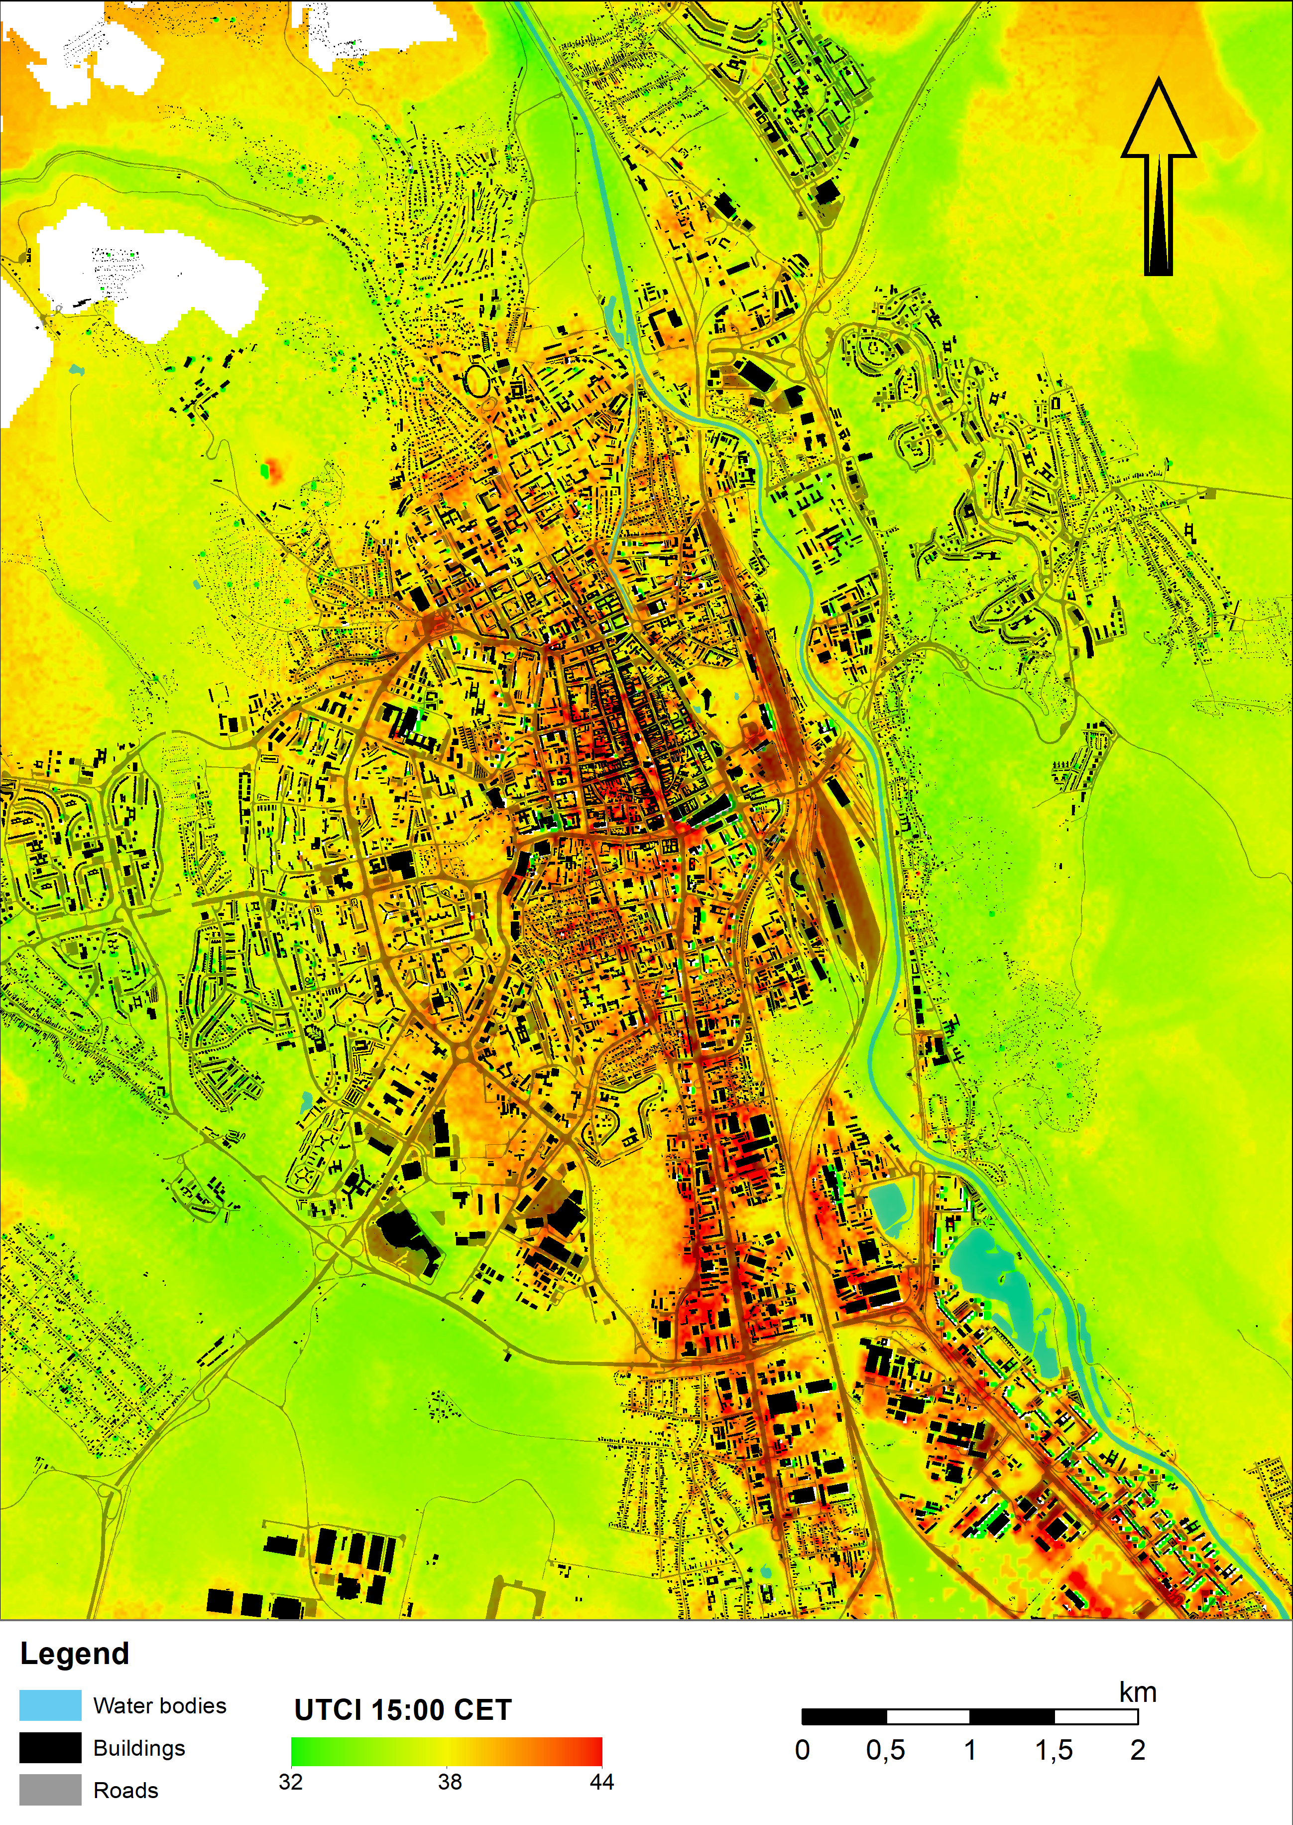

Figure 1: Thermal indices PET, SET and UTCI at 15:00 CET at pedestrian height (1.5 m) in Košice.

Project: VEGA No. 1/0780/24 (2024–2026) Integration of LiDAR and Hyperspectral Data with Machine Learning Methods for Improved Land Cover Classification

The project is funded by the Slovak Scientific Grant Agency VEGA No. 1/0780/24 (2024–2026) and is carried out at the Institute of Geography, Faculty of Science, Pavol Jozef Šafárik University in Košice. It focuses on integrating airborne and UAV-based LiDAR point clouds with hyperspectral imagery and machine learning to improve land-cover classification and 3D landscape characterization. The research develops transferable spectral–structural workflows combining LiDAR-derived metrics (e.g., CHM, vegetation volume, surface morphology) with VNIR–SWIR features, emphasizing feature fusion, dimensionality reduction (e.g., PCA), supervised classification, and independent validation. Applications include urban vegetation assessment, precision viticulture, and CAL/VAL support for hyperspectral satellite missions. A key output concerning urban environment is Svetozarov & Gallay (2024) (Geografický časopis, 76(3), 221–247, https://doi.org/10.31577/geogrcas.2024.76.3.12), which quantified 31.12 million m³ of urban vegetation in Košice from airborne laser scanning and showed that 3D volumetric indicators substantially refine green infrastructure assessment compared to 2D metrics. The project also contributes to hyperspectral CAL/VAL research. Melis et al. (2024) (ISPRS Archives, XLVIII-3-2024, 337–343; https://doi.org/10.5194/isprs-archives-XLVIII-3-2024-337-2024) reported first spectral and LiDAR results for Sal ’e Porcus (Sardinia, ~3.3 km²), including an initial evaporite spectral library, cross-scale consistency between field/UAV/satellite data (PRISMA, EnMAP), and LiDAR-based morphology patterns, supporting the site as a candidate European CAL/VAL area for current and forthcoming hyperspectral missions (e.g., PRISMA-SG, CHIME). The project team presented at WHISPERS 2025 conference in Barcelona two contributions on (i) hyperspectral–LiDAR integration for improved discrimination/classification of vineyards and (ii) UAV hyperspectral bridging ground and satellite measurements for CAL/VAL at Sal ’e Porcus. The project enters its final year in 2026 (https://www.ieee-whispers.com/wp-content/uploads/2025/11/Whispers_Program_2025_final.pdf).

Events: International Remote Sensing Summer School, Experiencing Remote Sensing on Sardinia inland site: Advanced summer school on instruments and methodology for a CAL/VAL site for Optical data, 21-25 July, 2025, San Vero Milis, Italy

Three academic staff members of the Institute of Geography, Faculty of Science, Pavol Jozef Šafárik University in Košice actively participated in the fourth edition of this summer school, held from 21 to 25 July 2025 in western Sardinia near the village of San Vero Milis as part of research and capacity-building activities linked to the VEGA project No. 1/0780/24. Hands-on training research and educational activities were focused on the seasonally drying salt lake Stagno di Sal’e Porcus, which—due to its geological specificity and exceptional spectral stability—is emerging as a potential European calibration and validation site for hyperspectral satellite sensors. During the summer school, they demonstrated and taught laser scanning and hyperspectral mapping using unpiloted aerial systems (UAS). The training aimed at the mutual sharing of knowledge and skills in the processing of hyperspectral and lidar data from ground, aerial, and satellite measurements for the purposes of calibration and validation of hyperspectral satellite data.

The event was co-organized by the Department of Chemical and Geological Sciences of the University of Cagliari in cooperation with the Italian National Institute of Geophysics and Volcanology (INGV), the Italian Association for Remote Sensing of the Earth (AIT) and the Italian Space Agency (ASI). Over five intensive days, 30 doctoral students from around the globe took part in demanding fieldwork and data acquisition, generating more than 300 GB of geospatial data. The summer school provided advanced practical experience in EO-based environmental monitoring and demonstrated the value of international collaboration for research training and methodological harmonization—outcomes that directly reinforce the VEGA project’s research objectives and dissemination/education activities.

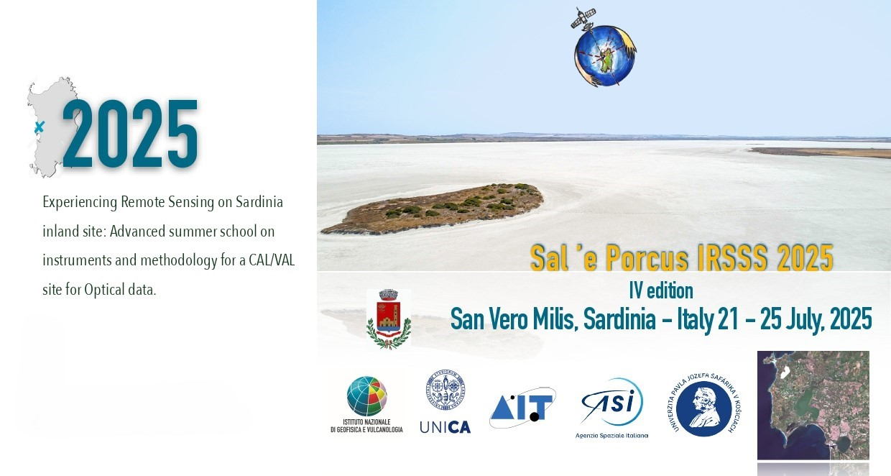
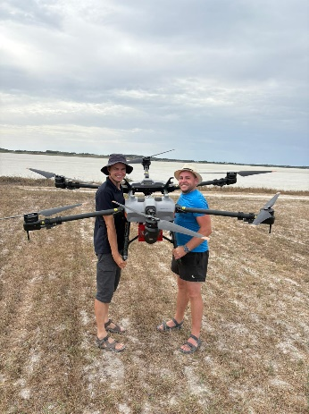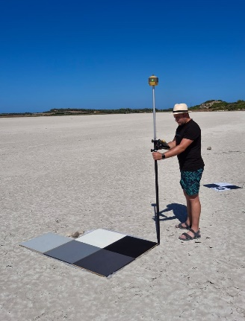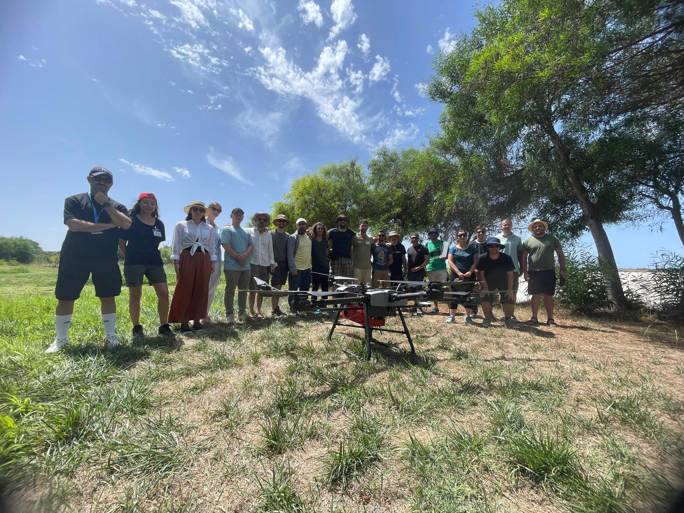
Figure 2. Field data collection at the seasonally drying salt lake Stagno di Sal’e Porcus, Sardinia. Participants conducted laser scanning and hyperspectral mapping using UAS for calibration and validation of hyperspectral satellite data.

Publication: MD, A., RUSNÁK, M., KAŇUK, J., ŠAŠAK, J. (2025). Coarse sediment grain size variability along gravel-bed rivers via automatic grain size detection (a case study of the Ondava River, Slovakia). Geomatics, Natural Hazards and Risk, 16, 1, 2582752.

The study focuses on grain size analysis as a key tool for understanding river hydraulics and sediment dynamics. Recent technological advances enable automated, noninvasive monitoring of river channels and sediment properties. Photosieving was applied to assess grain size distribution (GSD) on a gravel bar of the Ondava River in the Carpathians. Using BASEGRAIN and PebbleCount software, D50 values ranged from 33.1 mm to 76.9 mm and 31.4 mm to 59.1 mm, respectively, and were validated against traditional sieving. BASEGRAIN showed better agreement with laboratory results, particularly for finer sediments, while PebbleCountAuto was suitable for coarser fractions. Automated methods reduce effort and subjectivity compared to manual approaches, although further refinement is needed to achieve comparable accuracy and reliability.

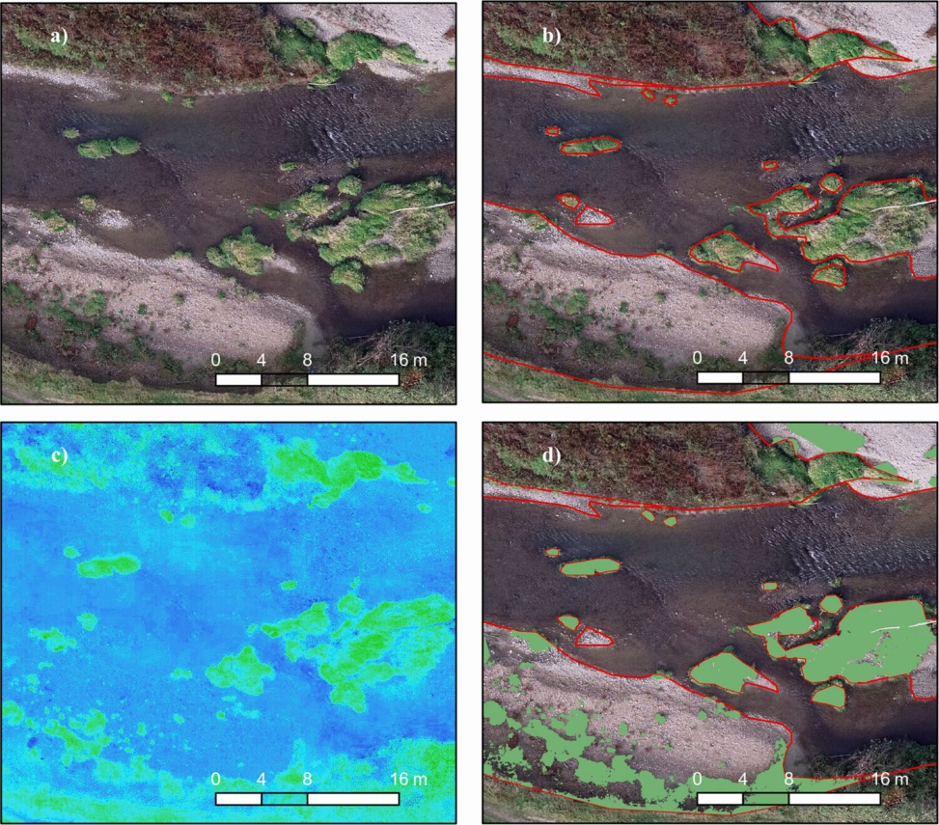

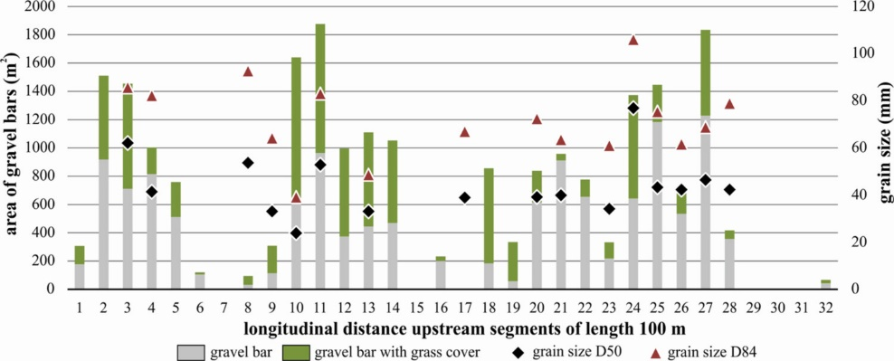

Figure 3. Manual vectorization of the main geomorphological unit from UAV orthophoto with a resolution of 2.08 cm (a), borders of in-channel gravel bar area (b), calculation of RGBVI indices (c) and the final intersection of the gravel bar area and reclassified RGBVI indices based on threshold 0.10 (d) (upper image); Longitudinal distribution of the gravel bar area, gravel bar area with vegetation cover and grain size distributions D50 and D90 from BASEGRAIN (lower image)
Publication: FISCHER, J., GROENEMEIJER, P., HOLZER, A., FELDMANN, M., SCHRÖER, K., BATTAGLIOLI, F., ... FEDOR, T., HOFIERKA, J., ... et al. (2025). Invited perspectives: Thunderstorm intensification from mountains to plains. Natural Hazards and Earth System Sciences, 25(8), 2629-2656.

The study addresses severe thunderstorms, among the most damaging and impactful weather phenomena. In Europe, they often occur in regions with complex terrain, where storm activity is frequent and exhibits a clear climate change signal, with increasing frequency. Despite their importance, understanding of severe convection in such areas, particularly under a changing climate, remains limited. This White Paper reviews current research on thunderstorms in complex orography, covering storm severity, pre-storm environment modifications, convection initiation, storm-terrain interactions, associated hazards, numerical modeling and forecasting, climatologies and climate change signals, and innovative observational methods. By identifying gaps in knowledge, the study emphasizes the need for a coordinated European field campaign—Thunderstorm Intensification from Mountains to Plains (TIM). Initial plans for the TIM campaign, developed by the contributing authors and institutions, are briefly presented. Collecting coordinated, high-resolution data on orographically driven storms is essential for improving warnings, forecasts, climate projections, and adaptation strategies.

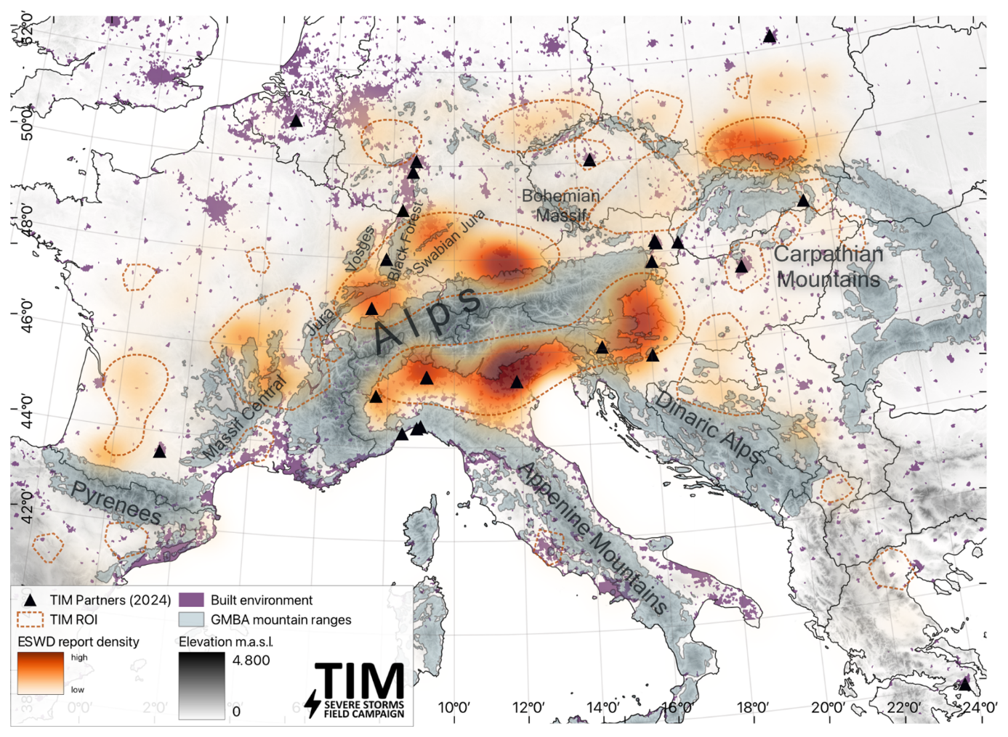

Figure 4. Map of the TIM domain with regions of interest (ROIs). ROIs were identified based on in-domain ESWD severe hail reports. The red shading indicates primary hotspots with high report densities from kernel-density estimation (KDE). To represent secondary clusters, reports grouped by density-based spatial clustering of applications (DBSCANs) are indicated with the dashed red contours. Also shown are mountain ranges of the GMBA mountain inventory and built-up surfaces (Snethlage et al., 2022b, a). The black triangles show official TIM partner institutions' headquarter locations as of May 2025.

Publication: BUCHALOVÁ, D., HOFIERKA, J., ŠUPINSKÝ, J., KAŇUK, J. (2025). Estimating Subcanopy Solar Radiation Using Point Clouds and GIS-based Solar Radiation Models. Remote Sensing, 17, 2, 328.

The study explores advanced methodologies for estimating subcanopy solar radiation using LiDAR (Light Detection and Ranging)-derived point clouds and GIS-based models, focusing on the influence of different LiDAR data types on model performance. Two modeling approaches—r.sun and the Point Cloud Solar Radiation Tool (PCSRT)—were compared in capturing solar radiation dynamics beneath tree canopies. The models were applied to contrasting environments: a forested area and a built-up area. The r.sun model, based on raster data, and PCSRT, using voxelized point clouds, were evaluated for accuracy and efficiency. LiDAR data were collected through terrestrial laser scanning (TLS), unmanned laser scanning (ULS), and aerial laser scanning (ALS) to capture canopy structural complexity. Results indicate that LiDAR type strongly affects model outputs. PCSRT’s voxel-based approach provided higher precision in heterogeneous forest environments. ULS data delivered the most accurate solar radiation estimates, closely matching in situ pyranometer measurements, due to its high-resolution coverage of canopy structures. TLS offered detailed local information but limited spatial coverage, while ALS provided broader coverage with lower precision under dense canopies. These findings highlight the importance of selecting suitable LiDAR data for modeling subcanopy solar radiation, particularly in complex environments.

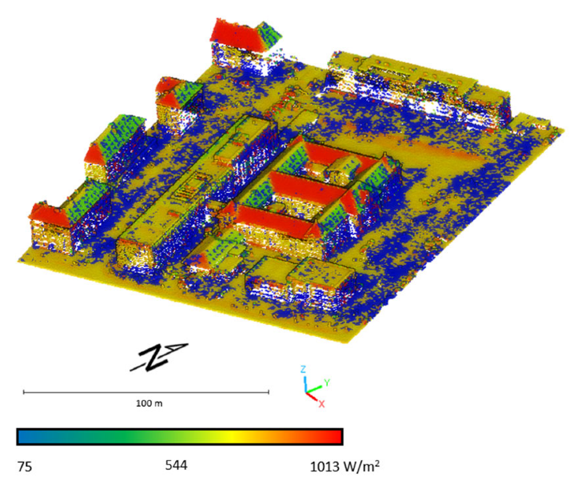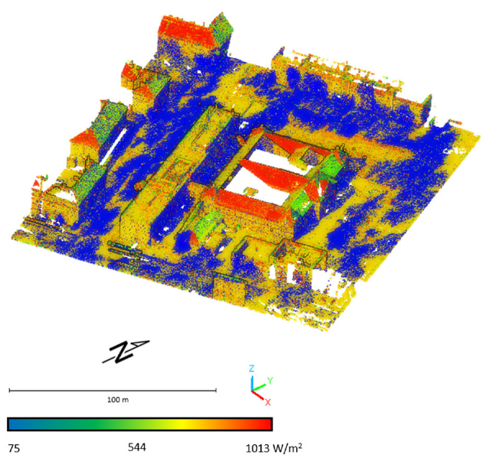

Figure 5. Figures present the results of solar radiation modeling on the terrain beneath the tree canopy in the built-up area. To enhance the visualization of solar radiation distribution, the point clouds representing the canopy were filtered out, revealing the underlying terrain. Left - Estimated subcanopy solar radiation by PCSRT in built-up area—ALS data; 27 September 2023, 12 a.m.; Right - Estimated subcanopy solar radiation by PCSRT in built-up area—TLS data; 27 September 2023, 12 a.m.

Publication: WITEK, A., WALUSIAK, G., HALICKI, M., REMISZ, J., BOROWICZ, D., PARZÓCH, K., KASPRZAK, Ł., LANGHAMMER, J., GALLAY, M., MIŘIJOVSKÝ, J., ŠAŠAK, J., KAŇUK, J., LENDZIOCH, T., MINAŘÍK, R., POPELKA, S., NIEDZIELSKI, T. (2025). Reconstructing bed topography of a shallow river from close-range aerial imagery: Multi-UAV experimental campaign in the Izera river (SW Poland/N Czechia). Geomorphology, 471, 109544.

The study aims to reconstruct the bathymetry of a shallow river using the Structure-from-Motion (SfM) algorithm and to evaluate the robustness of the approach in terms of repeatability and reproducibility. To this end, a multi-UAV experimental campaign was conducted on the gently flowing Izera River in SW Poland/Northern Czechia. The UAVs employed included one fixed-wing aircraft (eBee by SenseFly) and three multi-rotor platforms (DJI Matrice 210-RTK V2, DJI Mavic 2 Pro, DJI Phantom 4 Pro). Riverbed topography was reconstructed 48 times (2 sites × 4 platforms × 3 resolutions × 2 repetitions) using SfM, with corrections applied for refraction. Reference elevations of the riverbed were obtained via leveling, while water surface elevations were measured using a terrestrial laser scanner. Root mean square errors (RMSE) of the riverbed reconstructions—generally slightly underestimated—ranged from 2.6 cm to 109.3 cm, with a median of 17.5 cm, falling within the typical error range for through-water photogrammetry. Repeatability tests showed RMSE below 10 cm in 57 % of cases (up to 76 % for multi-rotor UAVs), while reproducibility tests achieved this in 47 % of cases (up to 60 % for multi-rotor UAVs). The results indicate that the SfM-based approach is robust, particularly when multi-rotor UAVs are used. However, reconstruction accuracy decreases near riverbanks, highlighting the influence of channel morphology on effectiveness.

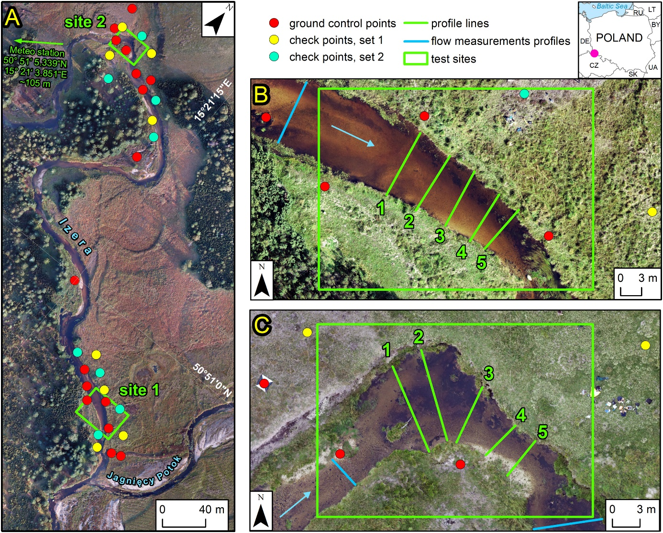
Figure 6. Study area (A), site 1 (B) and site 2 (C) location.

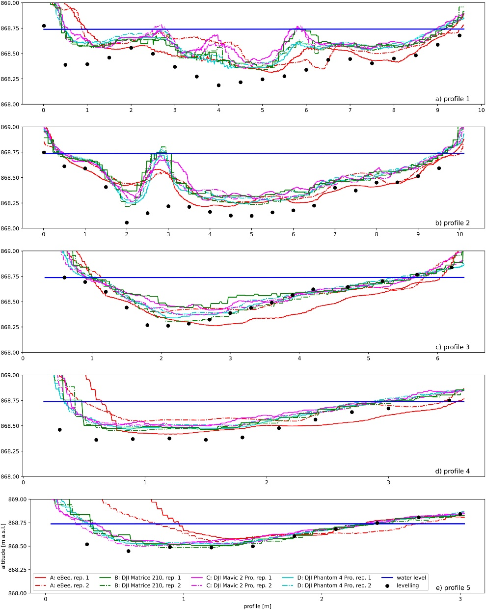
Figure 7. Corrected riverbed elevations for all platforms and one common resolution – 3 cm/px (site 2).

Publication: UHRIN, A., ONAČILLOVÁ, K. (2025). Spatiotemporal analysis of land surface temperature and land cover changes in Prešov city using downscaling approach and machine learning algorithms. Environ. Monit. Assess. 197, 126.

The study focuses on the evaluation of LST and land cover (LC) changes in the city of Prešov, Slovakia, a typical medium-sized European city that has recently undergone significant LC changes. In this study, we use the relationship between Landsat-8/Landsat-9-derived LST and spectral indices Normalized Difference Built-Up Index (NDBI), Normalized Difference Vegetation Index (NDVI), Normalized Difference Water Index (NDWI) derived from Landsat-8/Landsat-9 and Sentinel-2 to downscale LST to 10 m. Two machine learning (ML) algorithms, support vector machine (SVM) and random forest (RF), are used to assess image classification and identify how different types and LC changes in selected years 2017, 2019, and 2023 affect the pattern of LST. The results show that several decisions made during the last decade, such as the construction of new urban fabrics and roads, caused the increase in LST. The LC change evaluation, based on the RF classification algorithm, achieved overall accuracies of 93.2% in 2017, 89.6% in 2019, and 91.5% in 2023, outperforming SVM by 0.8% in 2017 and 4.3% in 2023. This approach identifies UHI-prone areas with higher spatial resolution, helping urban planning mitigate the negative effects of increasing urban LSTs.

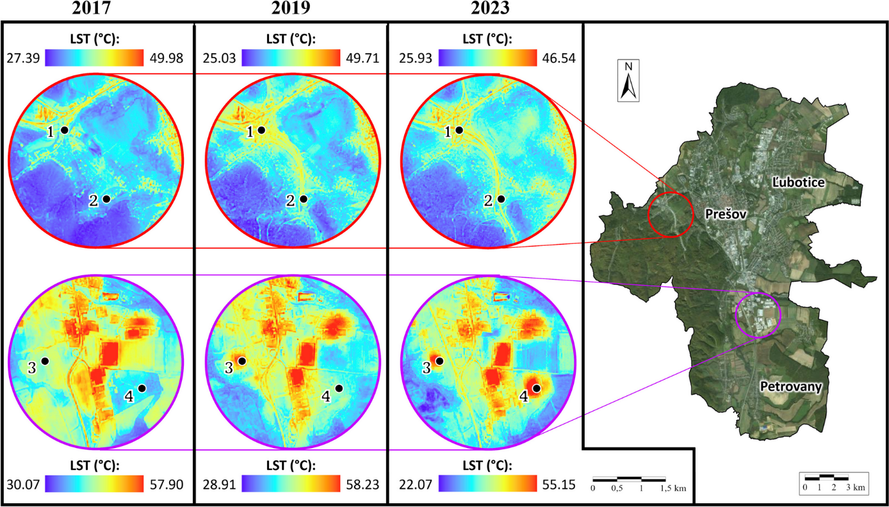

Figure 8. Selected locations (Sites 1–4) in Prešov city, Slovakia, where significant changes in land surface temperature between 2017 and 2023 were detected. Source: land surface temperature maps processed by the author; background true color map (right) © ESRI “World Imagery.”

